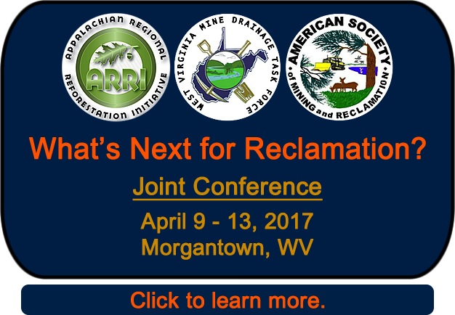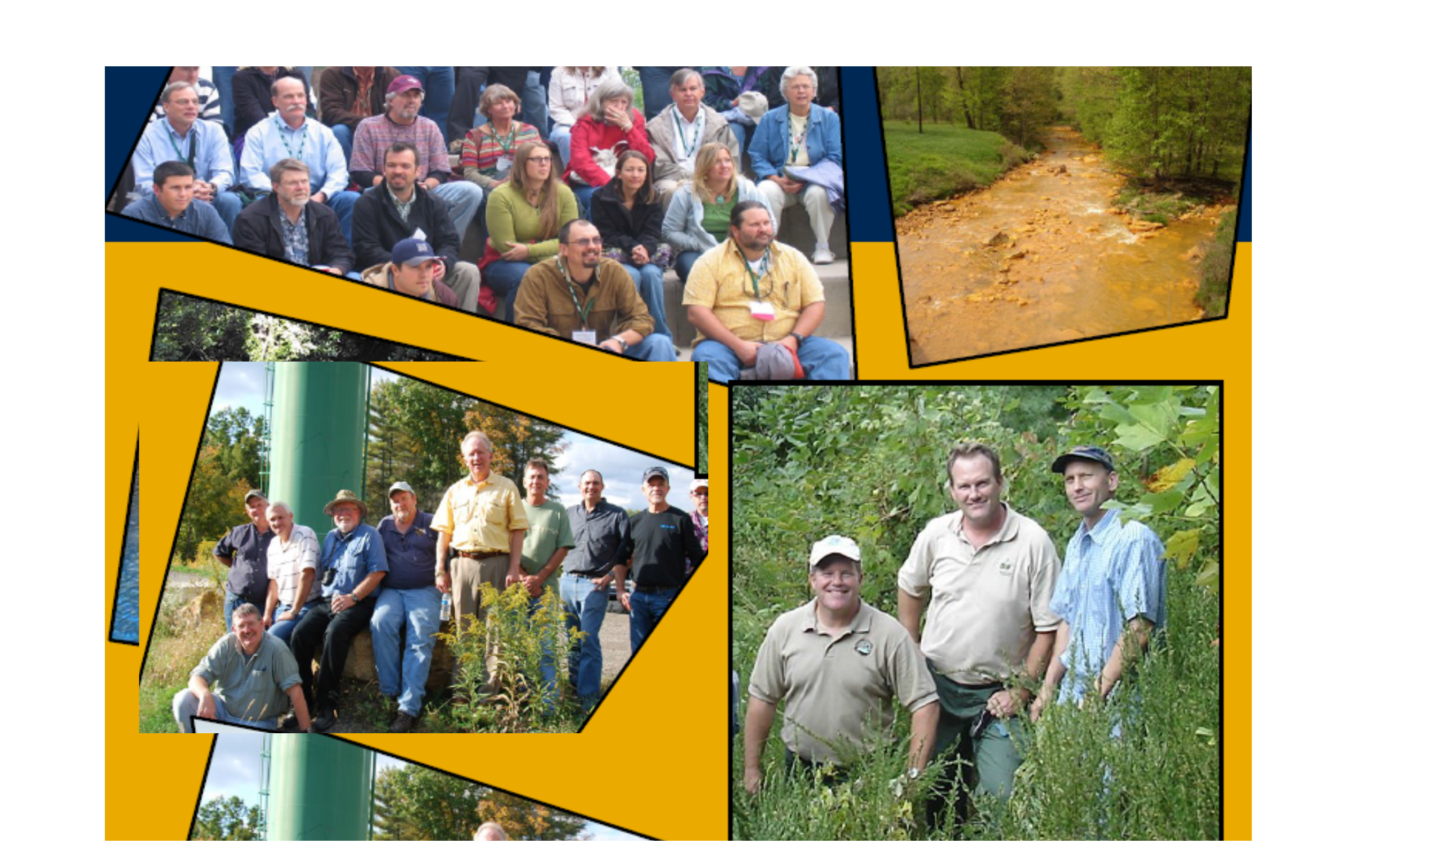
Registration Information

REGISTRATION TYPE AND FEES | Through Feb 28, 2017 | After Feb 28, 2017
Basic Registration* | $350 | $475
Student Registration* | $100 | $150
One Day Registration (Mon, Tue, Wed, Thu)** Which day? ________ | $150 | $150
Special Registration*** | variable | variable
*Basic and Student Registration includes program materials, all food functions (breakfasts, lunches, breaks, receptions), and admittance to all sessions. Workshops and field trips are not included.
**One-day registration includes the basic registration items listed above for that day.
***Please select if you are an exhibitor, sponsor, award or scholarship recipient, non-profit, spouse, or other special designee. Registration code will be given to you (contact jskousen@wvu.edu). Workshops and field trips are not included.

EXHIBITORS – 1 basic registration comes with each exhibit
Price based on location in lobbies (map available from Tiff Hilton)
Contact Tiff Hilton, 304-667-1952 or wopec@suddenlink.net

SPONSORSHIP Contact Jeff Skousen, 304-293-2667 or jskousen@wvu.edu

GOLD (includes 4 basic registrations) | $10,000
SILVER (includes 3 basic registrations) | $5,000
BRONZE (includes 2 basic registrations) | $2,500
COAL (includes 1 basic registration) | $1,500

WORKSHOPS (Sunday, April 9, 2017) | Through Feb 28, 2017 | After Feb 28, 2017
1 Mine Drainage Treatment Workshop | $100 | $125
2 Android- and IOS-based Geodatabase Collection | $20 | $50
3 Passive Treatment Design, Implementation, and O&M | $50 | $75
4 Natural Process for the Restoration of Drastically Disturbed Sites | $150 | $175
5 Reclamation Standards, Bonding and Compliance Inspections | $100 | $125

FIELD TRIPS (Tuesday, April 11, 2017) | Through Feb 28, 2017 | After Feb 28, 2017
1 Surface Mining and Post-mining Land Use (1/2 day) | $30 | $50
2 Acid Mine Drainage Chemical Treatment Plants (1/2 day) | $30 | $50
3 Passive Treatment of AMD (1/2 day) | $30 | $50
4 Longview Power Plant (1/2 day) | $30 | $50
5 ARRI Reforestation of Mined Lands – Flight 93 Site | $50 | $100

THREE OPTIONS TO REGISTER

1. ONLINE REGISTRATION AND PAY ONLINE. https://www.regonline.com/2017minedrainagetaskforce

2. OFF-LINE REGISTRATION WITH CHECK BY MAIL. Send this completed registration form and a check for $ ________.
Enclose check (drawn on US bank in US dollars and made payable to West Virginia University)
Send to Becky Casteel, G209 Agric. Sci. Bldg., West Virginia University, Morgantown, WV 26506-6108, 304-293-2565
Get Registration Form

3. OFF-LINE REGISTRATION WITH CREDIT CARD BY PHONE OR CREDIT CARD BY MAIL
Send this completed registration form and
a) Call Becky Casteel to give Credit Card information for payment, 304-293-2565.
b) Complete information below on form and send to
Becky Casteel, G209 Agric. Sci. Bldg., West Virginia University, Morgantown, WV 26506-6108,
Get Registration Form

Credit card type: American Express, MasterCard, Visa, Discover

Number Expiration Date 3-Digit Code

*Signature *(Required)

Total Amount Due $ ________

CANCELLATION POLICY
To be eligible for a refund of meeting registration fees, requests must be received in writing before the following dates:

Through April 1, 2017 Full refund After April 1, 2017 NO REFUND

The cancellation dates apply only to the meeting registration fees. Ticketed events may be canceled due to minimum attendance requirements. Refunds will be issued for CANCELED ticketed events only. There will be NO REFUNDS for non-canceled ticketed events. All approved refunds will be issued after the meeting in the form in which payment was made.

Registration Form

Name

First Middle Initial Last

Institution/Company
Address City
State/Province/Country Zip/Postal Code
Preferred first name on badge
E-mail (required) Phone

REGISTRATION TYPE AND FEES (Please circle selection) | Through Feb 28, 2017 | After Feb 28, 2017
Basic Registration* | $350 | $475
Student Registration* | $100 | $150
One Day Registration (Mon, Tue, Wed, Thu)** Which day? ________ | $150 | $150
Special Registration*** | variable | variable
*Basic and Student Registration includes program materials, all food functions (breakfasts, lunches, breaks, receptions), and admittance to all sessions. Workshops and field trips are not included.
**One-day registration includes the basic registration items listed above for that day.
***Please select if you are an exhibitor, sponsor, award or scholarship recipient, non-profit, spouse, or other special designee. Registration code will be given to you (Contact jskousen@wvu.edu). Workshops and field trips are not included.

EXHIBITORS – 1 basic registration comes with each exhibit
Price based on location in lobbies (map available from Tiff Hilton)
Contact Tiff Hilton, 304-667-1952 or wopec@suddenlink.net

SPONSORSHIP Contact Jeff Skousen, 304-293-2667 or jskousen@wvu.edu

GOLD (includes 4 basic registrations) | $10,000
SILVER (includes 3 basic registrations) | $5,000
BRONZE (includes 2 basic registrations) | $2,500
COAL (includes 1 basic registration) | $1,500

WORKSHOPS (Sunday, April 9, 2017) (Please circle selection) | Through Feb 28, 2017 | After Feb 28, 2017
1 Mine Drainage Treatment Workshop | $100 | $125
2 Android- and IOS-based Geodatabase Collection | $20 | $50
3 Passive Treatment Design, Implementation, and O&M | $50 | $75
4 Natural Process for the Restoration of Drastically Disturbed Sites | $150 | $175
5 Reclamation Standards, Bonding and Compliance Inspections | $100 | $125

FIELD TRIPS (Tuesday, April 11, 2017) (Please circle selection) | Through Feb 28, 2017 | After Feb 28, 2017
1 Surface Mining and Post-mining Land Use (1/2 day) | $30 | $50
2 Acid Mine Drainage Chemical Treatment Plants (1/2 day) | $30 | $50
3 Passive Treatment of AMD (1/2 day) | $30 | $50
4 Longview Power Plant (1/2 day) | $30 | $50
5 ARRI Reforestation of Mined Lands – Flight 93 Site | $50 | $100

THREE OPTIONS TO REGISTER

1. ONLINE REGISTRATION AND PAY ONLINE. https://www.regonline.com/2017minedrainagetaskforce

2. OFF-LINE REGISTRATION WITH CHECK BY MAIL. Send this completed registration form and a check for $ ________.
Enclose check (drawn on US bank in US dollars and made payable to West Virginia University)
Send to Becky Casteel, G209 Agric. Sci. Bldg., West Virginia University, Morgantown, WV 26506-6108, 304-293-2565

3. OFF-LINE REGISTRATION WITH CREDIT CARD BY PHONE OR CREDIT CARD BY MAIL
Send this completed registration form and
a) Call Becky Casteel to give Credit Card information for payment, 304-293-2565.
b) Complete information below on form and send to
Becky Casteel, G209 Agric. Sci. Bldg., West Virginia University, Morgantown, WV 26506-6108,

Credit card type: American Express, MasterCard, Visa, Discover

Number Expiration Date 3-Digit Code

*Signature *(Required)

Total Amount Due $ ________

CANCELLATION POLICY
To be eligible for a refund of meeting registration fees, requests must be received in writing before the following dates:

Through April 1, 2017 Full refund After April 1, 2017 NO REFUND

The cancellation dates apply only to the meeting registration fees. Ticketed events may be canceled due to minimum attendance requirements. Refunds will be issued for CANCELED ticketed events only. There will be NO REFUNDS for non-canceled ticketed events. All approved refunds will be issued after the meeting in the form in which payment was made.

