The 30th Anniversary of the Formation of the
West Virginia Mine Drainage Task Force:
A Historical Perspective

Jeff Skousen
Professor and Reclamation Specialist
West Virginia University, Morgantown, WV

and

Wayne Stanley
Stanley Industries, Bridgeport, WV

Introduction

On September 15, 1978, David Callaghan (WV Department of Natural Resources Director) held a meeting in Elkins, WV, to address the problem of acid mine drainage associated with surface mining the Kittanning coal seams in the central part of West Virginia. At a subsequent meeting, Director Callaghan appointed an interdisciplinary committee composed of industry and regulatory representatives, as well as West Virginia University researchers and persons from mining consulting firms. The committee was charged with defining the acid mine drainage (AMD) problem in the region and outlining procedures available that would allow mining and maintain good water quality after mining. Subsequently the committee became known as the West Virginia Surface Mine Drainage Task Force.

First Task Force Publication

After much deliberation at monthly meetings during the next year, members of the Task Force developed a landmark publication in 1979 entitled “Suggested Guidelines for Method of Operation in Surface Mining of Areas with Potentially Acid-Producing Materials” (Figure 1). The bulletin defined several basic characteristics for which a mine site must be examined before mining and included consideration of:

- ground and surface water,
- overburden analysis,
- topography and land use,
- geology,
- mining equipment, and
- economic feasibility.

The bulletin further identified specific techniques for handling surface water, ground water, and overburden during the mining process that would help control AMD. Concepts that were emphasized included:

- accurately sampling and analyzing overburden to identify alkaline- or acid-producing materials,
- mixing acid materials with alkaline materials or ameliorants for acid neutralization, and
- strategically placing acid-producing materials in the backfill where air and water contact are minimized.

The 1979 bulletin represented state-of-the-art technology for the control of AMD and became the standard throughout Appalachia for mining activities that involved mining and handling of potentially acid-producing materials.

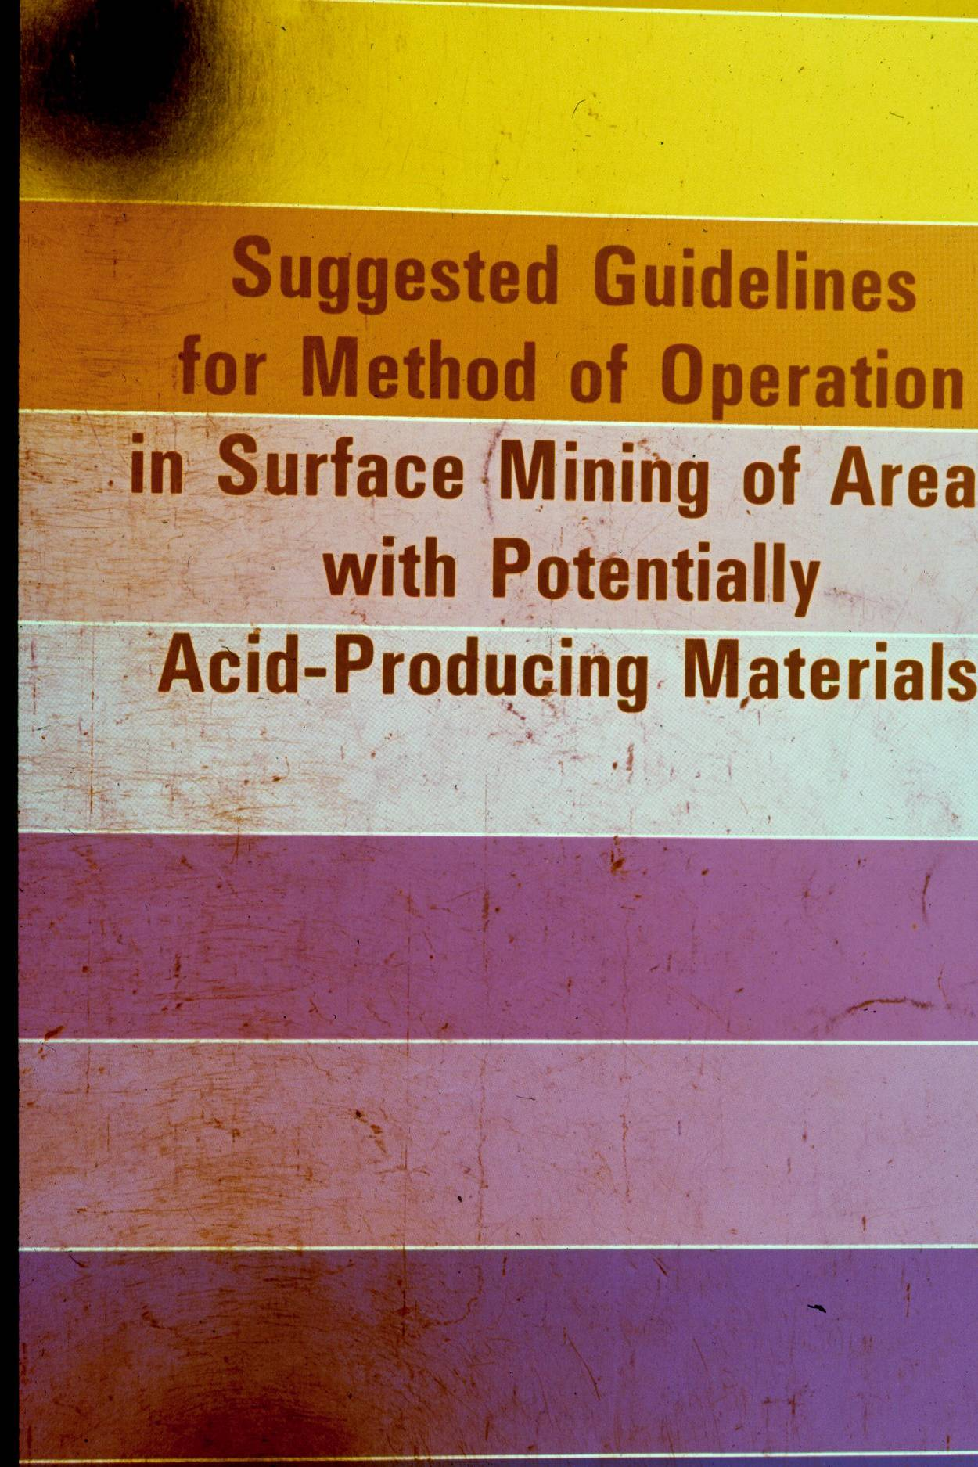

Figure 1. The 1979 Bulletin published by the WV Surface Mine Drainage Task Force.

Annual Symposia

After writing this bulletin, members of the Task Force realized that many other ideas and procedures were being developed to control and treat AMD. Therefore, the Task Force established new objectives in addition to the original mandate from Director Callaghan. The objectives of the Task Force were to keep current on new developments in AMD research including AMD treatment and control practices, and to present this information at annual symposia.

In April 1980, the first Task Force symposium was held in Clarksburg, WV, to a relatively small audience of 100 people. Since 1980, symposia have been held every spring (usually in Morgantown, WV). Attendance has fluctuated over the years due to changes in the mining and reclamation industry and in regulations, but has steadily grown to annual attendance figures of 250 to 300. Attendees come from all areas of the U.S. and several foreign countries. Many attendees consider Task Force meetings to contain the most current and important work in AMD in the world. Proceedings have been published and given to attendees each year. A website was developed in 2006 (www.wvmdtaskforce.com), which includes all past symposium papers, and is updated each year.

Complexity and Moratorium
After several months of implementation of these guidelines on active sites, the results showed mixed success. There was a net effect of lower acid production, but nearly all operations were still producing acid in areas with acid-producing materials. On some sites, even with special precautions of overburden analyses and special handling, there appeared to be no acid reduction at all. It was obvious that the AMD problem was very complex and that the members of the Task Force, being a volunteer group with career and family demands, were unable to devote more time to developing sophisticated approaches to solving the problem.
In September of 1981, a petition was served requesting the Director to designate 500 square miles in a three-county area (Upshur, Barbour, and Randolph) unsuitable for mining. Director Callaghan was faced with the possibility of being forced to lock up millions of tons of high quality coal because of the potential of AMD formation. This sparked a renewed interest in resolving the AMD problem (Skousen et al., 1987).
AMDTAC
Director Callaghan's approach to address the AMD problem was to form the Acid Mine Drainage Technical Advisory Committee (AMDTAC). This committee was made up of recognized experts in AMD research. The committee developed a proposal that it felt would lead to a solution of the problem, and with the Office of Surface Mining (OSM) paying the greatest share of the cost, initiated research aimed directly at stopping the formation of acid. The first set of proposals was funded from 1982 through 1985 at an approximate cost of $800,000. A second set of proposals was funded in 1985 at about the same level of funding.
The rationale behind organizing the Committee was based on tracing a drop of rain from the time it hit the mine surface, to its infiltrating the soil profile, permeating into the backfill, interacting with various rock and mineral components and eventually emerging as a seep or spring. At each stage of the water migration, key elements were described and experts who were actively doing research in these fields and who were knowledgeable of these subjects were identified and asked to become part of the Committee (Caruccio, 1982).
Within the framework of a reclaimed mine and starting at the uppermost layer of soil, where the chemistry of the infiltrating rain water becomes quickly established and affects the geochemistry of the mine backfill system, the importance of vegetation cover, mine soil identification and mine soil development was readily recognized. Levels of alkalinity are determined at this horizon and can radically affect the amount of acidity that may be produced. Dr. John Sencindiver, Division of Plant and Soil Science, West Virginia University was identified as the scientist who could contribute most to the understanding of this facet of the problem and was asked to Co-chair the Committee (Caruccio, 1982).
Once the water migrates through the mine soil, it permeates the pore spece of the backfill and begins to react with the rock and mineral matter of the overburden material. Initially the quality of the drainage will be affected and various degrees of alkalinity and acidity will form. Dr. Gwendelyn Geidel, Department of Geology, University of South Carolina, was selected to assist our understanding of how rock-water interactions take place in the backfill and affect drainage chemistry (Caruccio, 1982).
At this stage of mine drainage flow, it is important to know not only the leachate quality (whether it will be acid or alkaline) but the amount (load) of acidity or alkalinity produced. In this way a balance between the two can be made to predict the mine drainage quality that could be expected and whether or not the amount of neutralizing material blended in the backfill is effective. Dr. Jack Renton, Department of Geology, West Virginia University, has been doing considerable research in this field and will add to the Committee's understanding of the rates of rock-water interactions and the geochemistry of acid mine drainage (Caruccio, 1982).
Under certain conditions, as the mine drainage migrates through the backfill, the amount of acidity generated will be low, in which case moderate amounts of alkalinity produced by admixed limestone will be sufficient to neutralize the acid. We also know that iron-catalyzing bacteria accelerate acid production. Inhibiting the bacteria will reduce the acid loads and make limestone-generated alkalinity a reasonable and economical acid neutralizer. Dr. Bob Kleinmann, Acid Mine Drainage Research Section, U.S. Bureau of Mines, Pittsburgh, PA, has been doing outstanding research in the control of iron bacteria using detergents and will form an integral part of the development of the onsite control of acid mine drainage (Caruccio, 1982).
Along these same lines, if iron can be complexed in the early stages of acid production, acidity will not be formed. Dr. Al Stiller, Department of Chemical Engineering, West Virginia University, has been researching various iron- complexing agents and the methods of application. Within this realm lies the key toward acid mine drainage prevention and at the present time, the Committee's primary effort in acid mine drainage prevention (Caruccio, 1982).
Finally, the identification of the actual flow paths within the backfilled mine is critical toward our understanding of the effectiveness of the techniques. Are the clay seals ineffective, does water only contact the acid material and not the alkaline zones, does most of the water bleed from the highwall of a backfilled mine and travel along the pavement, never contacting the overburden material, where within the backfill does acid drainage form? These are some of the fundamental questions regarding the hydrology and geochemistry of the reclaimed mine and which will be addressed by Dr. Frank Caruccio, Department of Geology, University of South Carolina and who is also Co-chairman of the Committee (Caruccio, 1982).
Thus the committee felt that the total mine drainage system, from the beginning where water falls on the mine surface, through the inner workings of the geochemistry of the backfill, until the water emerges as a mine drainage flow, is covered in all respects by the six scientific experts appointed to the Committee. Although the solution to the problem looks good in the laboratory beaker, the manner in which it must be implemented in order for it to work must be economically and practically feasible. Further, all science must be blended with the ground truth of field experience so that the solutions to the problems will, in fact, be realistic. Two engineers were chosen to provide the Committee with this dimension, Mr. Charles Miller, Grafton Coal Company, Weston, WV and Mr. Hans Naumann, Island Creek Coal Company, Craigsville, WV. Finally, in rounding out the Committee membership to afford WVDNR representation, first hand knowledge of the problem areas and research needs, are Director David C. Callaghan, Mr. Pete Pitsenbarger and Mr. Roger Hall of the West Virginia Department of Natural Resources (Caruccio, 1982, Table 1).

Table 1. Members of the Acid Mine Drainage Technical Advisory Committee organized in 1980. 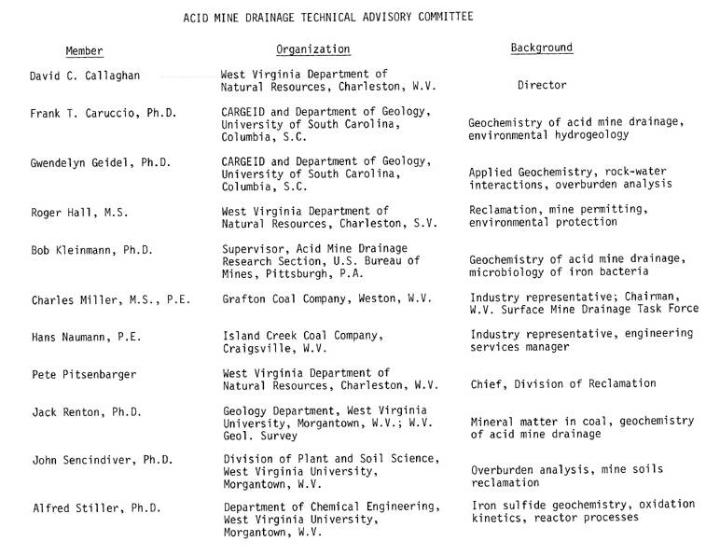
AMDTAC Reports at Task Force Symposia

The first major report on the direction of the AMDTAC group was given by Co-chair Frank Caruccio at the 1983 Task Force Symposium (Caruccio, 1983). Here are AMDTAC talks at the 1983 symposium:

"The Acid Mine Drainage Technical Advisory Committee," Dr. Frank T. Caruccio, Associate Professor of Geology, University of South Carolina, Columbia, SC.

"Assessing Acid Loads of Coal Mine Overburden as Related to Grain Size Distribution," Dr. Gwendelyn Geidel, Research Fellow, Department of Geology, University of South Carolina, Columbia.

"At-Source Control of Acid Mine Drainage," Dr. Robert Kleinmann, Supervisory Geologist, U.S. Bureau of Mines Research Center, Pittsburgh, PA.

"A Method for Prevention of Acid Mine Drainage: An Update Progress Report," Dr. A. H. Stiller, Assistant Professor, Chemical Engineering Department, West Virginia University, Morgantown, WV.

"Laboratory Studies of Acid Generation From Coal Associated Rocks," Dr. John J.Renton, Professor of Geology, West Virginia University, Morgantown, WV.

"Effects of Selected Reclamation Methods on Minesoil Properties: A Progress Report," Dr. John C. Sencindiver, Assistant Professor of Agronomy, Division of Plant & Soil Sciences, West Virginia University, Morgantown, WV.

"The Effect of Plastic Liner on Acid Loads: DLM Site," Dr. Frank T. Caruccio, Associate Professor of Geology, University of South Carolina, Columbia, SC.

"Field Applications of Phosphate and PVC Covering," Hans E. Naumann, Chief Engineer, Island Creek Coal Company, Craigsville, WV.

Here are some of the titles of paper of AMDTAC research in the 1984 Symposium.
"At Source Control Of Acid Mine Drainage: An Update," Dr. Robert Kleinmann, Supervisory Geologist, U.S. Bureau of Mines Research Center, Pittsburgh, PA.
"Analytical Procedures For AMD Prediction," Dr. John J. Renton, Professor of Geology, West Virginia University, Morgantown, WV; and Dr. A. H. Stiller, Assistant Professor of Chemical Engineering, West Virginia University Morgantown, WV.
"Use Of Alternative Topsoil Materials in Surface Mine Reclamation," Dr. John C. Sencindiver, Assistant Professor of Agronomy, Division of Plant & Soil Sciences, West Virginia University, Morgantown, WV.
"Research into the Use of Apatite Rock For Acidic Drainage Prevention," F. Allen Meek, Chief Engineer, Enoxy Coal, Inc., Upshur Complex, Tallmansville, WV.
“Induced alkaline recharge zones to mitigate active acidic seeps,” Dr. Frank Caruccio, Associate Professor of Geology, University of South Carolina, Columbia, SC.

“Assessing the alkaline and acid loads of coal mine overburden and the prediction of mine drainage quality,” Dr. Gwendelyn Geidel, Research Fellow, Department of Geology, University of South Carolina, Columbia, SC.
“Prong Site Study: 1) Demonstration of the effectiveness of current mining practices and identification of deficiencies,” Drs. Gwendelyn Geidel and Frank T. Caruccio.
“Quantitative Determination of the Acid Producing Potential of Toxic Overburden,” Drs. John J. Renton, Alfred H. Stiller, and Thomas Rymer.

1986 Task Force Bulletin
In 1985, the Surface Mine Drainage Task Force determined that an update or revision of the 1979 Suggested Guidelines Manual was needed especially due to the information generated from the AMDTAC research. Dr. John C. Sencindiver, a member of the Task Force and AMDTAC, developed a proposal that was accepted by the Task Force and the West Virginia University Energy and Water Research Center. These two groups provided funding for the writing and publishing of the revision which is entitled "A Review of Procedures for Surface Mining and Reclamation in Areas with Acid-Producing Materials" (Figure 2). Much information contained in this new bulletin is derived from research resulting from work conducted by the AMDTAC group. In addition, new material from other sources outside of Appalachia that are applicable to abatement of AMD have also been incorporated into the manual.

This update re-emphasized the use of overburden sampling techniques and analysis of overburden materials by Acid-Base Accounting and leaching techniques to predict their acid-producing potential. In addition, new developments in acid prevention such as alkaline trenches, liners and seals, bactericides, special handling procedures, and revegetation practices were detailed. New chemical treatment technologies were also highlighted, as well as introducing the concept of AMD treatment by passive methods such as wetlands.

Current Task Force Acitivities

Today, the 18 Task Force members represent the coal mining industry, regulators, private consultants, and research scientists (Table 2). The Task Force remains active by holding bi-monthly meetings, sponsoring the spring symposium, and hosting a fall field tour (Figures 3-5). In this way, the Task Force members continue to keep current on new technologies and practices in AMD control and treatment. The fall tours allow opportunities to visit and discuss new ideas and technologies with operators and researchers. The Task Force celebrates the 30th anniversary of its creation in 2008 at this symposium. Its goals remain the same as those outlined above.

If interested, CDs containing all papers from previous Task Force symposiums, as well as the 1979 and 1987 bulletins, can be ordered by calling Jeff Skousen at 304-293-6256 or emailing jskousen@wvu.edu. There is a small mailing fee for materials. All papers can be viewed or downloaded from the Internet at
http://www.wvu.edu/~agexten/landrec/land.htm#SURFACE

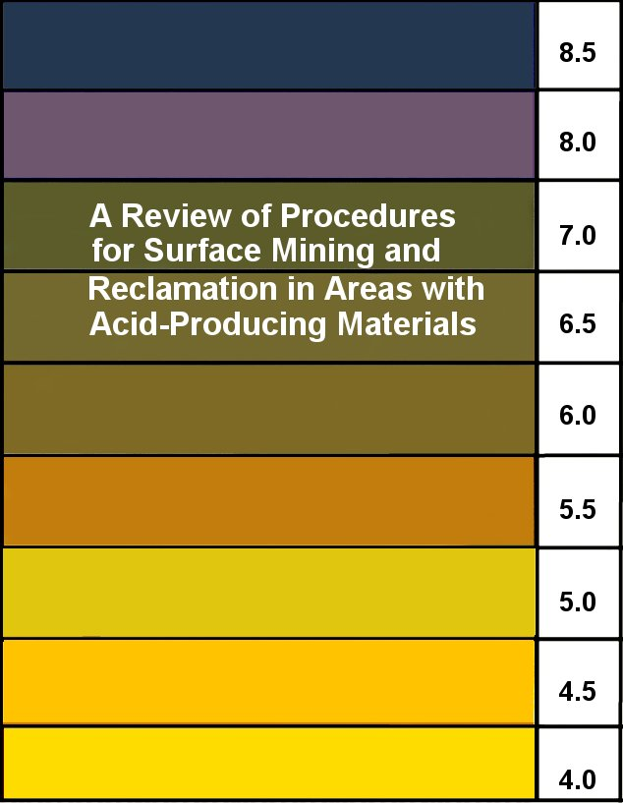

Figure 2. The 1987 Bulletin by Skousen, Sencindiver, and Smith.

Table 2. List of embers who have served on the Task Force.
Jim Ashby* Ron Hamric* Rocky Parsons*
John Belcastro* Tiff Hilton* B.S. Saluja
Rick Herd* Gary Tinnel Paul Ziemkiewicz*
Jim Copley* Ken Johnson* Jim Seckman*
Joann Erwin Steve Keen John Sencindiver*
Tom Kovalchuk* Mike Isabell* John Sturm*
Ben Faulkner* Ron Kolbash* Nick Schear*
Dennis Fredericks Bruce Leavitt* Frank Shreve*
John Freeman Randy Maggard* Randy Sims
Ben Greene* Al Meek Jeff Skousen*
Roger Hall Charles Miller* (Chairman) Wayne Stanley* (Treasurer)
*current members

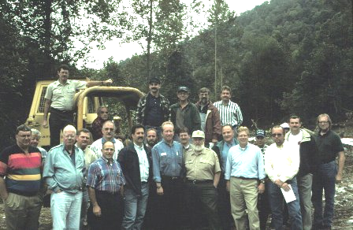

Figure 3. Task Force picture taken in 1997 during our fall tour. Front row: Ben Greene, Roger Hall, Jim Corsaro, John Belcastro, Wayne Stanley, Pete Pitsenbarger, Courtney Black, Tiff Hilton, Ben Faulkner, and Gary Persinger. Middle row: ?, Ron Lilly, Dave Martin, Roger Green, Randy Maggard, Charlie Miller, Jim Copley, ?. Back row: Rocky Parsons, dozer operator, Paul Ziemkiewicz, Jim Ashby, Bruce Leavitt, and Jim Seckman.

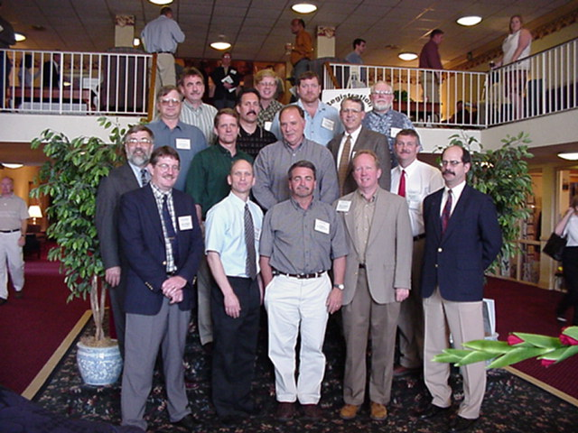
Figure 4. Task Force members in a picture taken during the 2002 Task Force Symposium. Bottom left to right: Randy Maggard, Jeff Skousen, Al Meek, Wayne Stanley, Paul Ziemkiewicz; Middle Row: Bruce Leavitt, Frank Shreve, Jim Ashby, John Belcastro, Charlie Miller, John Sencindiver, Ben Faulkner; Top Row: Jim Seckman, Courtney Black, Mike Isabell, Ken Johnson.

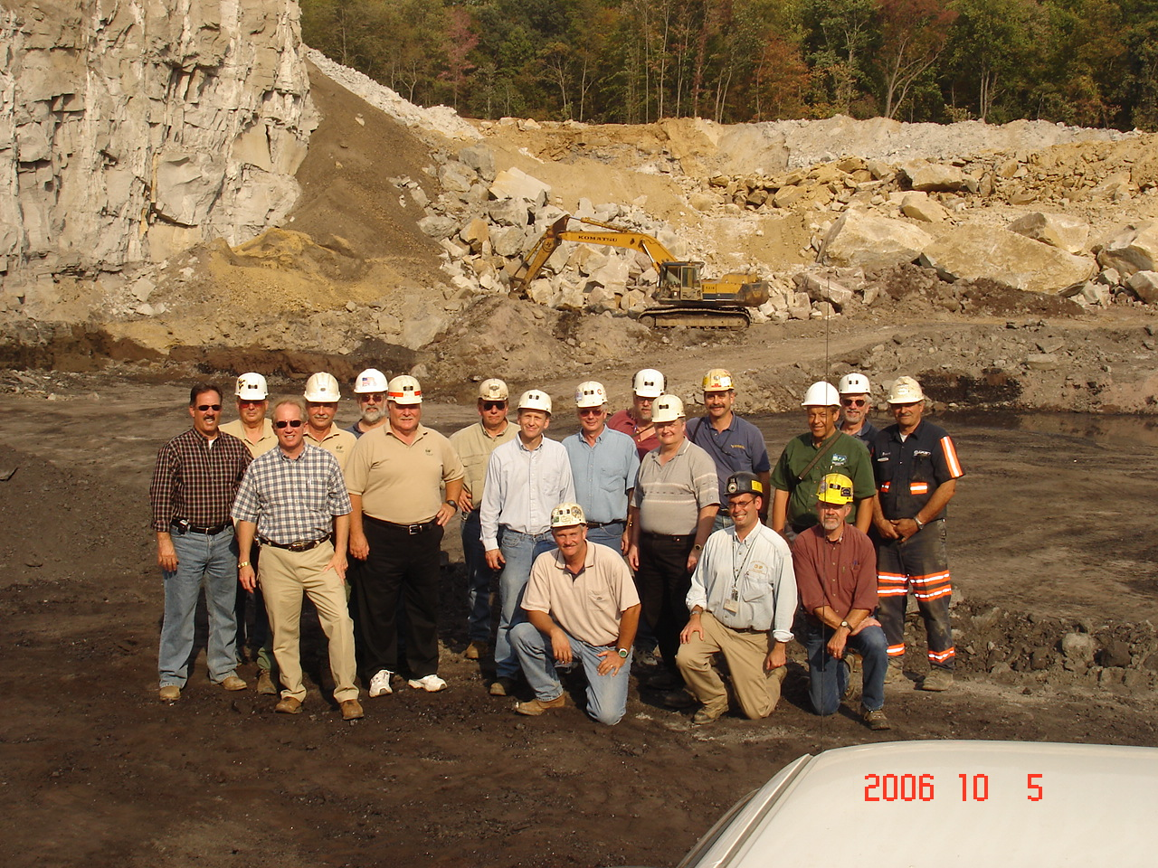
Figure 5. Task Force members at a Patriot Mine site during one of the fall tours in October 2006. Kneeling from left to right are Ben Faulkner, Nick Schaer, and Ron Hamric. First row: John Belcastro, Wayne Stanley, Charlie Miller, Jeff Skousen, Bob Hartman, Tom Kovulchuk. Back Row: Ben Green, Jim Seckman, Bruce Leavitt, Tiff Hilton, Jim Copley, Joe Donovan, Paul Ziemkiewicz, Rick Herd, Brownie Stuart.

References

Caruccio, F.T. 1982. The Role of the Acid Mine Drainage Technical Advisory Committee in Advancing West Virginia's Coal Industry. In: Proccedings, 3rd Annual West Virginia Surface Mine Drainage Task Force Symposium, May 17, 1982. www.wvmdtaskforce.com/proceedings/

Caruccio, F.T. 1983. The Acid Mine Technical Advisory Committee. In: Proccedings, 4th Annual West Virginia Surface Mine Drainage Task Force Symposium, May 26, 1983. www.wvmdtaskforce.com/proceedings/

Skousen, J.G., J.C. Sencindiver, and R.M. Smith. 1987. A review of procedures for surface mining and reclamation in areas with acid-producing materials. WVU Energy and Water Research Center. Publication EWRC 871. Morgantown, WV.

Skousen, J., J. Sencindiver, and R.M. Smith. 1987. Procedures for surface mining and reclamation in areas with acid-producing materials: An overview. In: Proccedings, 8th Annual West Virginia Surface Mine Drainage Task Force Symposium, April 7-8, 1987. www.wvmdtaskforce.com/proceedings/

Surface Mine Drainage Task Force. 1979. Suggested guidelines for method of operation in surface mining of areas with potentially acid-producing materials. West Virginia Mining and Reclamation Association, Charleston, WV. Green Lands 9: 21-40.

