Modeling AMD Geochemistry in Underground Mines

Bruce Leavitt, PE, PG, Consulting Hydrogeologists

James Stiles, Ph.D., PE, Limestone Engineering

Raymond Lovett, Ph.D., Shipshaper, LLP

Pyrite oxidation has been studied for decades in an effort to understand the relationship between the weathering of the mineral and the iron contaminated waters that emanate from underground mines. Some discharges are strongly acidic with pH values in the 2 to 3 range and high iron and aluminum concentrations, other discharges can be strongly alkaline with neutral pH and metal concentrations suitable for discharge without treatment.

This wide range of outcomes has been one of the difficulties in mine drainage prediction. Is the difference due to variations in the amount of pyrite present, or are there other factors that influence mine water quality? Various field studies have identified three mine drainage archetypes: the flooded mine discharging from shallow cover; the flooded mine discharging from deep cover; and up-dip or free draining mine. Figure 1 shows these three mine types. Each of these mines has its “typical” discharge chemistry and chemical evolution over time. Each archetype represents an idealized set of conditions that are infrequently found in the field in their pure form. Consequently most mine discharges are a combination of two of the three basic hydrologic settings.

Mine discharge quality is dependent on the amount of pyrite available for oxidation and on the rate of pyrite oxidation. The rate of pyrite oxidation is also dependent on the amount of ferric iron present which is also dependent of oxygen concentration. The prediction of post-mining mine drainage quality is further complicated by the quantity, quality, and location of mine recharge water. These waters are usually circum-neutral in pH, and can range from low to high alkalinity depending on the quantity of alkaline materials in the overburden rocks. In addition to mine hydrology, the produced acid can react with several mineral assemblages present in the mine leading to the dissolution of some of these minerals and the mobilization of other metals such as aluminum and manganese.

The relative importance of these various factors to the post closure discharge water quality has been the subject of scientific and regulatory debate for years. The purpose of this study is to use a combined groundwater flow and geochemistry model to evaluate the effect of these various factors, and to project a post closure water quality. The focus of this interim report is on the effect of mine hydrology on discharge water quality.

The TOUGHREACT Model

The computer model selected for this evaluation is called TOUGHREACT. TOUGHREACT was developed by the Earth Sciences Division, Lawrence Berkeley National Laboratory, University of California. TOUGHREACT was designed to solve the coupled equations of sub-surface multi-phase fluid and heat flow, solute transport, and chemical reactions in both the saturated and unsaturated aquifer zones. This design allows the program to be applied to many geologic systems and environmental problems, including geothermal systems, diagenetic and weathering processes, subsurface waste disposal, acid mine drainage remediation, contaminant transport, and groundwater quality.

TOUGHREACT is a finite difference model which allows the evaluation of groundwater chemistry and flow to be calculated at each node in a grid. For this study, a ten by ten grid was selected with each cell in the grid representing a part of the mine 300 meters by 300 meters. Consequently the entire mine is 3,000 meters by 3,000 meters. Different properties can be assigned to each cell in the grid. Figure 2 shows the different hydraulic conductivities assigned to the main entries and the mined out or gob areas. The mineralogy of each cell can be varied, however, for this evaluation the mineral assemblages in all cells were the same as well as the amount of each mineral in the cells. This mineral assemblage includes melanterite, which represents the latent acidity in the mine; calcite, which represents the rock dust; and pyrite. The quantity of each mineral in the cell is represented by the percentage of that mineral in the solid phase.

Mineral Reactions

TOUGHREACT assumes that all minerals assigned to the model are available for reaction. In an underground mine this is frequently not the case. A critical example is pyrite. Pyrite that is locked up in the interior of a mine pillar is in the mine, yet it is not available for reaction. When the model was run using a pyrite concentration typical of the Pittsburgh coal, the amount of acid produced exceeded observed levels. Through subsequent model runs, it was necessary to reduce the amount of pyrite present to 0.15 percent to reduce this over estimation. This reduced pyrite level is referred to as “Available Pyrite.” Available pyrite is not a measurable input parameter; consequently, the investigators are not able to verify the correctness of this estimate.

Mineral reaction kinetic and equilibrium values have been taken from a number of sources including Xu, Sonnenthal, Spycher, and Pruess (2004), and Parkhurst and Appelo (1999). Table 1 contains the mineral, its percentage in the mine, and its kinetic and equilibrium constants. Through multiple model runs of the free draining model, these mineral percentages have been adjusted so that the model results more closely resemble observed water quality from a free draining Pittsburgh seam mine 20 years after closure. The free draining archetype was selected because there is no effect of mine flooding on the geochemistry. It was necessary to increase kaolinite to 50 percent of mine volume in order to generate aluminum concentrations that are compatible with field observations. This level of mineralization is clearly unrealistic, and suggests that the rate of kaolinite dissolution may be too low, or that the dissolution of another mineral is the source of the aluminum.

Modeling the Three Mine Settings

There are two primary differences that separate the three archetype mines. The first difference is whether the mine is flooded or free draining. In modeling the free draining case, the recharge is set to a uniform 0.5 gallons per minute per acre on all cells, and the saturation is maintained at 20 percent of the mine void. Water is withdrawn from one cell in an amount that is equal to the combined recharge for the model. This is the cell that represents the discharge water chemistry.

The flooded mines are separated into two categories based on where the discharge is located relative to the infiltration. Prior work in the Pittsburgh Basin has shown that infiltration decreases with increasing overburden thickness. This leads to two possible conditions: the first is where the discharge is located in shallow cover where the infiltration is high; and the second is where the discharge is located in deep cover where the infiltration is low. An example of the first case is a down dip mine discharging at the coal outcrop. This is the most common flooded condition. An example of the second case is where a flooded mine is pumped, or drains by gravity from the deepest portion of the mine. These two cases are referred to as flooded high dilution and flooded low dilution.

In order to simulate these two conditions in the model, the infiltration rate for each row of cells was varied from 25 millimeters per year in row one to 470 millimeters per year in row ten of the model. The overall amount of water infiltrating this model is equal to 0.5 gallons per minute per acre even though the individual cells have higher or lower infiltration rates. This keeps the total infiltration in the flooded mine equal to the free draining mine. To change between the two flooded cases, it is only necessary to change the mine discharge location from the high infiltration end to the low infiltration end.

A net alkaline recharge water chemistry typical of Pittsburgh coal overburden was applied for all three archetype mines. Oxygen was set at 2 mg/l, bicarbonate was set at 310 mg/l, calcium was set at 120 mg/l, and sulfate was set at 0.015 mg/l. Iron, manganese and aluminum were below detection in the recharge water

Exemplar Mines

Long term chemistry data were obtained for three mines, each mine represents one of the three archetypes. The mines are: Maiden #1 representing the free draining type; Westland/Arden representing the high dilution type; and Montour 4, representing the flooded low dilution type. Maiden #1 is a pure example of a free draining mine with no obvious flooded areas. The mine breaths freely and in large volume at the discharge portal, maintaining oxygen concentrations in the mine atmosphere. The data set for this mine comes from several sources and only spans an eleven year period ending in December 2007. Both Westland/Arden and Montour 4/10 are not fully flooded. Montour 4/10 is pumped from the deepest part of the mine which is about 60 percent flooded. The Montour 4/10 data set begins in 1983 and extends through 2004. Westland is also a pumped discharge, but the point of withdrawal is near the coal outcrop in the connected, and fully flooded Arden mine. Because of this connection the Westland/Arden mine has a flow path that is different from the geometry used in the model. These variations in mine geometry were not included in the model so that any modeled differences in mine water chemistry are solely the result of the difference in mine setting. The Westland/Arden data set extends from 1986 to 1999.

Model Results

All three models were run with the same initial conditions with the exception of flooding level, infiltration rate, and discharge location. Consequently, any variations in the model results are solely the result of these variations in geometry and hydrology.

pH

Figure 3 shows the TOUGHREACT model results for pH under the three hydrodynamic conditions. In the model, both of the flooded mines have an initial pH after flooding of about 2. Over time, this pH rises to about 7 in the high dilution case and about 5.8 in the low dilution case. The observed data show a much more rapid rise. The observed pH for the high dilution mine only drops to 6.5 before returning to pH 7. The observed pH for the low high dilution mine initially drops to a low of 3 but quickly returns to 6 and ultimately stabilizing between pH 6.5 and 8.5. The pH results for the free draining model started at 2.2 and rose to 2.3 after 20 years. The observed pH for the free draining mine was between 2.8 and 3.1 after 23 years.

Iron

Figure 4 shows the TOUGHREACT model results for iron under the three hydrodynamic conditions. Although the absolute values of the model vary from the observed data, it is evident that the shape of the high dilution and low dilution curves are similar to the observed data. The peak iron concentrations in the low dilution model may be the result of too much initial melanterite in the mine, too rapid pyrite oxidation, or too much pyrite available for oxidation. Since these models were run, pyrrhotite has been identified as the source of most of the excess acid formation. The lower level of observed iron in the high dilution flooded mine, compared to model results, was likely the result of dilution in the Arden mine that was not considered in the model. The simulated discharge iron concentration from the free draining model after 20 years was higher than the observed free draining discharge iron concentration after 23 and 25 years. This suggests that the model’s pyrite oxidation rate was too rapid, or that there was an excess amount of pyrite available for oxidation.

Conclusion
The observed data collected from the high dilution flooded, the low dilution flooded, and the free draining mines indicated that the kinetic models implemented in TOUGHREACT are able to mimic the observed data. However, improvement is needed for the reaction of the minerals pyrite, kaolinite, and illite. The heterogeneous nature of abandoned underground coal mine aquifers also presents difficulties such that a realistic TOUGHREACT model of the heterogeneous system would be impractical given current computer technology. The homogeneous models discussed in this report took many hours to run on a modern personal computer; a more realistic heterogeneous model with 15 m by 15 m model cells would take at least 1,000 hours to run. Despite this limitation, the TOUGHREACT model presented here is a useful tool in understanding the effect of mine hydrodynamics on water chemistry, and is expected to be useful in evaluating the benefits of in situ remedial action.

Acknowledgment

The authors wish to acknowledge and thank the Office of Surface Mining for providing funding and support for this research effort.

Figure 1. Three type settings: Free Draining, Flooded high dilution, Flooded low dilution.

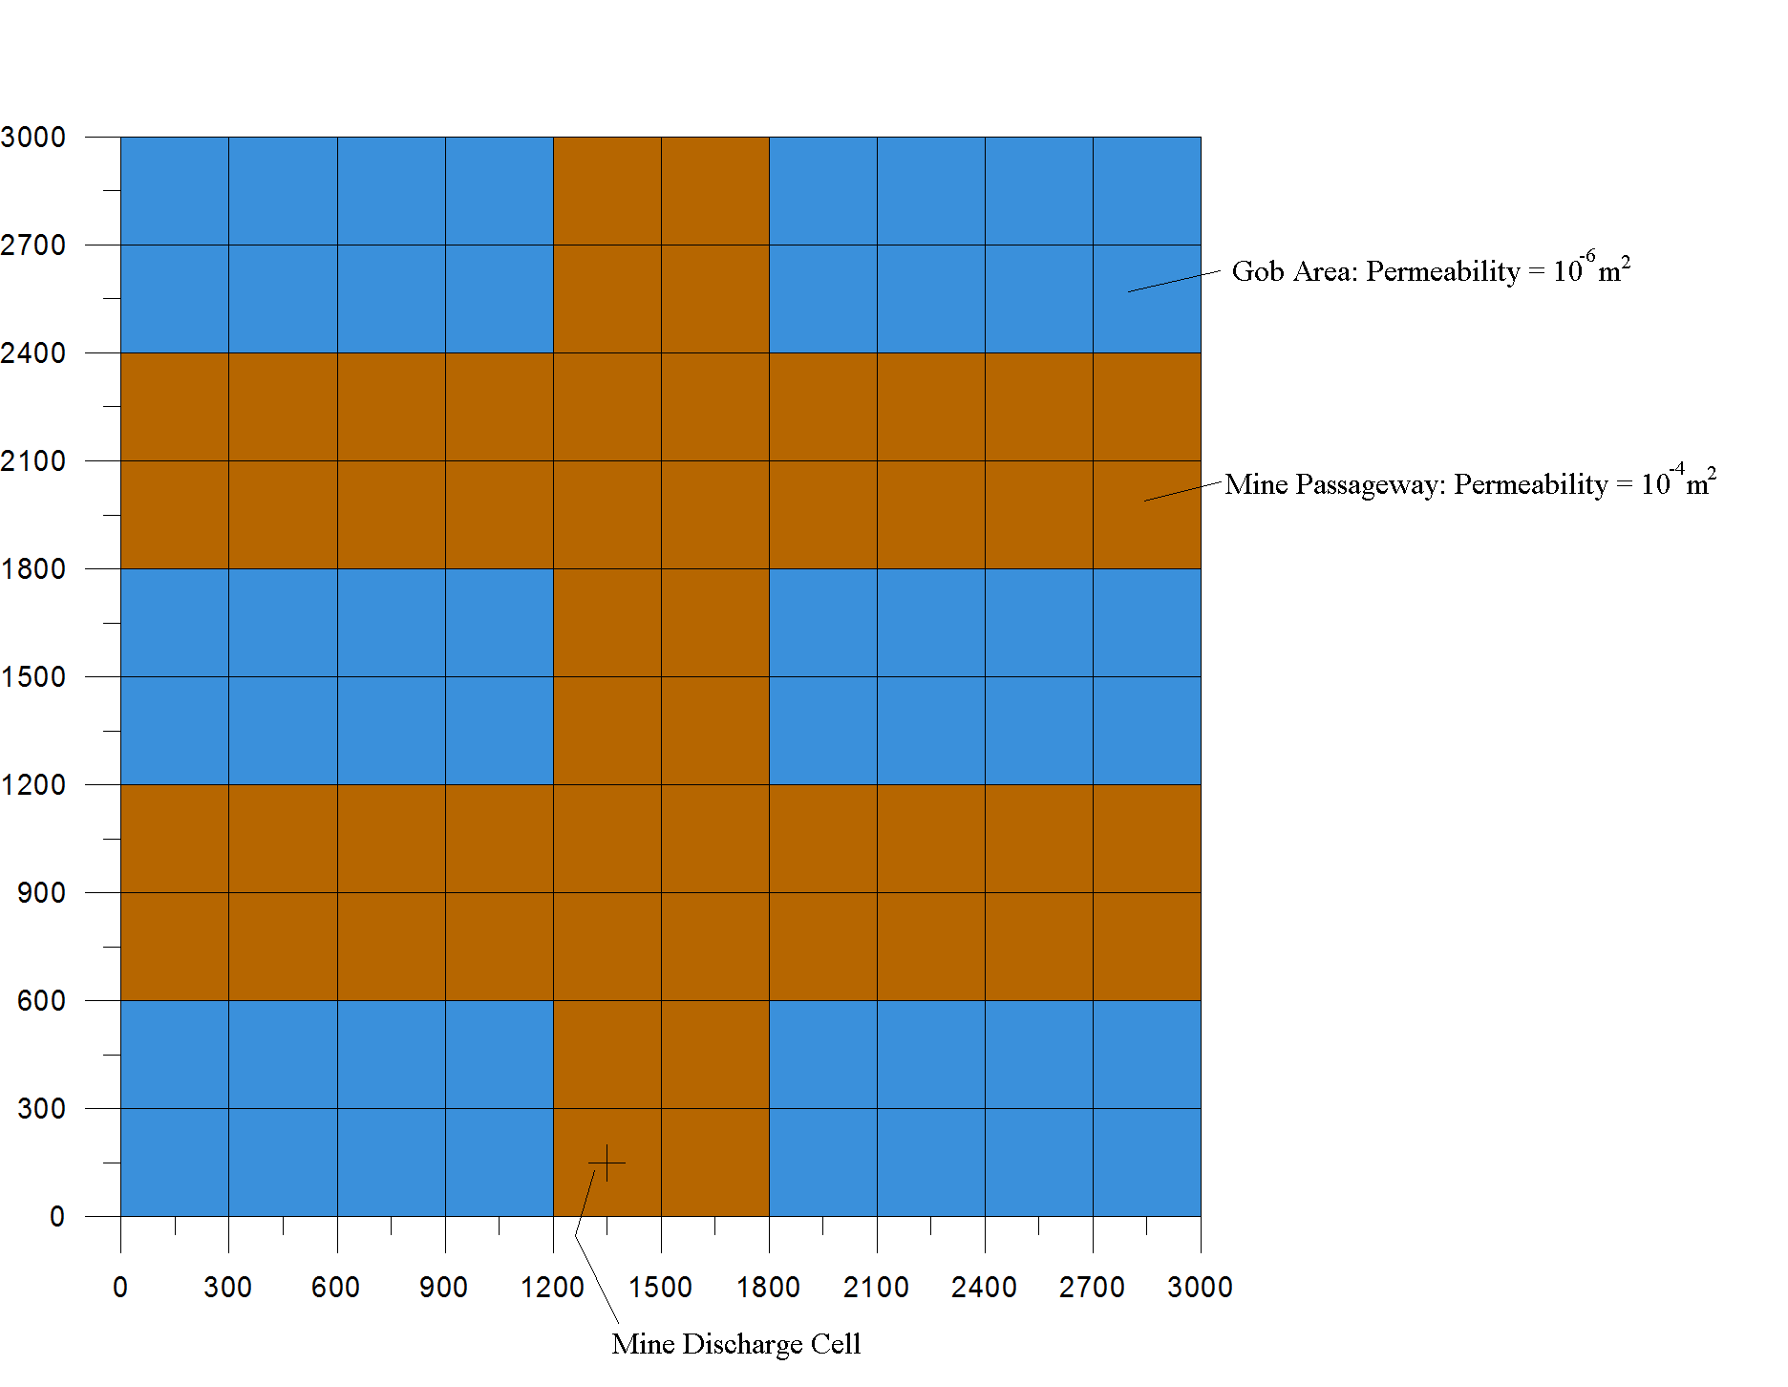
Figure 2. Model mine geometry, cells are 300 by 300 meters.

Figure 3. Modeled pH for the type mines.
Figure 4. Modeled iron discharge from three type mines.
Table 1. Volume concentration and kinetic rates for the simulated minerals.
Mineral | Volume Concentration | K₂₅ (mol/m²/s) | Ea (kJ/mol)
calcite | 0.001 | equilibrium | equilibrium
gypsum | 0.0001 | equilibrium | equilibrium
melanterite | 0.002 | equilibrium | equilibrium
rhodochrosite | 0.010 | 3.55x10⁻⁶ | 40.0
illite | 0.400 | 6.9185x10⁻¹³ | 22.2
jarosite | 0.001 | 6.9185x10⁻¹³ | 22.2
Al(OH)₃ (amorphous) | 0.001 | 6.9185x10⁻¹³ | 22.2
gibbsite | 0.001 | 6.9185x10⁻¹³ | 22.2
pyrolusite | 0.001 | 6.9185x10⁻¹³ | 22.2
ferrihydrite | 0.001 | 6.9185x10⁻¹³ | 22.2
jurbanite | 0.001 | 1.0233x10⁻¹⁴ | 87.7
quartz | 0.001 | 1.0233x10⁻¹⁴ | 87.7
kaolinite | 0.500 | Neutral 6.918x10⁻¹⁴  Acid 4.898x10⁻¹²  Base 8.913x10⁻¹⁸ | 22.2  65.9  17.9
chlorite | 0.001 | Neutral 3.020x10⁻¹³  Acid 7.762x10⁻¹²  Base N/A | 88.0  88.0  N/A
pyrite | 0.0015 | Neutral 2.818x10⁻⁶  Acid 3.020x10⁻⁹  Base N/A | 56.9  56.9  N/A
siderite | 0.001 | Neutral 1.660x10⁻⁹  Acid 2.570x10⁻⁴  Base N/A | 62.76  36.1  N/A
magnetite | 0.001 | Neutral 1.260x10⁻¹¹  Acid 6.457x10⁻⁹  Base N/A | 18.6  18.6  N/A

