Low-pH Fe(II) Oxidation Incorporated into
Passive Treatment

William D. Burgos*^{,1}
John M. Senko¹
Mary Ann Bruns²

The Pennsylvania State University
¹ Department of Civil and Environmental Engineering
² Department of Crop and Soil Sciences

Project Number PA DEP_AMD 42(0420)102.1
Commonwealth of Pennsylvania
Department of Environmental Protection
Bureau of Abandoned Mine Reclamation
Division of Acid Mine Drainage Abatement

*Principal Investigator – address: Department of Civil and Environmental Engineering, The Pennsylvania State University, 212 Sackett Building, University Park, PA, 16802-1408; telephone: 814-863-0578; fax: 814-863-7304: e-mail: wdb3@psu.edu
ABSTRACT
This project was supported by the Commonwealth of Pennsylvania’s Department of Environmental Protection (DEP), Bureau of Abandoned Mine Reclamation (BAMR), Cambria office in response to their direct request for a research proposal focused on biological low-pH iron(II) oxidation for the passive treatment of low-flow deep-mine discharges (10 to 40 gpm). Personnel at the BAMR Cambria office directed us to two discharges that were designated as “positive” and “negative” controls with respect to natural low-pH Fe(II) oxidation. The “positive” control site is along Gum Boot Run in McKean County, and the “negative” control site is the Fridays-2 discharge near Hollywood, Pennsylvania in Clearfield County. For both Gum Boot Run and Fridays-2 we have conducted field work to measure water chemistry (e.g., [Fe(II) aq], pH, dissolved oxygen (D.O.), temperature) downstream of the AMD source, and seasonally to gauge temperature effects. During our field work we also collected sediment samples, the upper “crusts” of the iron mounds, for microbial and mineralogical characterizations and for laboratory experiments. Iron mound sediments from both the Gum Boot Run and Fridays-2 systems were characterized by X-ray diffraction (XRD). This analysis revealed that goethite (α-FeOOH) was the predominant mineral phase in Gum Boot Run sediments, while schwertmannite (Fe₁₆O₁₆(OH)₁₂(SO₄)₂) was the predominant mineral phase in Fridays-2 sediments.
Fe(II) was oxidized and completely removed from solution at Gum Boot Run regardless of the season, although rates of Fe(II) oxidation did slow in winter months. Fe(II) was incompletely oxidized and removed from solution at Fridays-2 possibly due to shorter residence time across the iron mound, limited aeration of the water, differences in microbial communities and activities, or difference in litter fall from surrounding vegetation. In both the Gum Boot Run and Fridays-2 systems, numbers of Fe(II) oxidizing bacteria in iron mound sediments correlated well with field measurements of Fe(II) removal and Fe(II) oxidation rates measured in the laboratory. DNA-based analysis of bacterial communities in the iron mound sediments indicated that “classical” autotrophic (i.e., able to fix CO₂ for cell biomass) Fe(II)-oxidizing bacteria (i.e., Acidithiobacilli) were present at both sites, however, we found that heterotrophic bacteria (i.e., require organic carbon for cell biomass) were dominant at both sites. We also found that different groups of heterotrophic bacteria were dominant at the two sites. Chloroflexi were the dominant bacterial lineage at Gum Boot Run, while Actinobacteria were the dominant bacterial lineage at Fridays-2. Chloroflexi have not been previously associated with Fe(II) oxidation, while Actinobacteria have been associated with Fe(II) oxidation. The importance of “non-classical” bacterial groups was supported by laboratory experiments where we tracked Acidithiobacilli by measuring their iro (iron oxidase) genes. We found that iro gene numbers did not correlate with Fe(II) oxidation rates, suggesting that other bacterial groups (that do not contain the iro gene) are more important in Fe(II) oxidation. While there were differences between the Gum Boot Run and Fridays-2 microbial communities, our results suggest that the communities at both sites are capable of considerable Fe(II) oxidation given optimal physicochemical conditions.
The general conclusions of the studies that we present in this report are: 1) microbial communities capable of efficient oxidative precipitation of Fe(II) from AMD arise with no human intervention in response to the chemical “challenge” of such acidic fluids; 2) microbial communities that received Fe(II)-rich AMD were more similar to each other than those that did not; and 3) the highest laboratory rates of Fe(II) oxidation in the Fridays-2 system were as high as or greater than the highest laboratory rates of Fe(II) oxidation in the Gum Boot system. Therefore, our work suggests that by maximizing 1) the residence time, and 2) aeration of the AMD as it flows over iron mound sediments, efficient and low-cost passive Fe(II)-removal systems may be implemented. Indeed, over a ~15-month period at Fridays-2 we observed the establishment of new areas of active low-pH Fe(II) oxidation and precipitation on previously pristine soil and leaf litter. Passive biological treatment systems should be constructed to mimic the hydrologic characteristics of Gum Boot Run. These “aeration terraces” could be constructed as a series of steps to promote shallow flow and aeration of the AMD. Iron mound sediments from Gum Boot Run or other similar low-pH systems could be used to “seed” the aeration terraces, although that may be unnecessary.

1. INTRODUCTION
Acid mine drainage (AMD) is the single greatest pollutant source to the waterways of Pennsylvania. Cost effective treatment technologies for the remediation of AMD are needed. The removal of iron is probably the most important aspect of AMD treatment. Biological low-pH Fe(II) oxidation can improve the performance of conventional passive limestone treatment systems. Limestone dissolution neutralizes acidic water and promotes the precipitation of Fe(III) (hydr)oxides (Cravotta and Trahan, 1999; PA DEP, 1999; Johnson and Hallberg, 2005). Unfortunately, these Fe(III) (hydr)oxide precipitates chemically coat limestone surfaces (commonly called “armoring”), limiting further limestone dissolution and neutralization capacity, and hydraulically clog the limestone bed (PA DEP, 1999; Rose et al., 2004; Weaver et al., 2004).
To limit armoring and clogging, dissolved Fe may be removed from AMD before waters are neutralized with limestone. In the pH range typical of Appalachian AMD (2.5 – 4.5) (Cravotta et al., 1999), the abiotic oxidation of Fe(II) is kinetically limited, but hydrolysis and precipitation of Fe(III) will still occur (Stumm and Morgan, 1996). Under such conditions, acidophilic Fe(II) oxidizing bacteria (Fe(II)OB) may catalyze Fe(II) oxidation, allowing for the oxidative precipitation of Fe from AMD discharges at low pH (Kirby et al., 1999; Nicormat et al., 2006; Nengovhela et al., 2004; Johnson and Hallberg, 2005). This Fe-free water may then be neutralized using limestone before it is released into nearby streams (Nengovhela et al., 2004). The spatial separation of iron oxidation and precipitation from alkalinity addition would improve the operation and maintenance of limestone beds and reduce the associated costs. This spatial separation can be achieved by promoting low-pH Fe(II) oxidation across natural iron mounds (commonly found immediately downstream of emergent acidic mine discharges) before conveying the water to a limestone treatment bed.

2. OBJECTIVES
The purpose of this research was to study the microbial communities and mineral precipitates associated with low-pH Fe(II) oxidation at two deep mine discharges in north-central Pennsylvania. Personnel at Pennsylvania’s Department of Environmental Protection (DEP), Bureau of Abandoned Mine Reclamation (BAMR), Cambria office directed us to two discharges that were designated as “positive” and “negative” controls with respect to natural low-pH Fe(II) oxidation. The “positive” control site is along Gum Boot Run in McKean County, and the “negative” control site is the Fridays-2 discharge near Hollywood, Pennsylvania in Clearfield County. The objectives of this research were to: 1) study the microbial communities associated with low-pH Fe(II) oxidation at each site; 2) characterize the mineralogy of Fe(III) oxides at each site; and 3) determine how oxygen and carbon dioxide can control or promote the kinetics of low-pH Fe(II) oxidation in laboratory experiments.
3. SITE DESCRIPTIONS
The Gum Boot Run (GB) system is located in McKean County, Pennsylvania (41º 41’ 02” N; 78º 29’ 37” W). AMD at the GB system emerges at the crest of a hill and flows down its side in sheets approximately 5 mm deep. After emergence, water flows approximately 18 m downhill before flowing underground, reemerging at a point approximately 48 m downhill from the source, and finally entering a pool at the foot of the hill 127 m from the source (Figure 1). Water from the pool ultimately discharges into nearby Gum Boot Run. Samples were collected in October 2005, February 2006, May 2006, and July 2006 (fall, winter, spring, and summer sampling events, respectively) at discrete sampling points 0 m (AMD emergence point), 2 m, 9 m, 15 m, 60 m, 95 m, and 127 m (in the pool at the foot of the hill) downstream from the AMD emergence point.
The Fridays-2 (FR) system is located in Clearfield County, Pennsylvania (41º 14’ 34” N; 78º 32’ 28” W). AMD at the FR system emerges at a former mine entrance and flows in sheets (approximately 5 mm deep) approximately 10 m before entering an adjacent unnamed creek (Figure 2). Samples were collected in February 2006, May 2006, and July 2006 (winter, spring, and summer sampling events, respectively) at discrete sampling points 0 m (in the AMD source), 3 m, 8 m, and 10 m downstream from the AMD emergence point (Figure 2). Samples were also collected from the unnamed creek upstream and downstream of AMD entry. “Yellowboy” was apparent in creek sediments downstream of AMD entrance into the creek, but no Fe(III) was apparent upstream of the point of AMD entry.

4. MATERIALS AND METHODS
4.1 Sample collection
Sediments for laboratory incubations, bacterial enumerations, and DNA-based microbial community characterization were collected with sterile spatulas and placed in sterile centrifuge tubes or whirl-pak bags. Sediments were collected from the top 2 cm of sediment at each location. Water samples were filter-sterilized (0.2 µm) in the field. Samples intended for sulfate analysis were not preserved. Samples for analysis of soluble Fe were preserved with 0.5 N HCl, and samples for analysis of other metals were preserved with 0.5 N HNO₃. All samples were stored on ice for transport to the laboratory, except for samples intended for DNA-based microbial community analysis, which were transported on dry ice. Dissolved oxygen concentrations (D.O.), temperature, and pH were determined in the field using portable meters.

4.2 Enumeration of Fe(II) oxidizing bacteria
After collection, samples intended for microbial enumerations were stored at 4 °C for no more than 4 d before initiation of enumeration studies. Fe(II) oxidizing bacteria (Fe(II)OB) were enumerated by a plate counting technique described by Johnson (1995). This medium contained 14 mM (NH₄)₂SO₄, 2 mM MgSO₄, 0.25 g/l trypticase soy broth, and the pH was adjusted to 3.5 with H₂SO₄. Agarose (20 g/l; high gel strength from EMD Chemicals, Inc; Gibbstown, NJ) was used as a solidifying agent. FeSO₄ (25 mM) was provided as an electron donor. Since products of the hydrolysis of agarose in the acidic medium may inhibit the growth of Fe(II) oxidizing bacteria, plates were prepared with two layers of medium. The underlayer was inoculated (2.5% volume/volume) with the acidophilic organoheterotrophic bacterium Acidophilium organovorum (that was cultivated on the medium described above with galactose as an electron donor and carbon source) before pouring. The overlayer received no inoculum before pouring. The inclusion of A. organovorum served to minimize the accumulation of agarose hydrolysis products. Sediments were suspended in agarose-free medium (approximately 0.2 g sediment/ 5 ml medium; described above), homogenized by vortexing, serially diluted, and spread on plates. Fe(II)OB colony forming units (CFU) were indicated by the formation of red-orange colonies.
4.3 Sediment Incubations
Sediments collected from the sampling points described above were incubated with synthetic AMD (SAMD) in 160 ml serum bottles with air in the headspace and sealed with thin Teflon-coated stoppers. SAMD contained 7 mM FeSO₄, 5 mM CaSO₄, 4 mM MgSO₄, 1 mM Na₂SO₄, 0.5 mM Al₂(SO₄)₃, 0.4 mM MnSO₄, and 0.1 mM (NH₄)₂Fe(SO₄)₂. The pH of SAMD was adjusted to 3.5 with H₂SO₄. Where appropriate for abiotic controls, biological activity was deactivated by the addition of 1% formaldehyde, 0.1% sodium azide, or autoclaving. To measure Fe(II) oxidation kinetics, 8 g of sediments were combined with 20 ml of SAMD, leaving 140 ml of headspace, and an estimated 1.2 mmole O₂/bottle, with approximately 0.14 mmole Fe(II)/bottle. The pH was measured at the beginning and end of the incubations in sacrificed sediment-SAMD slurries. In initial experiments to determine effective abiotic controls, 10 g of sediment were incubated with 50 ml of SAMD. For these experiments, a larger volume was used to allow larger sample sizes so that pH could be determined throughout the experiment. Bottles contained approximately 0.9 mmole O₂ and 0.35 mmole Fe(II).

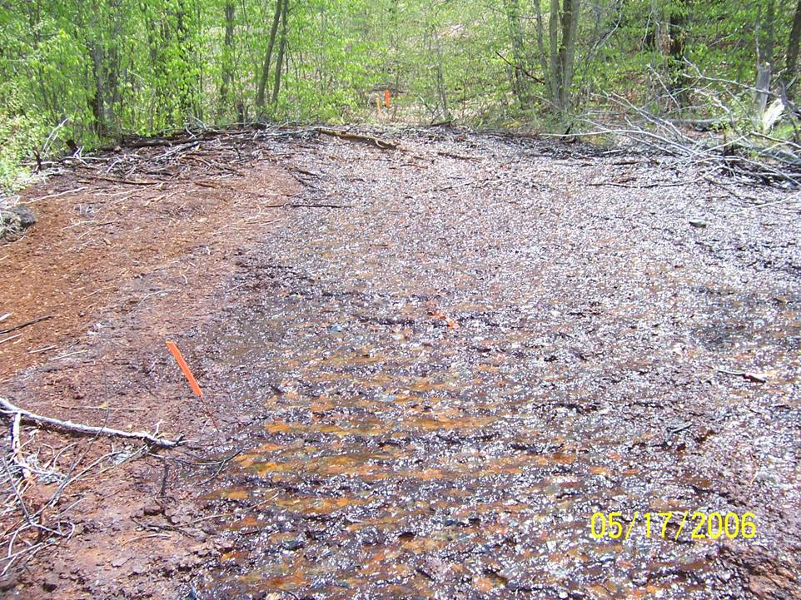

Figure 1. Natural “aeration terrace” promoting rapid biological low-pH Fe(II) oxidation. Discharge is located along Gum Boot Run, McKean County, Pennsylvania. Distance between orange flags is roughly 7 meters, and greater than 50 mg/L Fe(II) is removed over 15 meters (15 minute residence time) with no human intervention. Photo taken May 2006.

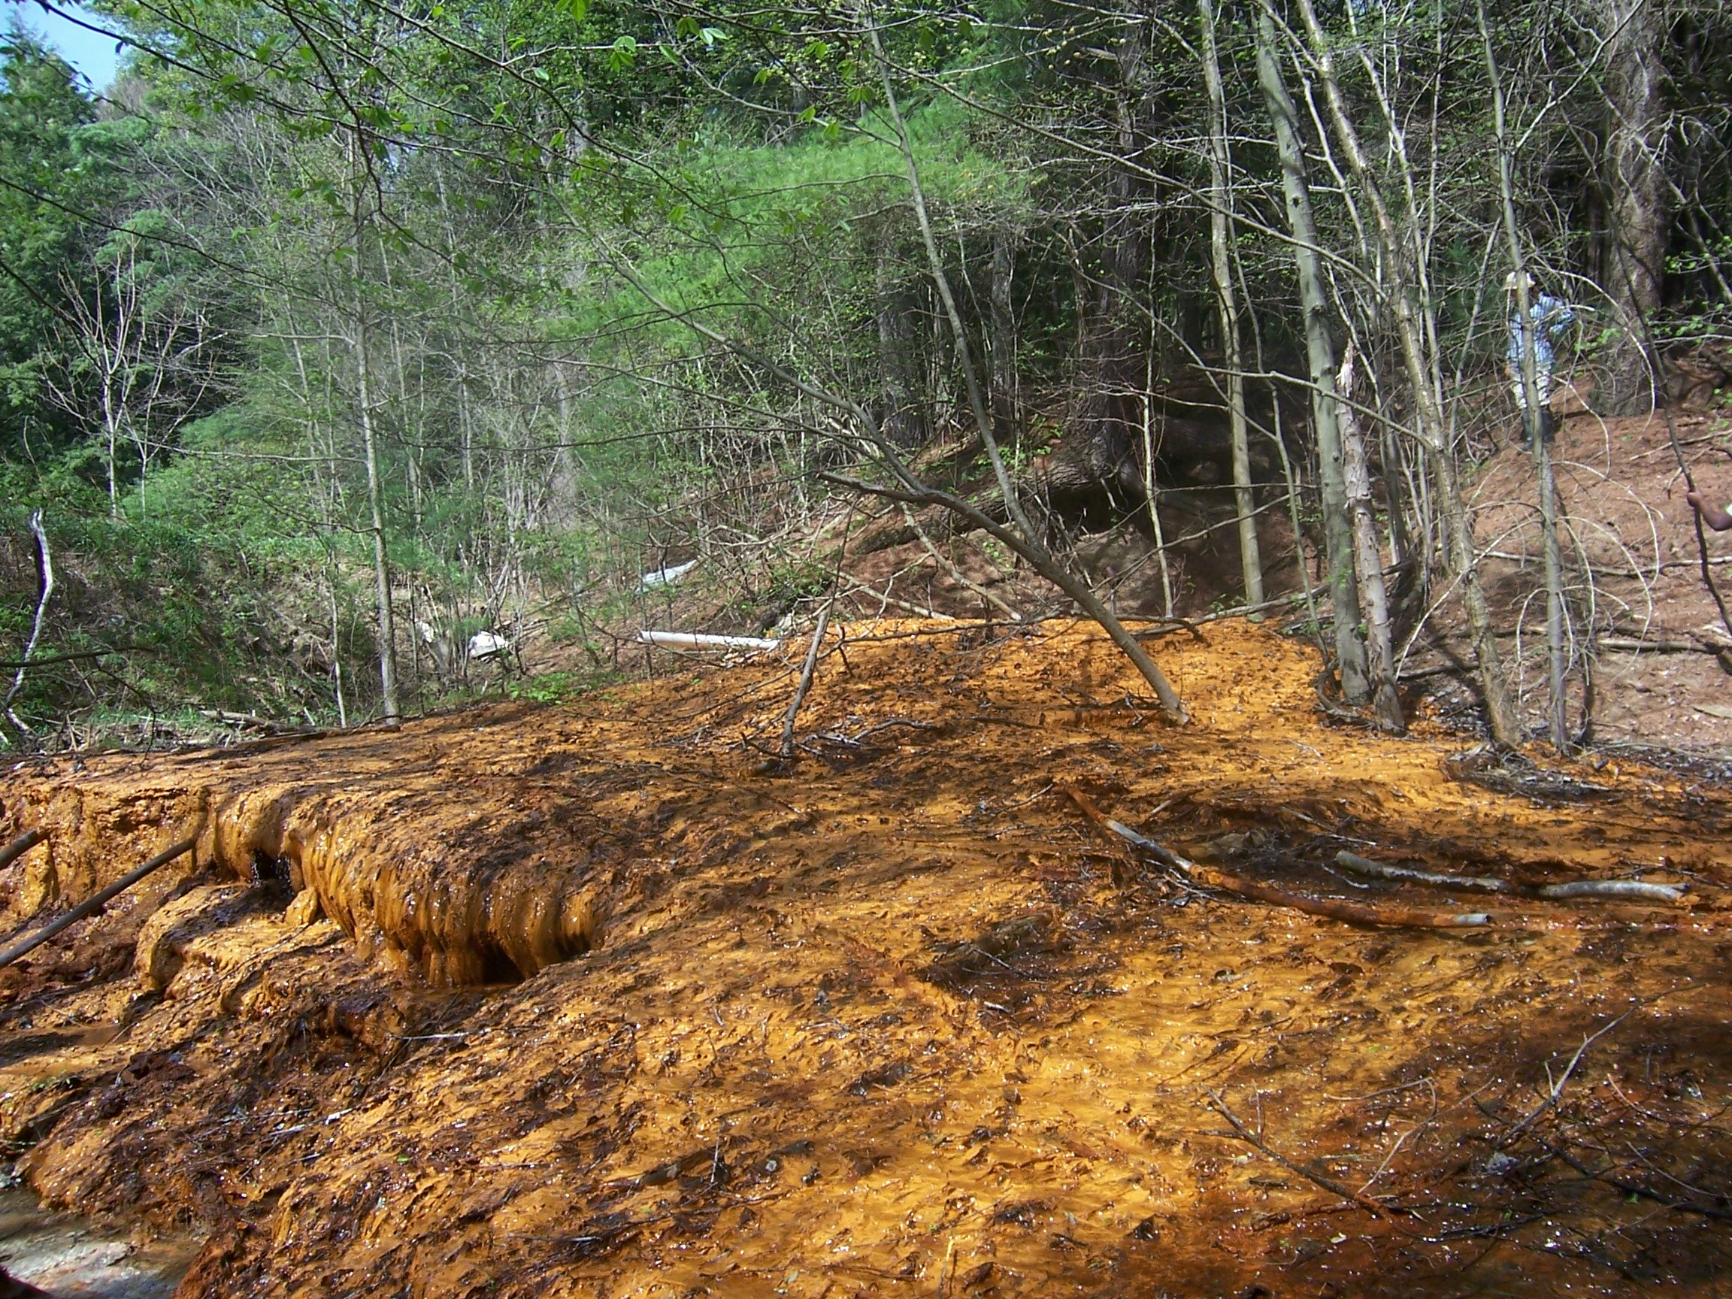

Figure 2. Natural “aeration terrace” at Fridays-2 where relatively little biological low-pH Fe(II) oxidation is currently occurring. Discharge is located near Hollywood, Pennsylvania in Clearfield County. Photo taken May 2007.

Incubations were periodically sampled using a needle and syringe. For experiments to determine the contribution of microbiological activity to oxidative precipitation of Fe, dissolved Fe(II) and Fe(III) were measured in the soluble fraction and total Fe(II) in the 0.5 N HCl-extractable fraction (Lovley and Phillips, 1987) by 1,10 phenanthroline and ferrozine assay (described below). We found that dissolved Fe(III) did not contribute to the total dissolved Fe detected and that adsorption of Fe(II) to sediments was minimal. Therefore, dissolved Fe(II) was quantified by ferrozine assay through the remainder of the study. First order Fe(II) oxidation rate constants (k) were determined by linear least squares regression fitting of ln[Fe(II)] versus time using the following equation:
ln[Fe(II)_{t}] = −kt+ln[Fe(II)_{initial}] (1)
After measuring Fe(II) oxidation kinetics with all the sediment samples, three sediments were further tested to evaluate the effects of dissolved oxygen and dissolved carbon dioxide. The three sediments are referred to as GB-2, FR-5 and FR-2 and were selected because GB-2 displayed the fastest rate from the “positive” control site, FR-5 displayed the fastest rate from the “negative” control site, and FR-2 displayed the slowest rate from the “negative” control site. Dissolved oxygen was varied from 20.7% to 0.7% to evaluate aeration requirements for effective treatment. Dissolved carbon dioxide was varied from 7.3% to 0.035% to (indirectly) evaluate the importance of autotrophic microbial activity on Fe(II) oxidation kinetics. Sediment incubations were conducted in a fashion similar to those described above except that the headspace was continuously flushed with a specific gas mix (Figure 3), and reactors were “re-spiked” with Fe(II) two additional times to allow for three “Fe(II) oxidation cycles.” The purpose of “re-spiking” the reactors was to enrich Fe(II)OB for subsequent enumeration and DNA-based characterization.
4.4 DNA-Based Bacterial Community Characterization
All samples for DNA-based microbial community analysis were stored at -80 °C until microbial DNA was extracted. Direct extraction of microbial DNA from Fe(III)-rich sediments proved difficult, so Fe(III) was removed from samples with 0.3 M ammonium oxalate (pH 3.0) as described by Nicormat et al. (2006a). Samples were incubated in ammonium oxalate solution for 1 hour at room temperature, centrifuged, the supernatant was decanted, and fresh ammonium oxalate solution was added. Removal of Fe(III) was indicated by a lack of orange color in the supernatant and was generally achieved after 6 washes. The remaining pellet (400 – 1000 mg (wet) recovered from 6 g of wet sediment) was then washed three times with TE buffer (10 mM tris-hydroxymethylaminomethane (Tris) and 1 mM ethylene diamine tetraacetic acid (EDTA), pH 8.0). Fe(III)-free samples were stored at -80°C before further processing. DNA was extracted from Fe(III)-free sediments using the MoBio UltraClean Soil DNA extraction kit (MoBio Laboratories, Inc., Carlsbad, CA). Ribosomal intergenic spacer analysis (RISA)-polymerase chain reaction (PCR) was performed as described by Castillo-Gonzalez and Bruns (2005) using bacteria-specific primers based on Escherichia coli positions 16S-926f (5’-AAAGTYAAAKGAATTGACGG-3’) and 23S-115r (5’-GGGTTBCCCCATTCGG-3’) (Lane, 1991) purchased from Invitrogen Corp. (Carlsbad, CA). PCR mixtures contained 2 µl of a 1:5 dilution of sediment-derived DNA, 5 µl of 10x HotMaster PCR buffer with 25 mM MgCl₂ (Eppendorf Corp., Westbury, NY), 1 µl of 10 mM dNTPs, 3 µl (each) of 10 mM primer, 0.5 µl of 50 mg/ml bovine serum albumin, 0.25 µl of 5 u/µl HotMaster Taq polymerase (Eppendorf Corp., Westbury, NY), and 35.25 µl of molecular biology grade water. PCR cycling in a 2400 Perkin-Elmer thermocycler consisted of an initial denaturation step for 5 min at 94 °C and 30 cycles of 94 ºC for 0.5 min, 54 ºC for 0.5 min, and 72 ºC for 1 min, followed by a final extension step at 72 ºC for 7 min. RISA-PCR products were separated based on DNA fragment size by agarose gel elctrophoresis (2% agarose in Tris-acetate-EDTA buffer (0.4 M tris-hydroxymethylaminomethane (Tris), 0.2 M acetic acid, and 0.01 M ethylene diamine tetraacetic acid (EDTA)), and 5 µg/ml ethidium bromide) at 85 V for 1.5 h. Ethidium bromide-stained DNA bands were visualized under UV illumination and photographed with EpiChemi II equipment (UVP Inc., Upland, CA).
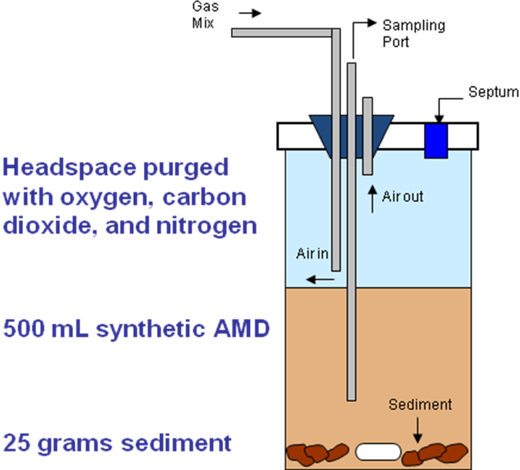

Figure 3. Schematic of laboratory experimental setup used to evaluate the effect of oxygen and carbon dioxide on the kinetics of low-pH Fe(II) oxidation.

To obtain 16S rRNA gene sequences from bands in the RISA gel, individual bands were excised from the gel, suspended in 50 µl of molecular biology grade water and macerated. The 16S rRNA gene portions of the RISA amplicons were amplified in 50 µl reaction mixtures as described above using bacteria-specific primers based on E. coli positions 16S-926f (5’-AAAGTYAAAKGAATTGACGG-3’) and 16S-1492r (5’-TACGGYTACCTTGTTACGACTT-3’). Fresh PCR products were directly cloned into TOPO-TA vector (Invitrogen) following the manufacturer’s instructions. Six PCR insert-containing clones were obtained per RISA band, grown to late log phase in Luria-Bertani broth (Atlas, 2004) that was supplemented with 75 µg ampicillin/ml, and stored in 12% glycerol at -80 ºC before further processing. PCR insert-containing TOPO-TA vectors were prepared for sequencing using TempliPhi rolling circle amplification (GE Healthcare Bio-Sciences Corp., Piscataway, NJ) in 96 well plate formats according to the manufacturer’s instructions. DNA sequencing was performed at The Pennsylvania State University’s DNA sequencing facility using an ABI Hitachi 3730XL DNA Analyzer.
For phylogenetic placement, 16S rRNA gene sequences were initially analyzed using Basic Local Alignment Search Tool (BLAST) (Altschul et al., 1997). Sequences checked for chimeras using the Ribosomal Database Project II’s chimera detection function (Cole et al., 2003). Sequences with more than 90 % similarity were considered to belong to the same operational taxonomic unit (OTU). OTUs were assigned phylum-level classifications using the Ribosomal Database Project II’s classifier function (Wang et al., 2007). Sequences obtained in this work and those obtained from GenBank were downloaded into a Geneious 3.0 software environment (Drummond et al., 2007). Sequences were aligned within the Geneious environment using the ClustalW algorithm (Thompson et al., 1994), and evolutionary distance trees (neighbor joining algorithm with Jukes-Cantor corrections) were produced using Geneious 3.0. We used the online application UniFrac (http://bmf2.colorado.edu/unifrac/; Lozupone et al., 2006) to assess evolutionary differences and similarities among the discrete environments within the GB and FR systems. Phyum-level evolutionary distance trees were produced as described above using 16S rRNA gene sequences from the GB and FR systems with Aquifex pyrophilus (GenBank accession number M83548) as an outgroup. This tree was annotated to indicate the environmental origin of each 16S rRNA gene sequence, and we produced descriptions of the GB or FR environments from which the sequences were obtained. The evolutionary distance tree and site descriptions were imported into the UniFrac environment and analyzed by principal coordinates analysis (PCoA) using the weighted UniFrac metric (Lozupone et al., 2007). To establish the phylogenetic affiliation of GB and FR-derived 16S rRNA gene sequences that were represented by more than one OTU in our clone libraries, phylum-level evolutionary distance trees were produced using sequences obtained in this study and those obtained from GenBank as described above.
We also developed a “functional DNA” assay and tested several microbial DNA extracts for copy numbers of “iro” genes, which encode the iron oxidase enzyme found in Acidithiobacillus ferrooxidans and its close relatives. It is important to note that the iro gene is not present in Leptospirillum spp., which are less acid-tolerant than Acidithiobacillus spp. This assay involved quantitative PCR amplification (Applied Biosystems) of microbial community DNA with iro-specific primers and comparisons with standard curves made from varying concentrations of A. ferrooxidans genomic DNA. We obtained estimates for “iro” gene copy numbers per gram of iron mound material sampled at GB-2 and FR-5 (both “fast” oxidation-rates) and FR-2 (“slow” oxidation-rate).
4.5 Analytical Techniques
Fe(II) was quantified with ferrozine (Lovley and Phillips, 1987) or by 1,10-phenanthroline assay (Tamura et al., 1974). For the quantification of dissolved Fe(III), samples were incubated in an anoxic glovebag for approximately 16 h with 0.25 M hydroxylamine-HCl/ 0.25 M HCl (Lovley and Phillips, 1987) to reduce Fe(III) to Fe(II), which was then quantified by 1,10-phenanthroline. Sulfate was quantified by ion chromatography on a Dionex 100 system fitted with an AS4A column with conductivity detection (Dionex Corp., Sunnyvale, CA). Dissolved Al, Ca, K, Mg, Mn, Na, Si, and Fe content of sediments were quantified by inductively coupled plasma emission spectrometry using a Leeman Labs PS3000UV ICP-AES (Teledyne Leeman Labs, Hudson, NH). Total organic carbon (TOC) was measured using a Shimadzu TOC-V total organic carbon analyzer (Shimadzu Corp., Columbia, MD).
4.6 Nucleotide sequence accession numbers.
16S rRNA gene sequences obtained in this study have been deposited under GenBank accession numbers EU220838 to EU220922.

5. FIELD SAMPLING RESULTS
5.1 Water Chemistry
Fe(II) has historically been observed to be effectively removed from AMD emanating from the Gum Boot (GB) discharge, but not from the Fridays-2 (FR) discharge, which led us to designate the GB and FR systems, respectively, as “positive” and “negative” controls with respect to natural low-pH Fe(II) oxidation. Neither of these sites has received substantial human intervention to remove Fe from the AMD, and waters emerging from both sites exhibit roughly similar chemical and flow characteristics even though the AMD flow rate at the FR system is greater than that of the GB system (Table 1). Data presented in Table 1 were from water samples collected in October 2005 and water flow rates were measured in February 2006.

Table 1. Dissolved constituents and physical characteristics of emergent AMD at GB and FR. BDL = below detection limit. Dissolved species were quantified as described in the text.

 | Gum Boot | Fridays-2
Al (µM) | 52 | 4
Ca (µM) | 344 | 232
K (µM) | 82 | 18
Mg (µM) | 313 | 103
Mn (µM) | 51 | BDL
Na (µM) | 530 | 174
Si (µM) | 436 | 129
Fe(II) (µM) | 869 | 1150
Fe(III) (µM) | 197 | 142
SO₄²⁻ (µM) | 987 | 3961
D.O. (µM) | BDL | BDL
pH | 4.10 | 4.50
Temperature (ºC) | 12 | 10
Flow rate (gal/min) | 13 | 35

At the GB system, AMD emerges from a seep at a flow rate of approximately 13 l/min (measured by cutthroat flume) and flows as a sheet (0.5 cm deep) over an Fe(III)-rich (approximately 60% Fe₂O₃ by mass) mound that contains goethite as the predominant crystalline mineral phase (based on X-ray diffraction (XRD) patterns). Photoeukaryotic organisms that are often observed in AMD-impacted systems (Brake et al., 2002) were not present at the GB system. Soil was not evident in the GB AMD flow path within the first 18 m from emergence (Figure 1). Dissolved Fe(II) was completely removed from GB AMD over a distance of approximately 15 m (Figure 4). At sampling locations greater than 48 m from AMD emergence, dissolved Fe(II) concentrations were low. Soil and algae/moss pinnacles were also evident at this sampling location, but orange Fe(III) (hydr)oxide precipitates were also present, suggesting episodic inputs of Fe(II)-rich AMD into these downstream sampling locations. Episodic inputs of Fe(II)-rich AMD may occur in colder winter months when the water temperature is lower and Fe(II) removal is less efficient. Water temperatures across the AMD flow path varied seasonally, with temperatures as high as 29 ºC observed in warmer months. The lack of soil and thick Fe(III) (hydr)oxide-rich sediments associated with the first 15 m of the GB AMD flow path led us to classify the sediments in the first 15 m of the flow path as those that received regular inputs of unaltered AMD (i.e. dissolved Fe(II)-rich and relatively low pH). After emergence, initially anoxic AMD was aerated within approximately 2 m of the AMD emergence point, and the pH of the AMD decreased concurrently with Fe(II) removal, suggesting that Fe(II) was oxidized to Fe(III), with subsequent hydrolysis and precipitation.
At the FR system, AMD emerges from a seep at a flow rate of approximately 35 l/min (measured by bucket and stopwatch) and flows as a 0.5 cm thick sheet in a manner similar to that at the GB system. The Fe(III) (hydr)oxide-rich mound at the FR system is also approximately 1 m thick, but the predominant mineral phase (determined by XRD) is schwertmannite. As with the GB system, photoeukaryotes were not present. No soil was evident in the FR system except for sediments in the unnamed creek, leading us to designate AMD flowing over the first 10 m of the FR flow path as unaltered. Fe(II) removal from AMD was not as efficient in the FR system as it was in the GB system (Figure 4). The water temperature of the FR system remained constant seasonally. The presence of the thick Fe(III) (hydr)oxide-rich sediments in the FR system suggested that Fe(II) was oxidatively precipitated there, but the persistence of dissolved Fe(II) suggested that this process does not occur as rapidly in the FR system as in the GB system. Alternatively, a decrease in dissolved Fe(II) in FR AMD may not have been observed due to the greater mass transfer of Fe(II) into the FR system compared to the GB system. AMD at the FR system traveled a greater distance (approximately 8 m) before it was well aerated compared to the GB system, perhaps due to the higher flow rate and/or other hydrodynamic factors.

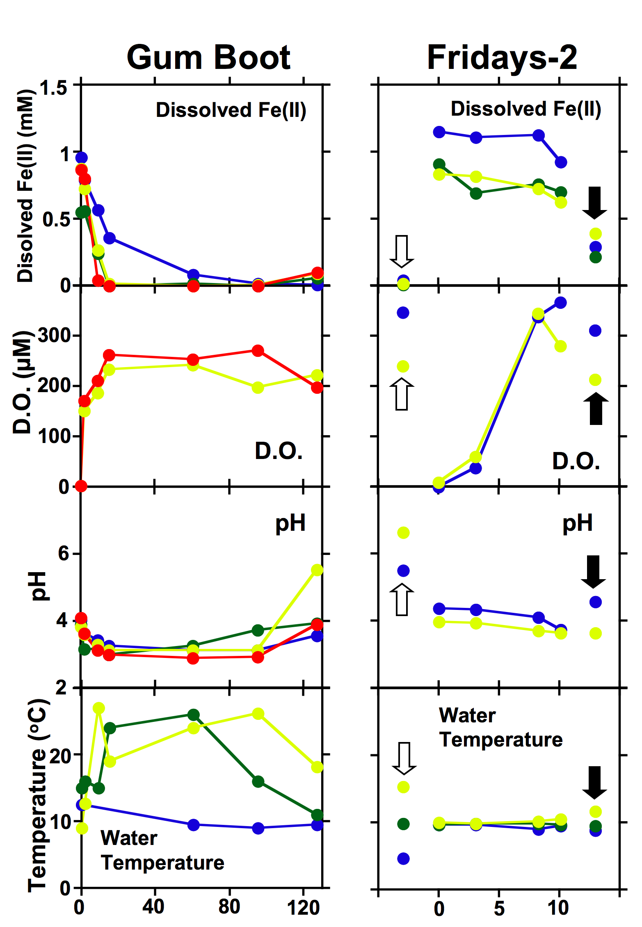
Figure 4. Seasonal variations in dissolved Fe(II) concentrations, dissolved oxygen (D.O.) concentrations, pH, and temperature in the Gum Boot Run and Fridays-2 systems. Blue markers denote winter sampling events, red markers denote fall sampling events, green markers denote spring sampling events, and yellow markers denote summer sampling events. In the Fridays-2 panels, upstream and downstream sampling points in the unnamed creek are pointed out using white arrows and black arrows, respectively.
5.2 Bacterial Community Characterizations
Since abiotic oxidation of Fe(II) by O₂ is strongly rate-limited in the pH range of the GB and FR systems, we hypothesized that the oxidation of Fe(II) and subsequent precipitation of Fe(III) (hydr)oxides in these systems was predominantly mediated by Fe(II) oxidizing bacteria (Fe(II)OB), although the presence of Fe(III) (hydr)oxides may enhance the kinetics of abiotic Fe(II) oxidation (Dempsey et al., 2001; Park and Dempsey, 2005). To assess the role of microbiological activity in the oxidative precipitation of Fe from AMD, we incubated non-sterile sediments from the GB system with synthetic AMD (SAMD). We compared rates of Fe(II) oxidation and precipitation by non-sterile sediments to Fe(II) oxidation rates by sediments in which biological activity was deactivated by formaldehyde or sodium azide poisoning or autoclaving. We tested a variety of methods for deactivating biological activity because each method had the potential to induce physicochemical changes to the sediments that could lead to improper interpretation of abiotic or microbiologically-mediated Fe(II) oxidation (Tebo, 1991; Shiller and Stephens, 2005). Oxidative precipitation of Fe was not observed in microbiologically deactivated incubations, regardless of the deactivation technique (Figure 5). The addition of formaldehyde to incubations altered solution chemistry less than the addition of sodium azide, which increased the solution pH, or autoclaving, which induced the release of dissolved Fe and a decrease in pH (Figure 5). Removal of Fe(II) from solution was only observed in non-sterile incubations and this occurred concomitantly with a decrease in pH, suggesting that the oxidative precipitation of Fe in systems such as GB and FR is predominantly mediated by Fe(II)OB.
We hypothesized that Fe(II)OB would be most abundant in regions of the AMD flow path where oxidative precipitation of Fe was evident based on field measurements (i.e. close to the AMD emergence point at the GB system, and distant from the AMD emergence point at the FR system), and that higher numbers of Fe(II)OB would correspond with faster rates of Fe(II) oxidation by sediments recovered from the respective sampling points. Indeed, culturable Fe(II)OB were most abundant at locations in the GB and FR systems where most Fe removal was occurring as determined by field measurements (e.g. the GB 2 m and FR 10 m sampling points; Figure 6). Fe(II)OB were most abundant in the GB system immediately below the AMD discharge point, in contrast to relatively low numbers of Fe(II)OB at downstream locations where all Fe(II) had been removed. In the FR system, Fe(II)OB were most abundant below the AMD discharge at the two most iron mound downstream sampling locations where the highest levels of dissolved oxygen were measured. The numbers of Fe(II)OB in the GB and FR systems (10³ – 10⁵ CFU/g in the AMD flow paths) are comparable to those reported in a similar AMD-impacted system (Hallberg and Johnson, 2005).

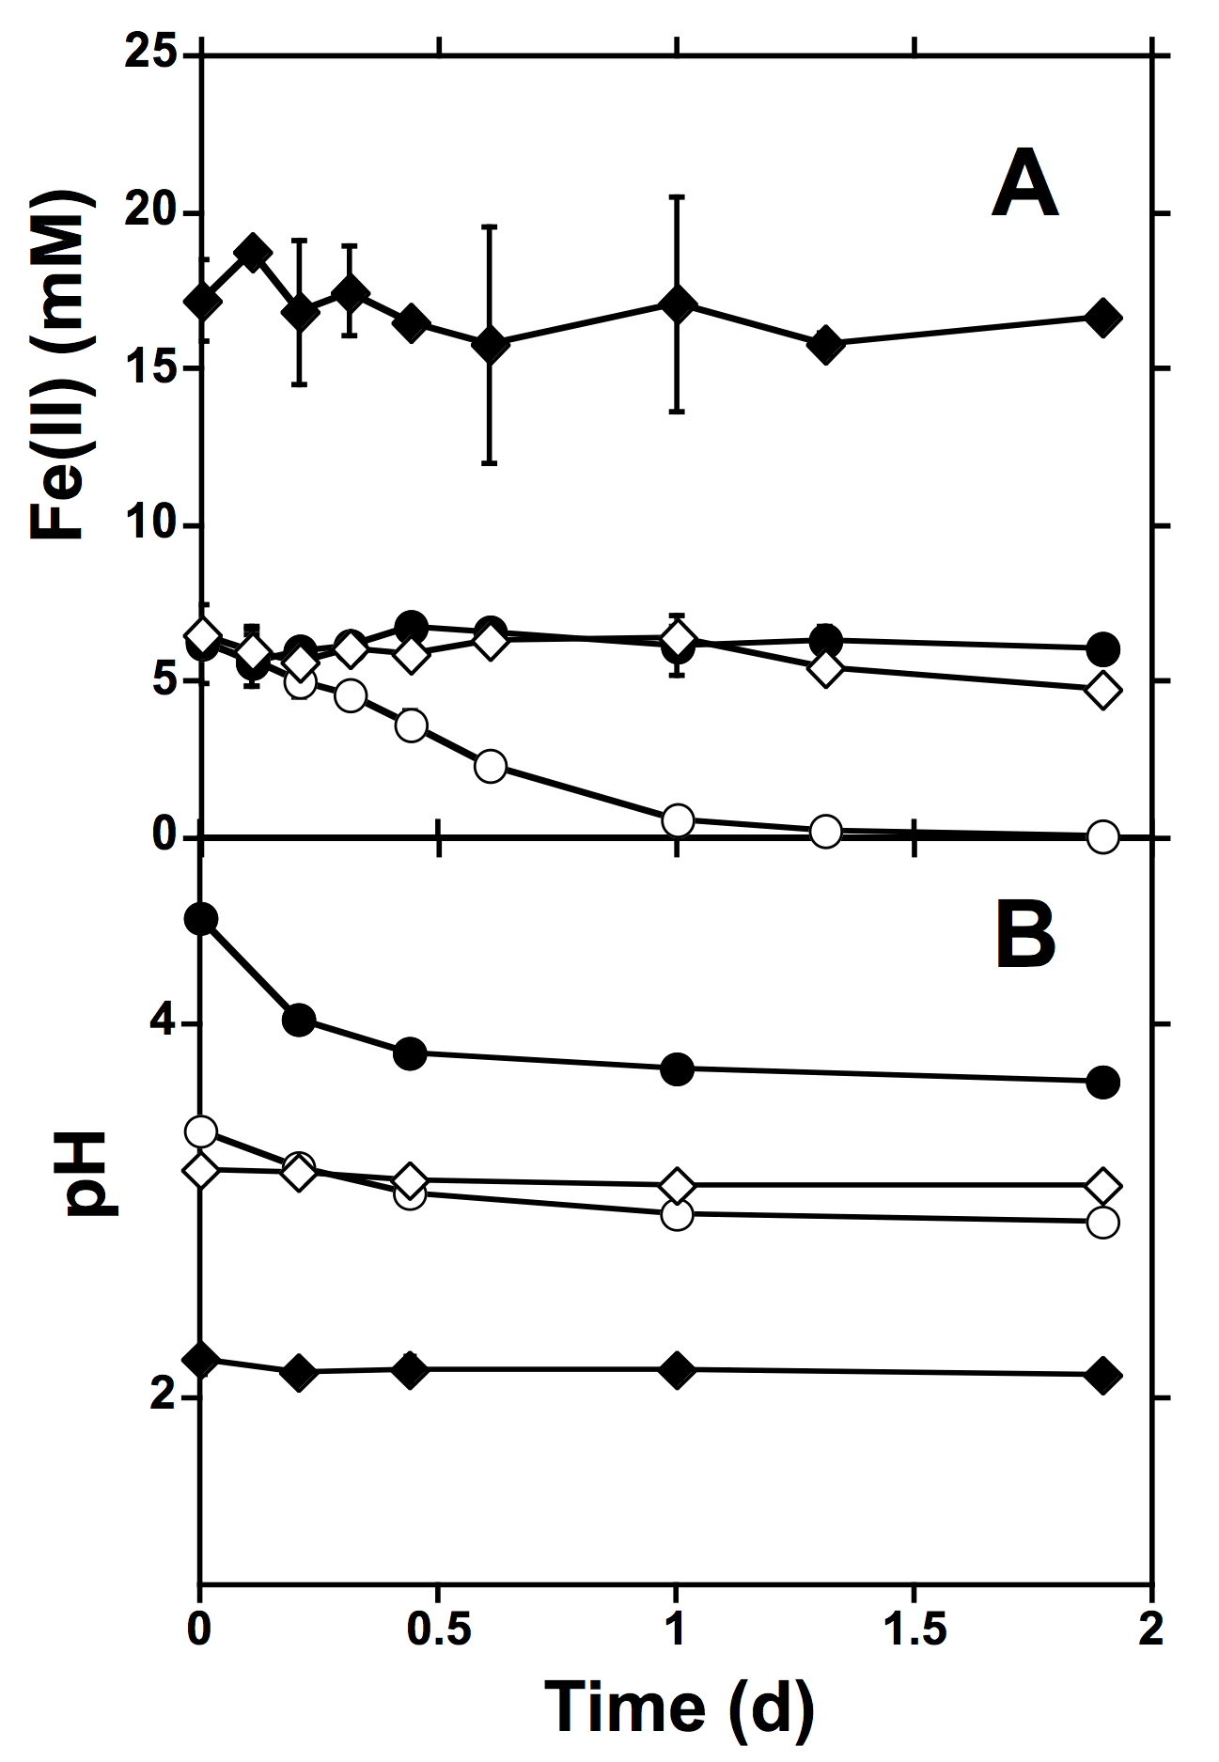
Figure 5. Fe(II) removal (A) and concurrent pH decrease (B) in non-sterile incubations containing sediments from the GB system (2 m sampling point) () compared to incubations that were biologically inactivated by autoclaving (♦) or the addition of 1% formaldehyde (), or 1 mg/l sodium azide (). Error bars represent one standard deviation.

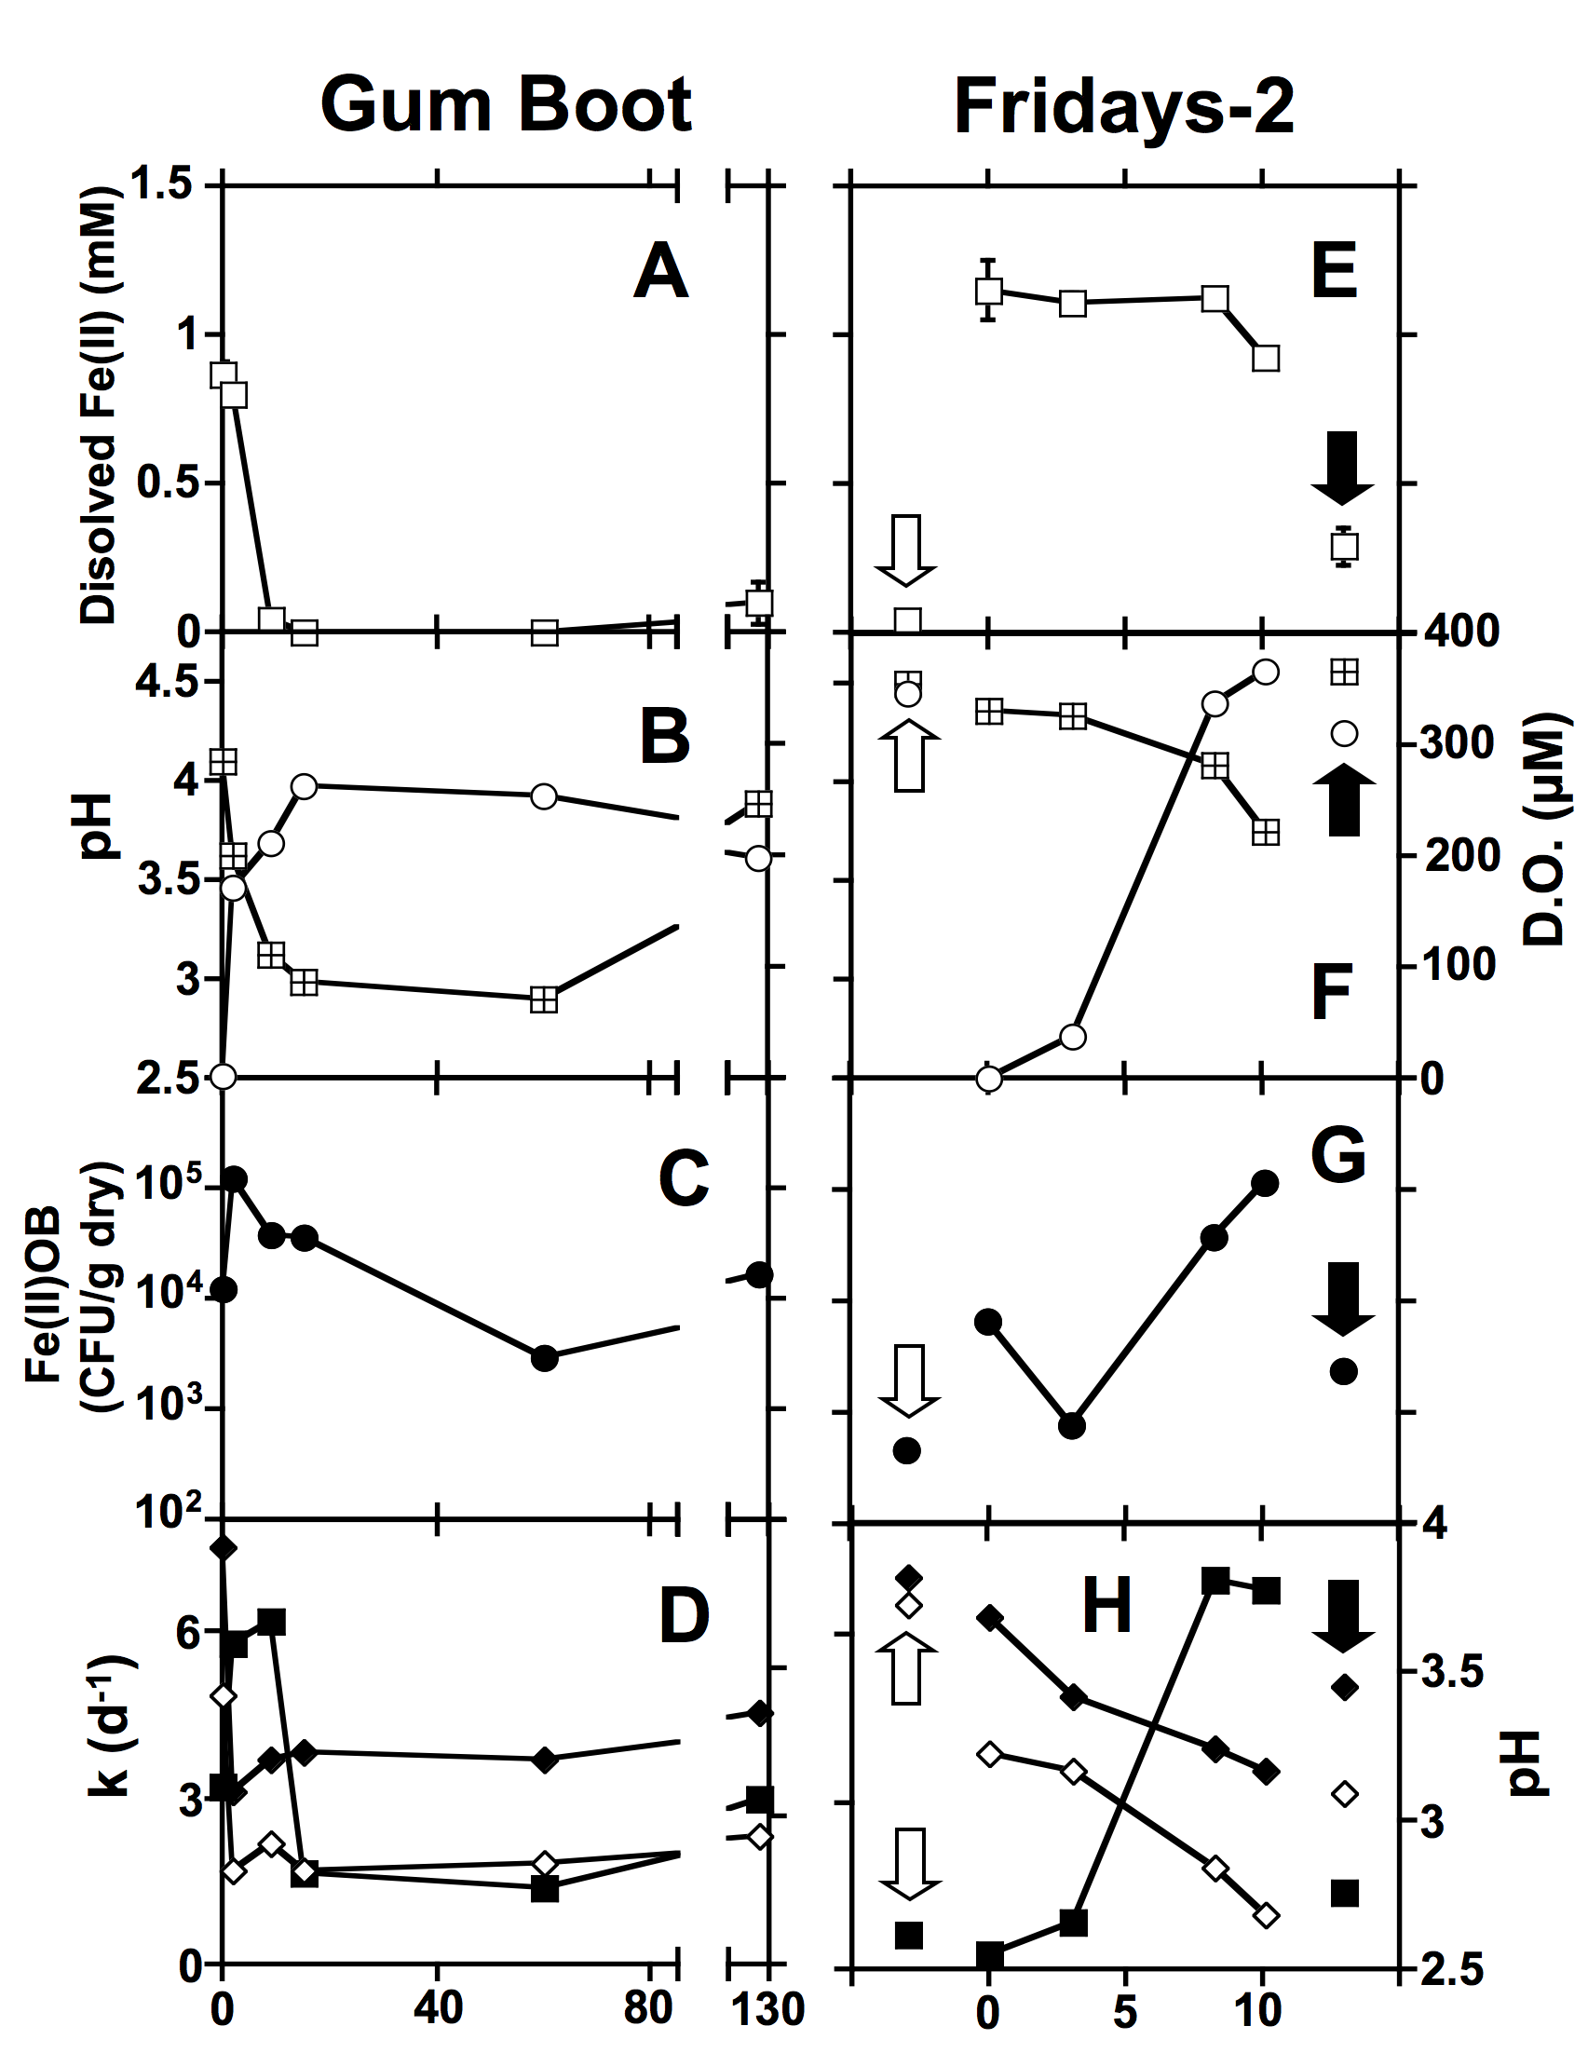
Figure 6. Characterization of water chemistry, abundance of culturable Fe(II) oxidizing bacteria (Fe(II)OB), and microbial activities from discrete sampling points in the GB and FR systems. Dissolved Fe(II) concentrations () are shown in panels A and E; pH () and dissolved oxygen concentrations () are shown in panels B and F; numbers of culturable Fe(II)OB () (as indicated by colony forming units CFU) are shown in C and G; first order rate constants (k) of Fe(II) oxidation (■) observed in sediment incubations and starting (♦) and ending () pH of the incubations are shown in panels D and H. In the Fridays-2 panels, upstream and downstream sampling points in the unnamed creek are pointed out using white arrows and black arrows, respectively. Error bars represent one standard deviation.
We hypothesized that bacterial communities present in Fe-rich sediments would exhibit community profiles dissimilar to those associated with sediments that did not receive regular inputs of unaltered AMD (i.e., in the 127 m sampling point at GB and within the unnamed creek at FR). We extracted bulk DNA from discrete sampling points at the GB and FR systems and used ribosomal RNA intergenic spacer analysis (RISA) to assess bacterial diversity at each sampling point. Bacterial communities associated with AMD sources and Fe(III)-rich sediments at both the GB and FR systems exhibited considerably less diversity (as indicated by the number of RISA bands observed in each lane) than those associated with sediments at the 127 m sampling point at GB and in the unnamed creek at FR (Figure 7). The AMD sources at both GB and FR (0 m) exhibited the lowest diversity of all sampling locations, and communities associated with sediments that oxidized Fe(II) most rapidly (GB 2 m, and FR10 m) exhibited similar banding patterns, suggesting similar community structures among these sampling locations. These observations are consistent with previous work suggesting that due to the relatively harsh chemical conditions of AMD, the diversity of microorganisms present in AMD systems is generally lower than the diversity observed in less chemically “extreme” systems (e.g. soils or sediments of circumneutral pH) (Baker and Banfield, 2003; Hallberg et al., 2006).
We obtained nucleotide sequences from the 16S rRNA gene portions of RISA amplicons recovered from the RISA gel, and used the phylogenetic diversity metric UniFrac (Lozupone et al., 2006; Lozupone et al., 2007) to compare the bacterial communities present at each sampling location in the GB and FR systems (Figure 8). UniFrac allows the simultaneous comparison of microbial communities present in several environments by evaluating the evolutionary relatedness of organisms present in those systems. The UniFrac metric determines the fraction of branch length within a phylogenetic tree that is unique to each system, and uses principal coordinates analysis (PCoA) to provide a graphical representation of the evolutionary similarity of microbial communities within each environment based on the “clustering” of environments. UniFrac-based PCoA separated microbial communities present in sediments receiving regular inputs of unaltered AMD from those in the GB system that did not receive regular inputs of Fe(II) (i.e. the GB 60 m and 127 m sampling locations) and those in the unnamed creek of the FR system (Figure 8). However, sediment samples exhibiting high rates of Fe(II) oxidation and high numbers of Fe(II)OB (i.e. the GB 2 m and FR 10 m sampling locations) were not separated from those that exhibited relatively low rates of Fe(II) oxidizing activity and low numbers of Fe(II)OB (i.e. the GB 0 m and FR 3 m sampling locations) (Figure 8). Therefore, it appears that the regular input of unaltered AMD is the primary controlling factor on the structure of microbial communities in AMD-impacted systems. Microbial communities receiving unaltered AMD are similar and have the potential for rapid oxidative removal of Fe(II) from AMD, but numbers of Fe(II)OB and rates of Fe(II) oxidation may be suppressed by the lack of O₂ availability.
Figure 7. Ribosomal RNA intergenic spacer analysis (RISA) (top panels) and phylum-level distribution of 16S rRNA gene sequences observed in clone libraries recovered from the RISA gel (bottom panel) of microbial communities present at discrete sampling points in the Gum Boot and Fridays-2 systems. “Unassignable” sequences are those that could not be assigned to an established bacterial phylum with ≥ 80% confidence using the Ribosomal Database Project II’s classifier function. n indicates the number of clones in each 16S rRNA gene clone library.

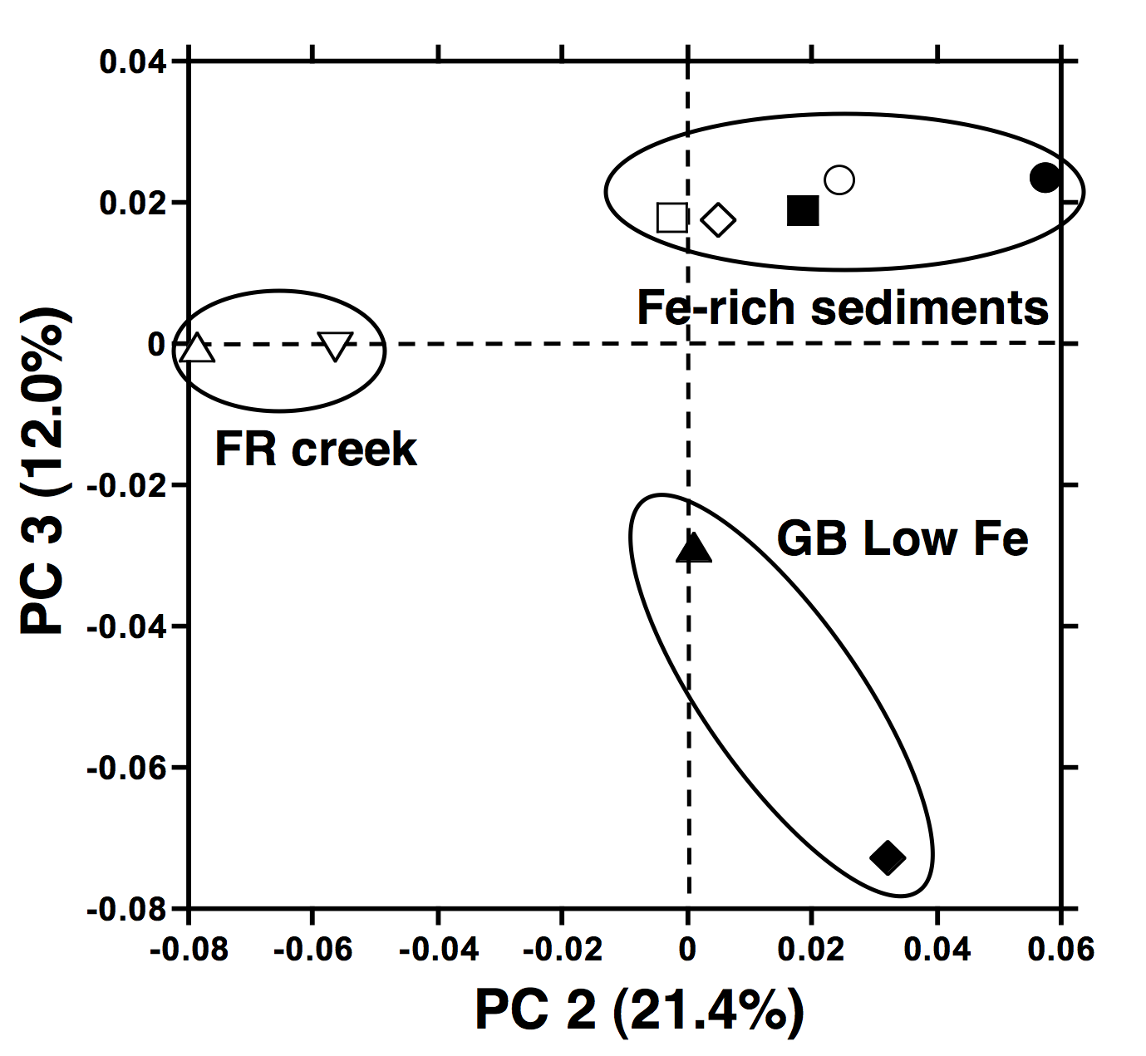
Figure 8. Principal coordinates analysis of microbial communities at discrete sampling locations in the Gum Boot (GB) and Fridays-2 (FR) systems using the UniFrac metric. Sampling points are designated by ● (GB 0 m), ■ (GB 2 m),  (GB 60 m), ▲ (GB 127 m),  (FR upstream), ○ (FR 0 m), □ (FR 3 m),  (FR 10 m), and  (FR downstream). Ovals indicate the clustering of Fe(III)-rich sediment-, creek sediment-, and low iron sediment-associated microbial communities in the GB and FR systems.

5.3 Sediment Mineralogy Characterization
The mineralogy of sediment samples were characterized primarily by X-ray diffraction (XRD) and, to a very limited extent, by Mossbauer spectroscopy. XRD and Mossbauer spectroscopy measurements were collected by colleagues at the Pacific Northwest National Laboratory (PNNL) through a separate but related research project funded jointly by the Department of Energy and the National Science Foundation. The most common iron minerals found across these two iron mounds were goethite and schwertmannite. Goethite was the predominant iron mineral at Gum Boot Run, while schwertmannite was the predominant iron mineral at Fridays-2 (Figure 9). These minerals were found to predominate at both the discharge location and across the iron mounds (Figure 10). However, at both sites there was evidence for the transformation of schwertmannite into goethite (goethite is the more thermodynamically stable phase). Schwertmannite is an iron-sulfate-hydroxide that tends to transform into goethite, an iron (hydr)oxide, as the pH of the system increases and/or as the sulfate concentration in the system decreases. The higher concentration of dissolved sulfate in the Fridays-2 AMD (Table 1) likely promoted the stability and predominance of schwertmannite (over goethite) at this site. The mound mineralogy likely affects the extent of abiotic heterogeneous oxidation occurring in the field, and observed to occur in laboratory experiments. 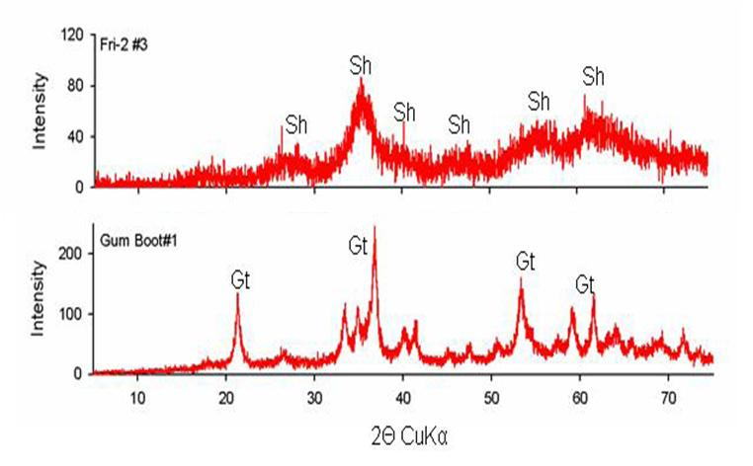
Figure 9. X-ray diffraction patterns from sediments collected from the top 2 cm of the iron mounds at Gum Boot Run and Fridays-2. The upper pattern is from a sediment sample collected 3 m downstream of the Fridays-2 discharge. The lower panel is from a sediment sample collected immediately downstream of the Gum Boot Run discharge. Sh designates XRD peaks that correspond to schwertmannite, and Gt designates XRD peaks that correspond to goethite.

Figure 10. X-ray diffraction patterns from sediments collected from the top 2 cm of various sampling points on the iron mounds at Gum Boot Run and Fridays-2. Reference spectra for goethite, schwertmannite, and quartz are shown in the top panels of the spectra.
6. CONCLUSIONS
The purpose of this research was to study the microbial communities and mineral precipitates associated with low-pH Fe(II) oxidation at two deep mine discharges in north-central Pennsylvania. Field sampling events were conducted over a 12 month period to evaluate how the water chemistry of each system responded to seasonal changes in temperature and water flow. Microbial communities associated with site sediments were characterized by culture-dependent methods (i.e., plate counts) and DNA-based methods (i.e., DNA extraction). Sediment minerals were characterized by X-ray diffraction. Select sediments were used in a series of laboratory experiments to evaluate the effects of dissolved oxygen and dissolved carbon dioxide on the kinetics of low-pH Fe(II) oxidation. The following conclusions can be drawn for this research:
- Low-pH Fe(II) oxidation occurred year-round at the Gum Boot Run site, effectively removing all Fe(II) from the discharge before it entered the adjacent creek. Fe(II) oxidation kinetics, however, did decline in winter months.
- For each site, culturable Fe(II) oxidizing bacteria were most abundant at sampling points along the AMD flow path corresponding to greatest Fe(II) removal and where overlying water contained abundant dissolved O₂.
- For each site, bacterial diversity was relatively limited at these locations corresponding to greatest Fe(II) removal.
- Within the Fridays-2 system, iron mound sediments where Fe(II) oxidation was “slow” yielded two-thirds as many iro gene copies as “fast” sediments, indicating that even “slow” locations have the potential to support faster Fe(II) oxidation under favorable conditions.
- Between the two sites, there were substantial differences in the bacterial community members at the locations corresponding to greatest Fe(II) removal. A notable difference between bacterial communities was the abundance of Chloroflexi-affiliated 16S rRNA gene sequences in clone libraries derived from the Gum Boot sediments.
- Choroflexi have not previously been detected in AMD-impacted sediments, and their exact role in the Gum Boot system is unclear. However, their abundance at the site suggests that they play an important role in Fe(II) oxidation.
The general conclusions of the studies that we present in this report are: 1) microbial communities capable of efficient oxidative precipitation of Fe(II) from AMD arise with no human intervention in response to the chemical “challenge” of such acidic fluids; 2) microbial communities that received Fe(II)-rich AMD were more similar to each other than those that did not; and 3) the highest laboratory rates of Fe(II) oxidation in the Fridays-2 system were as high as or greater than the highest laboratory rates of Fe(II) oxidation in the Gum Boot system. Therefore, our work suggests that by maximizing 1) the residence time, and 2) aeration of the AMD as it flows over iron mound sediments, efficient and low-cost passive Fe(II)-removal systems may be implemented. Indeed, over a ~15-month period at Fridays-2 we observed the establishment of new areas of active low-pH Fe(II) oxidation and precipitation on previously pristine soil and leaf litter. Passive biological treatment systems should be constructed to mimic the hydrologic characteristics of Gum Boot Run. These “aeration terraces” could be constructed as a series of steps to promote shallow flow and aeration of the AMD. Iron mound sediments from Gum Boot Run or other similar low-pH systems could be used to “seed” the aeration terraces, although that may be unnecessary.

7. REFERENCES
Altschul SF, Madden TL, Schäffer AA, Zhang J, Zhang Z, Miller W, Lipman DJ (1997) Gapped BLAST and PSI-BLAST: a new generation of protein database search programs. Nucl. Acid Res. 25:3389-3402.
Atlas RM (2004) Handbook of Microbiological Media, 3rd Edition, CRC Press, New York, New York, USA.
Baker BJ, Banfield JF (2003) Microbial communities in acid mine drainage. FEMS Microbiol. Ecol. 44:139-152.
Bond PL, Smriga SP, Banfield JF (2000) Phylogeny of microorganisms populating a thick, subaerial, predominantly lithotrophic biofilm at an extreme acid mine drainage site. Appl. Environ. Microbiol. 66:3842-3849
Boone DR, Castenholtz RW (2001) Bergey’s Manual of Systematic Bacteriology (Vol. 1, 2nd edition), Springer, Secaucus, New Jersey, USA.
Brake SS, Hasiotis ST, Dannelly HK, Connors KA (2002) Eukaryotic stromatolite builders in acid mine drainage: implications for Precambrian iron formations and oxygenation of the atmosphere? Geology 30:599-602.
Brodie EL, DeSantis TZ, Joyner DC, Baek SM, Larsen JT, Anderson GL, et al. (2006) Application of a high-density oligonucleotide microarray approach to study bacterial population dynamics during uranium reduction and reoxidation. Appl. Environ. Microbiol. 72:6288-6298.
Brofft JE, McArthur JV, Shimkets LJ (2002) Recovery of novel bacterial diversity from a forested wetland impacted by reject coal. Environ. Microbiol. 4:764-769.
Castillo-Gonzalez HA, Bruns MA (2005) Dissimilatory iron reduction and odor abatement by biofilm communities in swine manure microcosms. Appl. Environ. Microbiol. 71:4972-4978.
Clark DA, Norris PR (1996) Acidimicrobium ferrooxidans gen. nov., sp. nov.: mixed-culture ferrous iron oxidation with Sulfobacillus species. Microbiology 142:785-790
Cole JR, Chai B, Marsh TL, Farris RJ, Wang Q, Kulam SA, et al. (2003) The Ribosomal Database Project (RDP-II): previewing a new autoaligner that allows regular updates and the new prokaryotic taxonomy. Nucleic Acids Res. 31:442-443.
Costello EK, Schmidt SK (2006) Microbial diversity in alpine tundra wet meadow soil: novel Chloroflexi from a cold, water saturated environment. Environ. Microbiol. 8:1471-1486.
Coupland K, Johnson DB (2004) Geochemistry and microbiology of an impounded subterranean acidic water body at Myndd Parys, Anglesey, Wales. Geobiology 2:77-86.
Cravotta CA III, Brady, KBC, Rose AW, Douds JB (1999) Frequency distribution of the pH of coal-mine drainage in Pennsylvania. Water-Resources Investigations Report (United States Geological Survey) 99-4018A, USGS Toxic Substances Hydrology Program. 1:313-324.
Cravotta CA III, Trahan, MK (1999) Limestone drains to increase pH and remove dissolved metals from acidic mine drainage. Appl Geochem. 14:581-606.
Davis KER, Joseph SJ, Janssen PH (2005) Effects of growth medium, inoculum size, and incubation time on culturability and isolation of soil bacteria. Appl. Environ. Microbiol. 71:826-834.
Dedysh SN, Pankratov TA, Belova SE, Kulichevskaya IS, Liesack W (2006) Phylogenetic analysis and in situ identification of bacteria community composition in an acidic Sphagnum peat bog. Appl. Environ. Microbiol. 72: 2110-2117.
Dempsey BA, Roscoe HC, Ames R, Hedin R, Jeon B-H (2001) Ferrous oxidation chemistry in passive abiotic systems for the treatment of mine drainage. Geochem.: Exploration Environ. Analysis. 1:81-88.
Dojka MA, Harris JK, Pace NR (2000) Expanding the known diversity and environmental distribution of an uncultured phyolgenetic division of bacteria. Appl Environ. Microbiol. 66:1617-1621.
Dugan PR, MacMillan CB, Pfister RM (1970) Aerobic heterotrophic bacteria indigenous to pH 2.8 acid mine water: microscopic examination of acid streamers. J. Bacteriol. 101:973-981.
Drummond AJ, Ashton B, Cheung M, Heled J, Kearse M, Moir R, et al. (2007) Geneious v3.0. Available from http://www.geneious.com/
Druschel GK, Baker BJ, Gihring TM, Banfield JF (2004) Acid mine drainage biogeochemistry at Iron Mountain, California. Geochem. Trans. 5:13-32
Gomez-Alvarez V, King GM, Nüsslein K (2007) Comparative bacterial diversity in recent Hawaiian volcanic deposits of different ages. FEMS Microbiol. Ecol. 60:60-73.
Hallberg KB, Coupland K, Kimura S, Johnson DB (2006) Macroscopic streamer growths in acidic, metal-rich mine waters in North Wales consist of novel and remarkably simple bacterial communities. Appl. Environ. Microbiol. 72:2022-2030
Hallberg KB, Johnson DB (2001) Biodiversity of Acidophilic Prokaryotes. Adv. Appl Microbiol. 49:37-84.
Hallberg KB, Johnson DB (2003) Novel acidophiles isolated form moderately acidic mine drainage waters. Hydrometallurgy. 71:139-148.
Hallberg KB, Johnson DB (2005) Microbiology of a wetland ecosystem constructed to remediate mine drainage from a heavy metal mine. Sci. Tot. Environ. 338:53-56.
He Z, Xiao S, Xie X, Zhong H, Hu Y, Li Q, et al. (2007) Molecular diversity of microbial community in acid mine drainages of Yunfu sulfide mine. Extremophiles 11:305-314
Herlihy AT, Kaufmann PR, Mitch ME (1990) Regional estimates of acid mine drainage impact on streams in the Mid-Atlantic and Southeastern United States. Wat. Air Soil Pollut. 50:91-107.
Hugenholtz P (2002) Exploring prokaryotic diversity in the genomic era. Genome Biol. 3:reviews0003.1-0003.8.
Hugenholtz P, Goebel BM, Pace NR (1998) Impact of culture-independent studies on the emerging phylogenetic view of bacterial diversity. J. Bacteriol. 180:4765-4774.
Johnson DB (1995) Selective solid media for isolating and enumerating acidophilic bacteria. J. Microbiol. Meth. 23:205-218.
Johnson DB, Hallberg KB (2002) Pitfalls of passive mine water treatment. Re/Views in Environ. Sci. Bio/Technol. 1:335-343.
Johnson DB, Hallberg KB (2005) Acid mine drainage remediation options: a review. Sci. Tot. Environ. 338:3-14.
Johnson DB, Okibe N, Hallberg KB (2005) Differentiation and identification of iron-oxidizing acidophilic bacteria using cultivation techniques and amplified ribosomal DNA restriction enzyme analysis. J. Microbiol. Meth. 60:299-313.
Johnson DB, Roberto FF (1997) Heterotrophic acidophiles and their roles in the bioleaching of sulfide minerals. In: Rawlings DE (Ed.) Biomining: Theory, Microbes and Industrial Processes. R.G. Landes Co., pp 259-279.
Kirby CS, Thomas HM, Southam G, Donald R (1999) Relative contributions of abiotic and biological factors in Fe(II) oxidation in mine drainage. Appl. Geochem. 14:511-530.
Lane DJ, Harrison AP, Stahl D, Pace B, Giovannoni SJ, Olsen GJ, Pace NJ (1992) The evolutionary relationships among sulfur- and iron-oxidizing eubacteria. J. Bacteriol. 174:269-278.
Lovley DR, Phillips EJP (1987) Rapid assay for microbially reducible ferric iron in aquatic sediments. Appl. Environ. Microbiol. 53:1536-1540.
Lozupone C, Hamady M, Knight R (2006) UniFrac – An online tool for comparing microbial community diversity in a phylogenetic context. BMC Bioinformat. 7:371-384.
Lozupone CA, Hamady M, Kelley ST, Knight R (2007) Quantitative and qualitative β diversity measures lead to different insights into factors that structure microbial communities. Appl. Environ. Microbiol. 73:1576-1585.
Nengovhela NR, Strydom CA, Maree JP, Greben HA (2004) Chemical and biological oxidation of iron in acid mine water. Mine Wat. Environ. 23:76-80.
Nicormat D, Dick WA, Tuovinen OH (2006a) Assessment of the microbial community in a constructed wetland that receives acid coal mine drainage. Microbial Ecol. 51:83-89.
Nicormat D, Dick WA, Tuovinen OH (2006b) Microbial populations identified by fluorescence in situ hybridization in a constructed wetland treating acid mine drainage. J. Environ. Qual. 35:1329-1337.
Olem H, Unz RF (1977) Acid mine drainage treatment with rotating biological contactors. Biotechnol. Bioeng. 19: 1475-1491.
Oyaizu H, Debrunner-Vossbrinck B, Mandelco L, Studier JA, Woese CR (1987) The green non-sulfur bacteria: a deep branching in the eubacterial line of descent. System. Appl. Microbiol. 9:47-53.
Park B, Dempsey BA (2005) Heterogeneous oxidation of Fe(II) on ferric oxide at neutral pH and a low partial pressure of O₂. Environ. Sci. Technol. 39:6494-6500.
Pennsylvania Department of Environmental Protection (PA-DEP) (1999) The Science of Acid Mine Drainage and Passive Treatment. PA-DEP publication, Bureau of Abandoned Mine Reclamation.
Pierson BK, Parenteau MN (2000) Phototrophs in high iron microbial mats: microstructure of mats in iron depositing hot springs. FEMS Microbiol. Ecol. 32:181-196.
Pierson BK, Parenteau MN, Griffin BM (1999) Phototrophs in high-iron-concentration microbial mats: physiological ecology of phototrophs in an iron-depositing hot spring. Appl. Environ. Microbiol. 65,5474-5483.
Rappé MS, Giovannoni SJ (2003) The uncultured microbial majority. Ann. Rev. Microbiol. 57:369-394.
Rose AW, Bisko D, Daniel, A, Bower MA (2004) An “autopsy” of the failed Tangascootak #1 vertical flow pond. Proceedings of the National Meeting of the American Society of Mining and Reclamation and the 25th West Virginia Surface Mine Drainage Task Force. Published by ASMR, Lexington KY.
Selenska-Pobell S, Kampf G, Flemming K, Radeva G, Satchanska G (2001) Bacterial diversity in soil samples from two uranium waste piles as determined by rep-APD, RISA, and 16S rDNA retrieval. Antonie van Leeuwenhoek. 79:149-161.
Shiller AM, Stephens TH (2005) Microbial manganese oxidation in the lower Mississippi River: methods and evidence. Geomicrobiol. J. 22:117-125.
Spring S, Amann R, Ludwig W, Schleifer K-H, van Gemerden H, Petersen N (1993) Dominating role of an unusual magnetotactic bacterium in the microaerobic zone of a freshwater sediment. Appl Environ. Microbiol. 59:2397-2403.
Stumm W, Morgan JJ (1996) Aquatic Chemistry. Wiley-Interscience, Hoboken, New Jersey, USA.
Tamura H, Goto K, Yotsuynagi T, Nagayama M (1974) Spectrophotometric determination of iron(II) with 1,10-phenanthroline in the presence of large amounts of iron(III). Talanta. 21:314-318.
Tan GL, Shu WS, Hallberg KB, Li F, Lan CY, Huang LN (2007) Cultivation-dependent and cultivation-independent characterization of the microbial community in acid mine drainage associated with acidic Pb/Zn mine tailings at Lechang, Guangdong, China. FEMS Microbiol. Ecol. 59:118-126
Tarutis WJ Jr, Unz RF, Brooks RP (1992) Behavior of sedimentary Fe and Mn in a natural wetland receiving acidic mine drainage, Pennsylvania USA. Appl. Geochem. 7:77-85.
Tarutis WJ Jr, Unz RF (1995) Iron and manganese release in coal mine drainage wetland microcosms. Wat. Sci. Technol. 32:187-192.
Tebo BM (1991) Manganese(II) oxidation in the suboxic zone of the Black Sea. Deep-Sea Res. 38:S883-S905.
Thompson JD, Higgins DG, Gibson TJ (1994) CLUSTAL W: improving the sensitivity of progressive multiple sequence alignment through sequence weighting, positions-specific gap penalties and weight matrix choice. Nucl. Acids Res. 22:4673-4680.
Trouwborst RE, Johnston A, Koch G, Luther GW III, Pierson BK (2007) Biogeochemistry of Fe(II) oxidation in a photosynthetic microbial mat: implications for Precambrian Fe(II) oxidation. Geochim. Cosmochim. Acta doi:10.1016/j.gca.2007.07.018.
Tyson GW, Lo I, Baker BJ, Allen EE, Hugenholtz P, Banfield JF (2005) Genome-directed isolation of the key nitrogen fixer Leptospirillum ferrodiazotrophum sp. nov. from an acidophilic microbial community. Appl. Environ. Microbiol. 71:6319-6324 .
Unz RF, Olem H, Wichlacz BS (1979) Microbiological ferrous iron oxidation in acid mine drainage. Process Biochem. 14:2-6, 28.
Vile MA, Wieder RK (1993) Alkalinity generation by iron(III) reduction versus sulfate reduction in wetlands constructed for acid mine drainage treatment. Wat. Air Soil Pollut. 69:425-441.
Wang Q, Garrity GM, Tiedje JM, Cole JR (2007) Naïve Bayesian classifier for rapid assignment of rRNA sequences into the new bacterial taxonomy. Appl. Environ. Microbiol. 73:5261-5267.
Weaver KR, Lagnese KM, Hedin RS (2004) Technology and design advances in passive treatment system flushing. Proceedings of the National Meeting of the American Society of Mining and Reclamation and the 25th West Virginia Surface Mine Drainage Task Force. Published by ASMR, Lexington KY.

