**Spatial and Temporal Trends in Bromide Concentrations in Discharges from Coal Mining or Processing Facilities in Pennsylvania**

C.A. Cravotta III1, K.B.C. Brady2, G. Greenfield3, S.A. Hoffman1, A. McFadden4  
1U.S. Geological Survey, 215 Limekiln Rd., New Cumberland PA 17070,   
2Pennsylvania Department of Environmental Protection (Retired), Steelton, PA 17113  
3Pennsylvania Department of Environmental Protection, Harrisburg, PA 17101,   
4U.S. Environmental Protection Agency, Region III, Philadelphia, PA 19103

# Extended Abstract

Various halogen (Cl, Br, I), alkali earth (Na, K, Li), and alkaline earth (Sr, Ba) elements tend to be elevated in oil and gas brines or connate fluids (Dresel and Rose, 2010; Halusczak et al., 2013) but elevated concentrations of these elements are not typically identified with coal-mine drainage (CMD). Nevertheless, such brine constituents, notably bromide (Br-), have been documented in CMD samples from selected sites in Pennsylvania (Cravotta, 2008; Cravotta and Brady, 2015). Elevated concentrations of Br- in source water are cause for concern because of its potential to oxidize to bromate (BrO3-) or to interact with organic carbon forming brominated trihalomethane (THM) disinfection byproducts (DBPs), primarily as a consequence of ozonation or chlorination (U.S. Environmental Protection Agency, 2003; Parker et al., 2014). The drinking-water maximum contaminant levels (MCLs) for bromate and total trihalomethanes (TTHM) are 0.010 and 0.080 mg/L, respectively (U.S. Environmental Protection Agency, 2005, 2012). Management of the Br- from coal-mine sources requires an understanding of the origin of Br- and associated constituents, specifically, whether the Br- originates naturally from the bedrock formations subjected to mining, or if the Br- is the result of brine disposal practices.

In 1999, 2003, and 2011, the U.S. Geological Survey (USGS) collected and analyzed CMD samples from selected sites in Pennsylvania for more than 70 inorganic constituents (Cravotta, 2008; Cravotta and Brady, 2015). The sampling in 1999 was completed during base-flow conditions at 140 abandoned underground mines in the bituminous and anthracite coalfields; a subset of 19 of these sites was resampled in 2003 indicating similar results and no apparent temporal trends (Cravotta, 2008). In 2011, untreated and treated CMD samples also were collected at active coal mining or processing facilities, including 26 surface mines, 11 underground mines, and 5 coal-refuse disposal operations (Cravotta and Brady, 2015). The reported Br- concentrations for the 182 untreated CMD samples collected in 1999 and 2011 range from <0.003 to 12.8 mg/L, with a median of 0.036 mg/L. The median value is near the upper limit assumed for natural background levels in Pennsylvania waters (Pennsylvania Department of Environmental Protection, 2014). The highest Br- concentrations for the abandoned or active CMD were sampled in southwestern Pennsylvania, within the general extent of the Pittsburgh coal bed (Fig. 1). Three of the CMD samples collected in 2011, including two from deep mines and one from an associated coal-refuse facility, had anomalously high Br- concentrations (3.3 to 12.8 mg/L) compared to other sites sampled. Except for these outliers, the ranges of values for Br- and associated constituents in the CMD from active underground and surface mines in 2011 were similar to those for the abandoned underground mines sampled in 1999 and 2003 (Fig. 2).

The CMD samples with elevated Br- concentrations tend to originate from deep mines or from associated waste rock piles. These samples also had elevated Cl-, I-, Na+, and K+. Although these brine constituent concentrations are dilute in CMD compared to oil and gas brines or other sources of salinity, the Br/Cl ratios indicate many of the deep mine waters have enriched Br- compositions that are consistent with residual brine diluted with meteoric water (Fig. 3). In a study of oil and gas well brines in western Pennsylvania, Dresel and Rose (2010) found that “(m)any brines, especially those from the oil wells, represent mixtures of 70 to 90 percent dilute water and only 10 to 30 percent evaporated water.” The deepest coal mines in Pennsylvania occur at about the same depth as the shallowest oil wells in the Dresel and Rose (2010) study.

We suspect that the deep coal beds and associated overburden now being mined in the southwestern part of Pennsylvania may have had less interaction with meteoric water than shallow beds, possibly retaining more of the original connate fluids. The coal-bearing rocks of the Appalachian Plateau were once deeply buried and saturated with saline waters (Reed et al., 2005). Shallow rocks are more fractured and thus allow for greater flushing by meteoric water than deeper portions of the flow system (Wyrick and Borchers, 1981; Stoner et al., 1987; Callaghan et al., 1998; Brady, 1998). Thus, CMD samples with elevated concentrations of Br-, Cl-, and Na+ tend to originate from deep mines or from associated waste rock piles, and may not be affected by brine disposal practices. In general, the deeper flow systems have greater amounts of residual brine, including residual Na on cation exchange sites in the intermediate flow system, and Na and Cl in the regional system (Callaghan et al., 1998; Stoner et al., 1987). The transition from shallow water without influence from connate waters to deeper waters clearly influenced by connate waters is gradational.

To test the hypothesis that Br- is derived from the mined rock, we compared the Br contents of CMD with that of coal using the available data from the USGS coal-quality data base (Bragg et al.,1997; Northern and Central Appalachian Basin Coal Regions Assessment Team, 2000). Generally, based on a simple geographic distribution of Br data for coal (undifferentiated) and the CMD from abandoned and active sites, a correlation between Br in CMD and coal is not apparent (Fig. 1). The Br content in coal increases northeastward, opposite to that for CMD. The apparent lack of correlation between the coal and CMD quality implies that the coal is not the primary source of Br- in the CMD, but does not rule out the overlying rock as the source. Data on Br in overburden are not generally available. To further explain the chemistry of the CMD samples, we are in the process of estimating depth (overburden thickness) for each of the coal quality and CMD samples in order to identify the position of a mine and corresponding samples within the local and regional flow system.

# References Cited

Brady, K.B.C., 1998. Natural groundwater quality from unmined areas as a mine drainage quality prediction tool. In: Brady, K.B.C., Smith, M.W., Schueck, J.H. (Eds.), Coal mine drainage prediction and pollution prevention in Pennsylvania. Harrisburg, Pa., Pennsylvania Department of Environmental Protection, 5600-BK-DEP2256, 10.1-10.11.

Bragg, L.J., Oman, J.K., Tewalt, S.J., Oman, C.J., Rega, N.H., Washington, P.M., and Finkelman, R.B, 1997. U.S. Geological Survey Coal Quality (COALQUAL) Database, Version 2.0: U.S. Geological Survey Open-File Report 97-134.

Callaghan, T., Fleeger, G., Barnes, S., and Dalberto, A., 1998. Groundwater flow on the Appalachian Plateau of Pennsylvania. In: Coal Mine Drainage Prediction and Pollution Prevention in Pennsylvania. Pennsylvania Department of Environmental Protection, 5600-BK-DEP2256, p. 2.1–2.39.

Cravotta, C.A., III, 2008. Dissolved metals and associated constituents in abandoned coal-mine discharges, Pennsylvania, USA -- 1. Constituent concentrations and correlations. Appl. Geochem. 23, 166-202.

Cravotta, C.A. III, and Brady, K.B.C., 2015. Priority Pollutants in untreated and treated discharges from coal mines in Pennsylvania, U.S.A.: Appl. Geochem. ([doi.org/10.1016/j.apgeochem.2015.03.001](http://dx.doi.org/10.1016/j.apgeochem.2015.03.001))

Dresel, P.E., Rose, A.W., 2010. Chemistry and origin of oil and gas well brines in western Pennsylvania. Pennsyl. Geol. Surv. 4th ser., Open-File Report OFOG 10–01.0, 48 p.

Halusczak, L.O., Rose, A.W., Kump, L.R., 2013. Geochemical evaluation of flowback brine from Marcellus gas wells in Pennsylvania, USA. Appl. Geochem. 28, 55-61.

Northern and Central Appalachian Basin Coal Regions Assessment Team, 2000, 2000 resource assessment of selected coal beds and zones in the northern and central Appalachian Basin coal regions: U.S. Geological Survey Professional Paper 1625C, CD-ROM, version 2.0

Parker, K.M., Zeng, T., Harkness, J., Vengosh, A., and Mitch, W.A., 2014. Enhanced formation of disinfection byproducts in shale gas wastewater-impacted drinking water supplies: Environ. Sci. Technol., 48 (19) 11161–11169.

Pennsylvania Department of Environmental Protection , 2014, Bromide in surface waters in western Pennsylvania and its effects on disinfection by-product (DBP) formation in community water systems: PA Department of Environmental Protection, unpublished white paper.

Reed, J.S., Spotila, J.A., Eriksson, K.A., Bodnar, R.J., 2005. Burial and exhumation history of Pennsylvanian strata, central Appalachian basin: an integrated study. Basin Research 17, 259-268.

Stoner, J.D., Williams, D.R., Buckwalter, T.F., Felbinger, J.K., Pattison, K.L., 1987. Water resources and the effects of coal mining, Greene County, Pennsylvania. Pennsylvania Geological Survey Water Resources Report 63, 166 p.

U.S. Environmental Protection Agency, 2002. The occurrence of disinfection by-products (DBPs) of health concern in drinking water--Results of a nationwide DBP occurrence study: U.S. Environmental Protection Agency EPA/600/R-02/068.

U.S. Environmental Protection Agency, 2005. Drinking water criteria document for brominated trihalomethanes: U.S. Environmental Protection Agency EPA-822-R-05-011.

U.S. Environmental Protection Agency, 2012. 2012 Edition of the drinking water standards and health advisories (spring 2012). Washington, D.C., U.S. Environmental Protection Agency EPA 822-R-12-001, 12 p. (http://water.epa.gov/action/advisories/drinking/upload/dwstandards2012.pdf)

Wyrick, G.G., Borchers, J.W., 1981. Hydrologic effects of stress-relief fracturing in the Appalachian valley. U.S. Geol. Surv. Water-Supply Paper 2177, 51 p

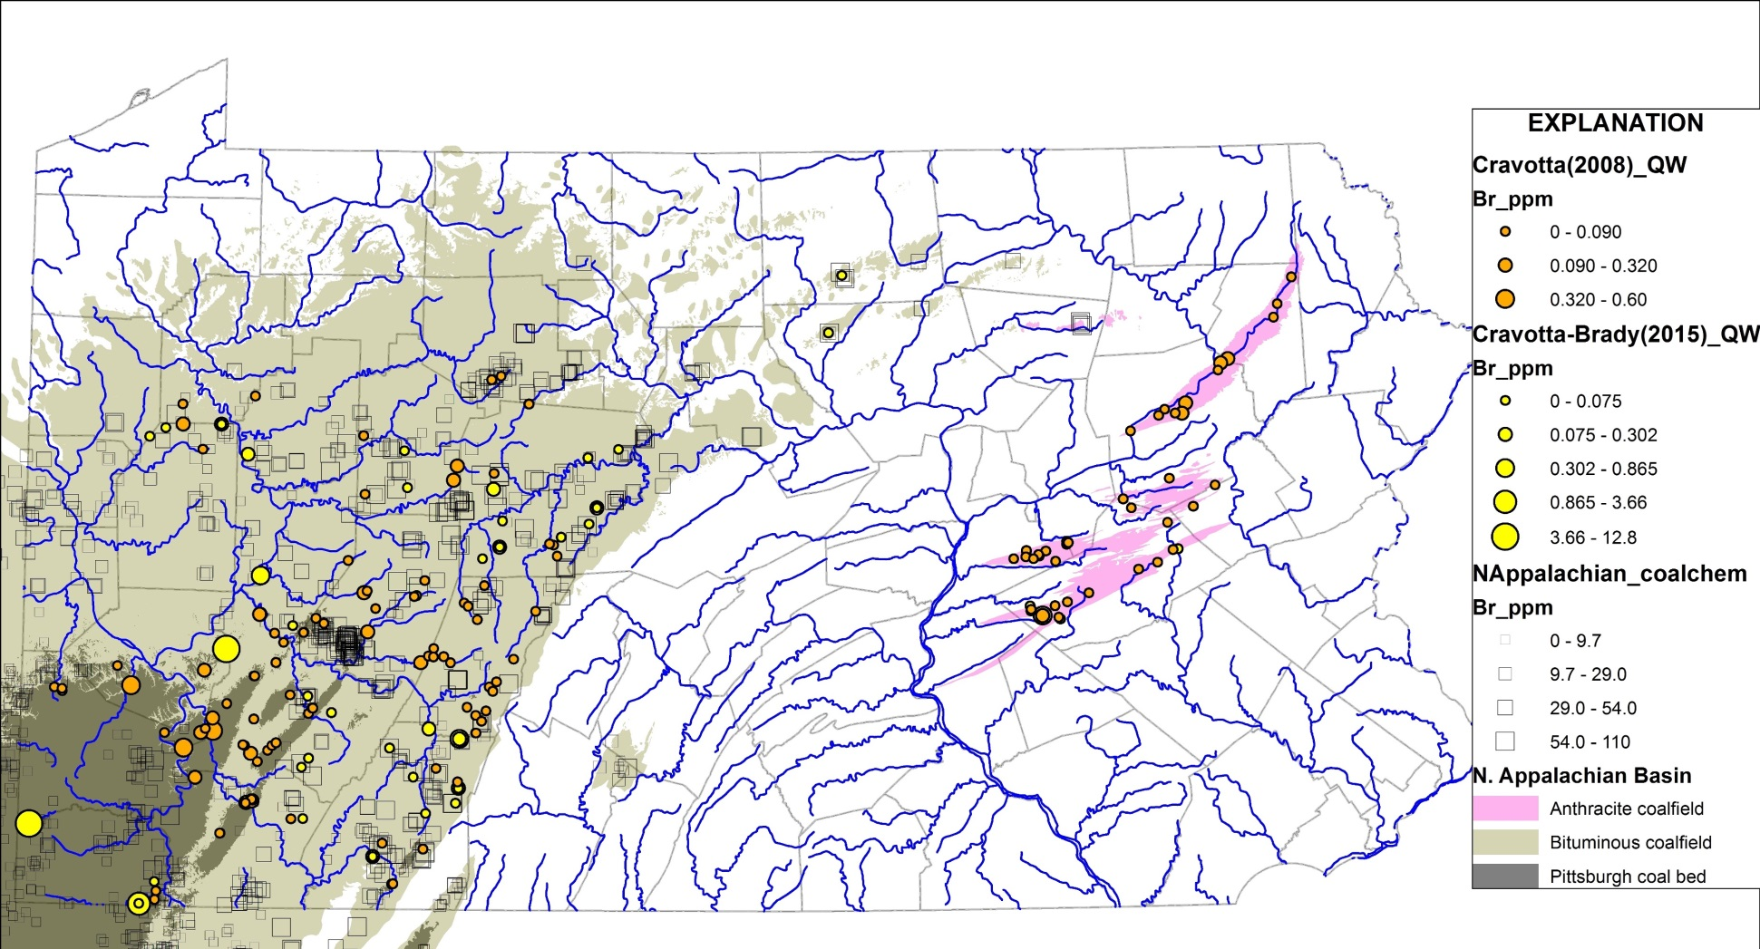

Fig. 1. Concentrations of bromide in CMD and coal samples from the bituminous and anthracite coalfields in Pennsylvania. CMD reported by Cravotta (2008) and Cravotta and Brady (2015). Coal reported by Bragg et al. (1997) and Northern and Central Appalachian Basin Coal Regions Assessment Team (2000). Pittsburgh coal bed from Northern and Central Appalachian Basin Coal Regions Assessment Team (2000).

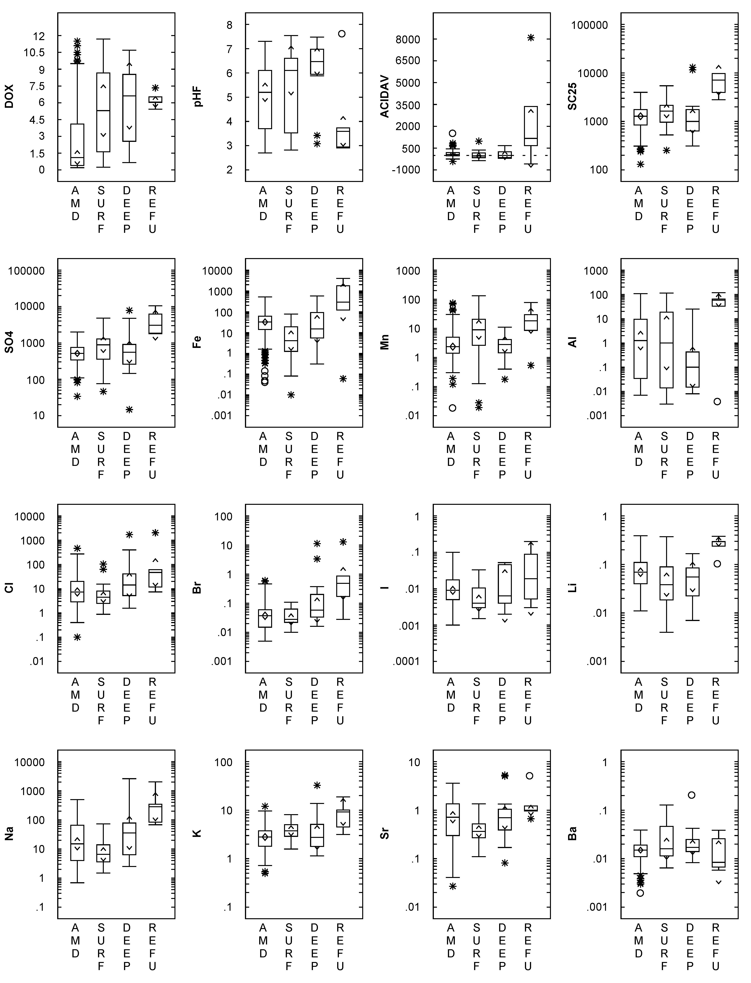

Fig. 2. Comparison of water quality among 182 coal-mine drainage samples from the bituminous and anthracite coalfields, Pennsylvania. Samples collected in 1999 reported by Cravotta (2008): AMD = abandoned mine drainage, n = 140. Samples collected in 2011 reported by Cravotta and Brady (2011): SURF = surface mine, n = 26; DEEP = deep mine, n = 11; REFU = refuse disposal facility, n = 5. Units are milligrams per liter, except for pH and specific conductance (SC25), in microSiemens per centimeter.

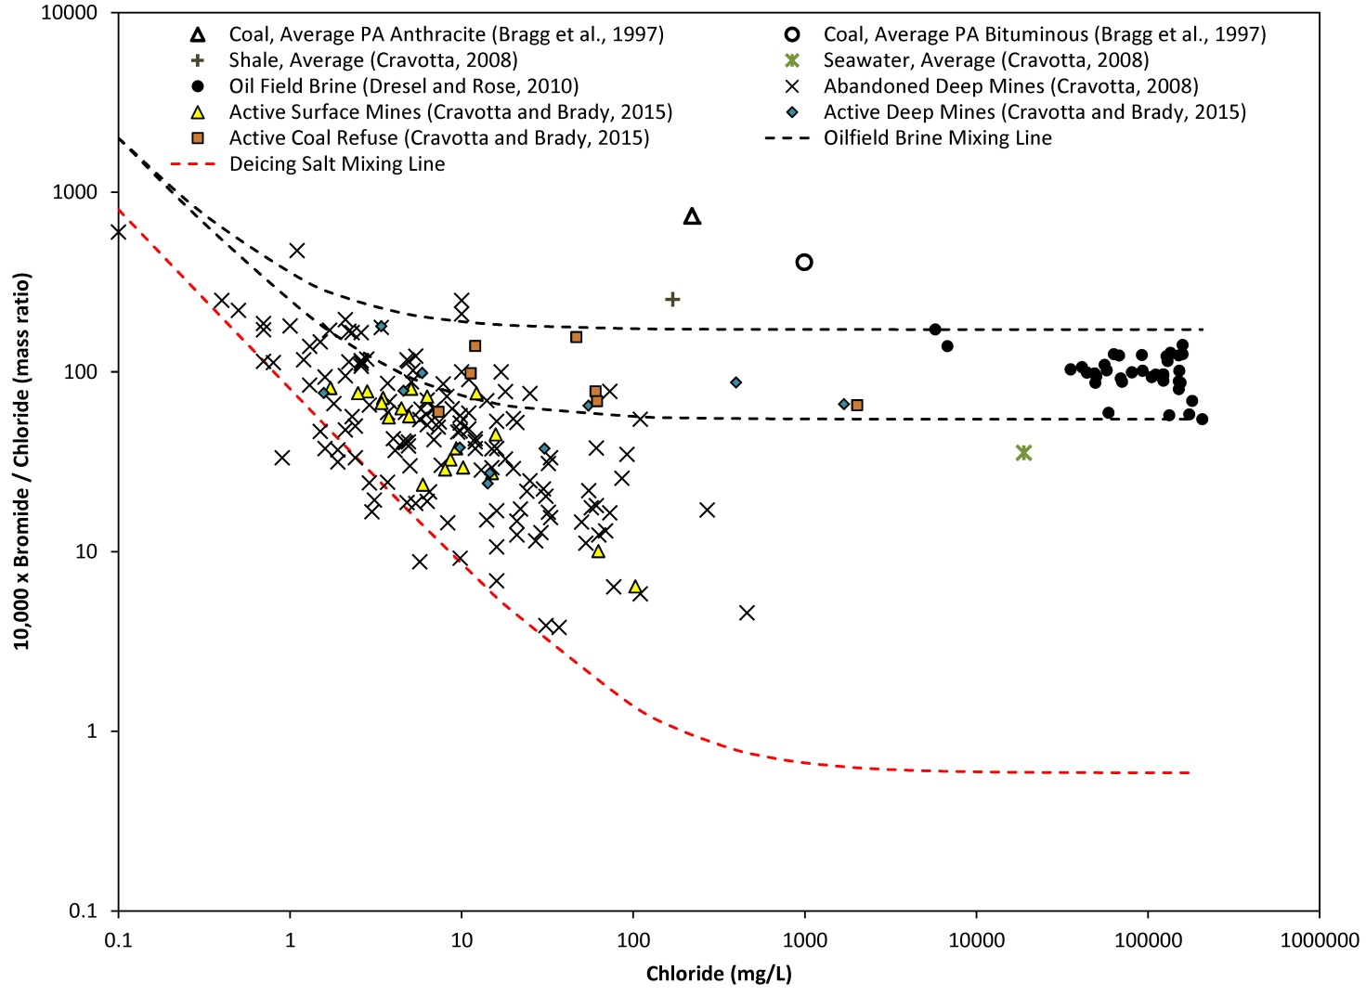

Fig. 3. Bromide/chloride ratios and chloride concentrations for untreated CMD samples (Cravotta, 2008; Cravotta and Brady, 2015) and oilfield brines from western Pennsylvania (Dresel and Rose, 2010). Coal data reported by Bragg et al. (1997). Deicing salt end-member based on results by Garth Llewellyn (written commun., 2013) for road-deicing salt dissolved in deionized water (Cl = 18700 mg/L, Br = 1.1 mg/L). Freshwater end-members assume Cl = 0.1 mg/L with Br = 0.001 or 0.02 mg/L.