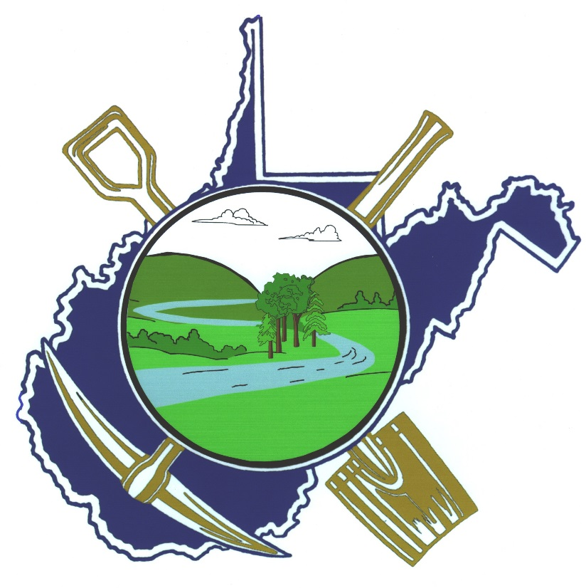**PROGRAM**

**West Virginia Mine Drainage**

**Task Force Symposium**

###### ***March 31 – April 1, 2015***

###### ***Morgantown, WV***

**CO-SPONSORED BY**

**WEST VIRGINIA MINE DRAINAGE TASK FORCE**

**WEST VIRGINIA UNIVERSITY**

**WEST VIRGINIA COAL ASSOCIATION**

**2015 PROGRAM**

**WEST VIRGINIA MINE DRAINAGE**

**TASK FORCE SYMPOSIUM**

**Ramada Inn, Morgantown, West Virginia**

**March 31 - April 1, 2015**

**Tuesday, March 31, 2015**

7:30 – 8:30 a.m. Registration

8:30 – 8:35 a.m. **Welcome and Opening Remarks**

Moderator: Randy Maggard, MEPCO, Morgantown, WV

8:35 – 8:45 a.m. **“WVMDTF Fall Tour”**

Tim Danehy

Biomost

Pittsburgh, PA

8:45 – 9:15 a.m. **“Status of West Virginia Mining and Reclamation”**

Lewis Halstead

West Virginia Department of Environmental Protection

Charleston, WV

9:15 – 9:45 a.m. **“OSM Update on Mining, Reclamation and AMD”**

Joe Pizarchik

OSMRE

Washington, DC

9:45 – 10:15 a.m. **“TDS Release Prediction Based on Acid-Base Account Parameters”**

Jessica Odenheimer Joyce and Louis McDonald

Moody and Assoc. Inc., and West Virginia University

Houston, PA, and Morgantown, WV

10:15 - 10:30 a.m. **BREAK**

10:30 - 11:00 a.m. **“Evaluation of TDS Concentrations from Valley Fills”**

Carl Zipper

Virginia Tech

Blacksburg, VA

11:00 – 11:30 a.m. **“Fish IBI Scores and TDS Effects on Game vs. Sensitive Fish”**

Todd Petty

West Virginia University

Morgantown, WV

11:30 - 12:00 noon **“Effects of Carbon Dioxide on Acidity Measurement and Water Treatment”**

Brent Means

OSMRE

Harrisburg, PA

12:00 - 1:30 p.m. **LUNCH**

1:30 - 1: 35 p.m. **REGROUP**

**Afternoon Moderators:** Ron Hamric, Arch Coal, Morgantown, WV

Mike Isabell, Cliffs Natural Resources, Beckley, WV

1:35 - 2:00 p.m. **“2014-15 Legislative Issues on Mining, Reclamation and Water Quality”**

Jason Bostic

West Virginia Coal Association

Charleston, WV

2:00 - 2:30 p.m. **“Water Treatment with Pressure Cavitation”**

Mike Mitton

Mitton Valves

Brantford, Canada

2:30 - 3:00 p.m. **“Cost Saving and Performance Enhancements at the Rushton AMD Plant”**

Jon Dietz

Dietz-Gourley Consulting

Clearfield, PA

3:00 - 3:30 p.m. **BREAK**

3:30 - 4:00 p.m. **“Changes in Bromide Concentrations in Underground Mines in PA”**

Chuck Cravotta

U.S. Geological Survey

Harrisburg, PA

4:00 - 4:30 p.m. **“Sources of Bromide in Underground Mine Water”**

Joe Donovan

West Virginia University

Morgantown, WV

4:30 - 5:00 p.m. **“Managing Conductivity, TDS and Sulfate in the Monongahela River”**

Paul Ziemkiewicz

West Virginia University

Morgantown, WV

5:00 - 7:30 p.m. **RECEPTION AND EXHIBIT SESSION**

## Wednesday, April 1, 2015

8:00 – 8:30 a.m. **Registration**

8:25 - 8:30 a.m. **Welcome and Remarks:** Tiff Hilton, WOPEC, Lewisburg, WV

8:30 - 9:00 a.m. **“MCHM in the Elk and Kanawha Rivers after the January 2014 Spill”**

Jennifer Weidhaas and Lance Lin

West Virginia University

Morgantown, WV

9:00 – 9:30 a.m. **“MCHM Chemical Properties, Transport, and Fate in Coal Prep Plants”**

Aaron Noble and Tom He

West Virginia University

Morgantown, WV

9:30 - 10:00 a.m. **“Changes in Aboveground Storage Tank Safety and Containment Rules”**

Scott Mandirola

West Virginia Division of Environmental Protection

Charleston, WV

10:00 – 10:30 a.m. **BREAK**

10:30 – 11:00 p.m. **“Biofilm Remediation of Al, Fe, and Mn Using**

**“Microchip Wetland” Metal Removal Units (MRUs)”**

Collin Lennox

EcoIslands, LLC.

Altoona, PA

11:00 - 11:30 a.m. **“Seeing the Water through the Valley Fill: Emerging Hydrology Controls Across Scales”**

Nicolas Zegre

West Virginia University

Morgantown, WV

11:30 – 12:00 noon **“Moving Bed Biofilm Reactor for Selenium Reduction in Mine Effluents”**

Caroline Dale

Veolia Water Solutions and Tech.

Cary, NC

12:00 Noon ADJOURN