TDS Evolution from Fills at Coal-Mac, Inc.
Results of modified fill construction
Terry Potter, P.E.
Engineering Manager, Coal-Mac, Inc., Holden, WV

Coal-Mac operates a surface operation producing approximately three (3) million clean tons annually near Logan, WV. The mine utilizes Komatsu 5500 series excavators and Caterpillar front end loaders to move approximately 40 MM bank cubic yards of overburden per year overlying the Five Block, Stockton, and Coalburg coal horizons. Excess spoil from the mining operation not needed to achieve AOC is placed into adjacent fills. The West Virginia Department for Environmental Protection issued an Article 3 mining permit to Coal-Mac on September 5, 2008 but the Section 404 permit approval from the US Army Corps of Engineers (USCOE) was not issued until July 27, 2010 due to challenges from the US Environmental Protection Agency. The limited approval allowed construction of one (1) of the three (3) proposed fills and delayed future fill approvals pending completion of the first fill and meeting certain Conductivity thresholds in the stream immediately below the first fill. Conductivity values at or below 500 μS/cm were required to receive approval to construct subsequent fills.
The Adaptive Management Plan (AMP) for the valley fill construction process approved by the USCOE included several innovative construction techniques in an effort to reduce the dissolved solids from the fill runoff. The focus of these Best Management Practices (BMPs) was on proper construction practices which would minimize infiltration, reduce exposure to weathering and avoid un-necessary contact with water. The significant construction changes included:
- Construct all underdrains of the best available sandstone material for construction. The underdrain material chosen was very durable (SDI 98%), ph neutral, and low in sulfur content (0.001%). Wrap the in-hollow underdrain with filter fabric to prevent contamination from materials placed above.
- Construct a series of internal checks to lower sub-surface flow velocity. The reduction in velocity should prevent degradation of the fill underdrain.
- Limit initial brushing to the fifth bench level and, upon completion of the face of the fifth bench, place an internal drain on this level to move sub-surface water out of the fill.
- Construct an underdrain at the Coalburg seam level. This underdrain will intercept sub-surface water on the pavement level and move it away from the in-hollow fill area.
- Complete final reclamation on the various stages of the fill as quickly as possible to reduce surface water infiltration.

Construction of Valley Fill #1 began during the 4th quarter of 2010 and has continued without pause. Presently the top of the valley fill is located approximately 100’ above the Coalburg seam level and contains over 27 MM cubic yards of overburden. The face of the valley fill has been reclaimed to the twelve bench level of the fourteen benches proposed. As shown on Graph 1 below, specific conductivity readings taken at the monitoring location situated below the fill, Site BF 1&2, have remained well below the target level of 500 μS/cm since the commencement of fill placement.

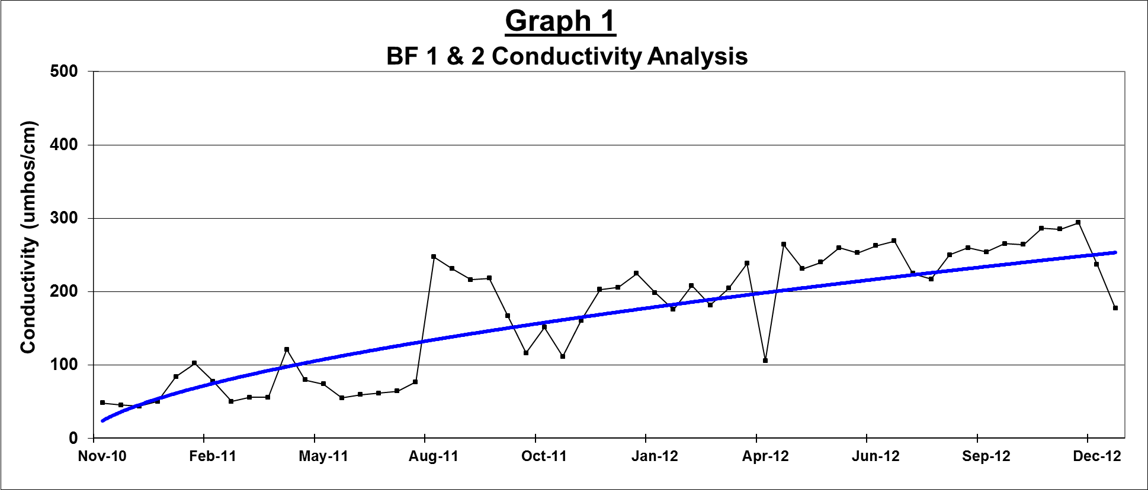
The breakdown of the dissolved solids of BF 1&2 flow is shown in Chart 1. The largest component, nearly half of the dissolved solids, consisted of sulfate. This is not surprising and follows the trend found below most typical valley fills. However, the sulfate concentration at BF 1&2 was 90 mg/l, which is very promising compared to older valley fills constructed in the Pine Creek watershed not using the new BMPs. For example, an in-stream sample below a near-by valley fill, containing 9.1 MM cubic yards, had a sulfate concentration of 640 mg/l. The reduced sulfate results from the new valley fill are a dramatic improvement.
Site BF1&2 - with BMPs Nearby VF4 - no BMPs
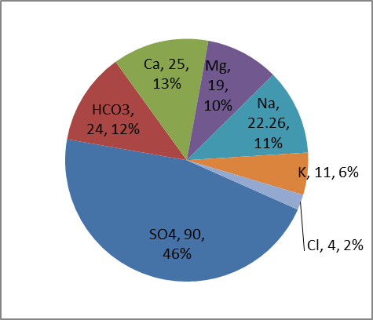

The improvement in the other dissolved solid parameters provides confirmation the modified construction techniques positively affected the discharge values below the Pine Creek Valley Fill #1.
In addition to establishing new BMPs for valley fill construction, a compensatory mitigation plan was developed to offset the impacts of the mining operation. The mitigation included the restoration of approximately 3,800’ of adjacent stream channel, the construction of three (3) stream crossings, and the installation of five (5) bio-filters. The bio-filters are designed to reduce specific conductivity levels in the stream during low flow conditions.
Benthic and water chemistry sampling and analysis have been conducted at several locations above and below the project area. Results of the sampling program have been mixed at best. Conductivity levels have decreased over the life of the project, indicating a successful outcome of the in-stream mitigation and the revised construction techniques. However, the results of the biological sampling have not shown a corresponding improvement. West Virginia Stream Condition Index (WVSCI) scores have declined nearly 20% from pre-disturbance values. Prior to mining, the benthic monitoring site located at the mouth of Left Fork of Pine Creek had WVSCI score of 76.36 during the Spring, 2010 sampling. The WVSCI score for the same site declined to 61.64 for Summer, 2012 sampling. The results of the monitoring would indicate that there is not a direct causal relationship between conductivity and the WVSCI score.

