**Passive Treatment of Coal-mine Drainage by a**

**Sulfate-reducing Bioreactor in the Illinois Coal Basin**

By: P. T. Behum, L. Lefticariu, E. Walter and R. Kiser

**Introduction**

Passive treatment, a technology pioneered to treat coal mine drainage in Appalachia (Hedin et al., 1994), has also been used to mediate environmental impacts of abandoned coal mine drainage in the Midwestern U.S. (Behum et al., 2002, 2010 and 2012). A major shortfall of the passive remediation technologies is the inability of providing long-term (>10 year) treatment of acid mine drainage (AMD) with high metal and in particular high aluminum contents (Al >20 mg/L). Premature passive treatment failure has been attributed to plugging by precipitates, dissolution of available carbonate minerals, and exhaustion of the organic carbon source (Thomas and Romanek, 2002; Neculita et al., 2008a and 2008b). However, one passive technology, sulfate-reducing bioreactors, has showed promise for treating this high aluminum, high acidity drainage (Behum, 2012; Behum et al., 2011). Sulfate-reducing bioreactors are similar in construction to a successive alkalinity producing systems (SAPS). The SAPS technology has been widely used in remediation of coal mine AMD in Appalachia (Kepler and McCleary, 1994). Bioreactors provide an environment in which organic carbon, as represented by CH2O, is oxidized to bicarbonate (HCO3-) and sulfate (SO42-) is reduced to hydrogen sulfide, H2S(aq). Bicarbonate is available to react with H+, decreasing the acidity in the system; dissolution of limestone included in the bioreactor adds to the bicarbonate alkalinity. H2S readily dissolves in water and combines with divalent metals (Me), such as Fe, Ni, and Zn, to form sulfide mineral precipitates (MeS). Additional metal removal can occur: (1) during biologically-mediated precipitation of metal oxyhydroxide in the oxidized zone (at a low pH where abiotic precipitation is unlikely); Thomas and Romanek, 2002; Burgos et al., 2008), and (2) by adsorption onto clay minerals and organic matter (Evangelou, 1998).

**Site Description**

Tab-Simco is an abandoned coal mine located southeast of Carbondale in Jackson County, Illinois. Underground mining of the Murphysboro and Mt. Rorah coal beds of the Pennsylvanian age Spoon Formation occurred between 1890 and 1955; surface coal mining affected the area in the 1960’s and 1970’s. A series of exploratory drill holes have delineated an acidic mine pool within the abandoned underground mine workings. AMD seeps from this mine pool at a rate of about 35,000 gallons per day, which resulted in a significant aquatic impact on nearby Sycamore Creek. Prior to treatment the largest, a 1.2 LPS (19 GPM) discharge, had a pH = 2.4, dissolved Fe = 422 mg/L, dissolved Al = 147 mg/L, dissolved Mn = 31.4 mg/L, SO42- = 2,370 mg/L, and total acidity = 1,816 mg/L CCE (all median values). This discharge flowed across small floodplain and created a 3.65-ha (9-acre) area “kill zone” devoid of vegetation (Fig. 1; Smith, 2002). Natural processes within this “kill zone” resulted in attenuation of metals and SO42-. For example, Fe was lowered to 196.3 mg/L, which represents a 53.5% reduction; Al was reduced to 124.4 mg/L, a 15.4% reduction; and, SO42- was reduced to 1,834 mg/L, a 22.6% reduction (Behum et al., 2011, 2012). Nevertheless, low pH (2.48) metal laden water effluent still had a negative impact on the receiving stream, Sycamore Creek. Baseline studies showed that downstream of the “kill zone”, the discharge was characterized by a pH = 2.92 mg/L, total Fe = 10.0 mg/L, total Al = 18.4 mg/L and total Mn = 33.8 mg/L (median values).

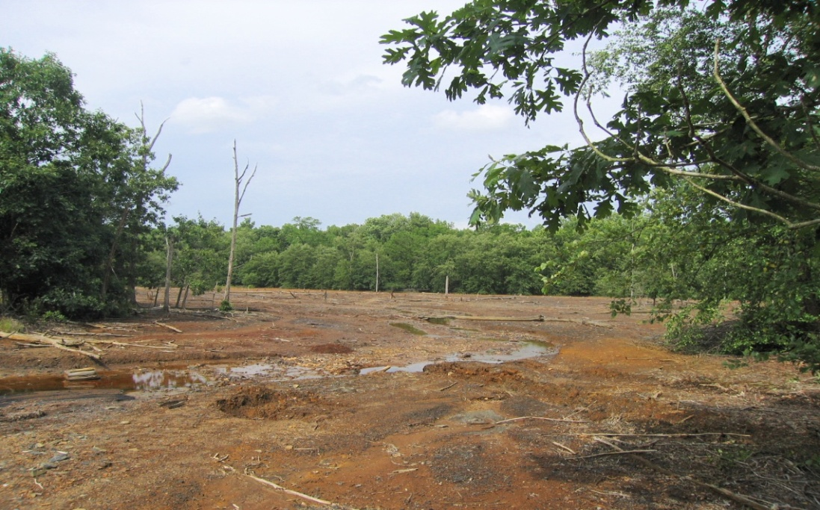

Figure 1. The Tab-Simco "kill zone" in 2006 prior to treatment system construction.

**Passive Treatment System Construction**

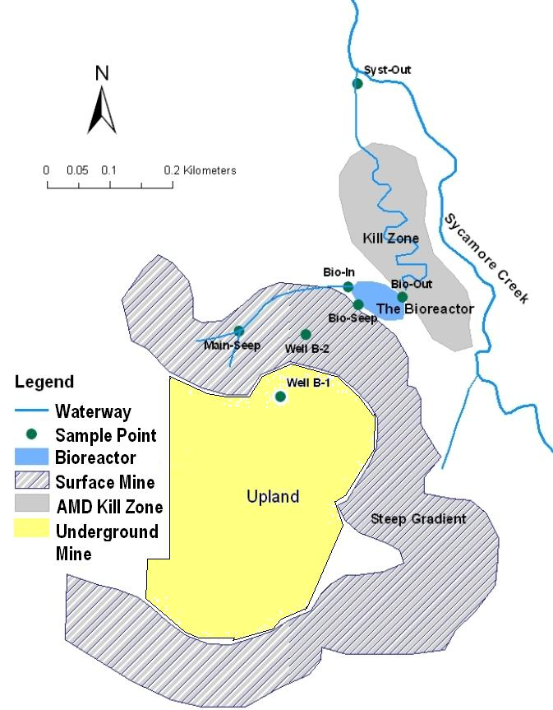The Illinois Department of Natural Resources, Office of Mines and Minerals (IDNR-OMM) constructed a passive-type treatment system in 2007 to abate the pollution caused by the largest of the mine’s AMD seeps (Main Seep, Fig. 2; Segid, 2010; Behum et al., 2011, 2012). The principle technology employed was a 0.3-ha (0.75-acre) sulfate-reducing bioreactor, which was one of the first full scale bioreactor employed for the treatment of acidic, coal mine drainage in the US. This bioreactor was constructed in three layers: a shallow (0.3 m deep) acid impoundment, an underlying thick (1.8 m) layer of compost, a geotextile fabric, and finally a 0.3 m-thick limestone layer with embedded drain pipes (Figs. 3-5). The organic substrate was composed of approximately 5,887 m3 (7,700 cubic yards) of “compost,” a blend of (by volume): 53% wood chips, 27% straw, 11% seasoned municipal (yard waste) compost and 9% agricultural ground limestone (Figs. 3 and 4). A series of oxidation cells/surface-flow wetlands follow the bioreactor unit constructed to allow for the precipitation of the remaining metals before the treated water discharges into Sycamore Creek (Fig. 5).

Figure 2. Overview of the Tab-Simco Treatment System, Illinois (Segid et. al., 2010).

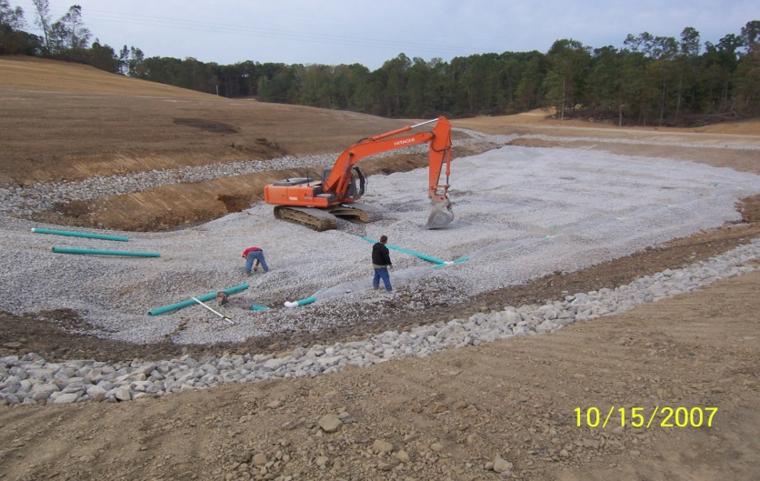

Figure 3. Construction of the Tab-Simco bioreactor cell: limestone-bedded underdrain.

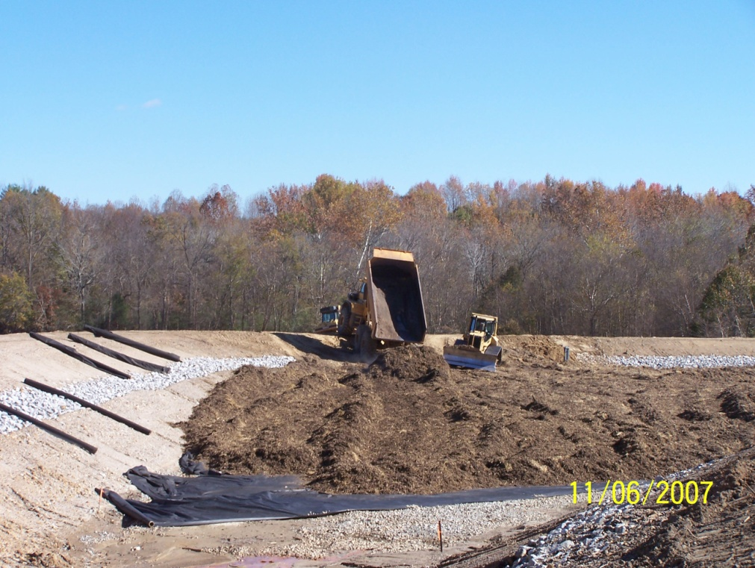

Figure 4. Construction of the Tab-Simco Bioreactor Cell: placement of the compost layer.

Currently, the Tab-Simco system treats a 1.35 LPS (21.5 GPM) coal mine discharge with a high Fe and Al content (Table 1; Smith, 2002; Segid, 2010; Behum et al., 2011, 2012). Following the 2007 construction, about 50% of the inlet AMD was captured by a collection ditch (Bioreactor In) with the remainder seeping directly into the cell from a series of small seeps (Bioreactor Seep); more extensive data collected for nearby monitoring well B-2 are used as a proxy for chemistry of Bioreactor Seeps (Figs. 2 and 3, Table 1).

**Table 1 – Median Geochemical Data for the Tab-Simco Treatment System, Illinois (2008-2011)\***

|  |  |  |  |  |  |  |  |  |  |
| --- | --- | --- | --- | --- | --- | --- | --- | --- | --- |
| **Site ID** | **pH** | **D. Fe** | **D. Mn** | **D. Al** | **D. Ni** | **D. Zn** | **Acidity** | **Alk.** | **SO4** |
| Main Seep | 2.83 | 654.2 | 38.4 | 173.5 | 2.25 | 2.87 | 2,551 | 0 | 3,563 |
| Well B-2 | 2.85 | 287.3 | 34.6 | 98.2 | 1.33 | 1.92 | 1,306 | 0 | 2,373 |
| Bioreactor In | 2.93 | 606.5 | 39.3 | 147.1 | 2.48 | 2.64 | 2,213 | 0 | 3,913 |
| Bioreactor in/ Well B-2 mix | 2.89 | 446.9 | 37.0 | 122.7 | 1.91 | 2.28 | 1,760 | 0 | 3,143 |
| Bioreactor Out | 6.34 | 113.0 | 32.5 | 0.85 | 0.07 | 0.12 | 275.8 | 289 | 2,099 |
| System Out | 5.79 | 6.80 | 24.6 | 0.96 | 0.16 | 0.25 | 71.0 | 27.3 | 1,691 |

*All values except pH are in mg/L; acidity and alkalinity (Alk.) are calcium carbonate equivalent values; acidity = calculated acidity; average pH for Bioreactor In/B-2 Mix calculated using [H+] values.

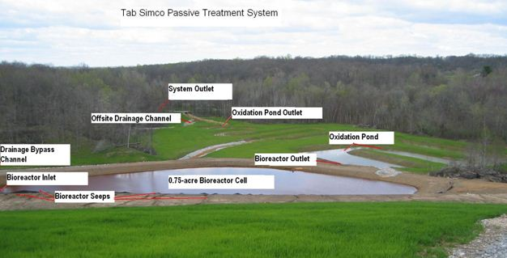

Figure 5. Overview looking north of the Tab-Simco passive treatment system in March 2008.

In a bioreactor system design, the cumulative divalent metal removal rate of the inlet AMD must be equal or less than the rate of SO42- removal by the bacterial sulfate reduction (BSR) process for a high level of metal removal (except for Mn) as monosulfides. However, most field installations are designed for metal removal instead of sulfate removal. Limited performance data is available from pilot-and full-scale bioreactors treating coal mine drainage to serve as a guide for design of new treatment systems (URS Corp., 2003). Designs are typically set by increasing the volume of the organic substrate to limit the sulfate or metal loading (mass/unit time) that is applied to the treatment cell. Gusek (2002) suggests a design goal a SO42- loading of 0.30 moles/m3/day. Therefore, in a 24 hour period AMD containing no more than a total of 24 grams of SO42- would pass through each cubic meter of organic substrate. However, researchers with the URS Corp (2003) recommend a relatively low cumulative heavy metal load value of 0.15 moles/m3/day. Due to the geotechnical constraints of the site, the Tab-Simco bioreactor component has a higher SO42- and metal loading than these design goals with a SO42- loading of 0.66 moles/m3/day and a cumulative metal loading (excluding Mn) of 0.26 moles/m3/day (Table 2). The Tab-Simco bioreactor is undersized, a design shortcoming that may potentially impact the longevity of the system.

**Sampling and Analysis**

The research team has conducted quarterly water quality measurements and sample collection since 2005 by IDNR-OMM with assistance from the Office of Surface Mining Reclamation and Enforcement (OSMRE) and Southern Illinois University Carbondale (SIUC). Details of field and laboratory methods were described by Behum et al. (2011). In brief, field parameter measured include pH, temperature, specific conductance, oxidation-reduction potential (ORP), and dissolved oxygen by electrochemical methods. Field laboratory tests include total and dissolved ferrous Fe by colorimetric methods and field alkalinity for samples with a pH more than 4.5 using the Hach micropipette method (Hach Company, 2002).

All analytical tests have been performed at IDNR, OSMRE and SIUC laboratories (Table 1). Metals analyses are by a combination of ion couple plasma (ICP) and Hitachi (Schaumburg, IL) Z-2000 Polarized Zeeman atomic absorption (AA) mass spectrometry and colorimetric methods following Standard Methods; major anions have been determined by ion chromatography (IC), colorimetric, and gravimetric methods. The stable isotope ratios of sulfur of the dissolved SO42- were measured at Indiana University using a Finnigan MAT 252 mass spectrometer equipped with an elemental analyzer. Sulfide and chemical oxygen demand (COD) analysis are conducted by colorimetric methods using a Hach DR 2800 spectrophotometer.

**Results**

Between January2008 and October 2011, important geochemical trends have been measured at the Tab-Simco site. Acidity of the AMD has dropped from a median of 1,760 mg/L CCE in the bioreactor inlet to 275.8 mg/L CCE in the cell’s discharge, an 84.3% improvement; SO42- has decreased by 33.2% at the bioreactor outlet to 2,099 mg/L (Fig. 8). During this period metal removal by the Tab-Simco bioreactor cell has averaged 74.7% for Fe, 99.3% for Al, 96.3% for Ni and 94.7% for Zn (Table 1). Over this time period the discharge from the follow-up oxidation pond and surface flow wetland has a median pH of 6.34 and is net alkaline (100.2 mg/L CCE; Table 1). The following water quality improvements have been recorded between 2008 and 2011 at the inlet AMD to the system outlet: (1) acidity has dropped from a median 1,760 to 71 mg/L CCE, a 96% improvement (Table 1), (2) SO42- has decreased by 43.4% (from a median of 3,143 to 1,691 mg/L), and (3) a cumulative dissolved metal removal of 99.7% (Table 2). Pollutant removal rates based on mass calculations in Table 2 are a more accurate because mass-based calculations account for variations in flow.

**Table 2 - Median Loading (2007-2011) and Removal Rates: Tab-Simco Passive Treatment System \***

|  |  |  |  |  |  |  |  |
| --- | --- | --- | --- | --- | --- | --- | --- |
| **Site ID** | **D. Fe** | **D. Al** | **D. Mn** | **D. Ni** | **D. Zn** | **Cumulative Metals** | **SO4** |
| Bioreactor Loading* Rate(moles/m3/day) | 0.160 | 0.091 | 0.0140 | 0.0005 | 0.0006 | 0.260 | 0.658 |
| Bioreactor Removal Rate(moles/m3/day) | 0.122 | 0.090 | 0.0018 | 0.0005 | 0.0006 | 0.214 | 0.202 |
| Removal (%) | 72.9 | 99.3 | 13.2 | 98.6 | 96.2 | 82.3 | 30.7 |
| Wetland Cell Load Rate(moles/m2/day) | 0.1477 | 0.0833 | 0.0127 | 0.0005 | 0.0006 | 0.2321 | 0.6139 |
| Wet. Cell Removal Rate(moles/m2/day) | 0.1208 | 0.0832 | 0.0018 | 0.0005 | 0.0006 | 0.2051 | 0.1868 |
| Cum. Removal (%) | 99.9 | 99.4 | 36.1 | 89.8 | 90.8 | 99.7 | 43.4 |

*Bioreactor inlet channel and B2 mix; All values except pH are in mg/L; acidity and alkalinity are calcium carbonate equivalent values; acidity = calculated non-manganese acidity.

**Discussion**

During the first 4-years of operation of the Tab-Simco system the high net acidity of the inlet AMD (median = 3,143 mg/L CCE; Table 1) is lowered by HCO3- alkalinity generated by the SO42- reduction reaction and carbonate dissolution. However, the trend acidity values at the bioreactor outlet have not been constant throughout this period. The median acidity during system start-up period (2008 and 2009) was 244.1 mg/L CCE at the bioreactor outlet. This increased to 545.4 mg/L CCE (median 2010 and 2011). Conversely, the bioreactor outlet alkalinity decreased from 340 mg/L CCE (median 2008 and 2009) to 159.2 mg/L CCE (median 2010 and 2011). The increase of bioreactor discharge acidity is paralleled by an increase of dissolved Fe in the bioreactor discharge (2008 to 2009 median = 75.0 mg/L; 2010-2011 median = 174.1 mg/L). This increase may be due to: (1) a loss of available organic matter adsorption sites (Evangelou, 1998), (2) a decrease in retention time due to the reduction of compost pore space as a result of accumulation of metal precipitates and compaction, and 3) a decrease in the rate of BSR processes.

Between 2008 and 2011 SO42- removal rate measured at the Tab-Simco system is 0.20 moles/m3/day, a value slightly lower than the optimal rates suggested by comparable bench- and pilot-scale studies (Gusek, 2002; URS Corp, 2003; Table 2). This may be due to the fact that the system is somewhat undersized. A 2009 study by the SIUC research team found that the average δ34S value of the SO42- in the untreated Tab-Simco AMD was 7.3 ‰; this value was similar to the δ34S values of the pyrite in the coal seams, indicating that pyrite was the source of the inlet SO42- (Segid, 2010). The δ34S value of SO42- increased in the bioreactor from an average value of 6.9‰ (inlet) to 9.2‰ (outlet), suggesting that BSR processes were ongoing (Segid, 2010). Geochemical analyses have showed a small seasonal variation in SO42- removal rates with the seasons, with average values of 33.0% in the cooler months (October-March) and 38.6% in the warmer months (April – September).

Our experience with bioreactor applications has suggested that during the initial period operation (< 4-yr.) most metals except Mn are retained within the bioreactor (Segid, 2010; Behum et al., 2011, 2012). This is consistent with published research that has shown that divalent metals such as ferrous Fe, Ni, Zn and Co are mostly retained as sulfides (e.g., Neculita et al., 2008b). Under the pH conditions of the bioreactor (pH > 4.5) dissolved Al is removed to a low level (0.85 mg/L). Aluminum is likely to be either precipitated as aluminum hydroxides or oxysulfates (Gusek, 2002; Thomas and Romanek, 2002). Between 2007 and 2011, an estimated 14.6 metric tons of Fe and 5.2 metric tons of Al are retained in the bioreactor annually. Considerable dissolved Fe may discharge from bioreactors where loading is high (Table 1). However, due to the high alkalinity and favorable pH of a fully functional bioreactor, the remaining dissolved Fe will rapidly precipitate whenever adequate oxidation structures are constructed following the bioreactor cell. Although the bioreactor cell discharge contained a median of 128.0 mg/L dissolved Fe, in follow up oxidation cells subsequent Fe precipitation occurs as Fe(III) sulfate and oxide-hydroxide minerals (Fig. 3), resulting in a decrease of dissolved Fe concentration in the system discharge to 6.8 mg/L (median values), an overall 98.5% Fe removal rate.

**Conclusions and Future Research**

Between the end of 2007 and 2011, the Tab-Simco system has effectively treated AMD of a quality that heretofore has been difficult to treat by passive methods due to the high acidity and aluminum content. During this period operation of the Tab-Simco treatment system has significantly reduced pollutant loads to of Sycamore Creek. Operational issues include plugging of the bioreactor discharge with ferruginous precipitates, seepage of untreated AMD into the “fresh” water bypass channel and the development of an 8-inch layer of precipitates on the bioreactor compost layer surface. System operational problems and the existence of an untreated AMD seep upstream have periodically impacted receiving stream water quality. A steep decline in bioreactor performance was observed in 2012 that is being investigated by SIUC under an OSM research cooperative agreement to support the 2013 maintenance efforts by IDNR-OMM. Additional research is needed to characterize the fate of metal precipitates within the Tab-Simco bioreactor. For example, Fe can be removed as Fe sulfate and oxyhydroxide precipitates in the upper oxidized zone, whereas the lower anoxic (sulfidic) zone Fe is removed as sulfide mineral precipitates. Additional SIUC research in 2013 will include solid phase analyses of mineral precipitates and biological diversity assessments to investigate the geochemistry and microbiology to provide insight into both the depletion of organic matter and armoring and clogging of substrate material by precipitated metal oxides, sulfates, and sulfides, conditions which will greatly affect performance and longevity.

**References Cited**

Behum, P.T., (2012) Passive treatment of low pH high aluminum acid mine drainage: A critical review of sulfate reducing technology, In: Effects of abandoned mine land reclamation on ground and surface water quality: Research and case histories from Indiana, Indiana Geol. Survey, Comer, J.C. (ed.), Special Pub. 72, pp. 325-351.

Behum, P.T., Jr., Kim, K., Garnett, K.W., Meier, L., Glascock, A., Mueller, M., and Phillips, M. (2002) Rehabilitation of the Old Bevier passive treatment wetland, Macon County, Missouri, In: Proceedings of the 24th Annual National Association of Abandoned Mine Land Programs Conference, September 15-18, 2002, Park City, Utah, 21 p.

Behum, P.T., Hause, D.R., Stacy, M.A., and Branam, T.D. (2010) Passive treatment of high volume, net acidic mine drainage: The Enos Reclamation Project, Indiana, In: Effects of abandoned mine land reclamation on ground and surface water quality: Research and case histories from Indiana, Indiana Geol. Survey, Comer, J.C. (ed.), Special Pub. 72, pp. 165-186.

Behum, P.T., Lefticariu L., Bender, K.S., Lewis, L., Segid, Y.T., Burns, A.S., and Pugh, C.C., (2012) Passive treatment of coalmine drainage by a sulfate-reducing bioreactor: A case study from the Illinois coal basin, USA. In: Proc., of the 9th International Conf. on Acid Rock Drainage (ICARD) May 20 - 25, 2012, Ottawa, Can.

Behum, P.T., Lefticariu L., Segid, Y.T., Bender, K.S., Pugh, C.C., Burns, A.S. (2011) Remediation of coalmine drainage by a sulfate-reducing bioreactor: A case study from the Illinois coal basin, USA. Applied Geochemistry, Vol. 26, No. 1, pp. 162-166.

Burgos, W.D., Senko, J.M., and Bruns, M.A. (2008) Low-pH Fe (II) oxidation incorporated into passive treatment, Project number PA DEP_AMD 42(0420)102, Pennsylvania State University, In: Proc. of the West Virginia Surface Mine Drainage Task Force, 164 p. <http://www.wvmdtaskforce.com/proceedings/08/Burgos.doc>, accessed February 8, 2013.

Evangelou, V.P. (1998) Environmental Soil and Water Chemistry, John Wiley and Sons, Inc, New York, NY, 564 p.

Gusek, J.J. (2002) Sulfate-reducing bioreactor design and operating issues: Is this the passive treatment technology for your mine drainage? In: Proc. of the 2002 National Meeting of the American Society of Mining and Reclamation, Sept 15-18, 2002, Park City, Utah.

Kepler, D.A. and McCleary, E.C. (1994) Successive alkalinity producing systems (SAPS) for the treatment of acidic mine drainage, In: Proc. Of the International Land Reclamation and Mine Drainage Conference and the 3rd International Conference of the Abatement of Acidic Drainage, April 1994, Pittsburgh, PA, pp. 195-204.

Neculita, C.M., Zagury, G.J., Bussière, B. (2008a) Effectiveness of sulfate-reducing passive bioreactors for treating highly contaminated acid mine drainage, Part I: Effect of hydraulic retention time, Applied Geochem., Vol. 23, pp. 3442-3451.

Neculita, C.M., Zagury, G.J., Bussière, B. (2008b) Effectiveness of sulfate-reducing passive bioreactors for treating highly contaminated acid mine drainage: Part II. Metal removal mechanisms and potential mobility, Applied Geochemistry, Vol. 23, pp. 3545-3560.

Segid, Y.T. (2010) Evaluation of the Tab-Simco Acid Mine Drainage Treatment System: Water Chemistry, Performance and Treatment process, Master of Science Thesis 5-1-2010, Southern Illinois University Carbondale, <http://opensiuc.lib.siu.edu/theses/203/>, accessed February 8, 2013.

Smith, P.A. (2002) Characterization of an acid mine drainage site in Southern Illinois, In: Proc. of the 2002 National Meeting of the American Society of Mining and Reclamation, Lexington, Kentucky, June 9-13, 2002, pp. 472-486.

Thomas, R. C. and Romanek, C. S. (2002) Passive Treatment of low-pH, ferric-iron dominated acid rock drainage in a vertical flow wetland II: Metal removal, In: Proc. of the 19th Annual Meeting, American Society of Mining and Reclamation, Lexington, Kentucky, June 9-13, pp. 753-775.

URS Corp (2003), Passive and semi-active treatment of acid rock drainage from metal mines – state of the practice: Final Draft Report, U.S. Army Corps of Engineers, April 2, 2003.