Reclamation of Marcellus Shale Drilling Sites in West Virginia
by
Jeff Skousen and Paul Ziemkiewicz
West Virginia University

Introduction

The rapidly developing boom in natural gas drilling into the Marcellus Shale in the Appalachian Region is the biggest economic and environmental event in the 21st Century. An estimated 100 to 500 trillion cubic feet of natural gas is trapped in the tiny pores of the Marcellus Shale. The U.S. uses about 20 trillion cubic feet of natural gas each year. Hydraulic fracturing (or hydrofracking) is the process of injecting fluids under high pressure into shale layers, thereby creating small fractures and allowing the natural gas to be released and extracted.

Hydraulic fracturing has been used by the oil and gas industry since the 1940s. Combined with more recently developed horizontal drilling techniques, it has made the region’s shale deposits economical for gas production. Hydraulic fracturing creates fissures, or fractures, in underground formations to allow trapped natural gas to flow into cracks where the gas can be collected. The Marcellus Shale natural gas deposits are located at depths of 3,000 feet in Ohio dipping to more than 9,000 feet in depth eastward near the Virginia border, and the average depth of Marcellus Shale wells in West Virginia is 5,300 feet. The Marcellus Shale layer varies from between 50 to 100 feet in thickness so it is important to locate and map the formation for accurate drilling.
In the drilling process, bore holes of 6 to 8 inches in diameter are vertically drilled down into the earth’s crust to the depth of the Marcellus Shale layer. About 500 feet above the shale layer, the bore hole is slanted or curved so that the bore hole gradually becomes horizontal when it reaches the shale formation (Figures 1 and 2). Drilling continues for up to 3,000 feet horizontally through the shale. Steel casing is linked together and passed down through the bore hole. After the casing is in place, the section in the Marcellus formation is perforated. Once the bore hole has been drilled and cased, water, sand and a mixture of chemicals are pumped down the well at high pressure to exit at the perforations and create fissures in the shale. The sand fills the fissures so that when the pressure is released the fissures remain open to permit the flow of gas to the well. The gas pushes the water back out of the well and they are separated at the surface. The gas is then collected for transport. After the initial pumping of flow back water, the well can supply natural gas with much lower levels of flow back water. Most of the flow back water comes to the surface about three weeks after the initial frac. Low volumes of water are then “produced” along with gas during the production stage.

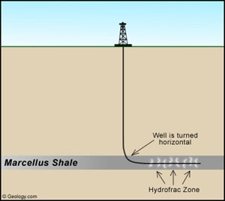
Figure 1. A simplified diagram of the horizontal drilling and hydrofracking procedure to capture natural gas contained in the Marcellus Shale (image courtesy of Brad Cole, Geology.com).

Landowners should become familiar with laws governing permitting requirements, pad site development, disposal of drill cuttings, water usage and wastewater disposal, gas withdrawal, road construction and maintenance, company access and royalties for natural gas withdrawn from wells near or on their property.

Environmental Concerns

Land

To drill a new Marcellus Shale natural gas well, the operator must obtain a well permit from the West Virginia Department of Environmental Protection and post a bond. The bond amount is $5,000. The company must provide maps showing the location of the well and proximity to other features like
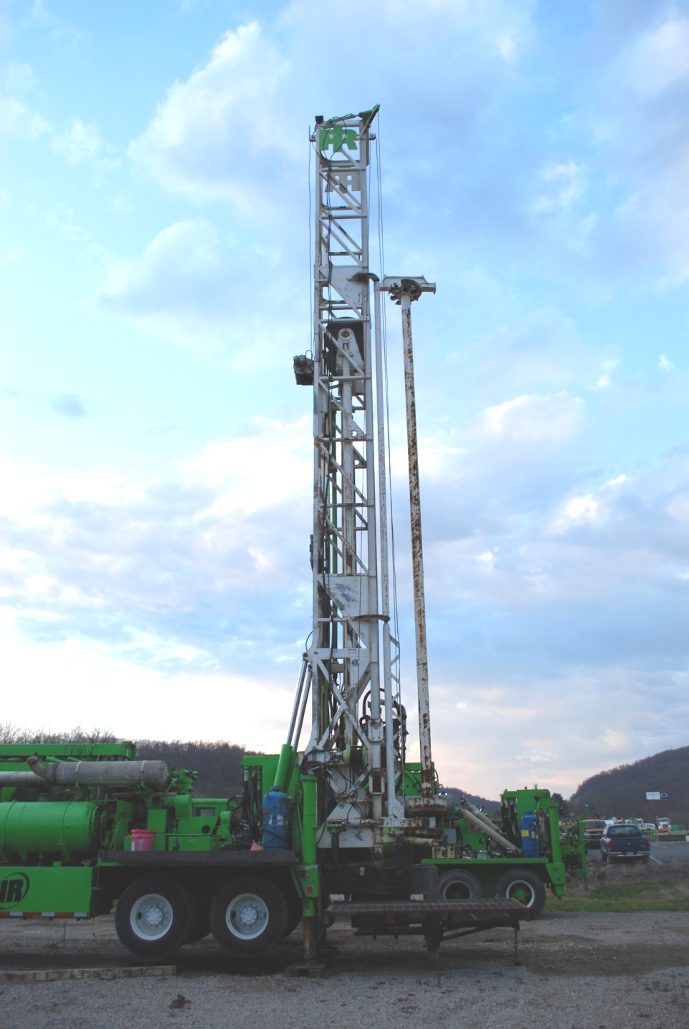
Figure 2. A Marcellus drill rig which is used to bore a vertical and horizontal well.

coal seams, houses and other structures, surface water locations like streams and rivers, and water supplies including ground water wells. Gas well drilling involves constructing roads, clearing and leveling land, and installing drilling pads and pipelines. Drilling pads may range in size from two to four acres and erosion control strategies must be in place to control erosion and sedimentation on the site. Site plans require gas companies to use preventative measures such as Best Management Practices to restore the site, including re-applying topsoil, and vegetation must be established within nine months of well completion by planting grass, trees or crops (Figure 3). The practices should
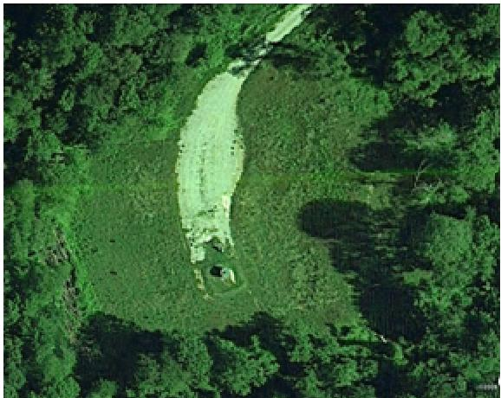
Figure 3. Reclaimed Marcellus drill site showing access road, well head and condensate tank.

minimize discharge of water from the drilling pad to surface waters and preserve the quality of streams and protect ground water supplies.

Water

Drilling and fracing a vertical Marcellus Shale gas well requires about 100,000 gallons of water. A typical horizontal well, on the other hand, takes between 2 and 6 million gallons of water. These water requirements, while large, are only one-time events and temporary. The water to conduct these activities can come from a variety of sources including nearby streams, rivers, and lakes. The water is often transported to the drilling sites in tanker trucks and stored on site in tanks or impoundments. The drilling company must identify where they plan to obtain and store the water during drilling operations. During drilling, water and drill cuttings are deposited into small ponds (Figure 4). Since the drill cuttings typically contain brine, plastic liners are
Figure 4. A holding pond lined with a plastic material to store drill cuttings and water at a Marcellus well site.

required to protect streams and groundwater. In addition, the landowner should request testing to ensure that toxic compounds or radioactivity, if present, are handled properly. The drill cuttings settle out in the ponds and the fluids can be reused in the drilling operation.

What is injected into the ground? Ninety nine percent of frac fluid is water. The other one percent is composed of sand and small amounts of other additives such as acids, gels, surfactants and corrosion inhibitors. The drilling operator must identify where the returned frac water (flow back water) will be stored, treated and disposed.
Wastewater must be recycled and reused, or collected and treated at a licensed wastewater treatment facility. The frac water initially contains little salt but it usually dissolves salts in the Marcellus formation and returns to the surface as brine. About 10 to 30% of the injected water returns to the surface. The remainder stays in the formation.
While it is unlikely that recycling returned frac water will eliminate all of the waste disposal problem, it has many benefits. Recycling reduces the amount of truck traffic needed to haul waste water away from the drill site and it reduces demands on fresh water supplies and the trucking needed to bring that water to the site.

Once the drilling is completed and the injected fluid returns to the surface, gas production begins and low volumes of very saline “produced water” are collected and periodically hauled away. Produced water can be disposed of by underground injection into permitted wells or it might be taken to a licensed treatment facility (Figure 5). The quality of the water may dictate the treatment and disposal options.

Figure 5. An underground injection well into which frac waters can be disposed.

What is in returned frac water? Returned frac water (RFW) contains both inorganic compounds like salts and metals as well as organic compounds like natural gas liquids and oils. Table 1 shows a typical range of inorganic concentrations in RFW. The wide range in salt content often reflects the stage in well development when the sample was taken. At the early stages after fracing, most of the RFW is the injected water and as that volume decreases, more salty water dominates, resulting in a decrease in flow but an increase in saltiness (Figure 6).

Table 1. Chemical analysis of five returned frac waters (RFW). All values other than pH are in mg/L. TDS is total dissolved solids, a measure of the salt content. TSS is suspended solids and O&G is oil and grease.
 | RFW 4 | RFW 5 | RFW 3 | RFW 2 | RFW 1
Total Dissolved Solids (TDS) | 189,000 | 104,000 | 38.7 | 12.61 | 8.8
Total Suspended Solids (TSS) | 519 | 570 | 99 | 220 | 44
Chlorine | 107,000 | 65,000 | 17,100 | 7,172 | 6,575
Sodium (Na) | 48,100 | 33.7 | 8,560 | 2,863 | 3,550
Calcium (Ca) | 22,200 | 12,800 | 1,640 | 1,749 | 319
Magnesium (Mg) | 2,000 | 1,470 | 193 | 122 | 31
Strontium (Sr) | 2,970 | 1,440 | 301 | nd | nd
Potassium (K) | 668 | 444 | 243 | 57 | nd
Sulfate (SO₄) | 49 | 414 | 28 | 71 | 99
Barium (Ba) | 1,300 | 176 | 175 | nd | 27
Iron (Fe) | 48 | 30 | 37 | 27 | 37
pH | 6 | 6 | 7 | 6 | 8
Oil & Grease | 3 | nd | 5 | 49 | 5

Figure 6. After completion of fracing, flow back of water to the surface is initially high but decreases rapidly. At the same time, salt concentrations increase.

