Aeration of Mine Water Using a TROMPE
B. R. Leavitt, PE, PG
Abstract: Mine water aeration is needed at most mine drainage treatment facilities to oxidize ferrous iron or to remove dissolved carbon dioxide. Through the years, this needed aeration has been accomplished using surface diffusion, cascade aeration, mechanical aeration, or in some cases oxidation has been accomplished using a chemical reagent such as hydrogen peroxide. Using the ancient technology of the TROMPE it is now possible to achieve passively, the benefits of mechanical aeration without the need for electricity, motors, or any moving parts.
A TROMPE was designed and installed at the Curley passive treatment facility in Fayette County Pennsylvania. Water from Pond 3 was transferred through the TROMPE to Pond Four. Compressed air generated by the trompe was used to aerate the raw water raising the dissolved oxygen (DO) of the water by nearly 3 milligrams per liter. The effect of this aeration was to increase the oxidized iron from 54.7% to 66.0% at the end of Pond two, and from 87.9% to 97.2% at the end of Pond three.

Introduction
Oxygen
Mine Drainage treatment frequently requires aeration as a key component of the treatment process. Whenever ferrous iron is present, oxygen must be added so that the ferrous iron can be converted to ferric iron for precipitation. The equation:
Fe²⁺ + ¼ O₂ + H⁺ → Fe³⁺ + ½ H₂O (1)
is familiar to most mine drainage practitioners.
Aeration during mine drainage treatment is accomplished using several general methods. These include: oxygen diffusion through the water air interface; cascade aeration, including stair step aerators, trough aerators, and rock cascades; and mechanical , including low and high speed surface aerators, compressed air diffusers, fountains, and venturi devices. In some cases oxygen may be generated in situ by biological processes where carbon dioxide is consumed and oxygen is generated.
Passive treatment systems have had to rely on diffusion or cascade techniques to add oxygen to the process. Diffusion is a slow process that requires considerable pond surface area and cascade techniques require an elevation change which may not be present at the desired location within the treatment system. Because of these constraints passive systems have been designed around an iron removal rate of 20 g m⁻² day⁻¹. Kirby et. al. 2007, modeled the effect of rapid oxidation and concluded that active aeration could reduce the area required for iron oxidation to ten percent of the area predicted using the 20 g m⁻² day⁻¹ criteria. It must be noted that the 20 g m⁻² day⁻¹criteria includes both iron oxidation and precipitation whereas the Kirby model only predicts iron oxidation.

Carbon Dioxide
Mine drainage from underground mines frequently contains excess carbon dioxide. The effect of this excess carbon dioxide is to lower the pH of the raw water. Aeration of mine water will remove the excess carbon dioxide and could increase pH (Kirby et al., 2009). Removing carbon dioxide before the addition of caustic chemicals reduces the amount of alkalinity required to treat the mine water (Jageman et al., 1988). Equation (2) shows the relationship of pH, represented by hydrogen ion, to carbon dioxide gas. The equation is reversible, dependent on the atmospheric carbon dioxide partial pressure relative to the
H⁺ + HCO₃⁻ ↔ H₂O + CO₂ (g) (2)
dissolved carbon dioxide in the water. This process can be time dependent. Aeration of a 500 ml water sample from T&T mine required 40 minutes to stabilize (Leavitt, 2010) but the pH during this aeration rose from 6.41 to 8.00 standard units. Figure 1 shows this relationship. Note that the bulk of the pH change occurred between 12 and 28 minutes.

Figure 1. Effect of aeration on pH
Iron Oxidation
The rate of iron oxidation is pH dependent. Consequently, removal of CO₂ can accelerate iron oxidation. Figure 2 shows the significance of this dependence. Dietz, 2008 states “Between pH 5 and 8 the oxidation rate doubles for every 0.15 pH increase.” Applying this doubling rate to the T&T aeration test, we find that aerating the water would increase the iron oxidation rate by a factor greater than 1000.
With regard to CO₂ treatment, Kirby and Cravotta, 2005 state:
If a solution to be treated reaches the surface laden with CO₂ the CO₂ will degas sufficiently rapidly and lose most of this CO₂ derived acidity within the treatment systems open to the atmosphere. In this way, the CO₂ derived acidity is ephemeral and does not require treatment.
While this statement is true, it assumes that the change in pH at the end of the treatment process is the only consideration. Removal of the dissolved CO₂ and realizing the pH gain early in the treatment process will enhance the ferrous iron oxidation rate. This has the potential to reduce the pond size that would be constructed to provide the residence time needed for iron oxidation.

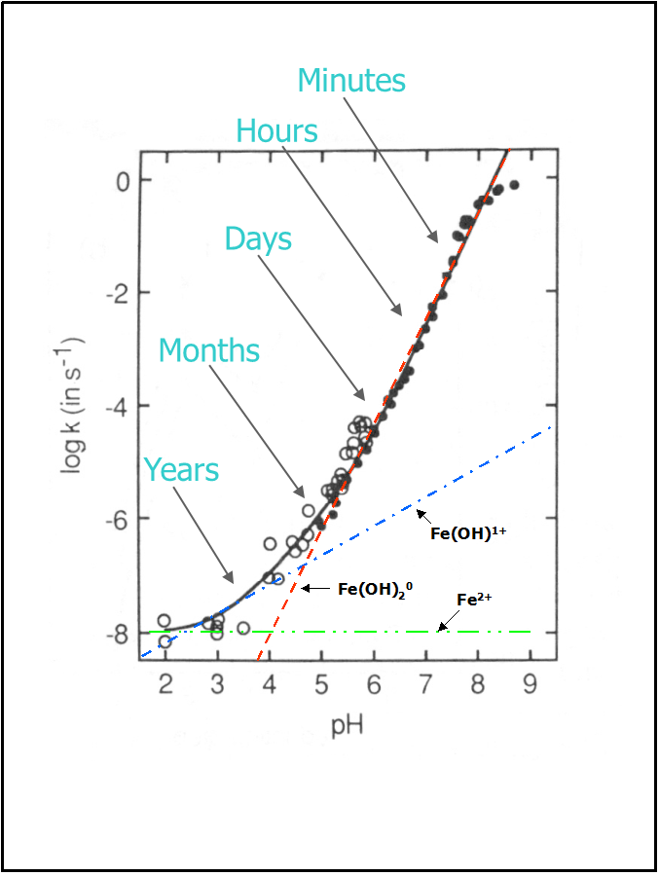
Figure 2. Iron oxidation rate vs. pH after Dietz 2008.
TROMPE Background

A trompe is a device that uses falling water to compress air. Water is allowed to fall down a vertical pipe, the velocity of the water in the pipe is high enough that air is entrained and carried down the pipe along with the water. A chamber, below the discharge elevation, separates the air from the water and the water is allowed to discharge. The compressed air is then available for use. The TROMPE contains no moving parts.
This concept was an integral part of the Catalan Forge developed in the 17th century. In Figure 3 water falling down the pipe carries air that is separated in the air box. Air thus compressed was directed to the forge replacing the bellows.
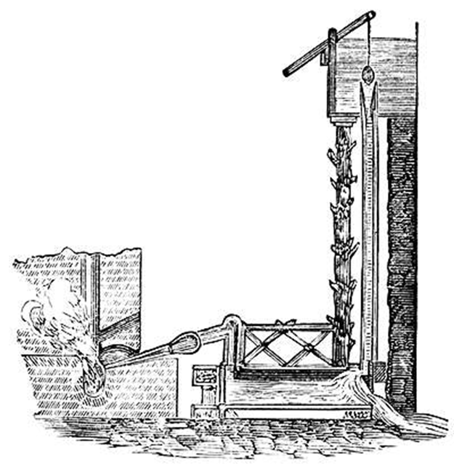
Figure 3. Catalan Forge
During the late 19th and early 20th century the TROMPE reached its zenith. Mr. Charles Havelock Taylor rediscovered the working principle of a trompe independently. In 1896 he built a compressor at Magog, Québec to supply compressed air to a cotton mill. This method of air compression became quite well known at the time and Mr. Taylor built a number of trompe style compressors in the United States (Washington, Michigan, Connecticut), Canada, Peru, and Germany. These compressors became so associated with Mr. Taylor that they became known as Taylor Compressors. In 1910, Mr. Taylor designed and built a compressor called Ragged Chute near Cobalt, Ontario, Canada. Figure 4 is a diagram of the Ragged Chute facility. This unit was in nearly continuous operation from 1910 until the intake heads were destroyed by fire in the 1980’s. The compressed air generated at Ragged Chute was used to operate rock drills in the area mines. The Ragged Chute design is in many ways similar to the compressor at Victoria, a copper mine in Michigan’s Upper Peninsula, but three times the capacity.
Measurements were made on the Victoria Mine compressor. Based on these data, the Victoria compressor was able to compress as much as 11,930 cubic feet of free air per minute to 128 psi at an efficiency of 82.3 percent.

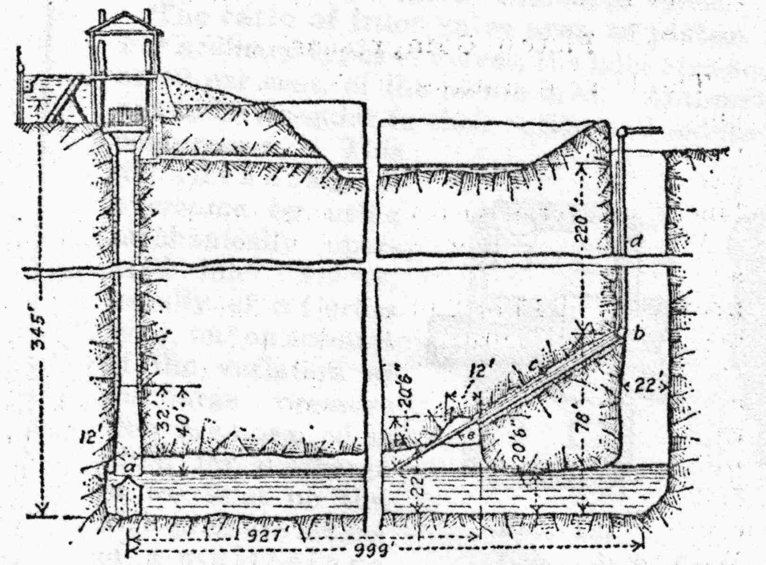
Figure 4. Ragged Chute compressor design
Curley Site
The Curley site is a net alkaline discharge resulting from surface mining on the Waynesburg coal seam. Flow, measured by the bucket and stop watch method, averages 54 gallons per minute (gpm) with a range of 31 to 100 gpm. A passive treatment system was constructed consisting of four ponds. Water enters at the point labeled C-RAW in figure 5. The raw water falls from the discharge pipe into a small plunge pool. At the end of the first pond there in a small cascade. Between Pond 2 and Pond 3 there is a limestone cascade about 6 feet in height. A corrugated culvert carries the water from Pond 3 to Pond 4 where it falls into a plunge pool.
The Curley raw water is strongly net alkaline. Alkalinities range from 425 to 450 mg/l with significant quantities of calcium and magnesium. Table 1 contains selected data from the raw water analysis.

Table 1 Curley Raw Data
Site | Date | EC | Al  total | Ca  total | Mg  total | Fe  total | Fe  dissolved | Mn  total
CURLEY RAW | 1/18/2011 | 3399 | 0.0177 | 486.2 | 276.9 | 21.59 | 22.04 | 10.13
CURLEY RAW | 1/26/2011 | 3584 | 0.02 | 508.5 | 296.1 | 23.7 | 22.66 | 10.85
CURLEY RAW | 2/26/2011 | 3815 | 0.02 | 500.4 | 286.0 | 25.47 | 25.89 | 11.57

Figure 5. Curley site
TROMPE Installation
Based on the average flow of 54 gpm a vertical pipe diameter of three inches was selected. Water from the end of Pond 3 is conveyed through the embankment to the top of the TROMPE in a six inch diameter PVC feeder pipe. A Tee was placed on the intake end of the pipe to minimize debris in the system, Figure 6. Water, from the feeder pipe, flows into the TROMPE, Figure 7. The TROMPE can be buried so that most of the device is below ground, Figures 8 & 9. The depth of burial is subject to site conditions and the required air pressure to be generated. In Figure 10, the piping is checked for plumb, and the trench is backfilled. Figure 11 shows the TROMPE in operation.
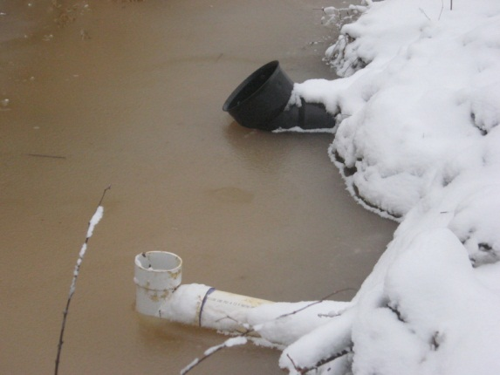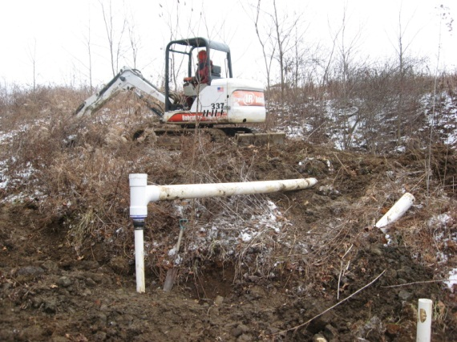
Figure 6. Tee on feeder pipe. Figure 7. Feeder pipe to top of TROMPE

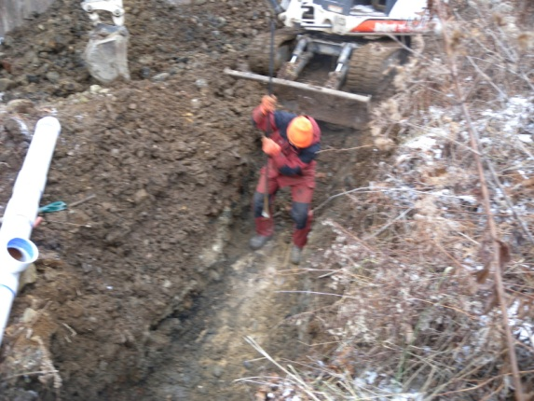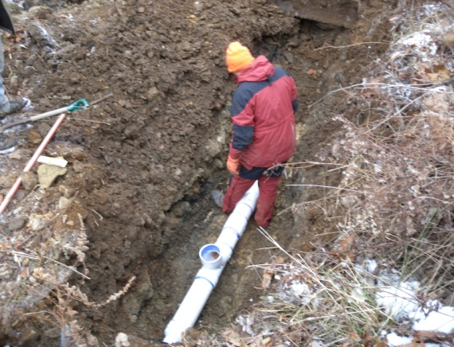
Figure 8. Limited depth in trench Figure 9. Air separator in trench
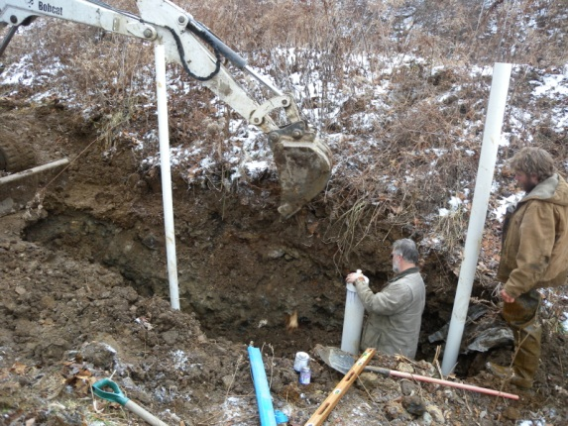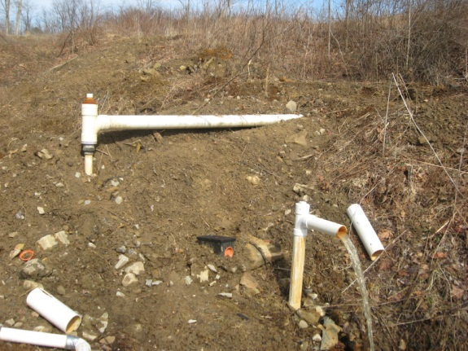
Figure 10. Inlet, outlet and air receiver. Figure 11. TROMPE in operation.
The amount of pressure generated by a TROMPE is dependent on the length of the return leg. The amount of pressure required for aeration is equal to the depth of submergence of the diffuser, the back pressure of the diffuser, and line losses in the air pipe. The amount of air generated is roughly 1 CFM per 25 gpm. This will vary depending on system efficiency and the amount of driving head. Smaller diameter TROMPEs are less efficient.
The Curley site was equipped with two nine inch fine bubble disc diffusers. Figure 12 shows these diffusers mounted to a paving stone. The diffusers are set in about three feet of water, and are connected to the TROMPE by a one inch diameter air line. The amount of oxygen transfer is proportional to the depth of submergence and inversely proportional to bubble size. Consequently, a fine bubble diffuser deeply set is the most efficient configuration. However, the deeper the diffuser the deeper the TROMPE must be set. This limits aeration diffuser depth to the excavation depth for the TROMPE. The amount of oxygen transferred to the mine water is thus a combination of air volume, bubble size, and depth of the diffuser.
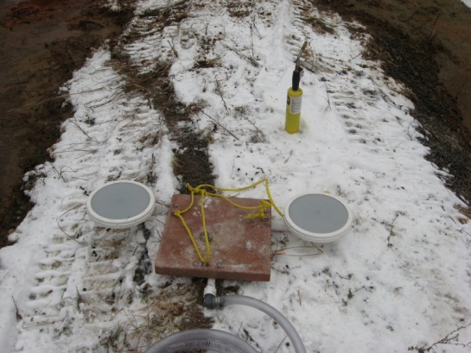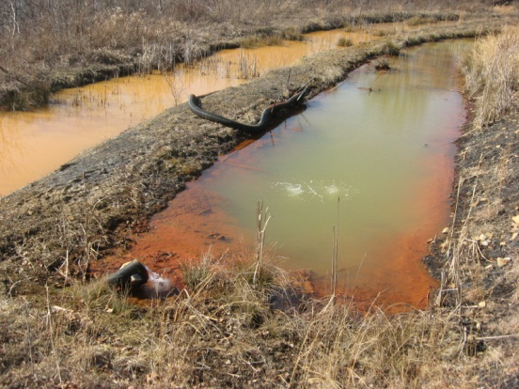
Figure 12. Nine inch fine bubble diffuser. Figure 13. Pond 1 and Pond 2.
In Figure 13. the air bubbles are visible in the center of the photograph. The raw water enters the pond from the black pipe in the lower left of the upper pond. With the aeration operating iron oxidation is taking place earlier in the treatment system.
A TROMPE can use water from any appropriate point in the treatment process, or any other available water source. However, clean water from the final discharge would minimize iron deposition within the TROMPE and use of water from the treatment system will be proportional the system iron load. The compressed air that is generated in the TROMPE can be piped to any point in the treatment system.
Effect of Aeration at Curley
A bridge was built across Pond 1 25 feet downstream from the diffuser. DO measurments were made every 16 inches across the width of the pond at three different depths, near the water surface (2 inches), at a depth of seven inches, and just above the pond bottom with the aerator turned off and with the aerator in operation. The average of the DO measurments with the aerator off was 3.28 mg/l. With the aerator in operation the DO average was 6.21 mg/l. At this location, the pond bottom was visible when the aeration was not operating but obscured by cloudy (iron) water when the aerator was in operation.
Water samples were collected at four locations in the Curley treatment system. In addition, pH and DO were measured at nine locations within the system. Water quality samples were taken at the source (Raw sampling point), at the beginning of pond 2 (Pond 1 sampling point), the end of pond 2 (Pond 2 sampling point), and at the TROMPE inlet (Pond 3 sampling point). The pH and DO measurements were made at the source (raw), just after the plunge pool (upstream of the aerator), at the bridge about 25 feet downstream of the aerator, at the beginning (Pond 1 sampling point) and end of pond 2 (Pond 2 sampling point), at the bottom of broad rock-lined cascade at the beginning of Pond 3 (Base Cascade sampling point) at the TROMPE inlet (Pond 3 sampling point), the Trompe outlet, and the end of pond 4.
The water samples were analyzed for total and dissolved metals. The dissolved metal samples were field filtered with a 0.45 micron filter. Both total and dissolved samples were field acidified with nitric acid. Analysis was performed by Inductively Coupled Plasma (ICP) spectrometry.
At each sample location, dissolved iron was subtracted from the total raw iron and the difference was divided by the total raw iron to yield the percent of the raw iron that had been oxidized. This technique assumes that the raw iron concentration remains constant over the retention time of the treatment system. The raw iron data in Table 1 suggest a gradual increase in iron overtime but at a rate that would not invalidate this assumption. The percentage iron oxidized was calculated for both aerated and non-aerated conditions and the results are plotted in Figure 14. These data indicate that the percentage of iron oxidized at the end of Pond 2 increased from 54.7 percent to 66.0 percent on January 18 and to 71.2 percent on February 26. This is an 11.3 and 16.5 percent improvement respectively over the non-aerated case. At the end of Pond 3 the percent of iron oxidized was 87.9 percent without aeration and it was 97.2 and 97.5 percent oxidized with aeration. This represents an increase of 9.3 percent on January 18, and an increase of 9.6 percent on February 26 due to aeration.
Figure 14. Iron oxidation in the Curley treatment system
It should be noted that the February sampling had both a higher raw iron and a higher iron oxidation rate.
One possible explanation for the difference between the January and February aeration performance is that in January the TROMPE was operating at 36 gpm which is below the minimum design flow of 40 gpm. As a result, aeration was intermittent. In February, the flow at the TROMPE was 44 gpm and the TROMPE was operating continuously.
Iron settlement in the Curley system is shown in Figure 15. Aeration provided a significant increase in iron settlement in Pond 3 as compared to the non-aerated sample on January 26. In February, 63 percent of the iron had settled by the end of Pond 3 compared to 37.2 percent in the non-aerated case.

Figure 15. Iron settled in the Curley treatment system
Field measurements of pH and DO with the aerator in operation (Figures 16 & 17) show that the pH rises rapidly in the first two ponds to about 7.5 and then it rises gradually to 7.7 at the system discharge. This suggests that carbon dioxide is being exsolved throughout the treatment process. Even though the pH is not rising significantly, it is continuing to rise while 26 percent of the iron in the raw water is still oxidizing and releasing acidity.
The TROMPE added nearly three mg/l of oxygen to the raw water over and above the existing oxygen transfer in Pond one. This amount of oxygen from the TROMPE is sufficient to oxidize 82 to 97 percent of the iron present in the raw sample. When this is combined with the natural aeration of the system, there is more than sufficient oxygen in the water to fully oxidize the iron load 25 feet downstream of the aerator in Pond One. The reason this oxidation does not occur until the end of Pond 3 is attributed to the control that pH exerts on iron oxidation as shown in Figure 2. In turn, the pH is controlled by the dissolved carbon dioxide. This suggests the need for additional aeration to drive off the CO₂ and increase the pH earlier in the treatment process.
Figure 16. Curley pH with aeration on. Figure 17. Curley DO with aeration on.

Conclusions
A TROMPE was successfully designed and installed at the Curley passive treatment system. The TROMPE is providing aeration to the raw water and has increased the DO level at the bridge from 3.28 to 6.21 mg/l. This has resulted in an 11 to 16 percent increase in iron oxidation at the end of Pond 2 and a 97.3 to 97.5 percent level of iron oxidation compared to 87.9 percent iron oxidation level without TROMPE aeration. Sufficient oxygen is present in the water to fully oxidize the ferrous iron present. However, dissolved carbon dioxide is believed to be retarding the rate of iron oxidation by keeping the pH below the level it would achieve if the carbon dioxide were in equilibrium with the atmospheric carbon dioxide partial pressure. The amount of iron settled increased significantly as a result of aeration, particularly in pond 3.
Aeration has not removed all of the carbon dioxide dissolved in the mine water. This is currently delaying iron oxidation in the treatment system. Installation of a second TROMPE aerator is recommended.
Acknowledgement
The author gratefully acknowledges the commitment and assistance of BioMost, Inc. in providing access to the Curley site and investing in this new technology. Without their enthusiastic support, this project would not be possible. A particular thanks is given to Tim Danehy who loves the smell of PVC glue in January, Bryan Page who will willingly wade into any pond, and Cody (Buck) Neely who just loves to help get the iron out.
References
Dietz, J. 2008. Aeration Approaches and Activated Iron Solids (AIS) for AMD Treatment: 2008 Pennsylvania Abandoned Mine Reclamation and Coal Mining Heritage Conference. http://www.treatminewater.com/2008/Presentations.html#141
Jageman, T.C., Yokley, R.A., and Heunisch, H.E. 1988. The Use of Preaeration to Reduce the Cost of Neutralizing Acid Mine Drainage: U.S. Bureau of Mines Information Circular IC 9183, p. 131-135.
Kirby, C.S., and Cravotta III, C.A., 2005. Net Alkalinity and Net Acidity 2: Practical Considerations: Applied Geochemistry,20:1941-1964
Kirby, C.S., Dennis, A., and Kahler, A. 2009. Aeration to Degas CO₂, Increase pH, and Increase Iron Oxidation Rates for Efficient Treatment of Net Alkaline Mine Drainage: Applied Geochemistry, 24:1175-1184.
Leavitt, B.R., 2010. In Situ Treatment with Hydrogen Peroxide: 2010 West Virginia Mine Drainage Task Force Symposium. Morgantown, West Virginia.

Patent Pending
Consulting Hydrogeologist 2776 S-Bridge Rd Washington, Pa. 15301

