Using AMDTreat and PHREEQC Titration Module for Prediction of Effluent Quality and Sludge Quantity
C.A. Cravotta III¹, D.L. Parkhurst², B.P. Means³, R.M. McKenzie⁴, W. Arthur⁵

¹U.S. Geological Survey, 215 Limekiln Rd., New Cumberland PA 17070 cravotta@usgs.gov
²U.S. Geological Survey, P.O. Box 25046, MS 413, Lakewood CO 80225-0046 dlpark@usgs.gov
³U.S. Office of Surface Mining, 415 Market Street, Harrisburg PA 17101 bmeans@osmre.gov
⁴U.S. Office of Surface Mining, 3 Parkway Center, Pittsburgh PA 15220 rmckenzie@osmre.gov
⁵U.S. Office of Surface Mining, 2875 Regency Rd., Lexington KY 40503 barthur@osmre.gov

Abstract
The AMDTreat computer program (http://amd.osmre.gov/) is widely used to compute costs for treatment of coal-mine drainage. Although AMDTreat can use results of titration with industrial chemicals to accurately compute costs for treatment of net-acidic or net-alkaline mine drainage, such empirical data are rarely available. To improve the capability of AMDTreat to estimate (1) the quantity and cost of caustic chemicals to attain a target pH, (2) the chemistry of treated effluent, and (3) the volume of sludge produced by the treatment, a titration simulation is being developed using the geochemical program PHREEQC (wwwbrr.cr.usgs.gov/projects/GWC_coupled/phreeqc/) that will be coupled to AMDTreat. The simulated titration results can be compared with or used in place of empirical titration data to estimate chemical quantities and costs. This paper describes the development, evaluation, and potential utilization of the PHREEQC titration module for AMDTreat.
Key words: caustic chemicals, active treatment, cost estimates, geochemical simulation, titration

Introduction
The incremental addition of caustic chemicals (NaOH, CaO, Ca(OH)₂, Na₂CO₃, and NH₃) to a metal-laden solution generally will increase pH; however, the amount of caustic needed to attain a target pH and the corresponding effluent composition and sludge volume can not be determined without empirical titration (dosing) data or the application of geochemical models to simulate titration with the caustic chemical(s). In addition to the precipitation of iron, manganese, and aluminum, compounds of magnesium (Mg(OH)₂) and, to a lesser extent, calcium (CaCO₃; Ca₆Al₂(SO₄)₃(OH)₁₂.26H₂O) may precipitate as the solution pH increases to alkaline values. The precipitation of such phases can consume substantial quantities of treatment chemicals and increase the quantity of sludge produced (Means and Hilton, 2004). Furthermore, the pH will not change linearly with each unit of chemical added because hydrolysis reactions with dissolved metals and CO₂ tend to buffer pH (Ott, 1988; Cravotta and Kirby, 2004).
The AMDTreat computer program is widely used to estimate costs for active and passive treatment of mine drainage (McKenzie, 2005). The treatment cost depends on the chemical used and increases with the quantities of chemical added and sludge produced. Although AMDTreat can use titration data to compute chemical costs for treatment of net-acidic or net-alkaline mine drainage, such data are rarely available. Typically, the amount of chemical to neutralize the effluent is assumed to equal the measured “hot” acidity or computed “net” acidity (Skousen et al., 2000; Cravotta and Kirby, 2004). However, for the same net acidity, the chemical requirement may differ for oxidized and unoxidized solutions. For net-alkaline effluent that may require active treatment to pH 10 to remove ferrous iron or manganese, AMDTreat wrongly assumes that no caustic chemicals and associated infrastructure would be needed and, thus, underestimates treatment cost. Furthermore, AMDTreat does not provide information on the potential quality of the effluent produced by the specified treatment.
This paper describes the development and potential utilization of a geochemical titration module for AMDTreat to estimate (1) the quantity and cost of selected caustic chemicals to attain a target pH, (2) the concentrations of dissolved metals in treated effluent, and (3) the volume of sludge produced by the treatment. Empirical and simulated titration data are presented as preliminary examples of this new method to refine cost estimates for chemical usage and sludge disposal.

Methods
Empirical titrations of acidic, metal-laden effluent from the “Cal Pike” coal-mine site in western Pennsylvania were conducted in the field to document effects of on-site chemical treatment. A Hach Digital Titrator® was used with a cartridge that had been filled with industrial strength liquid caustic (6.1 N NaOH = “20 %” NaOH). Filtered (0.45-μm pore size) effluent samples were collected to document changes in solute concentrations with treatment to different pH endpoints. Concentrations of major anions (SO₄²⁻, Cl⁻) were analyzed by ion chromatography, and concentrations of major cations (Ca, Mg) and selected trace metals (Fe, Mn, Al) in acidified subsamples were analyzed by inductively coupled plasma optical emission spectrometry at a commercial laboratory. The alkalinity and “hot peroxide” acidity (hot acidity) were titrated to pH of 4.5 and 8.3, respectively.
The data on pH and associated changes in concentrations of solutes resulting from the addition of caustic chemicals to the Cal Pike effluent were evaluated using the geochemical program PHREEQC (Parkhurst and Appelo, 1999). Titration simulations were developed using the initial chemistry of the effluent plus solubility data for compounds that could precipitate and control solute concentrations under equilibrium conditions. The pH was specified to increase incrementally, and the corresponding amount of chemical needed to attain that pH and the resulting solute concentrations and mineral saturation indices were computed. Temperature of 16 ºC, initial dissolved oxygen concentration of 0.5 mg/L, and redox speciation based on the H₂O/O₂ couple were specified for these computations.
AMDTreat 4.1c (U.S. Office of Surface Mining Reclamation and Enforcement, 2006) was used to estimate costs for the active treatment of the Cal Pike effluent with different caustic chemicals on the basis of the net-acidity and the PHREEQC titrations. To summarize the costs of chemicals for treatment to specified pH values, estimates of chemical purity, efficiency, and unit costs that are used as default values for these computations by AMDTreat were extracted for spreadsheet calculations. Costs also were estimated for sludge disposal. The quantity of sludge produced was estimated as the sum of unreacted caustic chemical, based on the efficiency factor, and the decrease in metals relative to initial concentrations. The metals were assumed to have precipitated as hydroxide or carbonate compounds (Fe(OH)₃, Al(OH)₃, Mn(OH)₂, Mg(OH)₂, CaCO₃).

Results and Discussion
The untreated Cal Pike effluent had pH of 2.8 and elevated concentrations of dissolved constituents (Fe = 44.1 mg/L; Al = 34.1 mg/L; Mn = 48.1 mg/L; Mg = 122.2 mg/L; Ca = 105.2 mg/L; SO₄ = 1505 mg/L). The measured hot acidity of 498+40 mg/L as CaCO₃ and computed net acidity of 456+20 mg/L as CaCO₃ were comparable to “cold” acidity of 343, 368, and 464 mg/L as CaCO₃ estimated by titration with liquid caustic (20 % NaOH) to pH of 7.0, 8.5, and 9.5, respectively (Fig. 1). General agreement among different estimates of acidity for the Cal Pike effluent implies that dissolved CO₂ was not an important source of acidity compared to contributions from dissolved metals and protons.
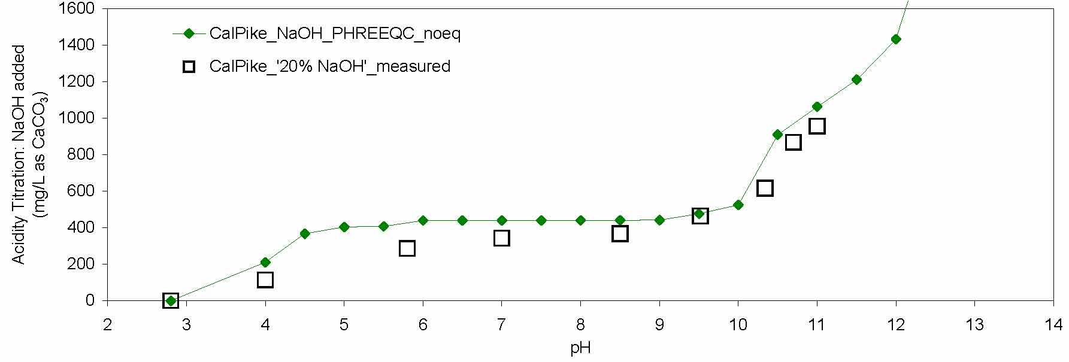
Figure 1. Data for titration of “Cal Pike” effluent with NaOH at 16 °C. Measured (open symbols) and simulated (filled symbols) values for amount of NaOH added, as CaCO₃ equivalent concentration, and corresponding pH. Measured titration used 20 % liquid caustic solution
The empirical and simulated titrations of the Cal Pike effluent with NaOH revealed characteristic pH buffering at pH of 3 to 5 and 9 to 12 (Fig. 1). Buffering at pH 3 to 5 has been interpreted to result from the formation of aqueous Fe³⁺ and Al³⁺ hydroxyl complexes and the consequent precipitation of ferric and aluminum hydroxide compounds (Ott, 1988; Cravotta and Kirby, 2004). Sharp decreases in the measured and simulated concentrations of iron and aluminum to values less than 0.1 mg/L as pH increased from 2.8 to 5 (Fig. 2) are consistent with solubility control by ferric and aluminum hydroxide compounds. Likewise, buffering at pH 9 to 11 can be interpreted to result from hydrolysis reactions involving Mn²⁺ and Mg²⁺ and the precipitation of pyrochroite (Mn(OH)₂) and brucite (Mg(OH)₂). At pH greater than 10, concentrations of Ca²⁺ also decreased (Fig. 2A, Table 1), which is consistent with solubility control by ettringite (Ca₆Al₂(SO₄)₃(OH)₁₂.26H₂O) (Fig. 2B). Precipitation of ettringite, gypsum (CaSO₄.2H₂O), schwertmannite (Fe₈O₈(OH)_{4.5}(SO₄)_{1.75}), and/or basaluminite (Al₄(OH)₁₀SO₄) also could account for decreases in the measured SO₄²⁻concentration (Fig. 2).
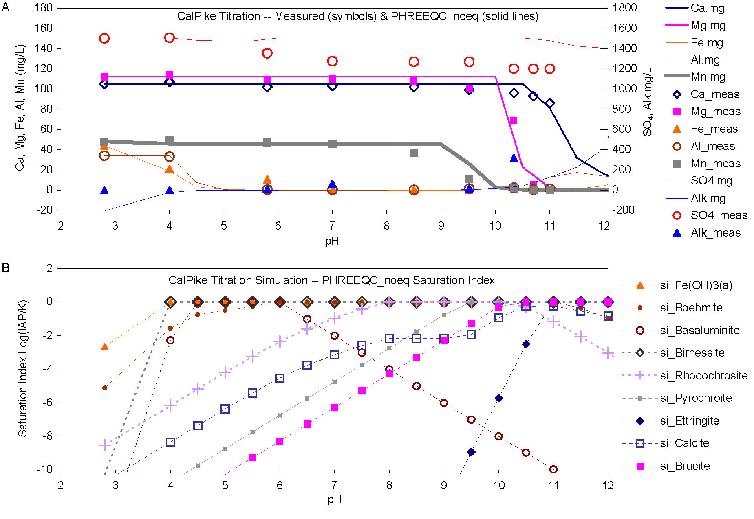Figure 2. A, Data for measured (symbols) and simulated (solid lines) titration of “Cal Pike” effluent with NaOH at 16 °C without gas exchange. B, Saturation indices for minerals and other solids as a function of pH for simulated solutions.
Nearly complete removal of iron without aeration at pH values less than 7 was simulated by the precipitation of Fe(OH)₃. Solubility control by this phase implies that iron was already in the ferric oxidation state. In contrast, negligible removal of manganese was observed at pH values less than 9 (Fig. 2A). The observed concentrations of manganese were approximately simulated without aeration by the precipitation of pyrochroite (Mn(OH)₂) (Fig. 2B). Simulated solute concentrations as a function of pH for scenarios without and with pre-aeration (oxidation) were similar among NaOH, ammonia (NH₃), hydrated lime (Ca(OH)₂), and quick lime (CaO) (Cravotta et al. 2010). However, simulated treatment with soda ash (Na₂CO₃) and other carbonate compounds produced different pH and concentration trends for divalent metals resulting from the precipitation of FeCO₃, MnCO₃, CaCO₃, and other carbonate minerals at near-neutral pH.
Given chemical consumption and sludge production estimates for specified pH endpoints, treatment costs were computed (Table 2). Although this paper shows results only for NaOH, costs can be evaluated for simulations with different chemicals and aeration scenarios (Cravotta et al., 2010). Users of AMDTreat may specify unit costs, chemical efficiency, and sludge density to vary estimates.
Table 1 Estimated quality of Cal Pike effluent treated with sodium hydroxide to specified pH, under conditions with no gas exchange with atmosphere
Solute conc. (mg/L) | pH | Treated to specified pH
Solute conc. (mg/L) | 2.8 | 6.0 | 6.5 | 7.0 | 7.5 | 8.0 | 8.5 | 9.0 | 9.5 | 10.0 | 10.5 | 11.0
Fe | 44.09 | 0.08 | 0.03 | 0.01 | 0.01 | 0.01 | 0.01 | 0.01 | 0.02 | 0.05 | 0.14 | 0.42
Al | 34.08 | 0.00 | 0.00 | 0.00 | 0.00 | 0.01 | 0.04 | 0.13 | 0.40 | 1.28 | 4.04 | 12.77
Mn | 48.10 | 45.80 | 45.80 | 45.80 | 45.80 | 45.69 | 45.32 | 45.21 | 26.65 | 2.79 | 0.33 | 0.04
Na | 200.4 | 402.7 | 402.8 | 402.9 | 402.9 | 403.0 | 403.3 | 403.6 | 419.9 | 442.0 | 618.8 | 689.1
Ca | 105.2 | 105.2 | 105.2 | 105.2 | 105.2 | 105.2 | 105.2 | 105.2 | 105.2 | 105.2 | 105.2 | 81.2
Mg | 112.2 | 112.2 | 112.2 | 112.2 | 112.2 | 112.2 | 112.2 | 112.2 | 112.2 | 112.2 | 22.7 | 2.4
SO₄ | 1505.1 | 1505.0 | 1505.0 | 1505.0 | 1505.0 | 1505.0 | 1505.0 | 1505.0 | 1505.0 | 1505.0 | 1505.0 | 1478.3
Alk | -206.8 | 0.1 | 0.4 | 0.5 | 0.7 | 0.7 | 0.7 | 1.7 | 4.9 | 14.5 | 41.8 | 127.1
Table 2. Estimated cost of sodium hydroxide for treating Cal Pike effluent to specified pH, under conditions with no gas exchange with atmosphere
Estimated quantity and cost  of chemical and sludge | Acid eq mg/L CaCO₃ | Treated to specified pH
Estimated quantity and cost  of chemical and sludge | Acid eq mg/L CaCO₃ | 6.0 | 6.5 | 7.0 | 7.5 | 8.0 | 8.5 | 9.0 | 9.5 | 10.0 | 10.5 | 11.0
Pure NaOH (g/L) | 0.36 | 0.35 | 0.35 | 0.35 | 0.35 | 0.35 | 0.35 | 0.35 | 0.38 | 0.42 | 0.73 | 0.85
Equivalent (g/L as CaCO3) | 0.46 | 0.44 | 0.44 | 0.44 | 0.44 | 0.44 | 0.44 | 0.44 | 0.48 | 0.53 | 0.91 | 1.06
Quantity (lb/1000 gal) |  | 2.96 | 2.96 | 2.96 | 2.96 | 2.96 | 2.97 | 2.97 | 3.21 | 3.54 | 6.12 | 7.15
Cost ($/1000 gal) |  | $1.06 | $1.06 | $1.06 | $1.06 | $1.06 | $1.07 | $1.07 | $1.15 | $1.27 | $2.20 | $2.56
Sludge (gal/1000 gal; 5%) |  | 14.13 | 14.14 | 14.14 | 14.14 | 14.15 | 14.19 | 14.18 | 16.40 | 19.12 | 35.03 | 41.34
Sludge cost ($/1000 gal) |  | $0.85 | $0.85 | $0.85 | $0.85 | $0.85 | $0.85 | $0.85 | $0.98 | $1.15 | $2.10 | $2.48

Conclusions
The simulated titration results and corresponding estimates of effluent quality and sludge volumes can be used to evaluate potential costs for treatment with different chemicals. After coupling the PHREEQC titration simulation as an add-in module to AMDTreat, titration simulations will indicate an approximate quantity of caustic chemicals to achieve specified pH values and the corresponding chemical concentrations in treated effluent. The user will be able to consider these results in place of empirical data for treatment with various caustic chemicals, and then specify the chemical type and quantity to achieve the desired pH in the active treatment screen of AMDTreat.

References
Cravotta CA III, Kirby CS (2004) Acidity and alkalinity in mine drainage--practical considerations, In 2004 National Meeting of the American Society of Mining and Reclamation. American Society of Mining and Reclamation, p. 334-365
Cravotta CA III, Parkhurst DL, Means B, McKenzie R, Morris H, Arthur W (2010) A geochemical module for “AMDTreat” to compute caustic quantity, effluent quality, and sludge volume, In 2010 National Meeting of the American Society of Mining and Reclamation, Pittsburgh, PA
Means B, Hilton T (2004) Comparison of three methods to measure acidity of coal-mine drainage, In 2004 National Meeting of the American Society of Mining and Reclamation. American Society of Mining and Reclamation, p. 1249-1277
Ott AN (1988) Dual acidity titration curves – Fingerprint, indicator of redox state, and estimator of iron and aluminum content of acid mine drainage and related waters. U.S. Geological Survey Water Supply Paper 2330, p. 19-33
Parkhurst DL, Appelo CAJ (1999) User’s guide to PHREEQC (Version 2)—A computer program for speciation, batch-reaction, one-dimensional transport, and inverse geochemical calculations. U.S. Geological Survey Water-Resources Investigations Report 99-4259, 310 p.
Skousen JG, Sextone A, Ziemkiewicz PF (2000) Acid mine drainage control and treatment, In Barnhisel RI, Daniels WL, Darmody RG (eds.) Reclamation of drastically disturbed lands. American Society of Agronomy Monograph 41, p. 131-168.
U.S. Office of Surface Mining Reclamation and Enforcement (2006) AMDTreat 4.1c. U.S. Office Surface Mining Reclamation and Enforcement (http://amd.osmre.gov).

