In Situ Field-Scale Treatment of Selenium-Bearing Spoil Units

Paul Ziemkiewicz, Jennifer Fulton, Raymond Lovett
West Virginia University and Shipshaper LLC
Morgantown, WV

Introduction

Developing an at source control method for selenium is of critical importance to the mining industry, regulatory agencies and the public. No other proven methods exist. Theoretically encapsulation would work but the lack of suitable barrier materials in the southern coalfields (the spoil is largely sandstone) makes this technique problematic in application. Other than encapsulation, there is no method for accomplishing at source selenium control. Ongoing laboratory weathering studies conducted at the National Mine Land Reclamation Center have indicated that commercially available ferrihydrite effectively sorbs selenium liberated by the weathering of organic shales. After 36 weeks of weathering and leaching, an application rate of 13% ferrihydrite has resulted in immobilization of 80% of the selenium produced by weathering selenium bearing coal refuse. These results are promising and indicate the need to investigate the potential to scale up the concept under field conditions. Figure 1 shows the performance of ferrihydrite in controlling selenium leaching. Patriot Coal, Inc. has indicated a willingness to participate in the project and the company will provide a field site, security, and test plot construction.

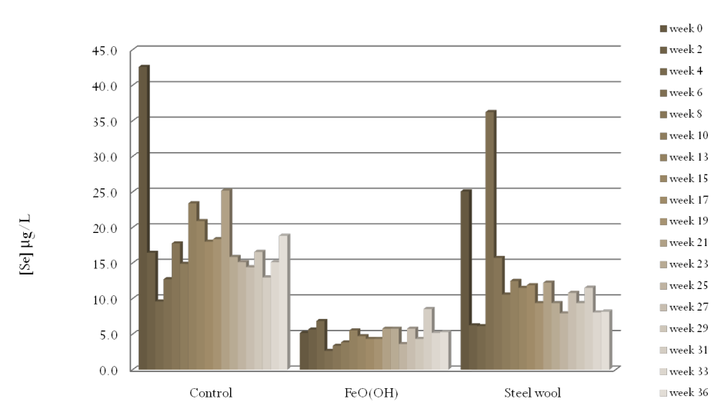
Figure 1. Results of leaching a selenium bearing refuse under controlled and treated conditions for 36 weeks. Treatments consisted of ferrihydrite FeO(OH) and zero valent iron (steel wool). All selenium concentrations were adjusted to reflect field leachate concentrations for both selenium and chloride.
Ferrihydrite can be obtained commercially as an expensive, reagent-grade product or as a byproduct from treatment of acid mine drainage. While desirable from the perspective of cost and availability, the latter may contain, in addition to ferrihydrite, substantial proportions of impurities such as gypsum, silicate, magnesium, manganese and aluminum hydroxides depending on raw water quality and treatment method. Scale up of ferrihydrite treatment for selenium control will require investigation of several sources of ferrihydrite to assess their effectiveness and ultimately handling options and application rates.
Objectives
This project will field test a method for using ferrihydrite to control selenium leaching from selenium bearing organic shale. Specifically, the project will:
- identify a laboratory screening method for identifying ferrihydrite sources
- identify ferrihydrite application rate necessary for selenium control
- develop a field demonstration of ferrihydrite to determine whether it is an effective method for at-source selenium control
- identify the selenium leaching rate under field conditions
Methods
The project will consist of two phases: 1) evaluation and selection of ferrihydrite sources and 2) experimental design including selection of treatment rates, handling methods, test plot design, test plot construction and monitoring. The project will take place over multiple years and will involve collaboration with an active mining operation. Planning will reflect the following task progression:
Task 1. Identify a laboratory screening method for identifying ferrihydrite sources.
The results in figure 1 indicate that weathering of selenium bearing organic shale/refuse initially yields the selenite oxyanion. Selenate on the other hand does not sorb to ferrihydrite and would not have been an effective treatment. Ferrihydrite can be obtained in nearly pure form from commercial suppliers or from AMD sludge. Commercial ferrihydrite is expensive but of known performance. AMD sludge varies widely in composition and, likely performance. This Ferrihydrite application is only practical, however if low cost, reliable supplies are available and if its performance can be evaluated prior to application.
This task will develop a laboratory method for evaluating ferrihydrite performance by applying the ferrihydrite samples to DI and mine water samples spiked with sodium selenite and determining the solution selenium concentration. Use of mine waters will determine interference with competing anions such as sulfate and chloride.

Task 2. Identify ferrihydrite application rate necessary for selenium control
Current laboratory testing has used a ferrihydrite application rate of 13% on a dry weight basis. This leaching study is in its 42nd week and results after 36 weeks indicate that about 16% of the selenium has been oxidized and leached. Those results will be followed and modeled to identify when selenium breakthrough occurs and those results will indicate an appropriate application rate for the field demonstration.
Task 3. Develop a field demonstration of ferrihydrite to determine whether it is an effective method for at-source selenium control
The results of tasks 1 and 2 will guide development of field trials. The nature of the field demonstration will also be a function of site conditions available containment options and materials availability. Containment under operating conditions would consist of large cells of selenium rich organic shale, perhaps multiples 100,000 cu yards each. They would likely be placed on the pit floor, treated with ferrihydrite either in layers or blended and finally compacted. They would then be covered with ROM spoil.
The demonstration plots would consist of controls and ferrihydrite treatments and would allow collection of leachate for regular sampling of ionic concentrations and discharge volume. It is expected that this process will consume the better part of a year with construction to take place by the end of year one.
Task 4. Identify the selenium leaching rate under field conditions
The selenium leaching rates will then be determined for all test cells and indicate the relationship between field and laboratory results. These results will indicate the longevity of selenium leaching and confirm the performance of ferrihydrite treatment. Volumetric sampling will also permit determination of each treatment cell’s mass ionic content initially and proportional leaching rate.
Progress to date
The laboratory leaching project has maintained selenium concentrations below 5 ug/L for over 60 weeks and on that basis, field lysimeters were installed at the Hobet 21 mine in Lincoln County, WV. These units were installed in the first half of March, 2010. Their construction and operation will be described.

