In Situ Treatment with hydrogen Peroxide
B. R. Leavitt, PE, PG¹
Abstract: Hydrogen peroxide is used to oxidize ferrous iron at some acid mine drainage (AMD) treatment plants. Its potential use for in situ treatment of net alkaline mine drainage is evaluated in this study. Mine maps were used to identify an entry in the T&T #2 mine that was believed to channel the entire flow from that mine. Two wells, one existing and one new, were used to inject 35 percent hydrogen peroxide into the mine. A pump installed in a third downstream well was used to observe the changes in water chemistry resulting from the peroxide addition. Raw mine water contained 32 to 47 mg/L of predominantly ferrous iron, had a field pH of 6.4, and a field alkalinity between 118 and 170 mg/L. Hydrogen peroxide addition, controlled by a peristaltic pump, was able to demonstrate a linear dose response in situ. The pH and ORP were measured during bench scale testing of the mine water and were shown to be predictive of the ferrous iron oxidation end point. These end points were observed in situ. Based on data from the bench testing the flow in the mine was calculated to be 2.61 l/s. The chemical cost of implementing this technology was calculated to be $0.174 per mg/L ferrous iron per 100,000 liters treated.
Introduction

Hydrogen peroxide is known to rapidly oxidize ferrous iron in mine drainage (American Public Health Association, 1998). The oxidized iron commonly precipitates as ferric hydroxide. The overall oxidation and hydrolysis reaction can result in a drop in pH. Equation (1), offered by US Peroxide, shows that alkalinity is consumed, but oxygen is not required for the reaction to proceed as is the case when ferrous iron is oxidized using aeration.
2 Fe²⁺ + H₂O₂ + 4 OH¯ → 2 Fe(OH)₃ (1)
In slow moving waters, such as those that would be encountered in a flooded mine entry, the precipitated iron is expected to settle relatively quickly. Use of hydrogen peroxide to precipitate iron from net alkaline mine water was demonstrated, at bench scale, at the Dogwood Lakes Treatment Plant (Ziemkiewicz, 2002). Additional bench scale testing by Ziemkiewicz (2004) showed that there was no detectable oxidation of pyrite in the subsurface mine due to the added hydrogen peroxide.
The chemistry of water emanating from below-drainage underground mines in the Pittsburgh coal seam has been shown to evolve from net acidic to net alkaline over time. Because of this evolution, as time passes there are increasing numbers of mine discharges that are net alkaline located in Pennsylvania and West Virginia. This net alkaline chemistry could be well suited for in situ reaction with hydrogen peroxide.
The successful application of hydrogen peroxide in in situ treatment is dependent on identifying points of concentrated flow in the underground mine. The ideal condition would be a point in the mine where all of the flow is concentrated in one or two entries. Examples of this condition can include: mine to mine transfers via entry or borehole; or restriction in the mine caused by internal barriers, mining conditions, or, in the case of older mines, water drainage entries.
This purpose of this project is to demonstrate the effectiveness of in situ hydrogen peroxide treatment under field conditions, and to use data gathered during the study to better understand the hydrology of the mine. Once the ability to treat and the flow conditions in the mine are established, then the cost effectiveness of in situ treatment using hydrogen peroxide can be established.
T&T Mine Complex
The T&T mine complex is composed of three mines in the Freeport coal located in Preston County West Virginia. These mines are T&T #2, T&T #3, and Ruthbelle. These three operations were mined independently but eventually they were connected at two key locations. Ruthbelle was the first of the three mines, its operation was conducted beginning in the 1940’s, and closed prior to 1977. In order to access additional coal reserves the T&T #2 mine drove a set of entries along the NE – SW strike just South East of the Ruthbelle mine, Figure 1. This corridor is two to four entries wide and about 1,800 meters in length. Water flows in this corridor from the T&T #2 mine to a discharge point along Muddy Creek. Along the corridor, about 600 meters from the main body of the T&T #2 mine; there is an interconnection between the Ruthbelle mine and the corridor. This connection allows water from Ruthbelle and from T&T #3 mines to join with the flow from T&T #2. From this point on the flow from all three mines is comingled to the discharge point along Muddy Creek. The three mines are roughly equal in size and in total represent about 1,500 acres of mining (Miller and Skiles, 1999). Mining ceased in 1993. In April 1994 a blowout occurred at the T&T #2 mine along Muddy Creek (Figure 1, mine discharge).
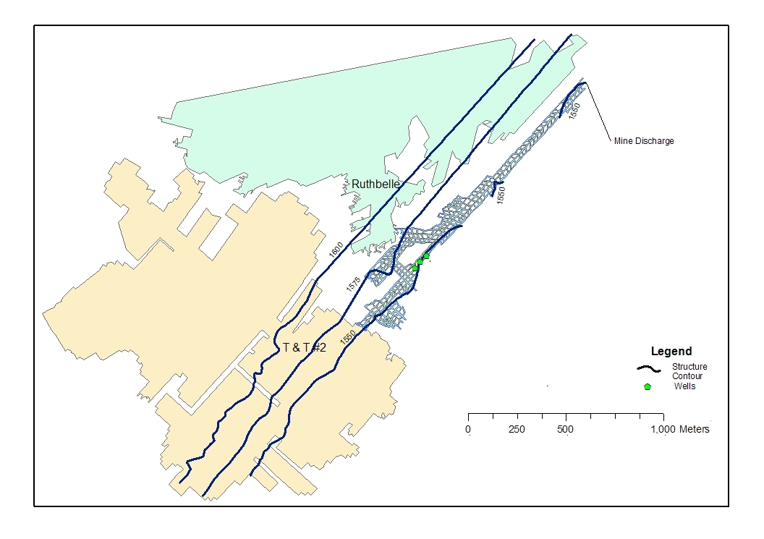
Figure 1. Position of T&T #2 and Ruthbelle relative to T&T #2 corridor.
In September, 1998 a consent decree was established between Coastal Coal, LLC and the West Virginia Department of Environmental Protection. Pursuant to this agreement Coastal Coal has injected over 72,575 metric tons (80,000 short tons) of limestone through a number of boreholes in an effort to neutralize the acidity in situ. A report on the effectiveness of this in situ treatment was issued in March 2002 (MWH, 2002). The analysis performed in this report documented a 20 percent reduction in acidity resulting from the limestone injection. In addition to limestone injection Coastal Coal, LLC took over the collection of water quality data from the WV DEP. One of the sampling sites included the T&T #2 pit mouth. Between the WV DEP and Coastal Coal a water quality data set has been created that spans from February 1996 to November 2001.
Water exiting the mine portal is treated by West Virginia DEP using anhydrous ammonia to raise the pH of the water. If needed, hydrogen peroxide is available on site to assist with ferrous iron oxidation, but it was not used during this field trial. Data collected in the period 1996-2001 have been averaged by year and are presented in Table 1. For comparison, raw water data from the current study (2009) are also presented. The current data are limited to just a few samples and are not as representative of the discharge as are the earlier data. From Table 1, it is evident that although the pH and the sulfate have not changed greatly, the acidity and the metals have shown significant reduction over time.
Table 1.
Livengood Test Site
The mine map of T&T #2 was studied to determine the point at which flow in the mine would be concentrated into a single entry, and where conditions on the surface would allow drilling access. Parameters considered in this analysis included the elevation of the existing mine discharge, the dip of the mine, the potential influence of the mine ventilation system, and water level information from open holes left by the Coastal project. A site was identified in a farmer’s field which had an old well from the Coastal project. The site is at the top of the hill and is nearly flat. Two wells were drilled, a two inch well was completed into the same mine entry as the Coastal well about 40.7 meters further into the mine (inby), the second well was completed as a four inch well in the same entry about 47.2 meters closer to the mine entrance than the Coastal well (outby). All of the test wells are located up gradient from the interconnection between Ruthbelle and the T&T #2 corridor. Figure 2 shows the relationship between the T&T #2 corridor and the Ruthbelle mine connection.
A shelter was established to house the hydrogen peroxide and to provide a location for field testing. Electric power was established to operate the sampling pump and the chemical injection pump. A variable speed peristaltic metering pump, STN-85MJL5A4S Stenner Series 85, was installed at the test site. A one half horsepower Grundfos pump was installed in the 4 inch well and water from this pump was sampled on May 10, 2009. Initially the pump produced cloudy water with some larger particles. Upon examination these particles were determined to be limestone. The presence of fine limestone in this well indicates that the Coastal well was used for limestone injection. In order to overcome the limestone sediment in the produced water, the pump was raised about one foot so that the pump intake was above the level of limestone in the well. Upon continued operation, the water produced from this well lost all of its turbidity. The water from this pump was piped overland to the test shelter a distance of about 88 meters. Pumping the water this distance resulted in a time delay of about 15 to 18 minutes from the time that the water entered the pump until it arrived at the testing station.
Initial water chemistry revealed that the T&T #2 water was significantly different from the water quality at the mine mouth. The T&T #2 water was net alkaline with a pH of 6.4 to 6.5, an average total iron content of 46.0 mg/L, an average dissolved iron content of 45.2 mg/L, and an average alkalinity of 133 mg/L as CaCO₃. This water quality, while unexpected at this location, is ideal for in situ hydrogen peroxide oxidation.
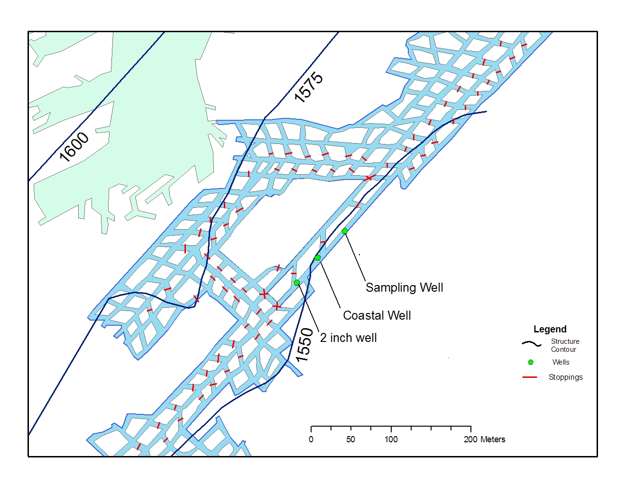
Figure 2. Well Locations in T&T #2 cooridor.
Hydrogen peroxide injection began into the two inch well at the rate of 8.5 ml/minute of 35% hydrogen peroxide while the water chemistry of the sampling well 100 meters downstream was monitored. Water pumped from the sampling well was combined with the hydrogen peroxide addition so that the concentration and hence the density of the hydrogen peroxide could be reduced. No significant changes in the mine water chemistry were observed over a three day period due to this injection. The injection rate was sequentially increased to 17 ml/minute, 25 ml/minute and ultimately 42 ml/minute over the next ten days without any observable effect on the mine water chemistry. At the end of this test it was clear that there is no connection between these two wells in the same entry 88 meters apart. Yet, the geometry of the mine required that any water exiting this mine had to flow past the downstream monitoring well.
The elevation of water in the three holes was measured to see if the pressure gradient was as expected. The elevations were 1551.79, 1551.57, and 1549.57 ft. msl from the two inch well, the Coastal well, and the sampling well, respectively. This indicates that there should be flow from the injection hole to the sampling hole. The mine map was reevaluated to see if there was an alternative flow path. A crosscut was observed 9.6 meters downstream from the injection well. This entry had the potential to be the source of the flow and if so it could leave the injection well isolated. This would be particularly true if there was an obstruction such as a stopping or a roof fall between the two. A test of this possibility would be to inject the hydrogen peroxide into the Coastal well and see if the iron oxidation reaction could be observed at the sampling well.
For a period of 13 days no injection took place to allow time for the previous peroxide injection to dissipate. During this time the Coastal well was refitted with a one inch PVC pipe to convey the peroxide to the mine. The existing hole did not have a casing or a liner and ground water inflow to this hole had resulted in iron hydroxide precipitation on the side of the hole. It was possible that the hydrogen peroxide could react with these iron deposits before it arrived in the mine pool. Installing the pipe eliminated this possibility.
Hydrogen peroxide injection was resumed on August 18. Table 2 contains the results of this initial test at the new location.
Table 2.
In less than 22 hours there was a clear response to the hydrogen peroxide injection. This confirmed that the initial injection well was not in the flow path. All of the field measurements confirmed the oxidation of ferrous iron in situ. The pH and alkalinity dropped and the DO and ORP increased. These data are believed to represent equilibrium conditions in the mine. Changes in DO and pH at the sampling well were observed in less than 1 hour following a change in hydrogen peroxide dose.
Bench Test
A 10-liter bench test was conducted at the test site to determine the amount of hydrogen peroxide required to fully oxidize the ferrous iron in the T&T #2 mine. Water was pumped from the mine at well three and measured using a graduated cylinder; the water was then placed in a five gallon bucket. The bucket was placed on a stir plate and a magnet was placed in the bucket to provide continuous stirring.
Thirty five percent hydrogen peroxide was diluted to 11.7 percent using two parts water to one part hydrogen peroxide. This dilution was used to provide greater detail in the test results. An Eppendorf micro pipette was used at setting 6.0. The weight of liquid delivered at this setting was determined by adding successive doses to a beaker that was being weighed on an Ohaus Adventurer balance. The average weight of 14 pipette doses was 0.023571 grams per dose.
Diluted hydrogen peroxide was added to the 10 liter mine water sample while DO, pH, and ORP were measured. These data were collected using a Hach HQ40D multi meter for pH and DO and an ExStick RE300 for ORP readings. The Hach meter determines DO using luminescence instead of a membrane. This method allows for a rapid measurement of DO. For most dosings, two replicates were measured of these three parameters to determine if additional mixing time changed the results. These data are plotted in Figures 3 through 5.
Figure 3. Change in DO with the addition of H₂O₂
Dissolved oxygen in the in situ mine water is very low, typically about 0.05 mg/L. As a result of water volume measuring and transfer, the DO content of the raw water increased to 4.91 mg/L. A plot of the DO content of the water during the hydrogen peroxide addition shows a gradual increase in DO, but there are no changes in the graph that would indicate the completion of ferrous oxidation.
As ferrous iron is oxidized, two hydroxyl ions are consumed for each iron atom that is oxidized and precipitated (Eqn. 1). Increasing the hydrogen ion concentration is expected to lower the pH. Indeed this can be observed in Figure 4. At a dose of 0.393 grams of 35 percent hydrogen peroxide, the pH of the mine water reached its lowest point, and a break occurred in the slope of the plot where all ferrous iron has been oxidized. Analysis of the pH data prior to the break in slope shows an exponential relationship between peroxide addition and pH reduction. This exponential curve represents a very slight improvement of 0.001 R² over the linear model. Given that pH is a log function, a linear fit should not be expected.
The best fit to the ORP data was a second order polynomial. This model improved the R² by 0.013 over the linear model. The plot of the ORP data also shows a break in slope. This break occurred at 0.385 grams of 35 percent hydrogen peroxide. This break in slope was at an ORP of 142 millivolts. The ferrous oxidation end point as determined by pH was only one pipette dose greater than the end point indicated by the ORP reading.
Either pH or ORP can be used to determine the end point of ferrous iron oxidation. This is an important consideration because the use of either of these end points will allow for the automation of dosing of the hydrogen peroxide using a programmable logic controller (PLC). The use of the pH endpoint will be site specific, and it may vary seasonally depending on water chemistry. Because the measured ORP relates to the ratio of Fe³⁺/Fe²⁺, (Nordstrom et al., 1979), the use of the ORP endpoint is expected to be transferable site to site, and is not expected to be subject to seasonal changes or variations in the ferrous iron concentration. The pH data show a crisp transition in slope while the ORP transition is more gradual.
Figure 4. Change in pH with the addition of H₂O₂
Figure 5. Change in ORP with the addition of H₂O₂

Carbon Dioxide
Dissolved carbon dioxide is known to lower the pH of water. Aeration of mine water will remove the excess carbon dioxide and could increase pH (Kirby et al., 2009). Removing carbon dioxide before the addition of caustic chemicals reduces the amount of alkalinity required to treat the mine water (Jageman et al., 1988). The effect of adding hydrogen peroxide on the dissolved carbon dioxide is unknown. To determine if there is an effect, two aeration tests were performed: one with untreated mine water; and the other with water that had been treated with hydrogen peroxide to the pH end point (full iron oxidation).
Five hundred milliliters of mine water were measured in a graduated cylinder. A small aquarium air pump was connected with tubing to a sparging stone and the stone was placed in the bottom of the cylinder. A pH probe was placed in the top of the cylinder and the pH was recorded at one minute intervals. This procedure was repeated using mine water that had been treated with hydrogen peroxide. The results of this testing are presented in Figure 6.
After 40 minutes of continuous aeration, the pH of the untreated mine water had risen from 6.41 to 8.00. The peroxide treated mine water reacted to the aeration more quickly. After 27 minutes, the pH of peroxide treated water had risen to 8.00. This indicates that if in situ peroxide addition is used, aeration of the water, prior to its release, should bring the pH of net alkaline mine discharges into compliance without the need for the addition of alkalinity. The slow response of the pH of untreated mine water to sparging could result from the slower rate of iron oxidation that occurs with oxygen vs. hydrogen peroxide oxidation. It could also result from the release of CO₂ associated with Fe(HCO₃)⁺ complexes; rapid oxidation of the ferrous iron by peroxide may have facilitated more rapid release of CO₂ with aeration.
The alkalinity of the peroxide treated mine water was measured before and after aeration. Before aeration the alkalinity was 36 mg/L, after aeration the alkalinity rose to 55 mg/L. Degassing of the carbon dioxide reduces the acidity of the water by removing carbonic acid. With less acidity to offset the available alkalinity, the net alkalinity of the water increases.
Figure 6. Comparative aeration test.
Flow in the Test Entry
Bench testing showed that 0.393 grams of 35 percent hydrogen peroxide was needed to fully oxidize the mine water pumped from Livengood well #3. The hydrogen peroxide dosing at Livengood #2 was adjusted to achieve, as nearly as possible, full oxidation of the ferrous iron in situ. Figure 7 is a graph of four different dosing rates. Three of these rates were less than the dose needed for complete oxidation. One dose exceeded the amount needed for complete oxidation. The percentage of the iron that was oxidized was calculated in two ways: The first method was to take the dissolved iron value of 32.46 mg/L, prior to peroxide addition, and subtract from that number the dissolved iron value remaining after each dosing level; the difference was then divided by the original amount of dissolved iron to yield the percent of the original iron that had been oxidized. The second method is identical except that the ferrous iron data was used for the calculation. Because there could not be any iron oxidation without peroxide addition the zero-zero point was plotted and used for regression analysis.
The plot of both methods is very similar, and the R² values are very high. This supports the assumption that the raw dissolved and ferrous iron values were not changing to any great degree during the test. Based on the extrapolation of these lines to 100 percent oxidation the amount of 35 percent hydrogen peroxide needed to oxidize the iron present was determined to be between 6.20 and 6.32 ml/minute. When these data are combined with the data from the 10 liter bench test the flow in the mine can be calculated. That flow is 2.70 l/s (42.87 gpm) or 2.76 l/s (43.70 gpm) depending on whether the dissolved or ferrous data are used. While this test was being conducted at the Livengood site the flow from the T&T #2 discharge was between 10.73 l/s (170 gpm) and 11.04 l/s (175 gpm).
Figure 7. In Situ Iron oxidation and settlement.
Effect of Hydrogen Peroxide addition on the T&T Discharge
Water from the T&T Ruthbelle mine complex exits through two entries known as: the “Pit Mouth” and the “Yellow Pipe” entries. The yellow pipe entry is slightly up-dip from the pit mouth entry and as a consequence only flows during times of high flow. During the period of hydrogen peroxide addition, this discharge was not flowing. The Pit mouth entry flows all year and has two HDPE pipes that convey the water from the mine, through the mine seal, and into a small basin where anhydrous ammonia is added for neutralization. Water from this basin flows though a 1.5 foot H-flume where the discharge flow is measured. During this field trial a pressure transducer was installed in the H-flume to record the rate of mine discharge. The transducer was set to record the water pressure in the flume on an hourly basis. Mine discharge measurement commenced on July 24 at 15:00 hours and continued through October 8 at 14:00 hours. A second transducer was set up to measure barometric pressure at the same frequency. The barometric pressure data are used to correct the pressure readings from the flume so that the height of water in the flume can be calculated. Several manual depth measurements were taken in the flume. These measurements are used initially to adjust the transducer data to a correct height of water in the flume. Subsequently these data are used to confirm that the transducer data is still representative of actual field conditions. The transducer and manual readings are presented in Figure 8.
Mine discharge during the field trial declined from about 325 gallons per minute to about 200 gallons per minute. This decline was not uniform. Periodic rises in the curve are indicative of recharge from precipitation followed by a decline after the rain fall ends. Underground mines that are poorly connected to the surface show a seasonal fluctuation in discharge, but do not show a response to individual precipitation events. On the other hand, mines like the T&T Ruthbelle complex that directly respond to precipitation may have zones that are highly connected to the surface allowing both air and water to enter.
Figure 8 is a plot of the mine discharge flow rate over time. ORP readings were taken periodically and are plotted with respect to time on the right hand axis. The periods of injection and no injection are delineated so that changes in ORP can be evaluated. There is a slow rise in the ORP values during the period of the first injection into the inby (2 inch) well. This rise appears to continue through the cessation of peroxide injection suggesting that the rise may not be related to the injection, or that the injected peroxide in being released very slowly from the point of injection. Once peroxide injection begins, in the Coastal hole, there is a rise of about 150 millivolts observed at the Pit mouth. When measured on October 8 the ORP value had returned to the levels observed prior to peroxide injection into the Coastal well.
Figure 9 compares the dissolved iron at the T&T discharge over time. The dissolved iron values vary within a narrow range whether hydrogen peroxide is being added or not added. The maximum variation is 15 percent (31 mg/L vs. 36.13 mg/L) over a period of 42 days. On August 29, with hydrogen peroxide added to excess, 100 percent of the ferrous iron was oxidized and 45 percent was settled before the water from T&T #2 mixed with the water from Ruthbelle and T&T #3. Yet despite this reduction in iron load there is no observable reduction in the iron concentration at the mine discharge. It is possible that oxidized iron from T&T #2 that did not settle in that mine may have been redissolved by the low pH water joining from the Ruthbelle mine. The pH of this water is not known, but it is expected to be lower than the 2.8 pH observed at the mine mouth due to the addition of alkaline water from T&T #2.
Figure 8. Discharge and ORP from T&T mine with injection periods.
Figure 9. Dissolved iron at the T&T discharge
Hydrodynamics
Analysis of hydrogen peroxide dosing in the test entry indicated a flow of 2.71 l/s (43 gallons per minute). The total mine discharge at that point in time was 11.04 l/s (175 gallons per minute). Consequently, flow in the target entry is 24.6 percent of the total mine discharge. On an area basis, the T&T #2 mine represents about 33 percent of the mined area. If there is equal recharge per unit area then 8.76 percent of the flow from T&T #2 is unaccounted for. A review of the mine map indicates that it is unlikely that the missing flow for this mine is in the up dip parallel entry. This is due to the interconnection between these two entries inby of the injection site without any ventilation stopings indicated on the mine map. At this point of interconnection, the dip of the mine would support flow to the test entry. Based on this analysis it appears that all of the flow from T&T #2 is traveling in the test entry. This also indicates that the recharge to the three mines may not be uniform. The effect of sludge disposal into the T&T #3 mine would serve to increase the apparent recharge rate to the T&T #3 / Ruthbelle complex relative to the T&T #2 mine. This increase could offset the apparent difference in recharge rates.
The raw mine water chemistry at the Livengood site is dramatically different from the raw water chemistry at the mine discharge. On July 22, 2009, water from the Livengood site and from the mine discharge were analyzed for major ions. Using these analyses and the flow ratios developed on August 27, 2009, it is possible to estimate the chemistry and the flow of water coming into the corridor between the T&T #2 mine and the mine discharge point.
Table 3 contains the water chemistry measured on July 22, 2009 and the water flow rates established on August 27, 2009. These flows were used to generate a flow weighted average chemistry for the Ruthbelle water. The flow from Ruthbelle is calculated by subtracting the Livengood flow from the mine discharge flow. The Ruthbelle pH results from the flow weighted average of the hydrogen ion concentrations indicated by the measured pH values at the livengood site and the mine discharge. This hydrogen ion concentration was then converted back to pH and reported below. The estimated pH of 2.68 is low enough to allow for the redissolution of the iron that was precipitated, but not settled, using hydrogen peroxide in the test entry. It is possible, using standard methods, to measure a negative acidity in addition to an alkalinity. For the purpose of this analysis the negative acidity of -48 mg/L reported by the laboratory was used for the flow weighted average instead of the alkalinity of 61 mg/L. Had the alkalinity value been used instead of the reported negative acidity, the indicated acidity of the Ruthbelle water would have been 375 mg/L, an increase of 4 mg/L. This difference is within the analytical error for alkalinity or acidity.
Table 3. Estimated water quality from Ruthbelle mine
Cost of Treatment
Flow in the mine during the test period was between 2.70 and 2.76 l/s. For the purpose of this analysis 2.71 l/s (43 gallons per minute) will be used. The ferrous iron content of the water was 33.45 mg/L. Between 6.2 and 6.32 mL/min of 35% hydrogen peroxide were needed to fully oxidize the water in the mine. Using these data, 146.51 ml are needed to oxidize 3,786 l (1,000 gallons) of mine water.
2271 l (600 gallons) of 35% hydrogen peroxide were purchased and delivered for a cost of $3,420.00. This is equal to $ 1.505 per liter. Multiplying the cost per liter times the liters required results in the cost to treat 3,786.24 l (1,000 gallons). At 33.45 mg/L ferrous iron, the cost to treat 3,786.24 l (1000 gallons) is $0.22. This can be converted to the cost per Fe mg/L per 3,786.24 l (1000 gallons) which is $0.0066.
When considering the cost of treatment, the capital cost of a project must also be included. These costs include: the cost of land, injection and monitoring wells, electric power, site security, support equipment and engineering. Table 10 includes estimates of these costs for a mine with 91.44 m (300 feet) of cover. These costs will not vary greatly with variations in mine water chemistry; consequently they may be either large or small relative to the chemical cost. Capital cost are typically amortized over a long period of time, frequently, 20 years is used. This would reduce the annual cost to the operation of $1,800.00 per year. Given the amount of flow at the demonstration site the capital cost represents about $ 0.08 per 3,786.24 l (1,000 gallons). If higher flows were present this cost would be significantly reduced.
Other operational costs may include periodic site visits and chemical analysis to check compliance. These annual costs are estimated at $ 13,000 and $ 2,000 respectively.
Table 4. Estimate of Capital Cost
Conclusions
In Situ oxidation of ferrous iron using hydrogen peroxide has been demonstrated. The reaction is rapid and proportional to dose.
Either pH, ORP, or both may be used to determine the completion of the oxidation process so that over treatment does not occur. These inputs can be used by a PLC to regulate the dose.
Hydrogen peroxide addition does not affect the amount of carbon dioxide dissolved in the mine water, but may affect aqueous carbonate speciation with ferrous ions. Exsolution of dissolved carbon dioxide will increase the pH of the raw mine water or the hydrogen peroxide treated mine water. This allows the treatment designer the ability to raise the pH at the mine discharge following in situ oxidation with hydrogen peroxide.
The reaction of hydrogen peroxide with ferrous iron in situ can be used in conjunction with bench testing to determine the rate of flow in the mine. Based on this calculation, it was possible to estimate the flow and water chemistry of the combined T&T #3 and Ruthbelle mines.
Injection of hydrogen peroxide into a point of concentrated flow was deemed essential during the project design, and this point was demonstrated when the designed injection well was not in the flow path.
The chemical cost of hydrogen peroxide treatment has been calculated to be $0.0066 per mg/L ferrous per 1000 gallons. The estimated capital cost for a single site is $36,000 although this number will vary with site specific conditions.
Settling of the iron hydroxide precipitate has been demonstrated at bench scale, is indicated by laboratory analysis at the Livengood sampling well, but could not be confirmed at the T&T pit mouth. This is believed to be attributable to the high velocity in the test entry combined with the low pH of the Ruthbelle flow which resulted in the re-dissolution of the iron precipitate.
The effect of hydrogen peroxide addition on the ORP and the ferrous iron data at the pit mouth was observable. In future applications if sufficient settling time is provided, precipitation of iron is presumed to take place in situ. This avoids the need for settling ponds and associated facilities at the surface. Nevertheless, consideration is warranted on the potential for Fe(OH)₃ to fill underground voids and change the flow path from the treatment location to the discharge point.
References
American Public Health Association. 1998b. 2310 Acidity, 2310 B. Titration method, In Clesceri, L.S., Greenberg, A.E., and Eaton, A.D. (eds.), Standard Methods for the Examination of Water and Wastewater (20th): Washington, D.C., American Public Health Association, p. 2.24-2.26.
Jageman, T.C., Yokley, R.A., and Heunisch, H.E. 1988. The use of preaeration to reduce the cost of neutralizing acid mine drainage: U.S. Bureau of Mines Information Circular IC 9183, p. 131-135.
Kirby, C.S., Dennis, A., and Kahler, A. 2009. Aeration to degas CO₂, increase pH, and increase iron oxidation rates for efficient treatment of net alkaline mine drainage: Applied Geochemistry, 24:1175-1184.
Miller, C. N. and Skiles K. D. 1999. T&T Environmental Restoration Project Feasibility Study, Report of Findings, June 1999, Coastal Coal – West Virginia, LLC
MWH. 2002. T&T Environmental Restoration Project, Results and Conclusions from a two-year Review of Alkaline Injection at the T&T Mine.
Nordstrom, D.K., Jenne, E.A., and Ball, J.W. 1979. Redox equilibria of iron in acid mine waters, In Jenne, E.A. (ed.), Chemical modeling in aqueous systems--Speciation, sorption, solubility, and kinetics: American Chemical Society Symposium Series 93:51-79.
Ziemkiewicz, P. F. 2002. WV173 Phase II Monongahela Basin Mine Pool Project Final Report. National Mine Land Reclamation Center, West Virginia University, Morgantown, West Virginia. 385 p.
Ziemkiewicz, P. F. 2004. WV173 Phase III Monongahela Basin Mine Pool Project Final Report. National Mine Land Reclamation Center, West Virginia University, Morgantown, West Virginia. 385 p.

