air lifting mechaniisms for oxidation in underground mines
B. R. Leavitt, PE, PG¹

Abstract
The addition of Hydrogen peroxide has been shown to oxidized ferrous iron in net alkaline mine drainage. The addition of air to the net alkaline mine water should be able to accomplish the same end although at a slower rate. The cost of air, as a reagent, is significantly lower than the cost of hydrogen peroxide. However, the cost of in situ aeration is adversely impacted by the need to compress the air to a high enough pressure to overcome the static head of the water in a flooded mine. This project investigates the potential to use an air lift to simultaneously aerate and circulate the water within a borehole and return the aerated water to the mine pool. The air lift used compressed air under low pressure to cause water to rise up a central pipe from the mine. The excess air is separated from the water, and the oxygenated water would be returned to the mine through the annulus.
Air lifts were created in four pipe diameters: 12 inch, 10 inch, 8 inch, and 6 inch using two different diffusers and two to three depth settings. The air flow, air pressure, and produced water flow were measured at a number of air flow rates. In the second phase of testing the test apparatus was taken to the Sulfur Run borehole in Cambria County. This borehole has a high volume of low dissolved oxygen water which was needed to test the oxygen transfer potential of the air lift system. The air lift tests were repeated measuring air flow, air pressure, dissolved oxygen, and pH. These tests included both diffuser types and two different depth settings. All results were graphed and best fit equations were developed. Using these equations, the data from the two experiments were combined to calculate the mass of oxygen transferred per minute for a given pipe diameter, diffuser type, air flow and depth setting. These results provide engineering data that can be used to design an in situ air lift system.

Introduction
Net alkaline mine drainage is often the long term condition of underground mines that are significantly flooded. These mines typically have a circum neutral pH and elevated levels of iron and low levels of dissolved oxygen. Aluminum and manganese are usually low or are already within discharge limits. The iron in these discharges is in the ferrous form and only lacks oxygen to cause the oxidation of the iron to the ferric form which will lead to its precipitation. Discharges from these mines are frequently located in stream valleys where very little land is available for passive system construction. In addition, sludge disposal can be a long term problem. If the flow of mine water could be intercepted underground, oxygen could be added causing the precipitation and settling of the iron in situ.
This study evaluates the engineering requirements for using a low pressure air lift system for adding oxygen to mine water. The concept of using an airlift system to cause mine water to circulate from the mine to the water surface in the borehole and then back to the mine through the annulus is illustrated in Figure 1. In this study, two diffusers were installed in several different pipes at different depths, and at different air flows to measure the ability of each configuration to move water up the central pipe to the water surface. Oxygen transfer rates were also measured under the various configurations so that the ability of this technique to transfer oxygen to the mine could be determined.
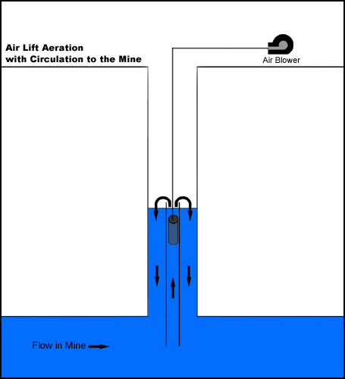
Figure 1. Induced circulation using low pressure air.
Methodology
The project was separated into two components. The first component was to develop the test equipment and to test it at a secure and easily accessible facility. Accessibility included access to tools, electric power, plumbing supply stores, and a water source with large surface area. The focus of this phase of the testing was on the amount of water produced for a given input of air.
The second component required that the test equipment be moved to a site that had a large continuous water flow that was also low in dissolved oxygen. Because this site was remote from all support, it was important to resolve all of the equipment problems before going into the field.
Equipment & Facilities; Water Flow
Initially, this testing was to be performed in a re-circulating closed system utilizing a water velocity meter inside the inner pipe to determine the water flow rate. This configuration most closely matches the system as it would be installed in the field. In another project, the utilization of a water velocity meter in a pipe yielded results that were not repeatable. This lack of precision would have rendered the results of the testing unreliable for the design of future applications of this technology. Consequently, the testing protocol was changed to an open system. This change allowed for removal of water from the system, and its measurement using a bucket and stop watch technique. In this case the bucket is a 300 gallon polyethylene tank. This change significantly improved the accuracy of the flow measurement.
Equipment & Facilities; Water Flow
The amount of water that will flow up a pipe under air lift conditions is affected by how high the water must be lifted above the static water level. In a mine operation this head difference should be zero. This condition exists when the top of the air lift pipe is at or below the static water surface. Unfortunately, this condition cannot exist in an open system because it would result in flow whether or not air was injected. In order to most closely duplicate mine conditions, the riser pipe was maintained less than ¼ inch above the static water surface. Another consequence of utilizing an open system is that the water level in the test system can fluctuate due to the removal of water from the system by the testing procedure. This effect is minimized by conducting the test in a body of water with a large surface area such as a lake or pond. Flow testing was conducted in a ¼-acre farm pond. The removal of 300 gallons from a ¼-acre pond results in a water level change of 0.044 inches. This change in initial water level is not expected to have a significant influence on the test data.
Figure 2 is a cross section of the pond and dam site showing the test apparatus connected to the existing pond drain pipe. Below the dam the drain pipe is conveyed to a 300 gallon polyethylene tank. A four inch gate valve allows the water to bypass the tank when open or to be directed to the tank when closed. Water from the test apparatus in the pond flows through a pre-existing four inch PVC pipe under the dam. Flow in this pipe is controlled by a four inch ball valve. Closing of this valve allows the air lift system to operate without the loss of water from the pond.
Figure 3 is a line drawing showing the physical arrangement of the equipment on the pond side of the dam. A 1.5 horsepower regenerative blower, Sweetwater® model S45, provides low pressure air for the system. This blower can provide 80 cfm at 50 inches water gauge (WG) and 90 cfm at 40 inches WG. Smaller blowers are available to more closely match system requirements. The amount of air is regulated with a two inch gate valve.
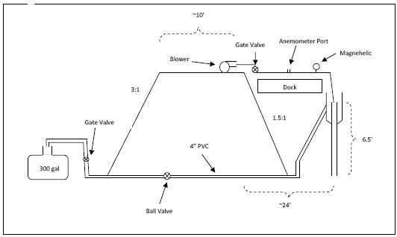
Figure 2. Dam cross section

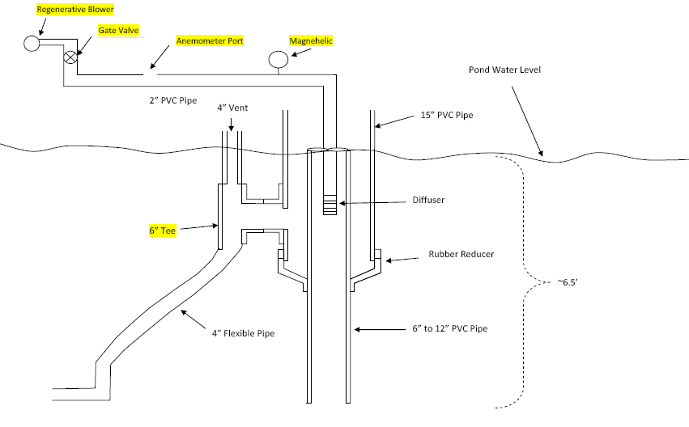
Figure 3. Air lift detail

A pressure relief valve between the blower and the gate valve compensates for the difference between the blower output and the air that is used in the test. The pipe, convening the air from the blower, transitions from a two inch schedule 40 diameter, to a three inch schedule 80 diameter. This transition is made to accommodate the Pacer Anemometer which has an outside diameter of 2.75 inches. The anemometer port is located 18.8 pipe diameters from the upstream elbow and about 10 pipe diameters from the downstream reduction back to two inch pipe. This placement helps to minimize the effects of eddy currents on the anemometer reading. The anemometer is installed in a three inch rubber pipe coupling. This allows for insertion and removal of the anemometer (Figure 4). When the anemometer is removed the port in the pipe can be sealed with a rubber pipe coupling. Air injection pressure is monitored using a 0 to 60 inch WG Magnehelic.
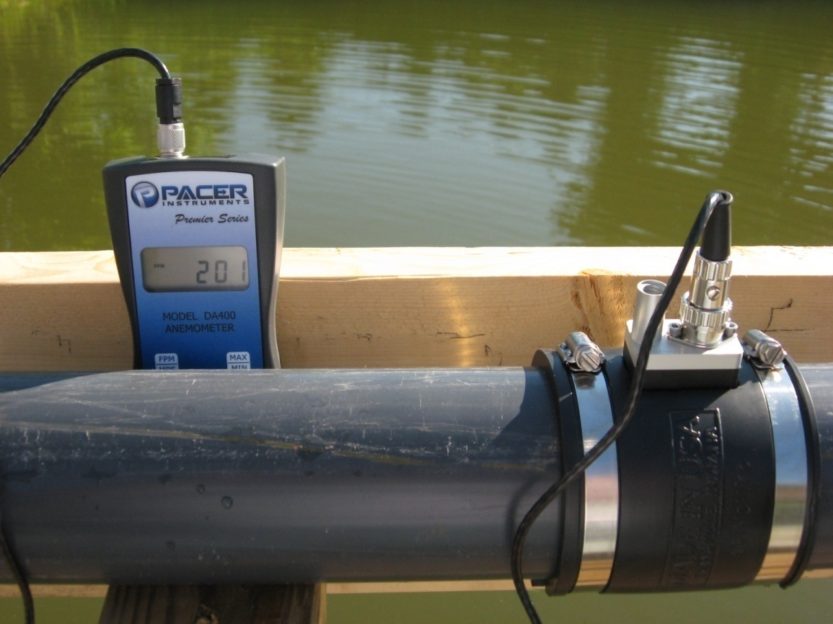
Figure 4. Anemometer in 3 inch SCH 80 PVC pipe
Four different diameters of pipe are evaluated in this study, 6 inch, 8 inch, 10 inch and 12 inch. Each pipe segment is 6.5 feet in length. This length is dictated by the available water depth in the pond. Water that is produced by the air lift is collected in a short piece of 15 inch diameter PVC pipe. The 15 inch pipe is sealed to the test pipe using a rubber reducing coupler. A 6 inch discharge pipe is located on the side of the 15 inch pipe, about a foot below the water level in the pond (Figure 5). This pipe connects to the 4 inch discharge line under the dam, and a 4 inch air vent. This assembly is attached to the dock in order to provide a stable platform for the testing. The dock is supported on steel legs extending down to the lake bottom. Level adjustment is accomplished using two ¾ all thread bolts that connect the dock to the legs.
It is anticipated that in mine use, the air lift pipe would be below the static water level in the mine, perhaps by as much as a foot. This configuration would allow for the air bubbles to separate from the water before the aerated water returns to the mine through the annulus. In the test apparatus it was necessary to provide air removal so that entrained air would not diminish the flow through the 4 inch pipe under the dam.
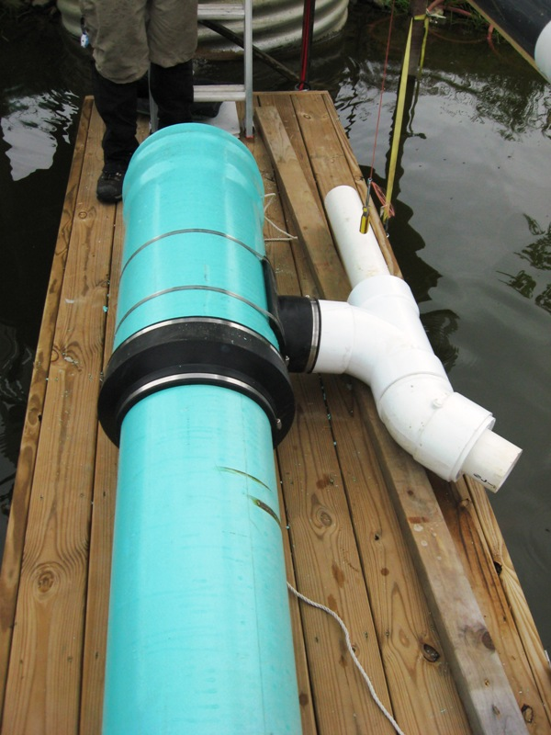
Figure 5. 15 inch diameter receiver pipe, the 12 inch diameter riser pipe, and the 6 inch auto burper. A 4 inch flexible pipe is connected to the auto burper on the lower right.
Two different style diffusers were used in this study. The first diffuser is a one foot section of number ten well screen, and the second style diffuser is an aeration or sparging stone used in aquaculture aeration. The well screen is made of plastic wire that is wrapped in a helix with a 10 thousandth inch slot separating the wires (Figure 6). The diameter of the well screen is 2 inches. This style diffuser produces large bubbles with very low pressure drop. It is expected that this style diffuser will be resistant to plugging and that it will be easy to clean. The disadvantages of this diffuser are that the large bubbles are not expected to enhance oxygen transfer, and the bubbles are concentrated near the diffuser which can limit the effectiveness of the air lift.
The diffuser stones are 1.5 inches square and 12 inches long. Each stone has a recommended throughput of 1 cfm although this is not a strict limitation if you are willing to accept greater pressure drop. The stone diffusers produce a medium size bubble that is more efficient at oxygen transfer. The disadvantage of the stones over the well screen is the extra energy required for an equivalent air flow, and the greater potential for iron deposition potentially requiring more frequent maintenance. Multiple stones were used depending on pipe diameter. In the 10 inch and 12 inch pipes nine stones were used (Figure 7), in the 8 inch pipe five stones were used, and in the 6 inch pipe 6 stones were used.
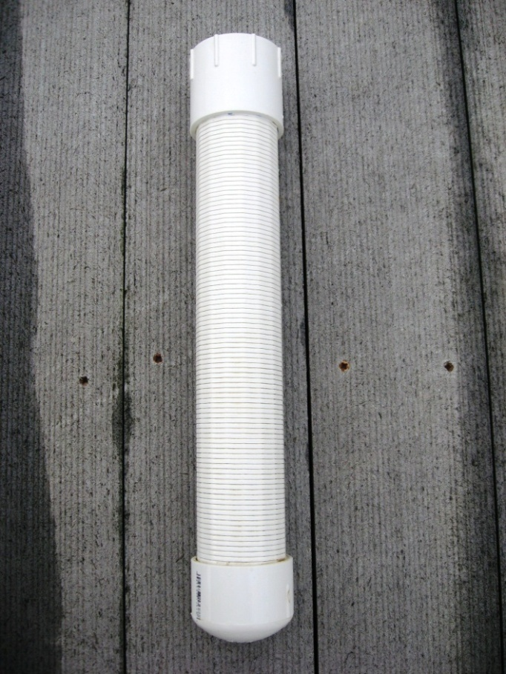
Figure 6. 2 inch continuous slot PVC well screen 0.010 slot, 1 foot exposed screen
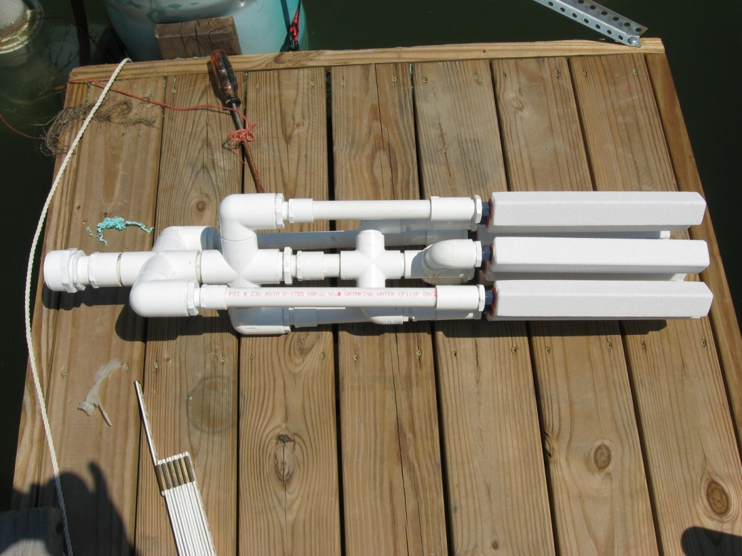
Figure 7. Nine stone diffuser
Figure 8 shows the equipment installed and ready for testing. The canoe was used to observe the water level in the test pipe so that the weight of the observer would not affect the measurement.
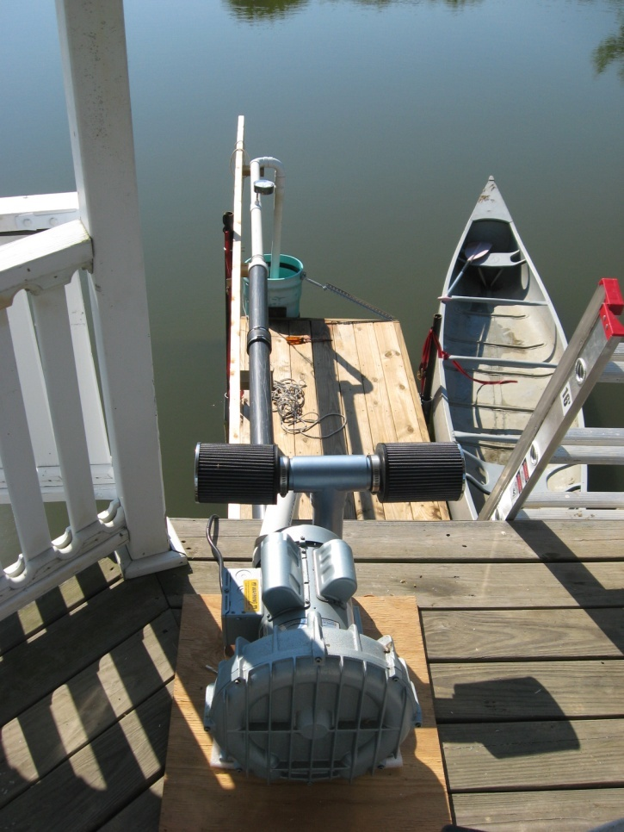
Figure 8. Pond installation
Equipment & Facilities; Oxygen Transfer
Testing for oxygen transfer rate was conducted at the Sulfur Run Borehole in Cambria County Pennsylvania. This borehole was selected because of its high volume low DO water. The high flow volume of the borehole prevented recirculation of the water so that the test results only represent a single pass through the apparatus. The same test equipment was used for the oxygen transfer experiments with the exception that the 15 inch diameter collection pipe was not needed. The produced water was allowed to overflow the borehole.
A portion of the water produced by the air lift was captured in a 2 inch diameter PVC pipe and conveyed to small water trap located below the edge of the borehole. This pipe was vented to the atmosphere to allow air to escape. A Hach HQ40d meter was used to measure the pH and the DO of the water as it flowed through the trap. The trap arrangement successfully removed any remaining air bubbles so that they would not interfere with the DO readings. The Hach HQ40d meter uses IntelliCal probes which remember their calibration. In addition, The DO probe uses LDO technology (luminescent Dissolved oxygen). This method does not require a membrane and is effective at low DO concentrations.
Test Procedure; Water Flow
At the beginning of each day, or after a rainfall, the height of the dock must be adjusted so that the test pipe is less than ¼ inch above water level in the pond when no one is standing on the dock, Figure 9. This adjustment is controlled by two ¾ inch diameter all thread rods which minimize any movement of the dock during the test. Once the dock is adjusted the depth of the diffuser is measured and recorded.
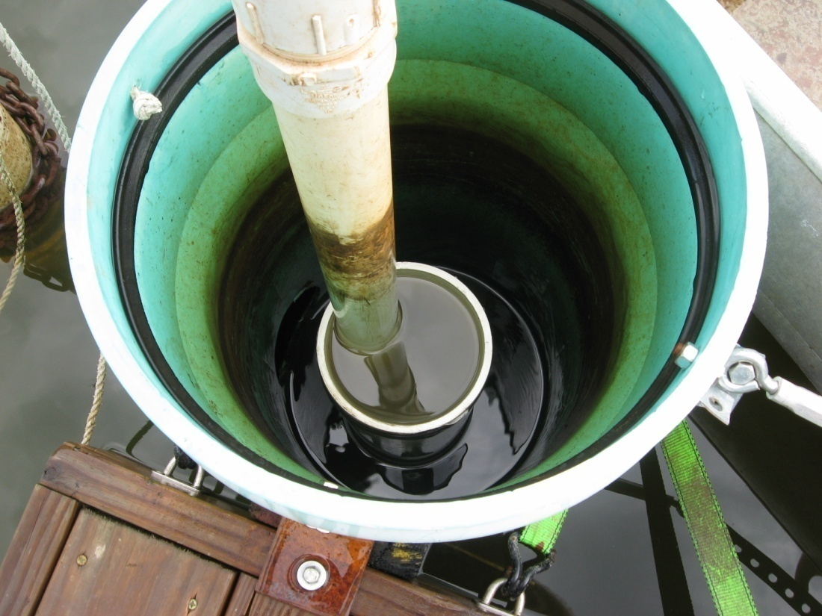
Figure 9. Water level in 6 inch test pipe adjusted to within ¼ inch of overflow.
Initial conditions: 300 gallon tank empty; tank drain valve closed; waste valve open; main dam drain valve is closed.
Prior to each test the regenerative blower is started and allowed to reach operating temperature. The anemometer is installed in the air line and the air flow is adjusted using the two inch gate valve. All final valve adjustments are made in the clockwise, (valve closing) direction. This reduces air flow variations due to play in the valve stem. Once the desired air flow is set, the anemometer is removed and the rubber coupling is installed over the opening in the pipe. This coupling is secured with four band clamps to prevent leakage. Once these clamps are secure air is flowing to the diffuser and the air lift is in operation. Figure 10 illustrates the water production in the six inch PVC pipe.
Air pressure is read on the Magnehelic gauge and recorded. The main drain valve, under the dam, is then opened and water is allowed to flow to waste until the flow stabilizes, approximately 30 seconds. The waste valve is then closed and a stop watch is used to time the filling of the 300 gallon tank (Figure 11). The tank is considered full when water begins to overflow the tank. The time required to fill the tank is recorded. The waste valve is opened the tank drain valve is opened, and the main drain valve is closed. At this point the anemometer is reinserted into the apparatus and a second air flow reading is taken. The before and after air flow readings are averaged to arrive at the test air flow value. If there is a large discrepancy in the before and after air flow the test is rerun.

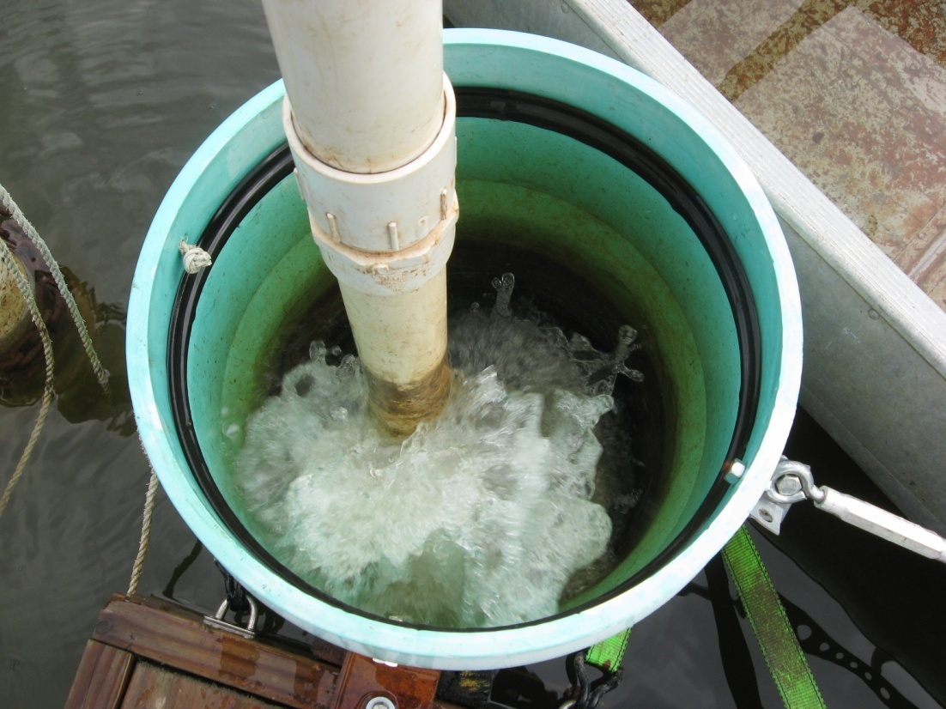
Figure 10. Water production in the 6 inch test pipe.
Tank volume was determined by allowing the full tank to drain through a positive displacement water meter. As a backup to this method, the tank was weighed on a truck scale in both the empty and full conditions. The truck scale reads in 50 pound increments so the volume computed via this method was only used for confirmation of the water meter data.
In order to maintain water level in the pond a ½ horsepower pump was used to return the water in the 300 gallon tank to the pond. In addition, water from the receiving stream was pumped up to the pond to allow testing to continue during the summer.
Test Procedure; Oxygen Transfer
The test procedures involving the air supply were nearly identical to the flow testing with the exception that the anemometer was left in place thorough out the testing. Nine air velocity settings were targeted for this phase of the testing. Because these readings were to be graphed, and a precise adjustment was very difficult, a reading that was ± 10 feet per second of the desired reading was close enough for the purpose. The target air velocities were: 300, 250, 210, 170, 140, 110, 80, 65, 50 feet per second.
Two people were required for this phase of the testing. One person adjusted the air flow, read the Magnehelic, and read the anemometer before and after the test. The other person measured the depth of submergence, recorded the pH and three DO readings. After testing the DO readings were averaged. If one of the three DO readings was significantly different, then a fourth reading was taken and the closest three were averaged.

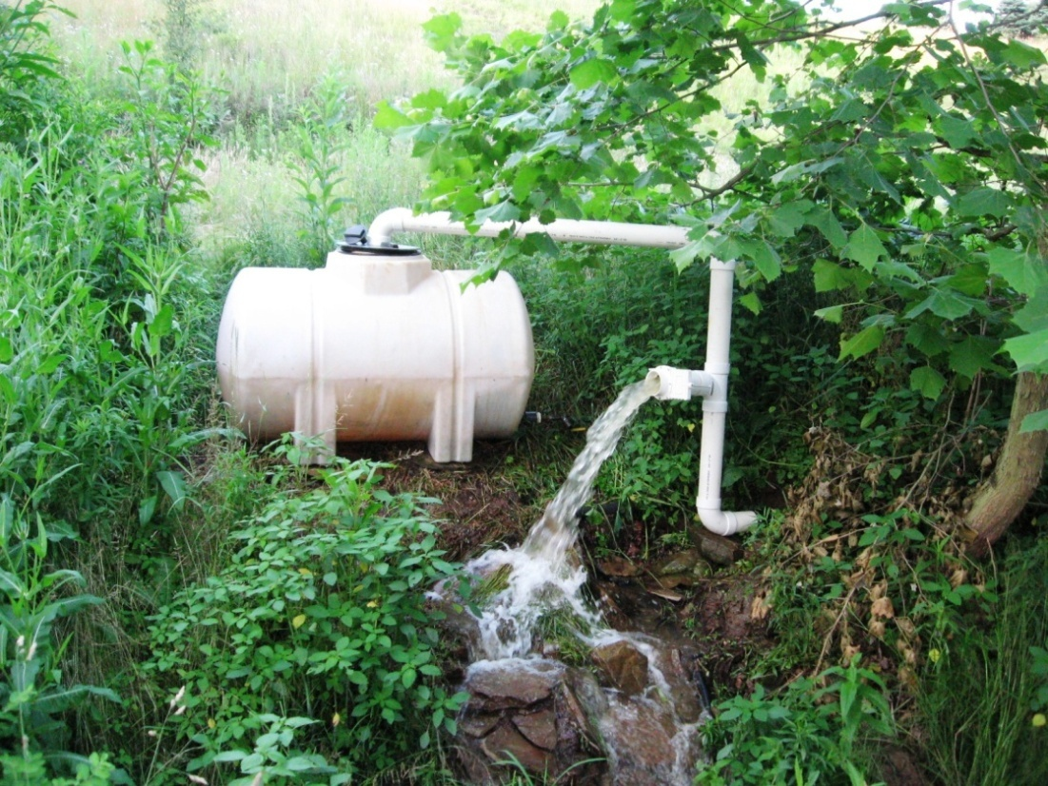
Figure 11. 300 gallon polyethylene tank with waste valve open
Results and Discussion
Water Flow
Figures 12 through 19 are plots of the data collected during flow testing. The first test series used a 12 inch diameter riser pipe and the 2 inch PVC well screen diffuser. The open area of this diffuser is one foot in length, and it was tested at depths of 15.0, 25.75, 38.75, and 50.25 inches. In all of the tests water flow increased with air flow as expected. This test also shows that increasing depth increases water flow even at the same air flow. The test series at 25, 38, and possibly 50 inches show a break in the slope of the plot. Water flow rises rapidly as air flow is increased until a break point is reached, then the produced water increases more slowly as air flow increases. This break point is between three and four cubic feet per minute.
A second observation is that water flow increases with depth of the diffuser for a given air flow. This increase diminishes as the depth increases suggesting that there is a maximum depth beyond which no additional flow will be derived from an increase in the depth of the diffuser. Based on the low water production at shallow depth (15 inches), testing at this depth was discontinued for the other pipe diameters.
The water production, in gallons per minute, formed a linear relationship with air flow above 4 cubic feet per minute, and water flow less than 200 gallons per minute for all pipe diameters. Two hundred gallons per minute appears to be the upper limit of the test apparatus. The four inch pipe under the dam is probably the source of this limitation.
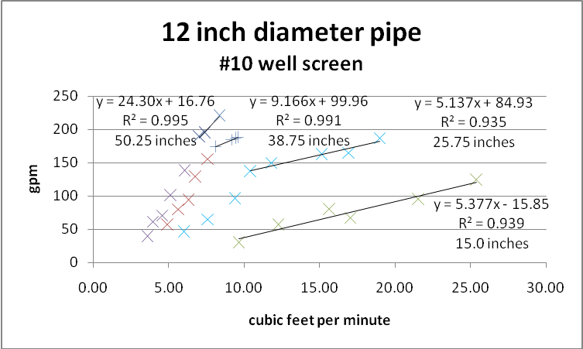
Figure 12. Flow test in 12 inch riser pipe using the well screen

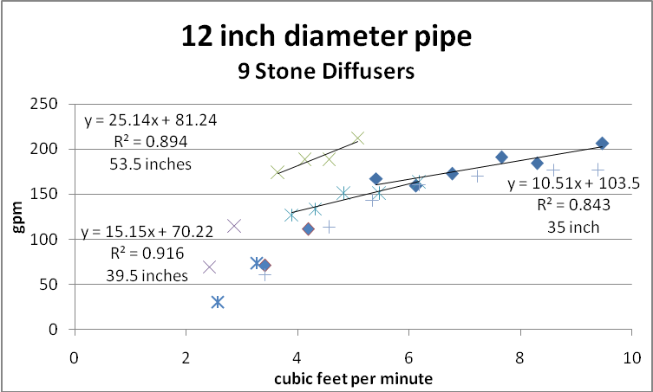
Figure 13. Flow test in 12 inch pipe using a 9 stone diffuser
Microsoft Excel was used to generate best fit equations for these data. Seventy-two percent of the regression analysis yielded R² fits greater than 0.95, and 92 percent of the fits were greater than 0.91. The data collected from the 12 inch pipe and 9 stone diffuser combination was the most problematic, they contain the three lowest R² values. This may reflect problems with the test apparatus that were resolved in subsequent experimental runs. Most of these problems involved system rigidity during testing.
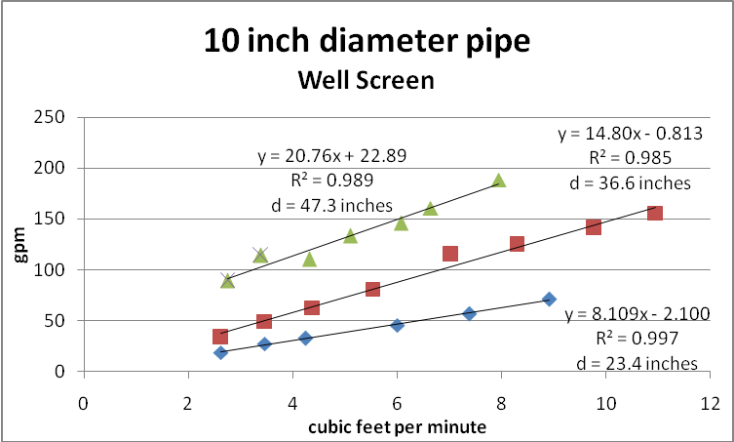
Figure 14. Flow test in 10 inch riser pipe using the well screen

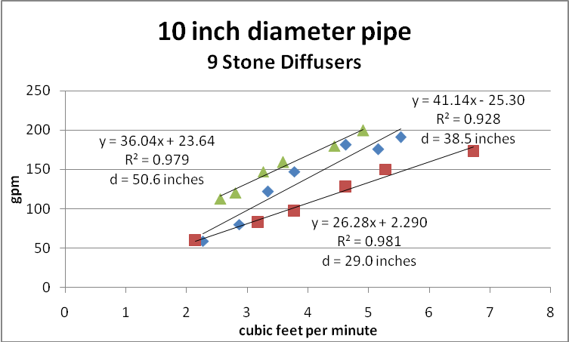
Figure 15. Flow test in 10 inch riser pipe using the 9 stone diffuser
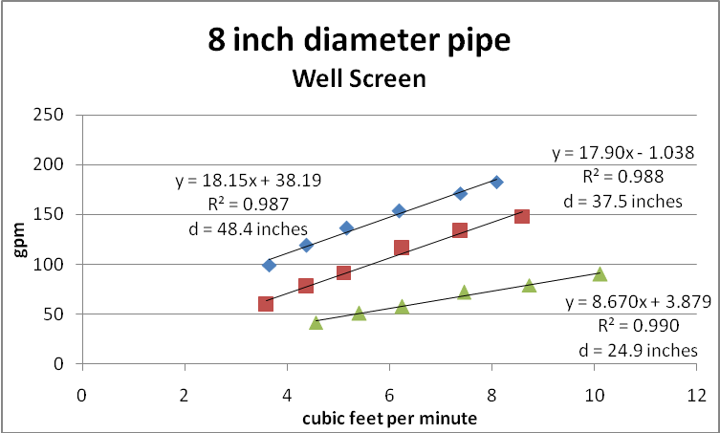
Figure 16. Flow test in 8 inch riser pipe using the well screen

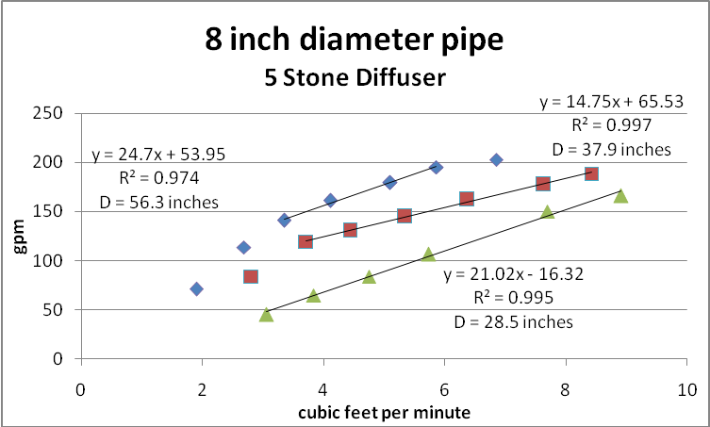
Figure 17. Flow test in 8 inch riser pipe using the 5 stone diffuser
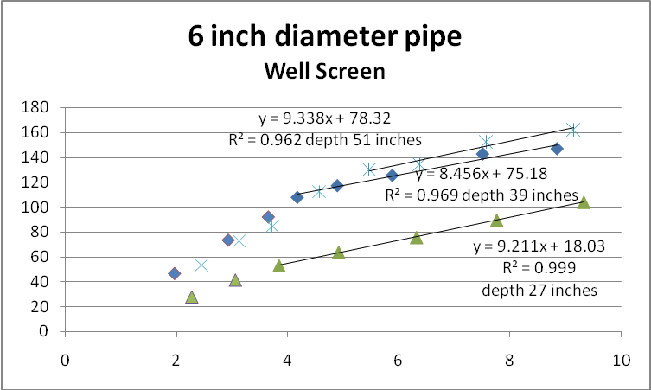
Figure 18. Flow test in 6 inch riser pipe using the well screen

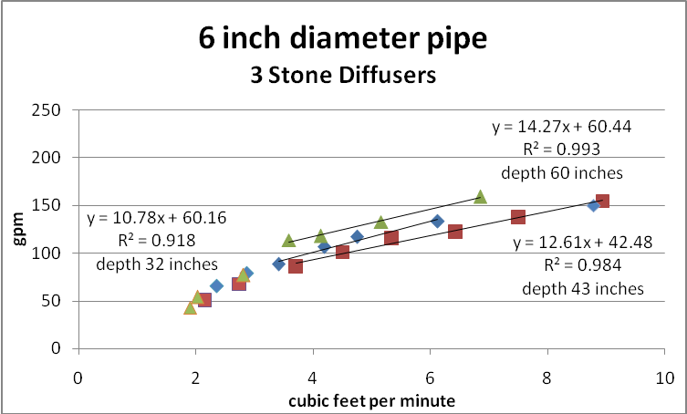
Figure 19. Flow test in 6 inch riser pipe using the three stone diffuser

Dissolved Oxygen
Sulfur Run Borehole is a high volume low oxygen discharge that presented excellent conditions for the oxygen transfer test. Table 1 contains the raw water conditions that were measured prior to testing on three different days. Note that the DO is consistently low and that any observed increase in DO is almost entirely due to the effect of aeration
Table 1. Sulfur Run Raw Water
Date | pH | DO | ORP
9-30-2009 | 3.35 | 0.05 | 322
10-3-2009 | 3.40 | 0.09 | 313
10-5-2009 | 3.41 | 0.07 | NA

Figure 20 shows the Sulfur Run Borehole with the eight inch test pipe suspended from the angle iron in the middle. The upper section of the borehole is constructed of a three foot diameter concrete culvert. Note, at the top of the photo, the two inch PVC air line running back to the regenerative blower, the gate valve, and the Magnehelic gage.
Under normal operation the water level in the borehole is controlled by two PVC pipes (bottom center and bottom left) which carry the flow from the culvert and drop it on the ground. This left the water level in the culvert too low to accept the 6.5 foot riser pipe that was used during the flow testing. However if the water level was raised to the top of the culvert then the borehole would accommodate the riser pipe. A basket ball served as the perfect “ball valve” for the larger pipe resulting in the bulk of the flow overtopping the culvert.
Figure 21 shows the sample collection pipe in place at the edge of the riser pipe during testing of the 8 inch riser pipe. A portion of the air lifted water can be seen flowing into this pipe past the pH and DO probes. In addition to collecting a sample of the air lifted water, the transfer pipe allows air bubbles to escape from the produced water before the pH and DO are measured. A ¼ inch hole in the top of the pipe allows this venting to occur. An elbow provides the point of measurement. A hole was drilled through the pipe large enough to accept the pH probe. The DO probe was placed in the discharge side of the elbow.
Figures 22 through 29 are the results of the dissolved oxygen testing conducted at Sulfur Run Borehole. In all of these plots, the data plotted as a square represents the deeper diffuser setting, about 4 feet, while the blue diamonds are plots of the data from the shallower depth setting, about 3 feet. These data indicate that, in general, the DO content of the water increases with increasing input air to the diffuser, although not dramatically. In several cases, the DO content was essentially flat with increasing air input.
Based on the DO measurements, there does not seem to be a significant difference between the two diffuser types. Both had an upper limit of about 3 to 3.5 mg/L at high flow. The effect of depth of the diffuser on oxygen transfer is somewhat counter intuitive. In most cases the shallower diffuser setting produces a higher DO content as compared to the deeper diffuser setting. This is likely the result of higher residence time resulting from the lower water flow rate associated with the shallower depth.
At low air flow rates, generally less than four cubic feet per minute, the DO levels in the water rose with decreasing air flow. This is believed to be a further manifestation of the residence time increase caused by low water velocities. But since these low air flows do not produce much water flow, the benefit of high DO levels does not translate into high oxygen delivery to the mine.
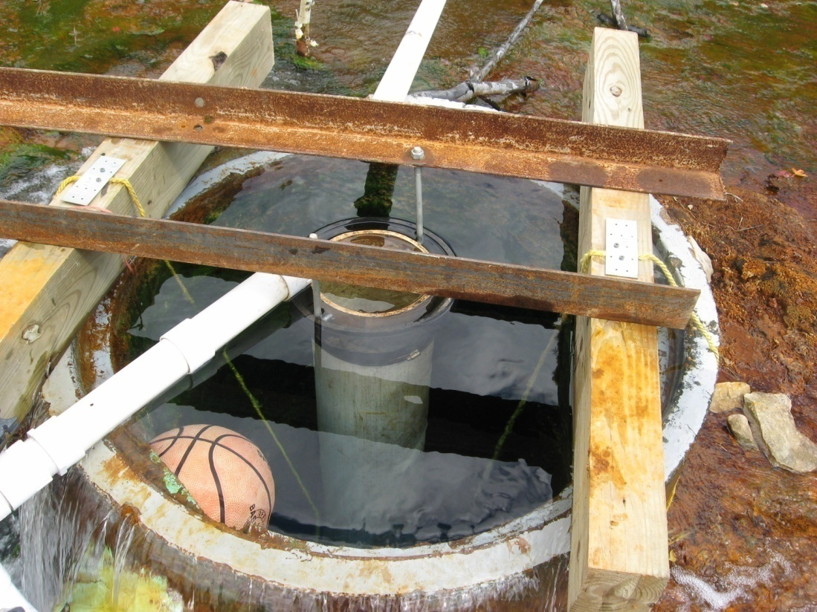
Figure 20. Eight inch pipe adjusted to water surface with sampling pipe in position.
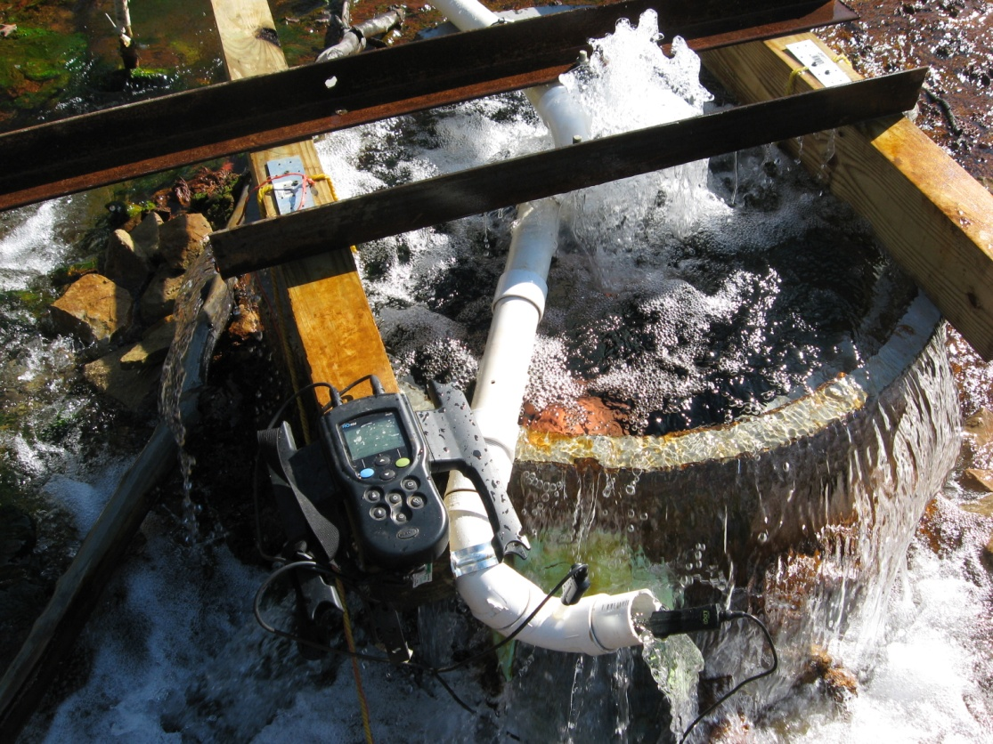
Figure 21. Water produced by the air lift is being measured for pH and DO. (bottom center)

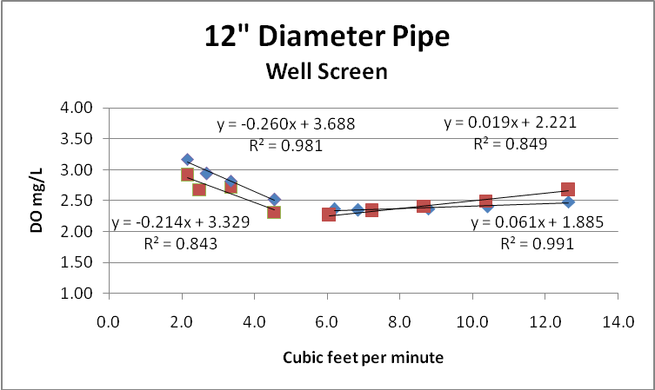
Figure 22. Oxygen concentration in the 12 inch pipe using the well screen

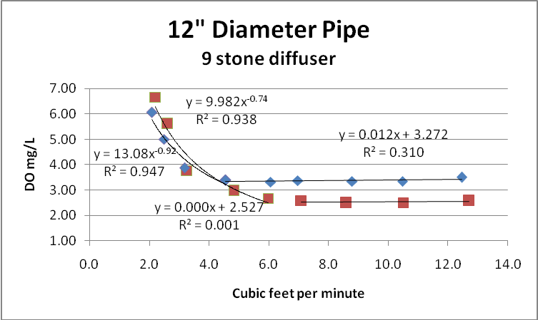
Figure 23. Oxygen concentration in the 12 inch pipe using the 9 stone diffuser.
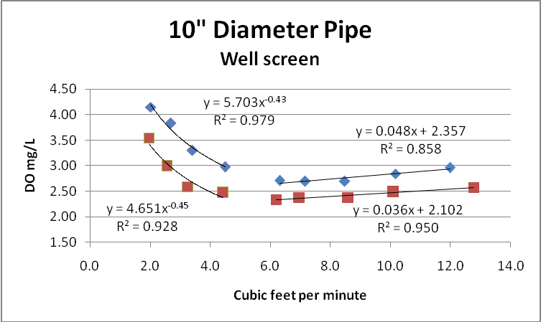
Figure 24. Oxygen concentration in the 10 inch pipe using the well screen

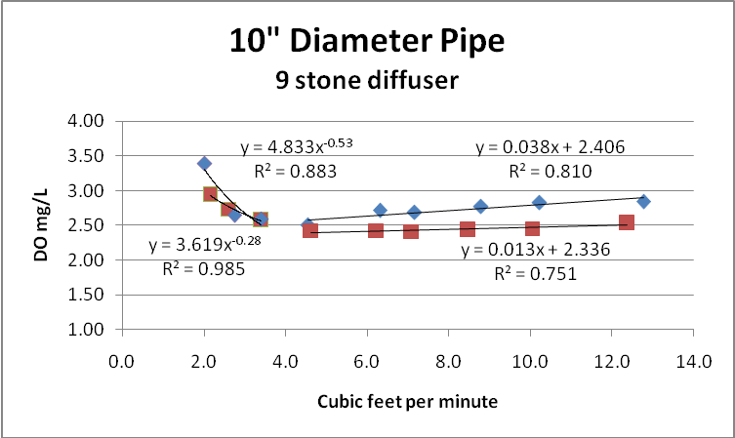
Figure 25. Oxygen concentration in the 10 inch pipe using the 9 stone diffuser.
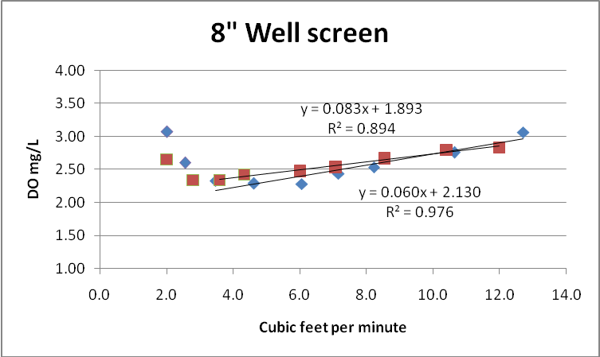
Figure 26. Oxygen concentration in the 8 inch pipe using the well screen

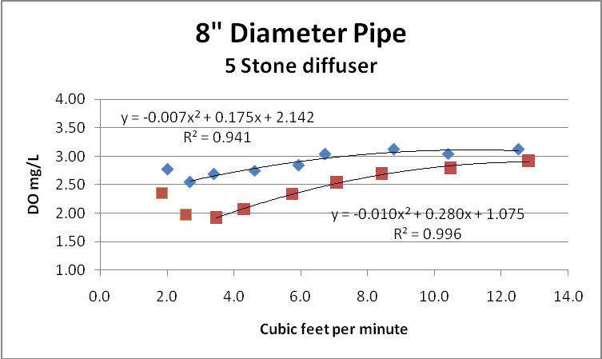
Figure 27. Oxygen concentration in the 8 inch pipe using the 9 stone diffuser.
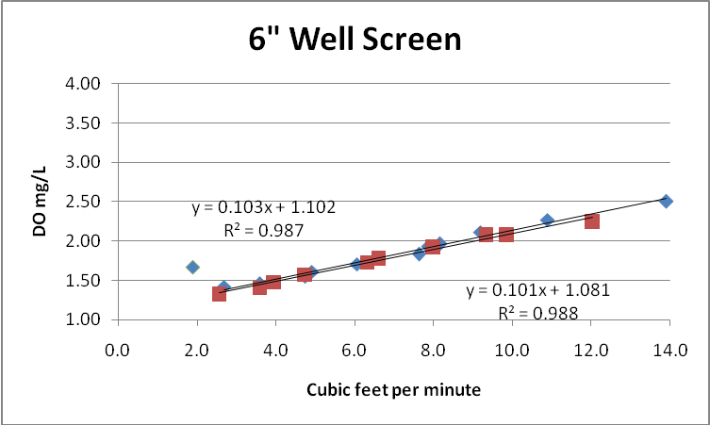
Figure 28. Oxygen concentration in the 6 inch pipe using the well screen

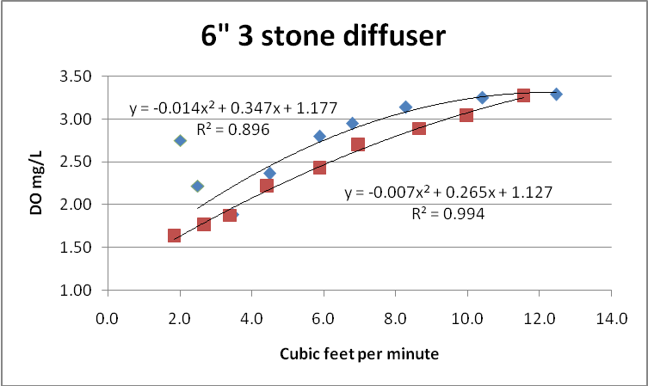
Figure 29. Oxygen concentration in the 6 inch pipe using the 9 stone diffuser.

CO₂ removal
Carbon dioxide is a common dissolved gas in mine drainage. It adds to the acidity and lowers the pH of the mine water. Aeration can remove the carbon dioxide resulting in an increase in pH. Such an increase is desirable because ferrous iron is known to oxidize more quickly as the pH rises.
The pH of the Sulfur Run Borehole was monitored during the testing to see if there was a detectable rise in the pH resulting from the aeration. No rise in pH was observed. This is not unexpected given the very short contact time with the air. Removal of CO₂ from mine water can take up to 20 minutes to reach completion.
Oxygen Mass Transfer
The amount of oxygen that can be delivered to the mine via this air lift method is a function of both the flow and the DO content of the water. Since the DO content did not vary significantly between the various diffusers and pipe diameters the primary factor influencing oxygen delivery is the water flow that is generated by the air lift.
The amount of oxygen that can be delivered to the mine was calculated utilizing the regression equations of water flow versus air flow and the equations of DO versus air flow. Values of air flow were substituted into each equation resulting in the conversion of DO to grams O₂ per minute. Figures 30 through 37 contain the results of this calculation.
In some cases the flows calculated by the best fit equations represent extrapolations of the data beyond the 200 gpm limit of the test facility. Given the linear relationships that were observed below 200 gpm and the size of the flow estimates relative to the pipe diameter these extrapolations are believed to be reasonable. The exception to this assessment may be the curve generated for the 12 inch diameter pipe and the well screen at 50 inches submergence. The three data points that form the basis for this equation do not span a significant range of air input values and may not form an accurate representation of the resulting flow.
Based on these results, the eight inch and the ten inch pipe with deep stone diffusers produced oxygen transfer rates of about 5 grams oxygen per minute. Given the similarity of these results and the cost of pipe and boreholes the eight inch pipe has a clear advantage. However, selection of an appropriate pipe diameter and air input should be based on the flow rate in the mine and the oxygen demand generated by the in situ ferrous iron content.

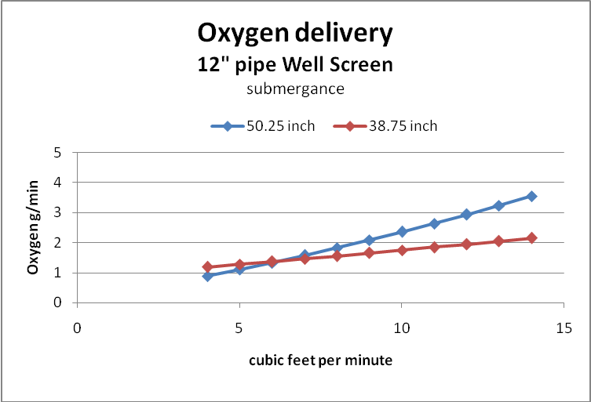
Figure 30. Oxygen mass transfer 12 inch pipe well screen diffuser

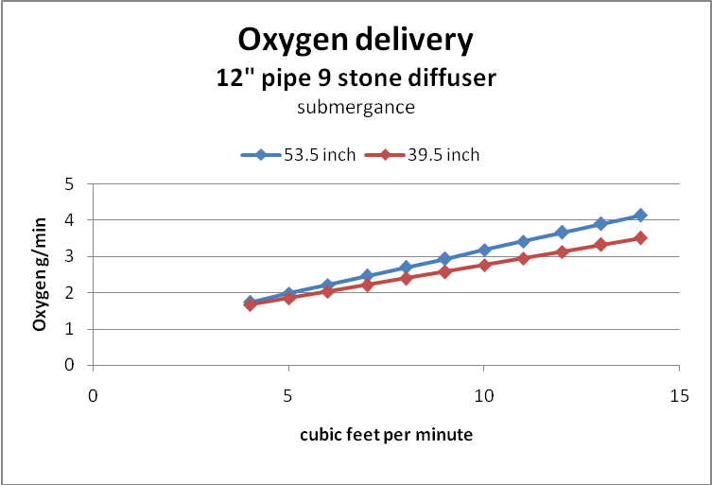
Figure 31. Oxygen mass transfer 12 inch pipe 9 stone diffuser

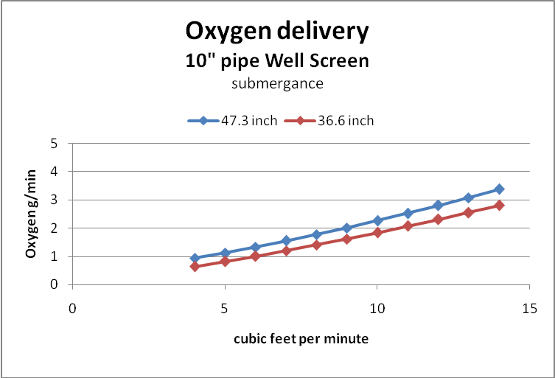
Figure 32. Oxygen mass transfer 10 inch pipe well screen diffuser

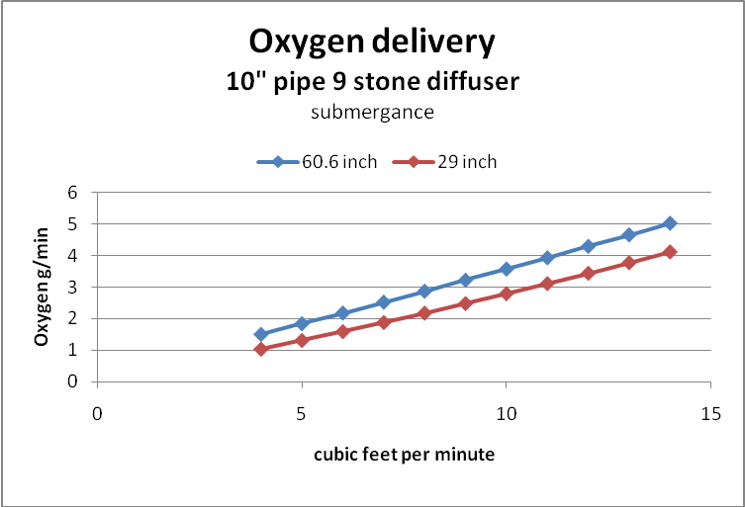
Figure 33. Oxygen mass transfer 10 inch pipe 9 stone diffuser

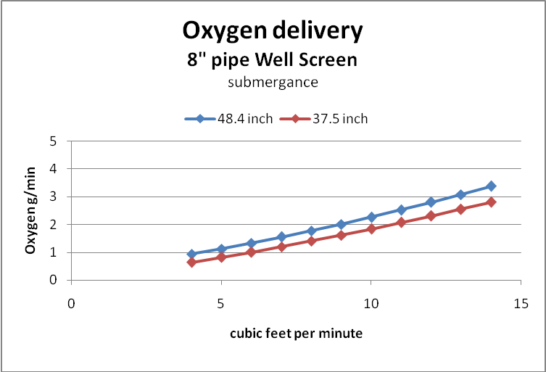
Figure 34. Oxygen mass transfer 8 inch pipe well screen diffuser

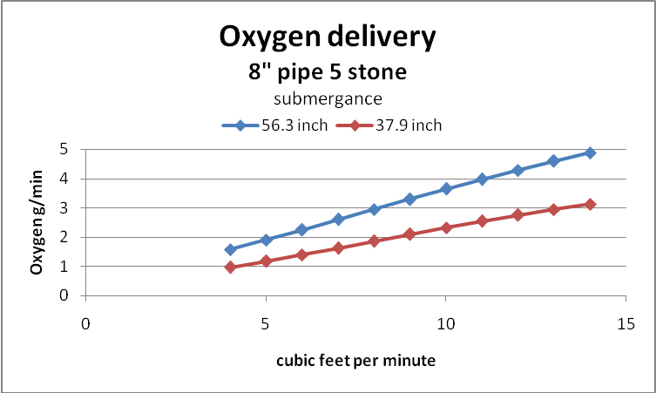
Figure 35. Oxygen mass transfer 8 inch pipe 9 stone diffuser
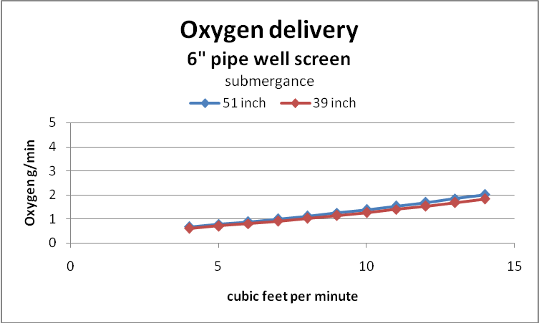
Figure 36. Oxygen mass transfer 6 inch pipe well screen diffuser

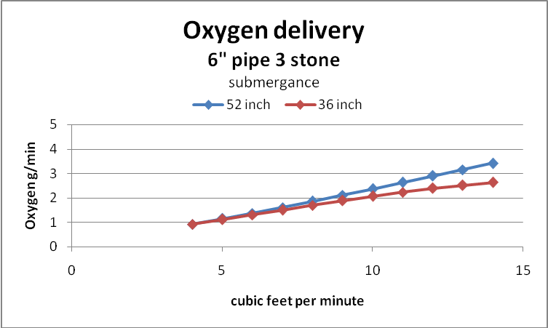
Figure 37. Oxygen mass transfer 6 inch pipe 9 stone diffuser
Conclusions
The use of low pressure air to create flow in a zero static head setting has been demonstrated. The volume of water moved with such a small volume of air surpassed expectations. Five cubic feet of air per minute is able to generate 200 gallons per minute of water flow.
Oxygen transfer to the produced water only achieved 25 percent to 30 percent saturation under the best conditions. This low level of DO in the produced water is, no doubt, related to the high volume of water that was produced and the consequent short contact time. In most tests, there is not a significant difference between the DO produced by the well screen and the stone diffuser at the same depth. There is however, a tendency for the shallower depth setting to produce a higher DO than the deeper setting. This is believed to be associated with the lower water flow realized at this depth.
Oxygen mass transfer is easier to evaluate than oxygen transfer because both the DO and the water flow rate are included in the analysis. Oxygen mass transfer clearly demonstrates the benefit of the deep placement of aeration diffuser, and the benefit of stones over well screen. Table 2 compares the screen and the stone diffusers at the deep setting.
Table 2. Oxygen Mass Transfer Comparison
 | Aeration stone | Well Screen | Improvement
Pipe Diameter | grams / minute | grams / minute | percent
12 inch | 4.14 | 3.55 | 16.6
10 inch | 5.03 | 3.38 | 48.8
8 inch | 4.87 | 3.05 | 59.6
6 inch | 3.41 | 2.01 | 69.6

The oxygen mass transfer results suggest that there may be increased performance possible from the use of a deeper diffuser setting. The 1.5 horse power regenerative blower that was used in this testing had a maximum delivery pressure of 60 inches WG, and air volume well in excess of what was needed. Operational costs will be reduced by using a more properly sized blower. Equivalent results can be obtained from a HPB34. This unit delivers 25 cfm at 65 inches WG. This unit only requires ¾ horse power. If an increased depth setting is desired, the HPB100 can deliver 20 cfm at 80 inches WG. Both of these units exceed the maximum conditions used in this test of 14 cfm and 60 inches pressure.
Based on the oxygen delivery to the mine contained in table 2 and assuming full utilization of the oxygen in oxidizing ferrous iron then between 23.8 and 35.1 grams of iron per minute can be oxidized. This rate of iron oxidation is equal to 75.6 to 111.4 pounds iron per day.
The cost of electricity to operate a ¾ horsepower blower continuously for one day is $1.34 if the cost of electricity is $0.10 per kilowatt hour. This yields an annual electricity cost of $490.00 for the oxidation of up to 20 tons of iron.

