An Evaluation of the Mayfly Abundances and WV-SCI Scores Compared to Levels of Conductivity in Several Streams in Southern West Virginia¹
Ed J. Kirk², Ryan A. Johnston³, and Randall Maggard⁴
Abstract. 28 streams and 109 separate sites have been sampled bi-yearly for up to 30 times to comprise a data set of over 800 events. Benthic macroinvertebrate and water chemistry data suggest large differences in the % abundance of mayflies and specifically the levels of conductivity compared between reference and unmined sites, and those sites located below mining operations. The WV-SCI did differ also, but not as dramatically. Habitat scores varied little. Statistical analysis showed that a conductivity level of just over 1,000 µs was likely needed to produce a WV-SCI score lower than the 60.6, which is the cut-off level utilized to categorize the stream as “impaired.” Mean conductivity of the Mined sites was 774 µs while the WV-SCI still remained above the impaired level with a mean of 63.1. These data demonstrate that conductivity levels, if used as a regulatory tool, should be set closer to this level instead of levels discussed in the 200 – 300 µs range. Statistical analysis further demonstrated that the WV-SCI would likely drop below 60.6 should the abundance of mayflies drop below 9.2% of the samples composition.
Key Words: mayflies, Ephemeroptera, conductivity, WV-SCI, coal mining.

Introduction
When development of any kind occurs in a watershed, some type of earth-disturbing action is almost always involved. It has been acknowledged that such land disturbance activities affect water quality in some manner. Almost always, there is a potential for increases in Total Suspended Solids (TSS) and Total Dissolved Solids (TDS; also measured as specific conductance, or conductivity). Increased scrutiny in recent years has occurred, almost exclusively targeted at coal mining activities in Central Appalachia, and specifically in regard to the impacts these increases in TDS or specific conductance have on the biologic component of the affected watersheds. Practically all states have a “Narrative Criteria” in regard to this biological component, and have developed various multimetric indices to evaluate the quality of that component. West Virginia’s multimetric index, the Stream Condition Index (or SCI), was developed by Tetra Tech, Inc. (Gerritsen et al., 2000), and has been widely used as a tool for evaluating the aquatic health of streams.

In coal mining, particularly surface mining, it is well agreed that hundreds and possibility as much as thousands of feet of headwater ephemeral and intermittent streams are displaced as a result of mining and the construction of valley fills and the sediment control ponds located close downstream of these fills. With the placement of fill material, and subsequent displacement of the original stream channel, comes the elimination of the aquatic insect community in the immediate location of the fill placement. Additional effects can potentially be detected downstream as a result of the increased weathering of the exposed fill materials. The additional contact time with the excavated overburden can increase concentrations of elements in the receiving waters such as calcium and magnesium (Maggard, 2009). These concentrations can increase by several orders of magnitude.
_________________________________________________________________
¹ Paper presented at the 2010 WV Mine Drainage Task Force Symposium, Morgantown, WV, March 30 – 31, 2010.
² Ed J. Kirk, Director – Biological Department, REI Consultants, Inc. 225 Industrial Park Rd., Beaver, WV 25813.
³ Ryan Johnston, NABS-Certified Taxonomist, REI Consultants, Inc. 225 Industrial Park Rd., Beaver, WV 25813.
⁴ Randall Maggard, Env. Compliance Manager, Argus Energy-WV, LLC, Route 1 Box 155, Dunlow, WV 25511.
Changes to the hydrology also result usually with a notable increase in base stream flow, and a more stable water temperature regime throughout the year. Much discussion has been generated by recent papers written by Pond et al. (2008 and 2009) regarding effects of mountaintop coal mining. We wanted to add a somewhat different perspective to the data presented within that paper, and to determine if statistically, we could calculate levels of the variables conductivity, % mayfly abundance, and habitat scores which triggered a WV-SCI score of 60.6. An attempt to evaluate the effects of Mined sites compared to Reference, Unmined, Residential, and Downstream sites was made, but separating out the effects from residences, county and state roads, and larger habitat types can be next to impossible.
Methods
REI Consultants has been evaluating the water quality, physical habitat, and macroinvertebrate populations associated with Argus Energy-WV, LLC since 1995. The region evaluated for this paper is located in southwest West Virginia, primarily in Wayne, Lincoln, Mingo, and Logan Counties (FIGURE 1). The majority of the stream sites were located on the East Fork of Twelvepole Creek, Kiah Creek, Trough Fork, and tributaries of these larger streams such as Wiley Branch, Frances Creek, Pretty Branch, Laurel Creek, Copley Trace Branch, Rollem Fork, Mare Branch, and Milam Creek (FIGURES 2 and 3).
Over 28 separate streams and over 109 specific locations have been sampled on or near property leased by Argus Energy. Some of these sites have only been sampled one time; others have been sampled as many as 30 times, or bi-yearly for more than 15 years. This paper is a result of these sampling events, and comprises over 800 sample data sets.
Some sampling locations were positioned very high up within the watershed and were locations proposed for future hollow fills such as in upper Pretty Branch, Wiley Branch, and Copley Trace Branch. These sites would have been located within the upper intermittent sections of 1° or 2° Order streams. Many of the sites were located in much larger 3° or 4° Order streams such as in the lower reaches of the East Fork of Twelvepole Creek. At least four reference streams have been established and utilized, three being located in the undisturbed intermittent sections of small headwater streams (Frances Creek, Mare Branch, and Ivy Branch), and one located on a larger, intermittent/perennial stream (Big Laurel Creek).
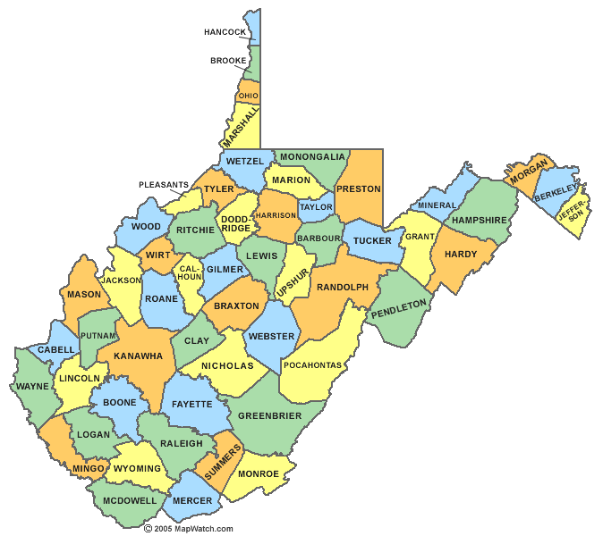 FIGURE 1. Study area shown in red.

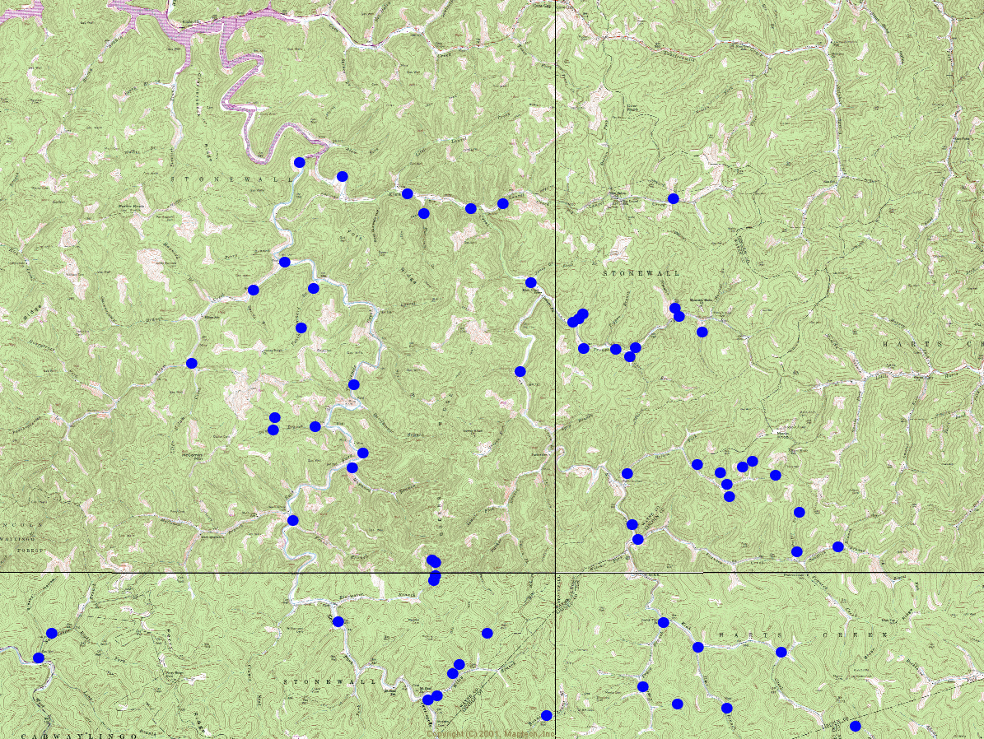
FIGURE 2. Two principle watersheds, the East Fork of Twelvepole Creek and Kiah Creek, and their respective sampling locations (blue dots) utilized for this study.
Kiah Creek
East Fork Twelvepole Creek
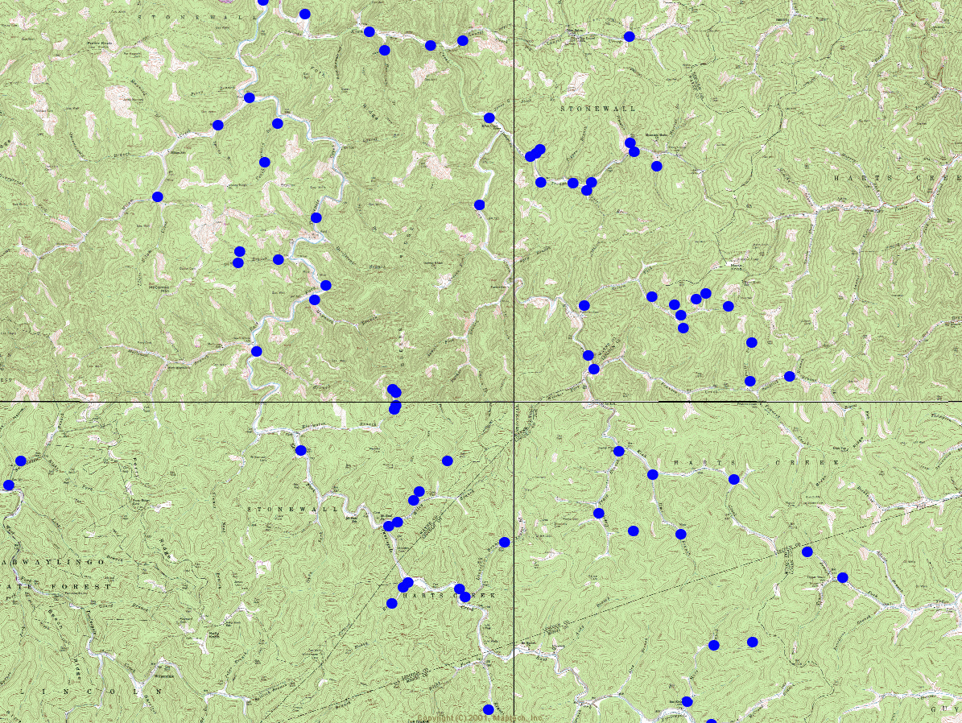
FIGURE 3. Primary sub-watersheds and the respective sampling locations (blue dots) utilized for this study.
Kiah Creek
East Fork Twelvepole Creek
Trough Fork
Rollem Fork
Frances Creek
Milam Creek
Benthic Macroinvertebrates
Macroinvertebrates were collected primarily from riffle areas of a 100-m stream reach using a 0.5-m wide rectangular-frame kicknet (500-µm mesh). Four semi-quantitative kick-net samples were composited from a riffle/run area to equal 1-m² sampling area. Samples were placed in 1-liter plastic containers, preserved in either 10% formalyn or 70% ethanol, and returned to the laboratory for processing. Samples were then picked under microscope and detrital material was discarded only after a second check to insure that no macroinvertebrates had been missed. The WV-SCI score was calculated using the “200 organism” method. The whole kick sample was spread onto a 100-gridded sieve. Grids were selected at random and picked under dissecting scopes, until 200 (+/- 10%) insects were obtained. Those insects were then identified to the lowest possible taxonomic level, and although Genus Level was typically achieved, the data is lumped to the Family Level to calculate the WV-SCI score. At least 25% of the 100 grids were picked and identified, and then extrapolated to determine the number of insects in the total kick sample. All macroinvertebrates were identified to lowest practical taxonomic level, usually Genus, and were enumerated. Chironomids were identified only to Family Level. Several benthic macroinvertebrate metrics were then calculated for each station. Of particular focus to this paper were the % mayfly composition and the West Virginia Stream Condition Index (WV-SCI; Gerritsen et al. 2000). The rating utilized for the WV-SCI was as follows, and the ratings are those as utilized by the WVDEP.
WV-SCI Range | Rank
78.01 to 100 | “Very Good” | Not Impaired
68.01 to 78.00 | “Good” | Not Impaired
60.61 to 68.00 | “Gray Zone” | Not Impaired
45.01 to 60.60 | “Slightly Impaired” | Impaired
22.01 to 45.00 | “Moderately Impaired” | Impaired
0 to 22.00 | “Severely Impaired” | Impaired

Water Quality
Physical water quality was analyzed on-site at each station. Water temperature, pH, and conductivity were measured with an Oakton 300 series pH/CON multi-parameter probe. Dissolved Oxygen was measured using a Hach HQ30d flexi LDO meter. Flow was measured with a Marsh-McBirney™ Model 2000 portable flow meter. Stream widths, depths, and velocities were measured, and the resulting average discharge was reported for each station. Water chemistry samples were collected at each station and returned to REI Consultants, Incorporated for processing. Parameters analyzed included acidity, alkalinity, total hardness, nitrate/nitrite, chloride, sulfate, Total Suspended Solids (TSS), Total Dissolved Solids (TDS), total phosphorus, dissolved organic carbon, total aluminum, dissolved aluminum, antimony, arsenic, beryllium, cadmium, calcium, chromium, copper, total iron, dissolved iron, lead, total manganese, dissolved manganese, magnesium, mercury, nickel, potassium, selenium, silver, sodium, thallium, zinc, and at times fecal and total coliforms. For this paper, only conductivity data were presented as it has been generating considerable discussion as a quick indicator of stream health.

Habitat
Habitat was assessed and rated on ten parameters in three categories using the EPA Rapid bioassessment protocols for use in streams and wade able rivers (Barbour et al. 1999). All ten parameters were scored, and physical habitat could technically score from 0 to 200 points for the total site score. Habitat was scored throughout the reach, which was typically about 45 – 91 meters in length.
Site Type Designations
Sorting the sampling locations into discrete site types can prove to be quite arduous, and can also be held up to scrutiny and debate. Obviously, some differences exist between the individual sites within each of the categories, and some sites which were originally listed as Reference became Mined upon active mining operations upstream, or were lost if they were positioned within the proposed fill locations. Nevertheless, sites were broken into 5 types depending upon location in relation to mining areas, residences, and roads, and the following definitions were used to distinguish between the types. Our “Reference” sites were those sites that were located in undisturbed, intermittently, or perennially-flowing, headwater streams. No residences or mining/logging activities were upstream from the sampling points, and there were no access roads directly alongside the sampling reaches.
We defined our “Unmined” sites as those sites which contained no active mining, or existing valley fills upstream. They were in small, intermittently or perennially-flowing streams, and may have had past logging. We tried to exclude sites with residences nearby, but dirt access roads may exist. The primary distinction between the Reference and the Unmined was the presence/absence of dirt/gravel access roads.

Our definition of “Mined” sites were those that were in small, intermittently or perennially-flowing streams with active mining upstream, or with existing valley fills upstream, or ones which receive mine-water discharges. We tried to exclude sites with residences nearby, but dirt access roads may exist. Our definition of “Medium-Stream, Residential” sites were those that were in small, intermittently or perennially-flowing streams with residences adjacent and/or upstream. They all had active mining upstream, or with existing valley fills upstream. The primary difference between the Medium-Stream Residential sites and the Mined sites was the presence of residences nearby.

Finally, our definition of “Large-Stream, Roadside” sites were those that were in larger, perennially-flowing streams with either dirt or paved roads directly adjacent. Residences were normally not directly adjacent, but obviously many residences were along significant upper sections of the stream. They all had active mining and fills far upstream. The primary difference between the “Large-Stream, Roadside” sites and the “Medium-Stream, Residential” sites was the absence of residences directly nearby, and the size of the stream.
Results and Discussion
Mean mayfly abundance for the Reference sites was 22.9%; mean mayfly abundance for the Unmined sites was 22.0%; mean mayfly abundance for the Mined sites was 5.7%; mean mayfly abundance for the Medium-Stream Residential sites was 13.4%; and mean mayfly abundance for the Large-Stream Residential sites was 19.4% (TABLE 1). Mean conductivity for the Reference sites was 121 µs; mean conductivity for the Unmined sites was 114 µs; mean conductivity for the Mined sites was 774 µs; mean conductivity for the Medium-Stream Residential sites was 600 µs; and mean conductivity for the Large-Stream Roadside sites was 456 µs (TABLE 1).
TABLE 1. Means of % mayflies, conductivities, WV-SCI scores, and habitat scores for all site types at Argus Energy. Data comprises 805 data sets from 1995 through Fall 2009.
 | % Mayfly Abundance | Conductivity  (µs) | WV-SCI | EPA RBP II  Habitat
Reference  (n = 61) | 22.9 | 121 | 77.3 | 139
Unmined  (n = 179) | 22.0 | 114 | 73.9 | 138
Mined  (n = 85) | 5.7 | 774 | 63.1 | 140
Medium-Stream  Residential  (n = 162) | 13.4 | 600 | 63.6 | 125
Large-Stream  Roadside  (n = 318) | 19.4 | 456 | 61.2 | 135
Mean WV-SCI for the Reference sites was 77.3; mean WV-SCI for the Unmined sites was 73.9; mean WV-SCI for the Mined sites was 63.1; mean WV-SCI for the Medium-Stream Residential sites was 63.6; and mean WV-SCI for the Large-Stream Roadside sites was 61.2 (TABLE 1).
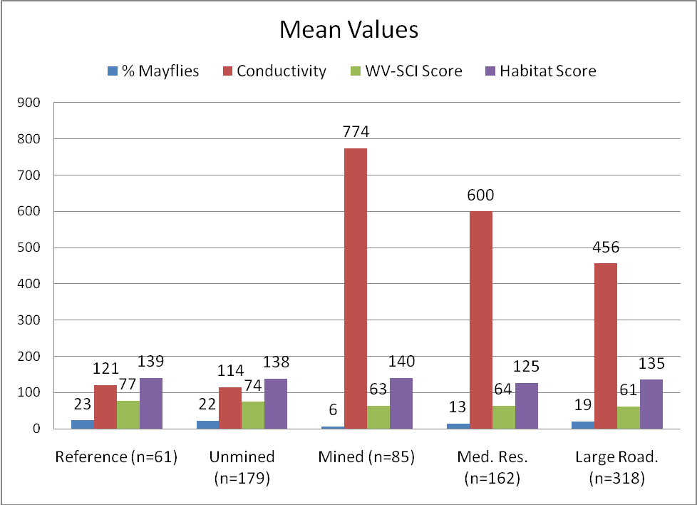
FIGURE 4. Means of % mayflies, conductivities, WV-SCI scores, and habitat scores for all site types at Argus Energy. Data comprises 805 data sets from 1995 through Fall 2009.
It is obvious from TABLE 1 and FIGURE 4 that % mayfly abundance was dramatically lower for the Mined sites compared to all other site types. Both the Reference sites and the Un-Mined sites were almost identical with respect to all variables compared in TABLE 1. Interestingly, the mean WV-SCI was lowest for the Large-Stream Roadside sites even though conductivity was substantially lower (456 µs) than at the Mined sites (774 µs) or the Medium-Stream Residential sites (600 µs). This is likely due to a shift in the benthic communities from typical swift-flowing, hardwood forested, steep-gradient, headwater streams to slower-flowing, roadside, low-gradient, sycamore strewn, deep-water streams. Percent mayfly abundance for the Large-Stream Roadside sites did increase substantially from the Medium-Stream Residential sites, and also from the Mined sites, and was near levels observed at the Reference and Unmined sites. However, taxa would be those more suited to the conditions described above for these downstream reaches, and would not be expected to mimic those taxa typically found in the uppermost headwater sections such as the Reference and some Unmined sites. Medium-Stream Residential sites had relatively low % mayfly abundances and marginal WV-SCI scores. The reason for this is more complex, but can be explained as these sites still have fairly high conductivity levels from the mining areas in upper reaches, in combination of (typically) the poorest habitat due to residences immediately nearby with all of the impacts from the residences (i.e. lack of suitable riparian, trash/debris present, “straight pipes” and gray water effluent).
Conductivity and Site Types
Conductivity ranged from 22 µs to 2,100 µs (FIGURE 5) with the lowest levels being recorded, not surprisingly, in the headwater streams where no mining activity had been conducted by the date sampled. 210 of the 805 total data sets (26.1%) of all sites had conductivities less than 100 µs, and these were generally the Reference and Unmined sites with some Medium-Stream Residential and Large-Stream Roadside sites included. 178 of the 805 data sets (22.1%) of all sites had conductivities from 100 – 250 µs, and these were generally the Medium-Stream Residential and Large-Stream Roadside sites with some Unmined and Reference sites included. 157 of the 805 data sets (19.5%) of all sites had conductivities from 250 – 500 µs, and these were generally the Medium-Stream Residential, Large-Stream Roadside, and Mined sites. 160 of the 805 data sets (19.9%) of all sites had conductivities from 500 – 1,000 µs, and these were generally the Medium-Stream Residential, Large-Stream Roadside, and Mined sites. 95 of the 805 data sets (11.8%) of all sites had conductivities greater than 1,000 µs, and these were generally the Medium-Stream Residential, Large-Stream Roadside, and Mined sites.
Conductivity and WV-SCI Scores
291 out of 805 data sets (36.1%) had WV-SCI scores less than the 60.6, and would therefore be considered “impaired” by the WV-DEP. Of these “impaired” sites, 11.7% were Mined sites; 23.4% were Medium-Stream Residential sites; 50.9% were Large-Stream Roadside sites; and 14.1% were either Reference or Unmined sites. The reason that so many Reference or Unmined sites scored below the 60.6 WV-SCI values is likely due to the lack of adequate streamflow during the fall sampling events. Many of the Reference sites are smaller streams which can dry up during low-flow periods, and therefore benthic communities are limited not by water quality, but by water quantity.
Of these 291 data sets with WV-SCI scores less than 60.6, 10.3% had conductivities less than 100 µs; 24.7% had conductivities ranging from 100 – 250 µs; 28.5% had conductivities ranging from 250 – 500 µs; 23.7% had conductivities ranging from 500 – 1,000 µs; and only 12.7% had conductivities > 1,000 µs. The relatively large number of low conductivity values in combination with WV-SCI scores less than 60.6 is directly related to the observation that many Reference and Unmined sites have difficulty in maintaining healthy populations of benthic organisms during low-flow periods. Likewise, the sites with high conductivities and whose WV-SCI scores were less than 60.6 are undoubtedly mining-related.
From the graph on the next page, one can see that the bulk of the Reference sites scored above the “Impaired” WV-SCI level of 60.6, and contained mostly low levels of conductivity (FIGURE 5). Unmined sites also normally scored above the 60.6, with low conductivity levels, but did have several times when the sites were rated as impaired even though conductivity was low. Conductivities ranged dramatically for the Mined sites, the Medium-Stream Residential sites, and for the Large-Stream Roadside sites, and these sites scored above the 60.6 WV-SCI level about as often as scoring below it. It is interesting to note the fairly large number of times that the Large-Stream Roadside sites scored less than 60.6 on the WV-SCI even with conductivities less than 500 µs.
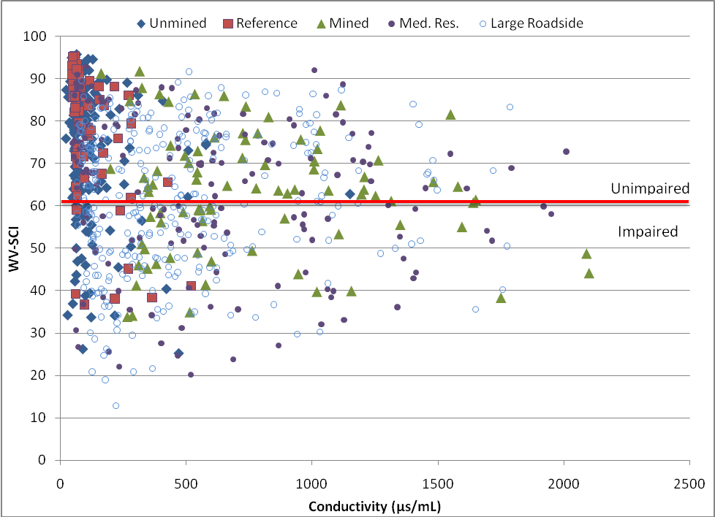
FIGURE 5. Conductivity versus WV-SCI for all site types at Argus Energy-WV, LLC. Data comprises 805 data sets from 1995 through Fall 2009.
95% Confidence Limits When Using Conductivity to Predict Stream Impairment
Because the cutoff for a stream to be listed on the WV-DEP’s 303-D list of impaired streams is a WV-SCI of less than 60.6, we wanted to know what conductivity would statistically generate such a listing. According to Dr. Stanley Wearden, Emeritus Professor of Bio-Statistics at West Virginia University, the statistically significant level of conductivity must be above 1,042.7 µs (95% CI of 871.3 & 1,214.1 µs) for the streams to generate a WV-SCI of < 60.6.
Success Rate of Conductivity in Prediction of Impaired Streams
When conductivity was used as the sole variable to predict impaired streams, the overall success rate was 61.63%, with a correct detection of streams that are impaired (WV-SCI < 60.6) being 44.93% and a correct detection of streams that are not impaired (WV-SCI > 60.6) being 63.33% of the time. Kruskal (J. Amer. Stat. Assoc., 1958) proposed that the overall per cent correct predictions can be thought of as a correlation coefficient for bi-variate data (r_{k} = 0.6163). The p-value for the r_{k} correlation is p < 0.0001, hence the prediction correlation is certainly significant. But the procedure isn’t very good for correctly predicting that a stream is impaired; of the 280 impaired streams in the dataset, the predicted WV-SCI ≤ 60.6 only 44.93% of the time (TABLE 2).
TABLE 2. Conductivity ≥ 1,042.7 µs used to predict impaired streams. Data comprises 748 data sets from 1995 through Spring 2009.
 | Observed
Predicted | Impaired | Not Impaired | Row Sum
Impaired | 31 (44.93%) | 38 (55.07%) | 69
Not Impaired | 249 (36.67%) | 430 (63.33%) | 679
Column Sum | 280 | 468 | 748

Conductivity and % Mayflies
From the figure below, one can see that the scatter plot of % mayflies versus conductivity showed a strong correlation (R² = 0.19), with mayfly percentages dropping off sharply once a conductivity level of about 650 µs is exceeded. % mayfly abundance rarely exceeded 10% when conductivities exceeded 1,100 µs (FIGURE 6).
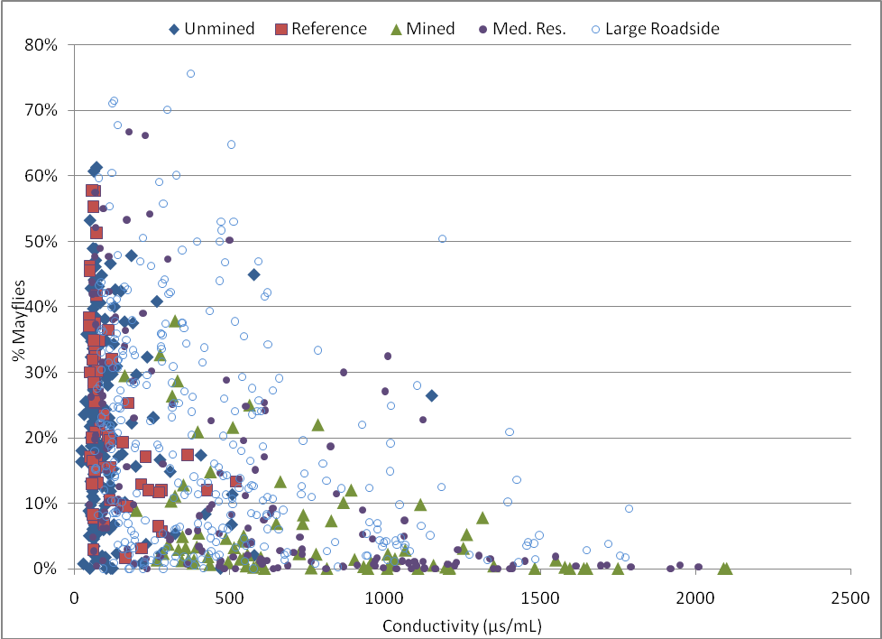
FIGURE 6. Conductivity versus % Mayflies all site types at Argus Energy-WV, LLC. Data comprises 805 data sets from 1995 through Fall 2009.
Percent mayfly abundances ranged from 0.0% to 75.6%. Not surprisingly, the lowest mayfly abundances were observed at those sites with the highest conductivities. Likewise, the highest mayfly abundances were usually observed at stations with the lower conductivity levels, but not always. Obviously, % mayfly abundance was directly correlated to the WV-SCI score, which ranged from a WV-SCI of 12.9 (site located downstream from East Lynn Lake on East Fork of Twelvepole Creek, April 2004) to a WV-SCI of 95.8 (upstream Bluewater Branch, April 2007).
WV-SCI and % Mayflies
Mean % Mayfly abundance for the 291 impaired data sets (WV-SCI < 60.6) was 8.7%, whereas mean % Mayfly abundance for the 508 not impaired data sets (WV-SCI > 60.6) was 22.7%. A fairly strong correlation was calculated (R² = 0.2676) between % Mayflies and the WV-SCI score. The trend line of % mayflies passes though the impaired WV-SCI score of 60.6 at about 15% mayflies (FIGURE 7). Thus, using this graph one could predict a WV-SCI score of < 60.6 when the benthic community comprises less than 15% mayflies. Dr. Stanley Wearden used a somewhat different regression equation, and determined that a 9.2% mayfly abundance was needed to statistically achieve a WV-SCI > 60.6 (95% CI of 7.0% & 11.1%). Dr. Wearden did believe that % Mayfly abundance was far more accurate at predicting stream impairment than Conductivity alone. Percent Mayfly abundance correctly predicted when a stream was impaired 65% of the time; and correctly predicted when a stream was not impaired 77% of the time. Overall success rate as calculated using the Kruskal (J. Amer. Stat. Assoc., 1958) correlation coefficient for bivariate data was 72.5%.
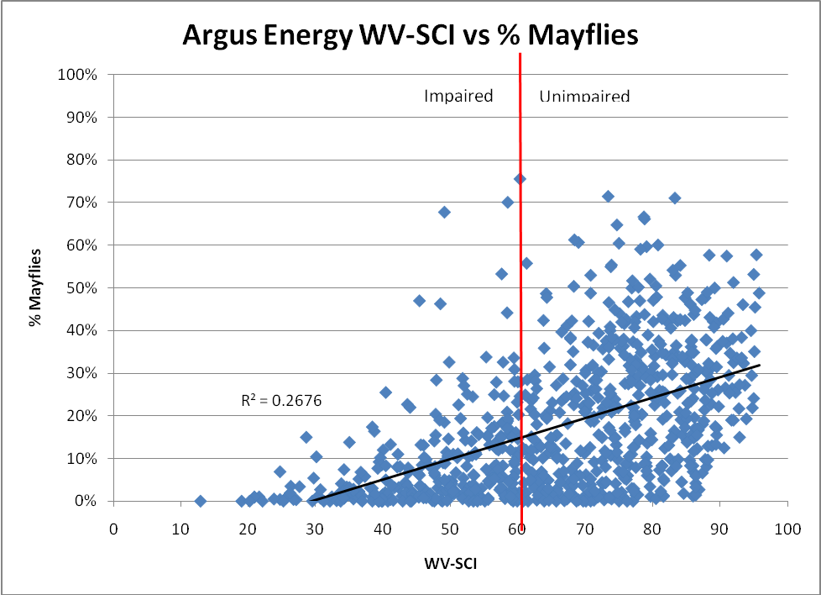
FIGURE 7. WV-SCI versus % Mayflies all site types at Argus Energy-WV, LLC. Data comprises 805 data sets from 1995 through Fall 2009.
Habitat Scores
Mean EPA RBP II habitat score of the impaired sites was 129 out of a possible 200, while mean habitat score for the unimpaired sites was 139. Therefore, not a large difference existed in overall habitat among most sites. Generally, habitat was quite desirable at the Reference sites and Unmined sites as well as many of the Mined sites, since most of these were directly downstream of mine areas, and were still in wooded areas with minimal residences. Habitat was less desirable at the Medium-Stream Residential sites, but usually improved somewhat by the time that the Large-Stream Roadside sites were reached. Habitat scores played some role in the benthic macroinvertebrate community, although the correlation between habitat score and WV-SCI was relatively low with an R² value of 0.0622 (FIGURE 8). Regression data analyzed by Dr. Stanley Wearden calculated that habitat needed to score > 110 (out of 200) in order to achieve a WV-SCI score > 60.6. However, using habitat as the only variable, habitat score correctly predicted when a stream was impaired only 21% of the time, but did correctly predict when a stream was not impaired 90% of the time. Overall success rate using the Kruskal correlation coefficient for bivariate data and using the habitat score to predict stream impairment was 64.6% (Kruskal; J. Amer. Stat. Assoc., 1958). In general, a modest increase in habitat could result in a substantial increase in the WV-SCI score.
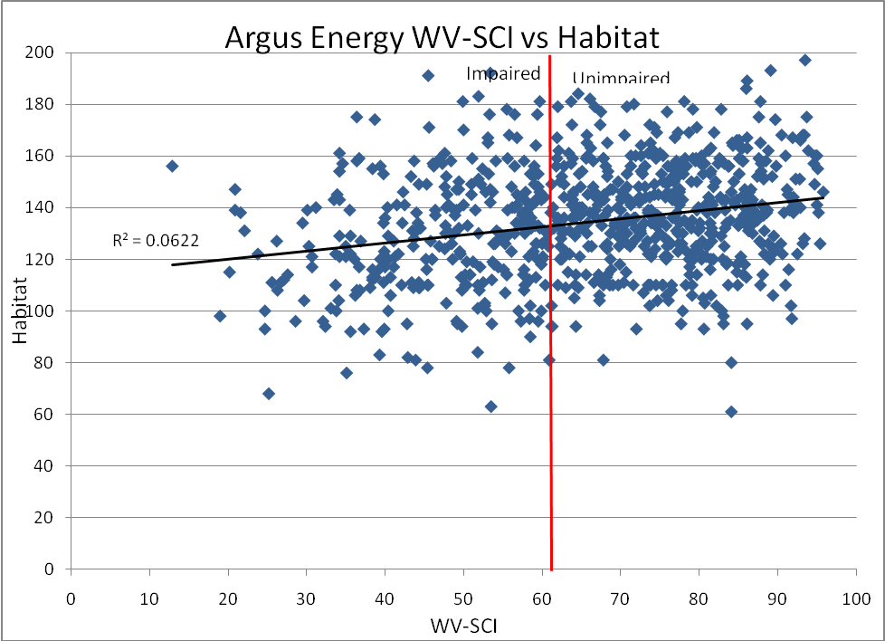
FIGURE 8. WV-SCI versus EPA RBP II habitat scores. Data comprises 805 data sets from 1995 through Fall 2009.

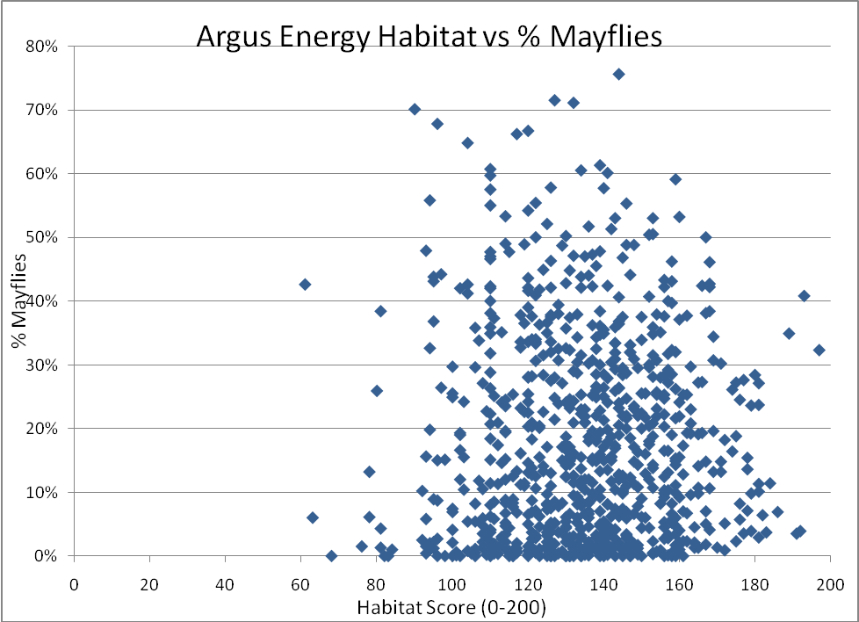
FIGURE 9. EPA RBP II habitat scores versus % mayfly abundance. Data comprises 805 data sets from 1995 through Fall 2009.
Although there was not a good correlation between Habitat scores and % Mayflies, it did appear that mayflies were not present at habitat sites scoring less than 90 (out of 200). However, this was because we had very few sites which actually scored below this level, and thus, the graph is somewhat misleading (FIGURE 9). This graph also illustrates that the % mayfly abundance was not tightly tied to habitat, but rather, is instead driven primarily by other factors such as water quality.
Closing
In closing, this paper is an on-going project. We are currently performing additional statistical analyses (ANOVAs) on the data to quantitatively determine if differences exist among the different site types with regards to conductivity, % mayfly abundance, and WV-SCI scores. It is fairly obvious that statistical differences will exist between the Mined sites and the Reference/Unmined sites, but it is not apparent if the Medium-Stream Residential and/or the Large-Stream Roadside sites will differ from the Mined sites or the Reference/Unmined sites. Lastly, we also are currently reviewing our database to evaluate the actual percentages of the functional feeding groups per site, by site type, in order that a statistical determination can be made with regards to functional feeding group.
References Cited
Gerritsen, J., J. Burton, and M.T. Barbour. 2000. A stream condition index for West Virginia wadeable streams. Tetra Tech, Inc., Owings Mills, Maryland. (Available from: http://www.wvdep.org/Docs/536_WV-Index.pdf).
Maggard, R.R. 2009. The effects of specific conductance of water on the benthic macroinvertebrate community downstream of coal mining activities. Paper presented at the 2008 Annual Meeting of the West Virginia Mine Drainage Task Force, Morgantown, WV March 31 – April 1, 2009
Pond, G.J. 2009. Patterns of Ephemeroptera taxa loss in Appalachian headwater streams (Kentucky, USA). Hydrobiologia. Published on-line: 14 January 2010.
Pond, G.J., M.E. Passmore, F.A. Borsuk, L. Reynolds, and C.J. Rose. 2008. Downstream effects of mountaintop coal mining: comparing biological conditions using family- and genus-level macroinvertebrate bioassessment tools. J. N. Am. Benthol. Soc., 27(3): 717-737.

