Datashed: An Online Tool for Passive Treatment System Monitoring and Maintenance¹

Shaun Busler², Peter Drake³, Bruce Golden⁴, Cliff Denholm², Tim Danehy², Tom Grote², and Margaret Dunn²

Abstract: Datashed is a user-friendly, interactive, GIS enabled online database developed by Stream Restoration Inc. to assist watershed groups, academic institutions, private industry and government agencies in the operation and maintenance of passive treatment systems. Using primarily open-source technology, Datashed provides a cost-effective and reliable solution to the management of data associated with environmental efforts. Specific, individualized functions can easily be added using common programming languages. One of these functions, called i-Map, is a Geographic Information System (GIS) that spatially connects the data stored within Datashed. Both anonymous and authorized users can easily upload, download, and print data from any standards-compliant web browser without the use of additional plug-ins or software.

Additional Keywords: database, open source, internet, Geographic Information System (GIS), operation and maintenance, AMD, mine drainage

_______________________________
¹Paper presented at the 2009 West Virginia Mine Drainage Task Force Symposium, Morgantown, WV, March 31 – April 1, 2009.

²Shaun Busler, GISP, Cliff Denholm, Env. Sci., Timothy Danehy, QEP, Tom Grote, Project Facilitor, and Margaret Dunn, PG are with Stream Restoration Incorporated (PA Non-Profit) and BioMost, Inc., Mars, PA.

³Peter Drake is the senior developer with 241 Computer Services, Mansfield, OH.

⁴Bruce Golden is the Regional Coordinator for the Western Pennsylvania Coalition of Abandoned Mine Reclamation, Greensburg, PA.

Introduction

For more than a decade, organizations have been installing passive systems to treat abandoned mine drainage throughout the Commonwealth of Pennsylvania. Through these activities, watersheds are being restored. According to an inventory of mine drainage treatment projects compiled by the Office of Surface Mining (OSM), over 280 systems exist within Pennsylvania. Many of these restoration projects, however, must be maintained properly in order to have a lasting impact. To prevent streams from reverting to their polluted condition, these projects must continue to function.

Volunteers, non-profit organizations, and government agencies have spent numerous hours collecting valuable water quality data in order to determine the effectiveness of these treatment systems. Dependent upon the organization, this data has a variety of end uses. Some groups enter this data into a computer database and use the data for reports, newsletters, etc. Other groups do not have a database and only keep paper records. Many times, government agencies store their data in proprietary databases behind firewalls for security. As a result, the availability of this data to the general public and to researchers is limited.

History

Stream Restoration Incorporated (SRI) has assisted numerous watershed groups throughout Pennsylvania with assessment, restoration, and protection projects. These efforts have included all necessary reports, studies, designs and construction oversight for the installation of over 30 passive treatment systems throughout Pennsylvania having a combined total of more than 200 components. With this experience, SRI understands the necessity of properly maintaining passive treatment systems and the need to make water quality data available to others.

In 2002, SRI began the development of the Datashed (www.datashed.org) web system to aid in the operation, maintenance, and monitoring of these passive systems. Work began on Datashed under a small United States Geologic Survey (USGS) grant to SRI to assist interns from Grove City College in monitoring passive treatment systems in the headwaters of the Slippery Rock Creek watershed. A small company, 241 Computer Services, offered to donate much of their time to create a simple interface for these interns to upload water quality data through the Internet and to provide downloadable information, such as schematics and inspection sheets, on the passive treatment systems. As funding was not readily available for Datashed, work was completed in small increments over time. Additional partners have contributed to Datashed since its inception and include: Western Pennsylvania Coalition for Abandoned Mine Reclamation (WPCAMR), BioMost, Inc., PA Department of Environmental Protection, US Environmental Protection Agency, Greene County Watershed Alliance, Indiana County Conservation District, Eastern Pennsylvania Coalition for Abandoned Mine Reclamation (EPCAMR), Slippery Rock Watershed Coalition, and others. The enhancements to Datashed have been increased with contributions from these project partners.

Features

As funding was limited, SRI decided to use Free and Open Source Software (FOSS) where available to reduce costs while increasing the longevity, security, reliability and stability of the web site. Commercial software would have cost hundreds of thousands of dollars to meet the requirements. The FOSS alternatives have met these requirements and reduced initial and recurring maintenance costs of the software. The current configuration of Datashed uses PHP, MySQL, Mapserver, Apache, and MediaWiki as well as a host of open source functional libraries. Datashed currently offers the following capabilities:

- Instant, 24/7 access to important documents such as Operation & Maintenance Plans, inspection sheets, directions to project sites, topographic maps, and aerial photos
- Password-protected data submissions (i.e., field data)
- i-Map, an interactive GIS map depicting all known passive treatment systems at abandoned mine sites in Pennsylvania and other datasets
- Multi-parameter project searches
- Printable monitoring reports and predefined graphs
- Public access to all water sampling data
- Wiki

Downloads:
One of the primary functions of Datashed is to offer access to materials that will allow organizations, especially volunteer-based programs, to easily monitor their passive systems. Datashed provides downloadable operation and maintenance plans, site schematics, aerial photos, as-built drawings, etc. In addition, Datashed uses Virtual Earth Web Services to allow users to view and print directions to the passive system based on their address.

Water Quality Data:
The data stored within Datashed can be viewed and downloaded from the web by anyone in several different formats. The data is found by searching for the passive system or stream within a multi-parameter query or by searching i-Map. Once the site is found, data can be viewed in dynamically-generated reports or downloaded as a CSV (comma separated value) file, which is easily opened in Excel, Access or other tools to allow further calculations and data manipulations.

No data may be uploaded to Datashed without first having an account. Users must type in their password before being able to access the data submission interface. Passwords protect Datashed from potential vandalism and false data entries and provide a traceable path to the source of the data. Data can be uploaded in several ways. For new organizations using Datashed, a tool has been developed to import large datasets in an electronic format. This tool assists in matching the fields within the organizations dataset to fields within Datashed. This tool also checks the data to ensure the data is within appropriate ranges (i,e., pH is between 0 and 14). Once an organization has imported the historic dataset, the organization could continue to use the import tool or they could use an interface where they simply type the data into an online form. For organizations that would like a comprehensive assessment of their passive treatment system, operation and maintenance forms can be created. Information, such as erosion, berm

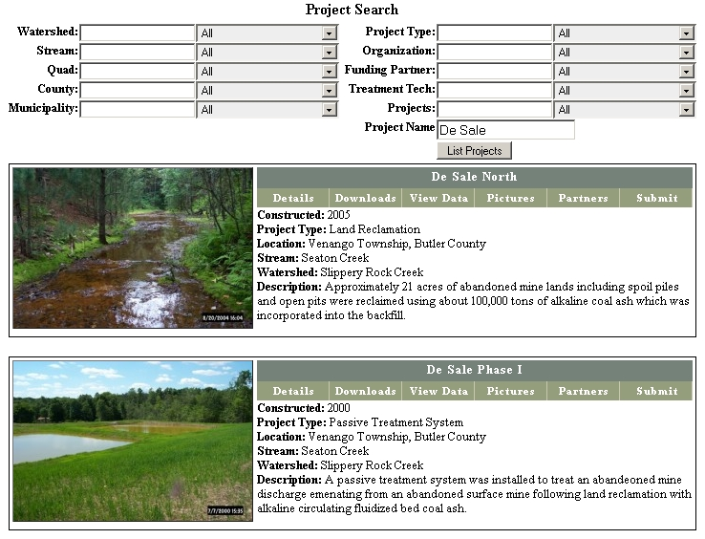
Figure 1: Project searches can be based on multiple parameters and by name.

stability, valve operability, etc., can be entered into an online form. In addition to water quality and operation and maintenance data, users may upload photos.

Once the data has been uploaded to Datashed, the data can be viewed or downloaded as stated previously. In addition, dynamically-generated graphs are available. These graphs use the most up-to-date information stored within Datashed at the moment they are generated. As new data is uploaded to Datashed, these graphs are updated to reflect these changes.
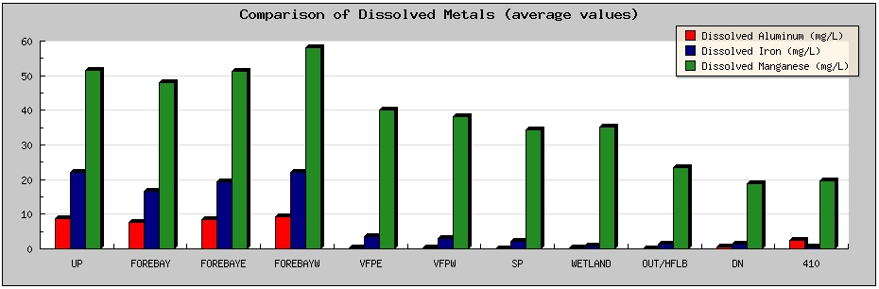
Figure 2: Example dynamically generated graph.

i-Map - Geographic Information System (GIS):
An innovative GIS application called i-Map has been developed to spatially connect the data stored in Datashed. The spatial component of Datashed is run utilizing MapServer, a robust, free and open source GIS software originally developed by the University of Minnesota ForNet project in cooperation with NASA and the Minnesota Department of Natural Resources (DNR). A wide variety of government agencies, non-profit organizations, businesses, and academia are actively involved in using and developing this software such as the US Army Corp of Engineers, Minnesota DNR, USDA Forest Service, and Canada Center for Remote Sensing and Natural Resources Canada. A custom-designed JavaScript/HTML interface allows users to easily find sampling points and directs users to additional content on the site. Each passive system can be queried for average water quality data. Terrabytes of additional geographic data are made available using Web Mapping Services (WMS), such as NASA’s Landsat 7 satellite and USGS topographic maps, and on-the-fly projections. Not only can i-Map be a WMS client, i-Map can serve spatial data to other internet and desktop applications. In addition, customized GIS maps can be generated from parameters stored within the database, such as the topographic maps found in the download section of Datashed.

FACTS:
Funding AMD Chemistry for Treatment Systems (FACTS) is a program of WPCAMR offering funding for chemical analyses to watershed organizations in Pennsylvania. In cooperation with WPCAMR, many new features have been incorporated to Datashed to create a powerful data management system and repository for data collected for the FACTS program. FACTS standardizes the process of establishing a sampling schedule and coordinates the analysis of water samples with the watershed organization and participating laboratories.

Wiki:
A wiki is a collection of web pages that is edited by users. Datashed uses wikis in several different ways. Administrators of Datashed are capable of adding and modifying content within the Help pages without having to learn HTML or other programming languages, which also prevents accidents with the code. In addition, any organization using Datashed can use the Community Wiki to generate content that may be useful to other organizations, such as instructions on how to use different types of field sampling equipment.

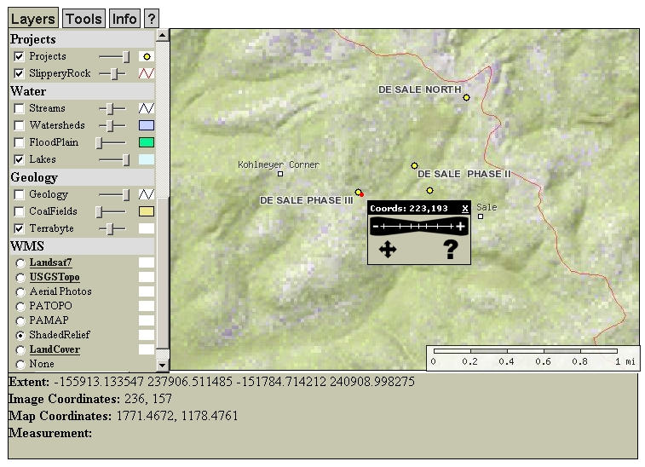
Figure 3: Screenshot of i-Map, the GIS component of Datashed.

Future Upgrades

Datashed is a work in progress. Additional features are being added to meet the needs of the project partners. Below is a list of a few of the more prominent feature requests:

- Tutorials on using Datashed.
- Allow the user to define custom graphs and reports based on date, location, etc.
- Modeling of passive treatment systems to determine the effectiveness of the system and when maintenance may be needed.
- Management interface to add, modify, transfer, or delete data.
- Develop online tools to calculate flows (multiple methods) and loading, unit conversions (ex. gallons to liters), etc.

Conclusion

It is the goal of SRI for local groups to be actively involved in the operation, maintenance, and monitoring of treatment systems. Datashed has begun to help us achieve this goal. Although a work in progress, many features are currently available to store and distribute data on passive systems. Please send us any comments or suggestions to make the site even better!

