INAP – Global Acid Rock Drainage (GARD) Best Practices for
AMD Control and Treatment

T.D. Chatwin and K.D. Ferguson

Abstract

The concept of the “Social License to Mine” that the mining industry must maintain with the people and governments of the world is now well accepted within the industry. The mining industry supplies the minerals and employment opportunities while maintaining the local environment to an ever increasing standard of response. Not only are these present standards becoming increasingly stringent, the anticipation of future regulations and maintenance of future conditions will become even more rigorous. For those companies that are mining or encountering sulphide minerals, whose exposure can cause acid rock drainage (ARD) the need to protect the environment and to meet evolving standards can be challenging. In this paper we will discuss INAP’s³ contributions to best practice management of ARD and in particular its efforts to develop the Global Acid Rock Drainage (GARD) Guide as a means to advance best practice management of ARD today and into the future.

Introduction

The essential task of the mining industry is to provide raw materials to the world’s economies at a reasonable cost. Metals and minerals are essential to life as we know it, and they are an important element of all economic activity. For the mining industry to accomplish this mission, they must be effective, efficient and profitable, and they must be good citizens. Don Argus, Chairman of BHP Billiton expanded upon this concept in the 2007 BHP Billiton Annual Review, “While shareholder value is our primary driver, every decision the Board makes takes into account the needs and expectations of all our stakeholders; customers, resources owners, communities and governments, partners, suppliers and our employees.” He goes on to say, “We have numerous examples that demonstrate our absolute commitment to improving the quality of life of the communities we work with and to minimising harm to the environment.”
For a mining company to be successful, it must pay attention to its bottom line. It must control and reduce risk, and it must be in a position to find and develop future mining opportunities.
For a mining company to be sustainable they must first be profitable. In a free market economy, you just can’t have a sustainable unprofitable company. In fact, the level of profitability in large degree determines the resources available to support the social license. But as mining companies are recognizing to be the “preferred mine developer” enhancing their sustainability they must be willing to share those profits with their stakeholders and well as their shareholders. Moreover, they must develop expertise in fields that were not established 20 years ago in the industry – sociology, community planning and micro-finance, to name three.
By becoming the “preferred mine developer” the mining company reduces its risks. It reduces the risk of not being selected to develop a new mine and to obtain permits and approvals, but also the risk of remediation costs of an unexpected ARD event. Mining companies can not just concentrate on the short term; they must plan for the future and mitigate any potential of adverse occurrences – financial, social or environmental. Mining companies must continually prepare to address future risk. Often times these risks are not just financial, they can impact the very core of a sustainable company - stakeholder trust.
Like every license, the social license to operate or mine, comes with a fee. That fee is the cost of assuring that all employees are safe and healthy, that the quality of life in the communities in which mines operate are improved and the environment is not harmed by the operations. During the past decade, mining companies have accepted this situation as a fact of life. In fact, the social license fee has become the price of entry into the game.
This change of attitude has occurred because the need to access resources has become more competitive, and mining companies must demonstrate their ability to find the ore, to mine the ore, to process the metals and to restore the land better than anyone else. As Paul Skinner, Chairman of Rio Tinto said, “Mining is a long term, capital intensive business, in which assets are often situated in remote locations, and can last for 30 years or more. This extended timescale means that, if we are to deliver financial returns to host governments, to local communities and our shareholders, we need economic, environmental and social stability.”
Paul Dowd of Newmont said, “Treating acid drainage once it has occurred, or mitigating environmental impact after it has occurred, is usually an admission that something has gone wrong either in the characterisation, planning, design or operation of a mine. It is Newmont’s belief that acid drainage can be prevented if some key principles are followed throughout the life of a mine, from exploration through to closure.” Paul Dowd listed some important principles of ARD management that we have modified and expanded:
- Focus on ARD prevention rather than treatment. (The mission of INAP)
- Minimize disturbed material.
- Complete characterization of ore, waste rock and tails.
- Plan and design for closure from the feasibility.
- Update detailed closure costs on a regular basis.
- Integrate mine rehabilitation into the day-to-day mine operations.
- Know the potentially acid forming (PAF) and non-acid forming (NAF) characteristics of all disturbed material
- Maintain good quality control of engineering works.
Rather than placing efforts relating to ARD at the end of the operation during mine closure, ARD planning and implementation activities needs to occur at “day one” of exploration and throughout the mine life. This planning should continue throughout design, construction, operation and closure. Continuous ARD planning and management is imperative to successful ARD prevention.
The cost of ARD mitigation for the United State ranges from $1.2 billion to $20.6 billion USD. These costs estimates were for operating company liabilities at hard rock sites. In addition to these costs, the U.S. Office of Surface Mining (OSM) estimates that the current ARD liability at coal sites as $8 billion USD, which includes liabilities relating to health and safety, as well as environmental costs.
THE Path forward
The path forward for ARD prevention has a number of participants. The primary drivers for the prevention of ARD are the mining companies. They need to do the planning, make the commitments, and earn the social license through demonstration of excellence. Next are the stakeholders, they in large degree are the beneficiaries of the mining company’s good works, but inturn they can enhance and return these good works. INAP is one of those stakeholders. In this section we will present INAP’s new initiatives, and update you on the progress of the GARD Guide. The final and perhaps the most important element of the path forward is you.
INAP’s Role
INAP is an organization of international mining companies dedicated to reducing liabilities associated with sulphide-bearing materials and metal leaching. INAP was founded in the mid-1990’s to develop and share information, experience and resources to prevent and treat acid drainage. To produce potential solutions for this problem INAP facilitates collaborative research. Some of our recent research topics include:
          - Treatment of Sulphate in Mine Effluents
          - Tailings and Waste Rock Co-Mix
          - Rum Jungle Waste Rock Cover
          - Store and Release Cover
          - Long-term Performance of Dry Covers
          - Scale-Up of Country Rock Testing
          - Hydrologic and Geochemical characterization of Waste Rock Dumps
          - Passivation of Acid Generating materials
One of the key elements of INAP is technology transfer. As our name indicates we are a network to transfer information, data and ideas within the mining industry and its stakeholders. We support forums to present and discuss ARD issues and solutions. INAP is the major sponsor of the International Conference of Acid Rock Drainage (ICARD). ICARD8 will be held in Skelleftea, Sweden on June 22-26, 2009. INAP is also planning to reinstitute technical focused workshops addressing specific needs of the industry. INAP believes that technology transfer and capacity building is key to the successful implementation of our mission. Not only do we as an industry need to develop and expand the technical and managerial capabilities of our people we must support the enhancement of the capacity building among our stakeholders.
The GARD Guide

INAP’s largest, potentially most influential activity to-date is the funding of the GARD Guide.
The development of the Global Acid Rock Drainage (GARD) Guide is sponsored by INAP with the support of the Global Alliance.

Research into the process of ARD formation and methods to minimize its impact have been conducted for over 50 years. Much progress has been made in the last 20 years through a number of research consortiums. As such, there is a considerable body of scientific and engineering guidance available on ARD already through INAP, MEND, BCARD, WV Mine Drainage Task Force, BC MEMPR, ADTI, ACMER, WRC, PADRE and other programs. The research however is in disparate references, not easily accessible and tends to be issue, commodity or geographical centric. INAP desires to consolidate the information and produce a Guide that would be up-to-date and global in scope.

The objective is to produce a guide that would be a key reference for the mining industry, regulators, NGO’s and the public on the subject. The Guide will address the production of contaminants from sulphide mineral oxidation that can result in ARD, neutral mine drainage (NMD) and saline mine drainage (SD).

The Guide will summarize the best technical and management practices with the objective of creating a body of work with high industry and external stakeholder credibility. The Guide will cover all phases of a mining operation from initial discovery through to final closure. In that way it will assist industry in providing high levels of environmental protection, assist governments in the assessment and regulation of affairs under their jurisdiction and enable the public to have a higher degree of confidence in and understanding of acid prevention proposals and practices. Overall, the Guide will provide a structured system to identify and catalogue new analysis techniques, new technology and understanding developed through INAP, the Global Alliance¹ and other organizations.

The overall challenge of the GARD Guide is to identify and synthesize the best available information in order to develop a global state-of-the-art summary while at the same time outlining options for different geo-climatic environments.

A modern GARD Guide will fill a need by being:

- Current with available scientific and engineering understanding
- Comprehensive by covering all aspects of ARD formation and management
- Global by considering geographic differences in climate and environmental setting
- User friendly with web based access and search capability
- Updatable via the web
- Accessible to a broad range of readers from those with a lower technical knowledge (eg. teachers and communities) to those with a technical background but not necessarily in ARD or environmental management

Principles of the GARD Guide

The purpose of the Guide is to articulate the issues and identify sound practices and gaps in knowledge or guidance on particular ARD issues. The guide is intended to promote consistency in approach and improve understanding and application of sound practices for ARD management.
Various definitions and nomenclature have been developed in different countries, regions and individual companies related to ARD management. The GARD Guide will provide key definitions and nomenclature early in the document to develop a common understanding for readers. The development and promotion of one set of definitions, nomenclature, acronyms and standards could be one of the most significant contributions made by the GARD Guide. Care is needed however to ensure the Guide does not have an overall North American bias.

The GARD Guide must be applicable to existing and historic ARD issues not just to new mines. The guide is not a design document as that requires a high level of understanding and site specific knowledge of a particular project or mine. Detailed design of ARD mitigation techniques will continue to be conducted by knowledgeable practitioners.

Specific objectives of the Guide are to:

- Articulate the issues associated with sulphide mineral oxidation;
- Reference and improve the understanding of best global practice, customized where necessary for special geo-climatic conditions;
- Promote a risk-based, pro-active, consistent approach by encouraging planning for and implementation of reduction and control of ARD at the source;
- Leverage the world’s ARD expertise and share expertise with developing countries;
- Support the ‘Equator Principles’ developed by a consortium of lending institutions and ICMM’s objectives by achieving ‘global best practice’ in future mining projects.

Considerable literature exists for the assessment, prediction, control and management of ARD from coal. Therefore key coal ARD guidelines, compendia and references will be summarized and referenced.

Target Audience
The target audience for the GARD guide includes:

- Mining and Mining Service Companies
- Governments (national regulatory or land management agencies, IFC, World Bank, regional development agencies etc.)
- Consultants
- Researchers/ Educators/ Academia
- Community / Communities of interest/ Stakeholders
  - Bankers
  - NGO’s
  - Indigenous Peoples

The Guide is a technical document designed primarily for a scientist or engineer with a reasonable background in chemistry and the basics of engineering with little specific knowledge of ARD. The principal user will typically be an employee of the mining industry, regulatory agency, research organization or consulting company.

Status of the GARD Guide

The development of the GARD Guide encompasses four phases:

First Phase
- Beta version prepared by Golder Associates
- Wiki structure developed for Guide
- Further expert input and targeted workshops
Second Phase
- Broad stakeholder review of draft through INAP website
Third Phase
- Update, publish and rollout by June 2009

Fourth Phase
- training sessions on use of Guide
- updates and continuous improvement of Guide

The project is currently in the second phase.

The GARD Guide is being created through the contributions of many individuals and organizations. A team lead by Golder Associates prepared a “beta version” of the Guide in June 2008. INAP established broad-based Steering and Advisory Committees to direct preparation of this document. INAP also received input from several other contributors, peer reviewers, workshop participants and interested stakeholders. INAP sponsored workshops in partnership with ADTI/US EPA and the South African Water Resources Commission in Denver, Colorado and Johannesburg, South Africa respectively to review selected chapters. The workshops were well attended and excellent input was obtained on the Guide. INAP gratefully acknowledges all of this assistance.

The GARD Guide is based on a “Wiki” model. Chapters and subchapters are constructed as pages. Internal links are provided for topics where more detail is available. Links to external web sites will be included to organizations and other more detailed or specific topic references.

The current draft of the GARD Guide has 10 Chapters:

- Introduction
- ARD Process
- Corporate, Regulatory and Community Aspects
- Characterization
- Prediction
- Prevention/Mitigation
- Treatment
- Monitoring
- Management and Performance Assessment
- Communication and Consultation

Sustainability considerations are woven throughout the draft Guide. The Guide is a “work in progress” and will be updated and improved through its “Wiki” structure.

The draft Guide contains a number of flow charts that guide the reader through the application of the technology. Example draft flow charts are shown in Figures 1 to 3. Where required, a practitioner would develop an ARD management plan fully integrated with mine operations (Figure 3). The successful implementation of an ARD plan is one of the key goals of the process outlined in the GARD Guide.

Draft GARD Guide Availability

The draft Guide is currently available for review at:

http://www480.pair.com/aturner/gardwiki/

INAP plans to hold additional workshops to review the draft Guide in Europe, Australia and South America in 2009. An updated version of the GARD Guide will be produced in May 2009, uploaded to INAP’s website and formally launched at the 8th ICARD conference.
YOUR ROLE
The final element of the path forward is you. You are the people that will combat this most serious and potentially enduring environmental problem of the mining industry. If we and our children are to continue a “quality of life” that we have grown to expect, the mining industry must prosper to supply the raw materials that feed the economies of the world. For the mining industry to prosper, the issues of ARD must be addressed. You have the education, the experience, and the ever growing knowledge base. Many people are working to supply the tools that you will need and to support your efforts.
INAP is working to create the GARD Guide as important tool in addressing ARD issues. INAP needs your help and invites all attendees of this workshop to contribute to its development by reviewing the draft Guide and providing comments to INAP by April 1, 2009 via:

Mr. Gilles Tremblay/Ms. Charlene Hogan
GARD Guide Secreteriate
gtrembla@nrcan.gc.ca
chogan@NRCan.gc.ca

REFERENCES
Argus D, Chairman’s Review, 2007 BHP Billiton Annual Review, P. 7, 2007.
Skinner P, Message from the Chairman, Rio Tinto 2006 Sustainable Development Review, P. 1, 2006.
Dowd P J, The Business Case for the Prevention of Acid Drainage, In ‘Proceedings of the 5th Australian Workshop on Acid and Metalliferous Drainage’, 2005.
Department of the Interior, Office of Surface Mining, Reclamation and enforcement, Abandoned Mine Land program: Accomplishments, Washington, D.C. DOE-OSMRE, 2003

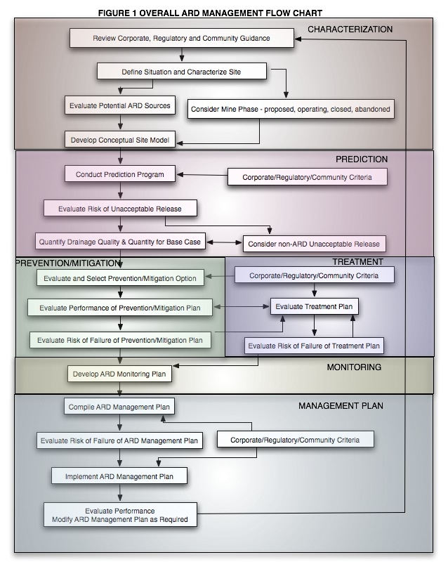
Figure 1 Draft Overall ARD Management Flow Chart

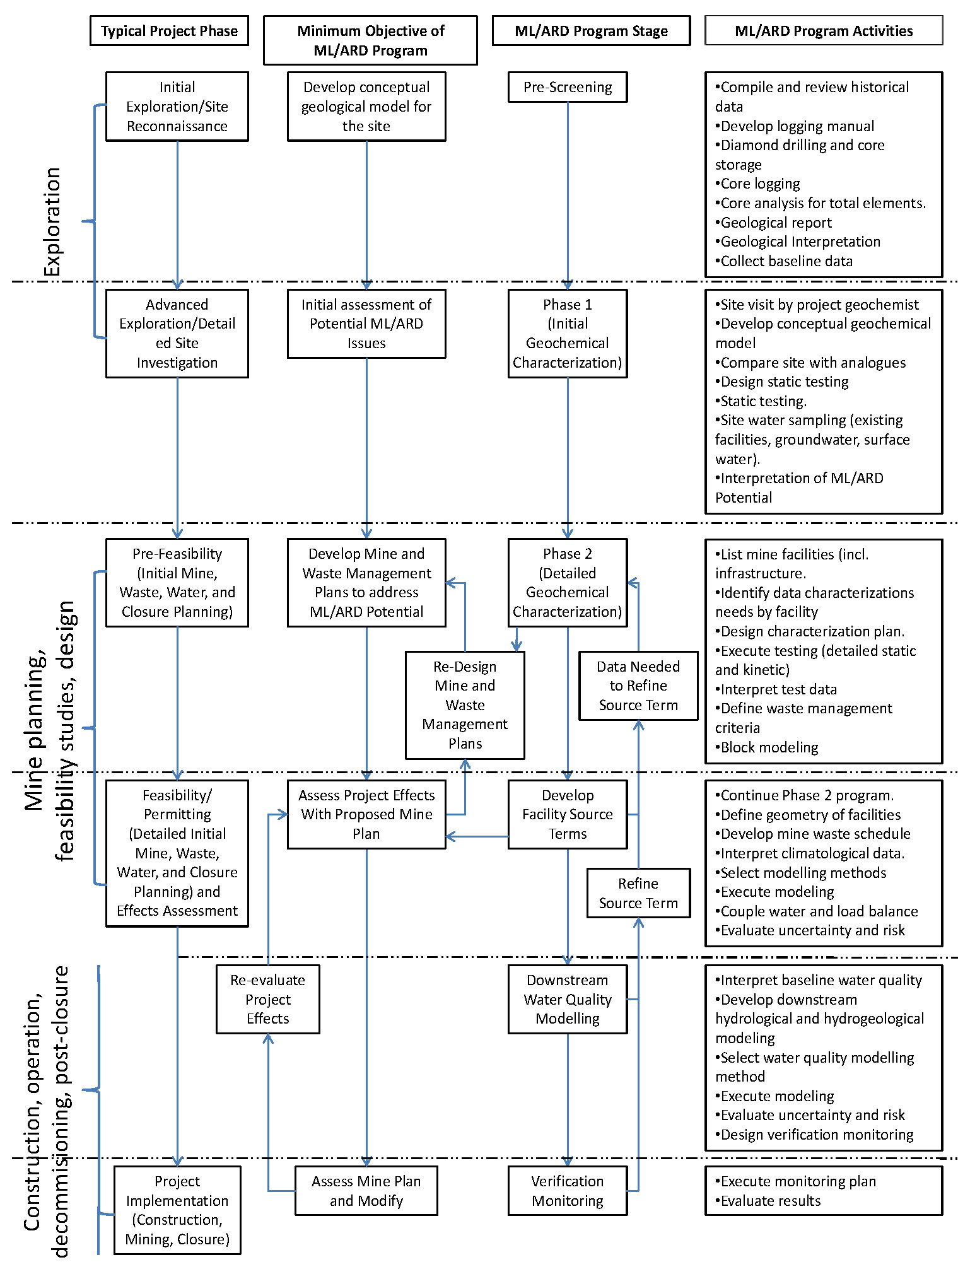
Figure 2 Draft Prediction Program Flow Chart

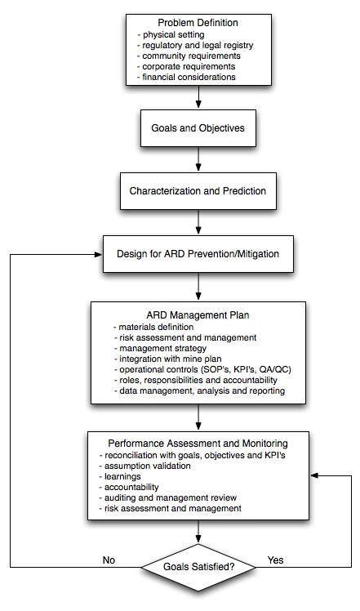
Figure 3 Draft ARD Management Plan Flow Chart

International Network for Acid Prevention (INAP), Salt Lake City, Utah, USA
Sustainability Engineering, North Vancouver, BC, Canada ³ INAP is presently composed of 9 member companies including Anglo American, Barrick Gold, BHP Billiton, Freeport McMoRan, Kinross Gold, Newmont Gold, Rio Tinto, Vale INCO and Xstrata.
Global Alliance is composed of regional environmental organizations that deal with water issues including mine-influenced waters. The Global Alliance includes Acid Drainage Technology Initiative (ADTI) in the United States, Mine Environmental Neutral Drainage (MEND) in Canada, Partnership for Acid Drainage Remediation in Europe (PADRE), Australian Centre for Extension and Research (ACMER), and the South African Water Research Commission (WRC).

