Flooding Conditions in the Meigs Mine Pool Complex

Mary Ann Borch
Ohio Department of Natural Resources,
Division of Mineral Resources Management
280 East State Street
Athens, Ohio 45710
Maryann.borch@dnr.state.oh.us

Abstract
The purpose of this paper is to provide background information and an update of hydrologic information regarding the Meigs Mine pool complex. Mine pool development, water quality, water quantity, and impacts to the local hydrology are briefly covered.

Mining was completed and the mine pool began to fill in 2002. The mine complex is below drainage with the exception of the western edge of the Raccoon mine where the coal seam is just at or near Raccoon Creek. The overburden thickness ranges from 200 to 600 feet. Pumping began from the Meigs 2 pool on January 28, 2008. The Meigs 31 mine has not yet begun pumping to control the mine pool.

Near surface aquifers are impacted by surface tension induced fractures. In areas of low cover the inflow of groundwater to the mine are direct. In most cases, the stream loss may be going into the shallow subsurface, facilitated by fracture dilation. If the strata are friable, the ability of the fractures to heal is diminished as is the case in some streambed dewatering above the Meigs 2 mine.

Recharge into the mines exhibits seasonal variability. Incremental differences in the fill rates are apparent from specific monitoring points. In general, the pool rises and falls in concert over the complex with the exception of the 3rd NE section of Meigs 2. Recharge rates were volumetrically determined for the mine pool complexes.

Since there is a potential for uncontrolled discharges to low-lying stream valleys, maintaining a lower pool elevation through pumping is required. Water quality is expected to improve dramatically with time. Due to the partially unflooded mine pool, the mine pool water quality may require perpetual treatment.

Introduction

As underground mines close, mine pools are becoming commonplace in the Appalachian coal-bearing region. Mine pools form and connect with nearby or adjacent mines to form aquifers that will require pumping in order to avoid uncontrolled discharges to the surface. These discharges have the potential to pollute streams and near-surface aquifers with high sulfate and metal-rich water. The purpose of this paper is to establish background and early to recent flooding conditions of the mines making up the Meigs Mine underground complex.

Background

The Raccoon, Meigs 31, and Meigs 2 mines comprise the complex located in Meigs, Vinton, and a small section in northern Gallia counties of southeastern Ohio near the town of Wilkesville. While mining has not occurred in this complex since 2002, the three no-longer mined complexes remain permitted, and additional permits have been obtained in order to build facilities that will pump and treat the water. The complex is located adjacent to an abandoned underground mine along Raccoon Creek. Mining began in 1972 in the Meigs 2 complex, mining in Meigs 31 started the following year, and then in 1974 mining began in the Raccoon section. The Meigs 1, Meigs 3, and Raccoon were connected during the active mining operation, and are now collectively referred to as Meigs 31. This descriptor will be used throughout the balance of this report.

All three mines exploited the Clarion No. 4 coal seam. Both room and pillar and longwall methods were used. The footprint of the entire mine complex is 23,500 acres (36.7 square miles). Figure 1 map shows the entire complex. The Meigs 31 and Raccoon mines are openly connected, whereas Meigs 2 is separated from them by a solid coal barrier, 1,350 feet wide at its narrowest point.

During mining, the workings were dewatered by pumping water to the surface for treatment. With mining complete, the potential exists for mine pool water to surface and contaminate various tributaries of Leading Creek and Raccoon Creek with metal laden water high in total dissolved solids. This potential discharge would occur in the low-lying stream valleys where vertical fractures from stress relief or from subsidence damage may provide a conduit to the surface.

CONSOL Energy Inc. (CONSOL) will provide for the perpetual treatment of the discharged mine water by building and operating a wastewater treatment plant. A maximum rate of 3000 gpm of contaminated mine water will be pumped from Meigs 2 and travel overland into Meigs 31 where it will mix with the Meigs 31 water. Water will then travel eastward and down dip and be withdrawn from the South Bleeder shaft and treated. In January of 2008, pumping from Meigs 2 began. Currently, Meigs 31 is not yet being pumped.

Physiographical and topographical Setting

The mine complex lies within the non-glaciated portion of the Allegheny Plateau. Surface relief is moderate with rolling and steep sided hills and narrow mature valleys. Over Meigs 31, the land surface elevations range from 640 to 1029 feet m.s.l. with a maximum relief of 400 feet. Over Meigs 2, the topographic elevations range from 590 to 870 feet m.s.l. with a maximum relief of 280 feet. Stream gradients in this region are low to moderate. Land use patterns are primarily hardwood forests and pasture.

Geology

The bedrock geology consists of sedimentary rocks of Pennsylvanian and Permian age. The strata are from the Allegheny and Conemaugh formations. These strata strike north 25.5° east and dip gently to the east-southeast (65.7°) at an average rate of 30 ft/mi. A grabben fault was encountered during mining beneath the mains separating Raccoon Mine from the old Mine 3. Very little limestone is encountered in the Meigs 2 overburden except on the southeast side. However, in the Meigs 31 complex, the Clarion Coal is overlain by the Vanport limestone.

Hydrogeology

The mine complex is entirely below drainage with the exception of the western edge of the Raccoon Mine where the coal seam is just at or near Raccoon Creek (Refer to Figures 2 and 3 topographic maps). The elevation of the Clarion coal ranges from 611 feet m.s.l. at the western edge of the mine declining to 250 feet m.s.l. on the eastern side. The coal thickness is from 4.5 – 6.5 feet and the overburden thickness ranges from 190 to 640 feet over Meigs 31 and 115 to 400 ft m.s.l. over Meigs 2. Above the complex, the lowest topography is at approximately 600 ft m.s.l.

No significant quantities of water were encountered during drilling operations at Meigs 2. However, much water was encountered during mining of low cover areas, especially in the west sides of the mine. The primary water producing zone is 77 to 148 feet below the surface which is at 764 ft m.s.l. The hydraulic conductivity in this zone ranged from impermeable to a high of 5.67 x 10^{–5} cm/sec. The controlling factor in productivity is due to secondary permeability that exists as joint systems, bedding planes, and natural fractures.

Groundwater flow in this area is almost solely restricted to the interaction between near vertical fractures and bedding planes separations, which is to be expected due to the low primary permeability of the strata. In Appalachian valleys, groundwater flow occurs as vertical infiltration along valley walls via stress-relief fractures and lateral movement along bedding planes fractures (Wyrick and Borchers, 1981). Permeability in this region is thought to decrease with depth by an order of magnitude for each 100 feet (Siplivy, 2004).

Effect of Longwall Mining on the Permeability of the Strata

The longwall method of underground mining includes the excavation of large rectangular coal blocks called panels. The face, where the coal is removed, is generally more than 1,000 feet wide and the length of these panels can be 5,000 feet or more. Longwall mining exhibits relatively predictable surface subsidence features. Total subsidence movement is to a large extent influenced by overburden thickness and lithology.

Kendorski (1993) provides a model that describes types of fracturing above longwall mines, from the mine roof to the ground surface as shown in Figure 4. The average mined seam thickness for the Meigs Mine complex was six (6) feet.

Aquifer dewatering is enhanced by enlargement of existing fractures or opening of new fractures above the zone of caving during a subsidence event. Both represent an increase in permeability and porosity that could result in dewatering aquifers or streams. Dewatering of the aquifer is usually limited to active mining areas. As the strata settles and becomes re-compressed, groundwater levels may rebound as flow paths to the mine become more restricted and less direct. These fractures may heal themselves with time if sufficient amount of clay and shale material are in the strata. On the other hand, if the strata are friable sandstone units with little silts and clays, the ability of the fractures to heal is diminished.

Near surface aquifers are dewatered by surface tension induced fractures. In areas of low cover where vertical subsidence-induced fractures intersect with surface tension fractures and natural stress-relief fractures, water infiltration into the mines may be direct. Wyrick and Borchers (1981)
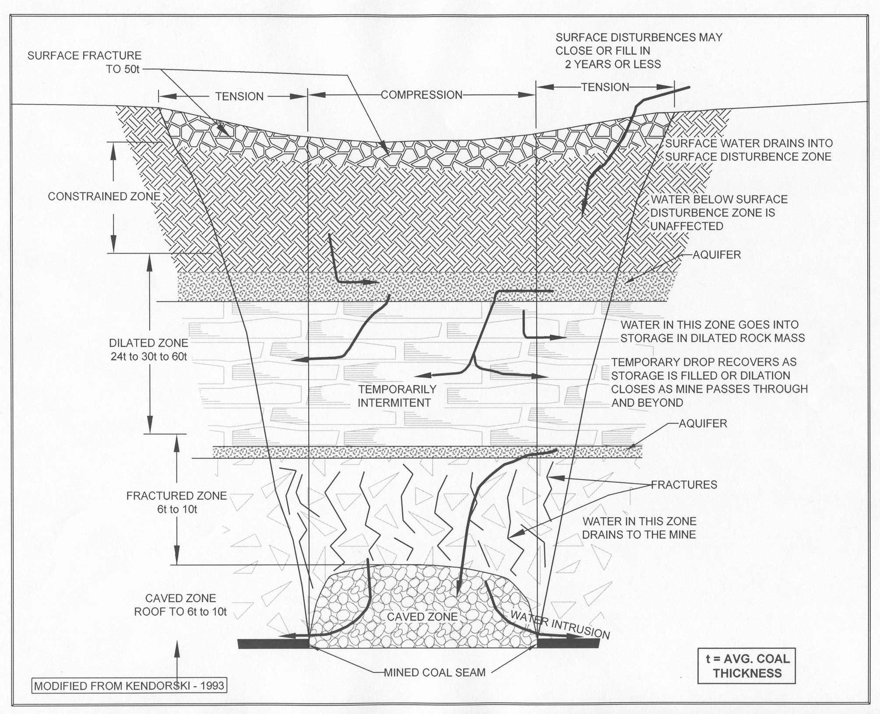
Figure 4. Longwall Subsidence Fracture Model

and Ferguson (1974) describe stress relief fractures in the Appalachians that extend to a depth of approximately 150 feet in valley bottoms and sides.

Mine Pool Characteristics

Mines are recharged by vertical infiltration, lateral inflow from adjacent flooded mines and from ground water in the coal itself. Seven mineshafts are accessible for pool level monitoring. The water sampling locations are the South Bleeder over Meigs 2 and the South Mains over Meigs 31. All shafts and monitoring locations are shown on the topographic maps. Recharge into the mines reflects the seasonal climatic precipitation as shown in Figure 5a and 5b. The graphs show a long-term trend of seasonal changes in mine water entering the mine pool. Due to the 1,350 foot barrier separating Meigs 2 from the Meigs 31 and Raccoon Mine complex, the Meigs 2 mine pool acts independently from the Raccoon and Meigs 31 mine pool. The Raccoon and Meigs 31 mines are hydrologically connected and therefore act in concert. Incremental differences in the fill rates from specific monitoring points are apparent.

Prior to pumping out of Meigs 2, the average monthly rate of change from Jan 2006 through January 2008 was 1.44 feet/month. The 3rd NE shaft was slightly slower at 1.2 ft/month. Meigs 31 also had an average monthly rate of change of ~ 1.4 ft/month prior to pumping from Meigs 2 into Meigs 31.
Figures 5a and 5b. Graphs showing the rate of mine pool flooding and seasonal variability

Recharge rate calculations

Different sections of the mine commonly have distinctly different recharge rates. Siplivy (2004) segregated eight recharge areas on the western side of the mine complex; primarily at the Meigs 2. These discrete inflow zones are defined as areas of the mine beneath a stream valley, areas with prominent lineaments, and areas with shallow cover ranging from 115 feet to 220 feet. Recharge rates were determined volumetrically for the Meigs 2 and for Meigs 31 (Raccoon, 1 and 3) sections. Siplivy based recharge rates on mine pool inflow volumes over a 322-day time period. After mining ceased, water levels were monitored in the mine pools. Volume and inflow rate were calculated using mine geometry parameters, in-mine elevations, type of mining, and areas of inundation and gob.

For Meigs 2, with a volume of 1,097,645,880 gallons, the inflow rate was estimated at 2367 gpm over 11,900 acres with a 75% coal recovery rate or 0.266 gpm/acre.

For Meigs 31, with a volume of 837,197,255 gallons, inflow rate was estimated at 1811 gpm over 11,600 acres with a 55% coal recovery rate or 0.284 gpm/acre.

Pumping mine pool to control pool elevation

If Meigs 2 were allowed to fill up, the pool would inundate to the maximum coal elevation of 585 feet m.s.l.; beyond this elevation, recharge will continue to increase the piezometric head of the mine pool above the actual elevation of the coal. As the pool rises to connect with the near-surface water table, a discharge (break-out) would occur at a topographic low at approximately 640 feet m.s.l. in Sisson Run in the northeast corner of Meigs 2. Two class V injection wells will pump water from Meigs 2 into Meigs 31 in order to maintain a safe pool or control elevation of approximately 560 feet m.s.l. With the mine pool held at or below this elevation, a built-in storage capacity will prevent an uncontrolled break-out should the pumps shutdown and/or the treatment system require maintenance. With the water held at or near 560 feet m.s.l., the mine will be 83% flooded (See Figure 6a. Meigs 2 cross-section). As of August 8, 2008, the NE section pool elevation was 568 ft msl; eight feet over the control elevation. This section of the mine pool has continued to act independently from the larger body of the Meigs 2 pool. CONSOL began pumping water out of Meigs 2 into Meigs 31on January 28, 2008 to reverse the rising water level in Meigs 2 and also to control the NE section whose level had surpassed the control elevation.

Similarly for the Meigs Mine 31 complex, the maximum coal elevation is 611 feet m.s.l. on the western side near Raccoon Creek. The Raccoon Mine portal elevation is 630 feet m.s.l. If left uncontrolled, break-out would eventually discharge into the lowest valleys along Raccoon Creek, Parker Run and Malloons Creek at approximately 600 feet m.s.l. The lowest surface elevation over the Raccoon Mine is a tributary to Strongs Run at 640 feet m.s.l. CONSOL would maintain the control pool elevation at 460 feet m.s.l. At this elevation the mine pool would be 64% flooded.

The cross sections in Figures 6a and 6b show the elevation of the coal seam, the estimated maximum pool elevation, and the control elevation for each mine. The location where the coal seam and control elevation cross is known as the “beach area,” indicating the percentages of flooding for each pool. Meigs 2 and 31 maps show the surface location of the cross section profile.

Flooding conditions of the Meigs 2 mine pool

Figures 7a and 7b show pool elevation through time representing distinct segments of the mine. The NE Seals and the NW shaft merged with the South Bleeder shaft by early 2005. These two sections now act as one pool evidenced by the identical water levels.

The pool monitored from the 3rd NE Intake shaft remained completely isolated from the rest of the flooded sections on Meigs 2 until August 2004, when the pool elevation rose to a coal elevation of 530 ft m.s.l. which is a topographic high point in-between Meigs 2 and the 3rd NE section.

Upon reaching the coal elevation the water then spilled over into the rest of Meigs 2 through the entry west of the 3rd NE intake shaft. The water levels appeared to be converging until about October 2006 after which time the elevation trends appear to be parallel. The 3rd NE Intake shaft shows water rising at a rate equal to or slightly slower than the rest of Meigs 2 although the elevation of the pool is higher.

Figure 6a Meigs Mine 2 cross section A – A’
A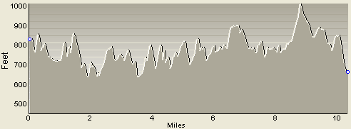
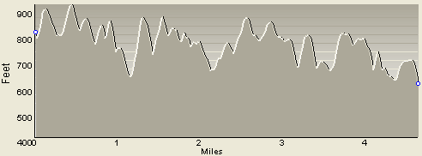
A’
Coal seam
Max mine pool
Control elevation – 560 ‘ msl

Figure 6b Meigs Mine 31 cross section B – B’
B
B’
Max mine pool
Coal seam
Control elevation – 460’ msl
Figure 7a: early flooding conditions

Figure 7b: recent flooding conditions

Figure 7b shows that the 3rd NE section has not converged with the rest of the mine pool. This section of the mine pool maintains a consistent hydrologic head signaling that it may be hydrologically separate from the rest of Meigs 2. However, when Meigs 2 began pumping water from the South Bleeder shaft into Meigs 31 on January 28, 2008 an immediate response was observed at rates of 3000 gpm. The South Bleeder shaft is a little less than six miles from the 3rd NE shaft thus indicating permeable conditions in the mine pool and between the mine pool and the 3rd NE shaft. The Meigs 2 mine pool had exceeded its control elevation in the NE section of the mine and was about 40 feet from topographically low elevations in stream valleys. Near surface aquifers may already have been affected. Most resident’s water supplies were replaced with centralized piped water systems after the longwall had impacted private water wells. The NE section of the mine, while still elevated above the rest of the mine pool did exhibit an immediate response to the pumping of the mine pool. As stated earlier, pumping occurs at the most southern part of the Meigs 2 pool from the South Bleeder Shaft.

Graph 7b and 7c show the effect of lowering the Meigs 2 mine pool by pumping from Meigs 2 into Meigs 31. The subsequent increase rate of rise in Meigs 31 is shown in graph 8b. Meigs 2 was experiencing a seasonal decline when pumping from the mine pool began. As pumping began, the rate declined as shown in the graphs for Meigs 2.

Figure 7c: Effect of pumping on water level in Meigs 2

The South Bleeder shaft shows the largest change in water level as this is where the pumps are located.

Flooding conditions of the Meigs 31 pool

Figures 8a, 8b, and 8c show early and recent flooding conditions for the Meigs 31 mine pool. All three monitoring points show that water levels converged throughout the Meigs 31 mine by mid 2005. The Meigs 31 control elevation of 460 feet m.s.l. was reached in June of 2008. Meigs 31 pool elevation has increased since Jan 28, 2008 when the injectate water from Meigs 2 was first introduced into Meigs 31.

The monthly rate increased from an average 1.4 feet per month to an average 2.9 feet per month. At this rate, a trend analysis indicates the mine pool would reach inundation (~ 600 feet m.s.l.) by the end of 2012 if it were not pumped. Projections for inundation do not account for the change in porosity of the fractured substrata above the mine in or changes in precipitation due to protracted drought or above average rainfall. However, CONSOL anticipates pumping and treating the pool from Meigs 31 by November 2008, therefore, an uncontrolled break out should not become a concern.

Figure 8a: Early flooding conditions of Meigs 31

Pumping begins out of Meigs 2 into Meigs 31.
Figure 8b: Recent flooding conditions of Meigs 31

Figure 8c: Monthly average change in water level

Water Quality

During active mining operations, the mine is an ideal environment for pyrite oxidation. Exposed pyrite-rich rocks and coal are constantly ventilated by moist air that facilitates large-scale oxidation. As discussed above, the mine pool will require pumping to control the unchecked discharges. The first pumped water is the frequently of the worst quality because of the flush of concentrated soluble pyrite oxidation products (iron sulfate salts). It is anticipated based on experience with other below-drainage Appalachian mines that water quality will improve dramatically with time. There are several reasons for this improvement.
- Pyrite oxidation ceases in the flooded sections (Watzlaf, 1992).
- After the initial flush, there are less readily available iron sulfates salts to dissolve.
- Alkaline strata in the roof rock in the mine pool will provide some neutralization to the water.
- Dilution and influx of alkalinity will occur from ground water inflows.
- The ground water flow path exhibits some short-circuiting. Areas of rapid transport or flow may exhibit better water quality than areas of restricted water movement.
- Geochemical reactions (e.g., sulfate reduction and cation exchange) can occur along the mine water flow path, thus improving the quality prior to discharge.

The northwest section of Meigs 2 should produce worse water quality due to the presence of pyritic roof rock and the absence of limestone. Limestone is present in the overburden in the southern portion of Meigs 2 and all of Meigs 31. When water first enters the mine, the quality tends to change as it flows slowly through the mine. It may get better or worse depending on where it enters, and the chemistry of the gob through which it flows. Given time, mine water tends to improve in quality as it slowly moves along the flow path. The longer the in-mine residence time, the more opportunity the mine water has to improve through geochemical processes, such as cation exchange and sulfate reduction. Mine water also stratifies with the worst water quality tending to be in the deeper sections.

Water quality from recently flooded deep mines is often more acidic with higher sulfate and metal concentrations than it was while the mine was in operation. A sample collected August 2005 (post-mining) from the South Bleeder shaft in Meigs 2 showed a pH of 6.2, TDS of 15,900 mg/L and iron of 2,700 mg/L. Meigs 31 sampled during the same time from South Mains shaft showed an average pH of 6.6, TDS of 5,106 mg/L, and iron of 90.2 mg/L (Moody and Assoc, Inc. 2006). Siplivy (2004) reported the following water quality. Water is drawn off from near the bottom of the pool.

Meigs Mines 2 and Mine 31 – Pool Water Quality from 2004
 | PH | Acidity  (Mg/L) | Alkalinity (Mg/L) | Iron  (Mg/L) | SO4  (Mg/L)
Meigs No. 2 | 3 – 5 | 3000 – 5000 | 0 – 75 | 200 – 3000 | > 5000
Meigs No. 31 | 6 – 7 | 5 – 100 | 200 – 400 | 100 – 200 | 1000 - 3000

The data show the Meigs 2 water quality is significantly worse than Meigs 31. The water in Meigs 31 owes it alkalinity and lower metals to the Vanport Limestone roof rock that is present in the southern part of Meigs 2 and all of the Meigs 31 complex.

Meigs Mines 2 and 31 - Average Pool Water Quality Since Pumping Began from 2008
 | pH | Acidity (mg/L) | Alkalinity (mg/L) | Iron (mg/L) | Aluminum (mg/L) | Manganese (mg/L) | Arsenic (mg/L) | SO4 (mg/L) | TDS (mg/L)
Meigs 2 | 6.2 | 1021 | 351 | 1053 | 3.3 | 7.8 | 0.034 | 7635 | 11525
Meigs 31 | 6.18 | 912 | 332 | 855 | 0.925 | 9.1 | 0.01 | 6125 | 10150

Water quality shown in the table above represents water that has been pumped from Meigs 2 into Meigs 31 since the beginning of 2008, but not yet pumped out of Meigs 31. Therefore, Meigs 31 is concentrating all the water and, in a sense, treating in-situ. There appears to be an improvement in water quality out of the Meigs 2 mine. Water from the Meigs 2 pool now has less oxygen and has benefited from initial flushing of the oxidized metals and acidity. A preferential flow path may also benefit the water quality. There is an increase in alkalinity, with less acidity, and a lower iron concentration. The water in Meigs 31 has not yet been pumped, but that part of the mine complex is receiving the worst water from Meigs 2, so it is not unusual that the two waters are beginning to look similar. Pumping from Meigs 31 is planned for January 2009.

Projected future water quality

With pumping of both pools the water quality is expected to improve over time. To the degree that the mine pool does not fully flood, water will continue to become exposed to oxidized pyrite, thus continually yielding acidity and metals to the water in the mine pool.

Projections have been made concerning the long-term water quality from the mine pool complex. Findings from the Pittsburgh seam coal mines in Pennsylvania and West Virginia have demonstrated that for each mine pool volume pumped, there is a corresponding improvement in water quality of approximately 50 percent (CONSOL , personal communication – 2005). A more thorough mixing of mine pool water may result in rapid improvement, however mixing makes prediction more difficult. In addition, partially flooded mines will continue to yield acidity and metals into the mine pool resulting in long-term poor water quality.

Meigs Mine 2: Given the volume and inflow rate for Meigs 2, the average residence time of the mine water after pumping starts (pumping rate – 3100 gpm) is predicted to be approximately 5.2 years. With a 50% improvement with each turnover of the mine pool, it would take approximately 52 years for the iron level to achieve direct discharge standards (< 3.0 mg/L) (CEC, 2005). This projection is speculative due to the partially flooded nature of the mine pool and assumes the rate of iron concentration improvement remains constant. A less optimistic outcome is projected to reduce iron to 600 mg/L after 50 years. However, research by Donovan and others (2000) provides arguments for a more rapid recovery.

Meigs Mine 31: The projected maximum pumping rate for Meigs 31 is 5000 gpm. Given the mine pool volume and inflow rate for Meigs 31, CEC (2005) predicts that the average residence time of the mine water will be 6.6 years. At a 50% improvement rate with each turnover, the mine pool is projected to take 40 years to reach water quality discharge standards for iron. Considering the partially flooded mine pool and incomplete mixing, less optimistic predictions may result in an iron concentration of 35 mg/L after 22 years.

Possible future scenarios

Since mine closure, water is accumulating in the mines and is developing into a “mine pool”. The development of these pools and its potential impact to both groundwater and surface water is of great concern for DMRM and CONSOL and has generated the need for permit revisions and modifications. The original permits issued were for operations that were already in existence. The original permits did not address mine pools, surface discharges, or the need for perpetual treatment. CONSOL will be required to create a trust or financial security from which funds can be perpetually used to pay for pump and treat operations. This option is a recent development after the promulgation of House Bill 443 in April of 2007. It allows CONSOL to create an alternative financial security from which the costs of treating underground mine drainage may be funded.

CONSOL will be required to maintain the mine pool at a safe elevation below low-lying valleys, adjacent abandoned underground mines, and near-surface groundwater. CONSOL states that the mine pools will be temporarily maintained by pumping and treating the excess pool water until such time that the mine pool water has improved to discharge without treatment. Specific time frames for this temporary period are varied and speculative. One prediction method gives approximately 52 years for this to occur at which time, through pumping and treating activities, a vast enhancement of the ground-water resources of Meigs and Vinton counties will have been achieved. Once pumping ceases, groundwater resources will be easily available and some streams will flow continually from the mine pool.

The worst scenario is one in which the pool will be perpetually pumped and treated. If pumping and treatment stops, water will freely discharge into streams in violation of state water quality standards contaminating portions of the Leading and Raccoon Creek watersheds and ground-water resources. The first mine water to discharge from Meigs 2 would occur in low-lying stream valleys such as tributaries to Sisson Run. Stream valleys underlain by vertical fractures from stress relief or from subsidence due to longwall mining may provide conduits in which mine water could easily rise to the surface. The first mine water to discharge from Meigs 31 would occur in low-lying stream valley such as Strongs Run at 640 feet m.s.l. and Raccoon Creek at 630 feet m.s.l. Earlier projections for inundation dates will be modified as new data become available and pumping goes into effect for both the Meigs 2 and Meigs 31 mine pools. Meigs 2 pool is currently being pumped into Meigs 31.

Throughout the Appalachian region, mine pools are flooding and resulting in unplanned discharges. Depending on the overburden rock type, the water quality of the discharge can be toxic or benign. Together, the coal industry and state regulatory authorities are addressing these mine pool issues and turning some potential disasters into success stories by turning mine pool water into a usable resource for commercial, aquaculture, and drinking water purposes (Donovan and Leavitt – 2004).

References

Civil & Environmental Consultants, Inc. 2005. Meigs No. 2 and Meigs No.31 Mines: Mine Drainage Handling and Treatment Feasibility Study, unpublished report.

Donovan J.J. and B. Leavitt. 2004. The future of mine-water discharges from Underground Coal Mines of the Pittsburgh Coal Basin, WV-PA.

Donovan J.J., B. Leavitt, E. Werner, E. Perry and K. Mc Coy. 2000. Long-term Hydro geological and Geochemical Response to Flooding of an Abandoned Below-drainage Pittsburgh Coal Mine, 21st West Virginia Surface Mine Drainage Task Force Symposium, Morgantown, WV, April 2000

Ferguson, H. F. 1974. Geological Observations and Geotechnical Effects of Valley Stress Relief in the Allegheny Plateau. ASCE National Meeting on Water Resources, Los Angeles, CA, 1974

Kendorski, F.S. 1993. Effect of High-Extraction Coal Mining on Surface Subsidence and Ground Water, Proceedings 12th Conference on Ground Control in Mining, West Virginia University, Morgantown, WV.
MFG, Inc. 2006. SOCCO, Meigs County No. 2 Mine, Unnamed Tributary to Sisson Run Field Investigation Report – unpublished.

Moody and Associates, Inc. 2006. A Probable Hydrologic Consequence (PHC) Statement, - unpublished report prepared for CONSOL Energy and ODNR DMRM.

Siplivy, William, P.E. Inc. 2004. Mine Pool Audit, Meigs No. 2 and No. 31 Mines, January 2005 – unpublished report.

Wyrick, G.G. and J.W. Borchers, 1981. Hydrologic effects of stress-relief fractures in an Appalachian valley, USGS Water-Supply Paper 2177.

Watzlaf. G.R. 1992. Pyrite Oxidation in Saturated and Unsaturated Coal Waste Proceedings, National Meeting of the American Society for Surface Mining and Reclamation, Duluth, MN., pp. 191-205.

