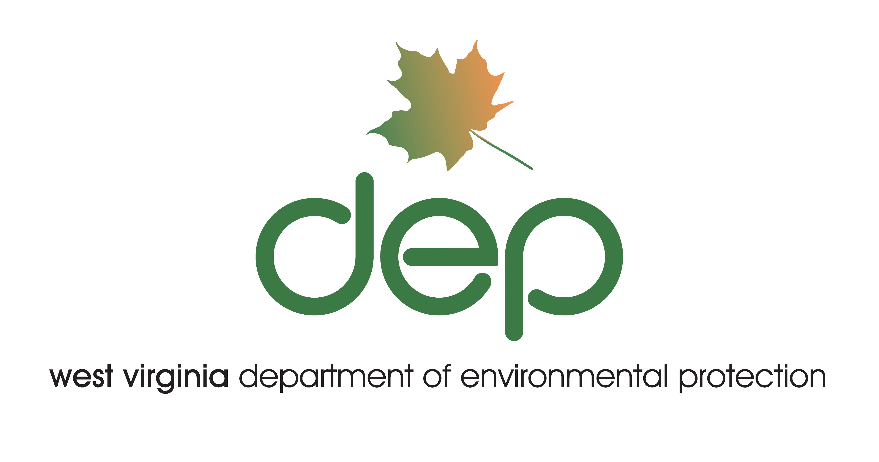

April 16, 2008

West Virginia Compensatory Mitigation Guidance under Section 401 of the Federal Clean Water Act for Coal Mining Activities

A Guidance Document for the Division of Mining and Reclamation, DEP/DMR

Purpose

To establish an improved framework for joint review processes by the West Virginia Department of Environmental Protection/Division of Mining and Reclamation (“WV DEP/DMR “) and the United States Army Corps of Engineers (“USACE”) of mitigation plans covered by mitigation requirements under the Clean Water Act Sections 401 and 404 regulatory programs. This document will not change or supercede any existing laws or regulation.

Definitions

Compensatory Mitigation
Compensatory mitigation is defined as, the restoration, creation, enhancement, or in exceptional cases preservation of wetlands and/or other aquatic resources for the purpose of compensating for unavoidable impacts.

Debits and Credits
Debit means a unit of measure (e.g., functional or area measure) representing the loss of aquatic functions at an impact or project site. The measure of function is based on the aquatic resource impacted by the authorized activity. Credit means a unit of measure (e.g., a functional or area measure) representing the accrual or attainment of aquatic functions at a compensatory mitigation site. The measure of function is based on the aquatic resources restored, established, enhanced, or preserved.

Functions
The physical, chemical, and biological processes that occur in aquatic resources and other ecosystems.

In-kind
In-kind means a resource type of a similar structural and functional type to the impacted resource.

In-lieu Fee Program
Is a program involving the restoration, establishment, enhancement, and/or preservation of aquatic resources through funds paid to a governmental or non-profit natural resources management entity to satisfy compensatory mitigation requirements for Department of Army (DA) or DEP permits.

Mitigation
Includes avoiding, minimizing, or compensating for resource losses.

Mitigation Bank
Means a site, or suite of sites, where resources (e.g., wetlands, streams, riparian areas) are restored, established, enhanced, and/or preserved for the purpose of providing compensatory mitigation for impacts authorized by DA permits.

Off-site
Off-site means an area that is neither located on the same parcel of land as the impact site, nor on a parcel of land contiguous to the parcel containing the impact site.

On-site
On-site means an area located on the same parcel of land as the impact site, or on a parcel of land contiguous to the impact site.

Out-of-kind
Out-of-kind means a resource of a different structural and functional type from the impacted resource.

Temporal Loss
Temporal loss is the time between initiation of mitigation and maturation of anticipated ecological functions on a compensatory mitigation site, is a concept that has long been used by regulatory and commenting resource agencies as justification for requiring appropriate mitigation ratios. Temporal loss is also defined as the time between the initiation of impacts and the initiation of mitigation.

Watershed Approach
Is an analytical process for making compensatory mitigation decisions the support the sustainability or improvement of aquatic resources in a watershed.

Legal Authority
Corps of Engineers 33 CFR Parts 325 and 332.
EPA 40 CFR Part 230.
West Virginia Chapter 22, Article 11, Section 7a., and 47 CSR 5A.

Program Coordination
Success in developing the program as defined above will require the close coordination between the WV DEP and the USACE.

Per existing statutes and regulations, WV DEP/DMR must approve all mitigation plans for impacts in a stream with a contributing watershed equal to or greater than 250 acres or greater than 0.5 acres of stream impact. Yet WV DEP can be involved in all projects – even if the projects fall below the regulatory mitigation thresholds. Both USACE and industry will ask WV DEP for assistance in identifying the highest priority mitigation projects in a given watershed

Coordinated Process Flow
The new procedural guidance is represented in Figure 1. The reader should note the color coded boxes as points in the process in which there is collaboration between principle parties in these matters.

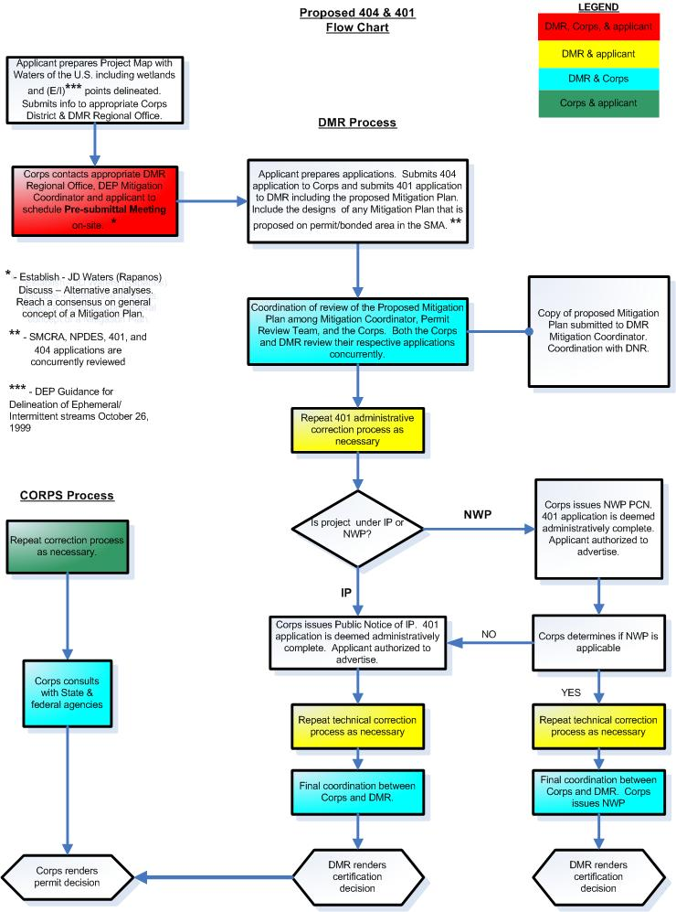
Figure 1
Procedure and Process

There are several pivotal “triggers” in this process that are designed to foster better communication between the various parties.

- The Pre-submittal Meeting between the applicant, the USACE and WV DEP is triggered by the receipt of the Jurisdictional Determination (“JD”) request from the applicant. USACE appoints a Project Manager who convenes the meeting and provides all relevant documentation to the participants. All information should flow from the Project Manager at the USACE to the Mitigation Coordinator at WV DEP/DMR as well as the Regional DEP Office.

- A Mitigation Meeting between the USACE and WV DEP is triggered if necessary when the applicant submits the mitigation plan to the WV DEP and the USACE, respectively. The mitigation plan is reviewed within 45 days by the DEP Permit Review Team and the USACE. A meeting or conference call is then convened (if necessary) by the USACE Project Manager with participation from WV DEP, the applicant and others as appropriate. The agenda is built around concerns and possible solutions to any barriers to approving the mitigation plan.

- A standing meeting between the USACE and WV DEP will be convened quarterly by the Huntington District of the Army Corps of Engineers. Agendas will be prepared jointly by the Chief of the Regulatory Branch at USACE and by the Director’s Office at the WV DEP/DMR. The purpose of these meetings will be to ensure that the two agencies are evaluating the mitigation planning process and other related issues and adjust procedures and/or processes to foster or more efficient and coordinated permit process.

Throughout the process, there is two-way communication between USACE and WV DEP until agreement is reached. In fact, the WV DEP/DMR Mitigation Coordinator and USACE Project Manager must collaborate to review the final plan requirements prior to the end of the permit process.

The provisions within the USACE Section 404 permits may satisfy WV DEP mitigation and compensation requirements contained in Section 22-11-7 (a), therefore no state compensation agreement will be required.

Mitigation Credits

Metrics and measures
All industry submissions related to the mitigation of stream impacts will be made and measured in linear feet with acreage noted as a parenthetical. All submissions related to the mitigation of wetland impacts will be made and measured in acreage. Both the USACE and WV DEP will evaluate the potential of these plans to offset the functional loss (e.g., uplift) of linear feet and/or acreage as appropriate.

Several “currencies” for impacts and compensatory mitigation may evolve in coming years. The interim functional assessment shows promise as a methodology that incorporates the physical, chemical and biological sciences. Current guidance may be re-written so as to allow the regulatory entities to evaluate mitigation plans using such a tool.

Prioritization
As per 33 CFR Part 332, 40 CFR Part 230, and WV DEP 47 CSR5A, federal and state requirements already apply to mitigation planning.

The three steps the applicant must take when impacts to the waters of the United States and/or the State are proposed are Avoidance, Minimization, and Compensation. Avoidance is determining whether the project can avoid such impacts. If hydrologic impacts are unavoidable, the USACE requires that impacts must be minimized to the greatest extent possible. Lastly, impacts must be compensated. Generally, USACE prioritizes the mitigation options in this sequence; mitigation banks as most preferable, “In-lieu of” fees as the next option, watershed based mitigation, on-site and in-kind mitigation, and lastly off-site out-of-kind mitigation. As prescribed in 33 CFR Part 230, the USACE and WV DEP will use a watershed approach to establish compensatory mitigation requirements to the extent appropriate and practicable.

WV DEP oftentimes takes more of a holistic watershed approach to mitigation where offsite projects may ultimately prove more beneficial to a watershed than re-creating the hydrology on or nearby the site of the land disturbance.

This guidance directs WV DEP to collaborate with USACE as in Figure 1 so as to reach agreements between government entities as early in the process as possible. WV DEP will use Figure 2 below and various alternative and functional analyses as the basis for conversations on what may generally be best for restoring the function and hydrology of the watershed. During the course of governmental discussions, it may prove out that USACE and WV DEP require projects other than on-site, in kind.

Ratios and Multipliers
Historically, both USACE and WV DEP have applied different ratios or multipliers to the required lengths and areas of mitigation depending upon the length and type of the hydrology disturbed, the temporal loss and the location of the mitigation project.

This guidance document proposes that replacement/mitigation is equitable relative to losses. The degree and types of mitigation required by the USACE and/or WV DEP depends on the impacted sites and the temporal loss as well as the specific mitigated sites. Regulators at both USACE and WV DEP ultimately need equitable and effective methods of evaluating sites and prioritizing mitigation needs.

Monetary Compensation
The “in lieu of” fees represent one option for mitigating stream impacts. Where appropriate, the $200,000/acre fee will continue to apply as part of the state compensatory mitigation program under WVC Section 22-11-7(a).

Wetland mitigation will continue to be managed as per current laws and practices provide.

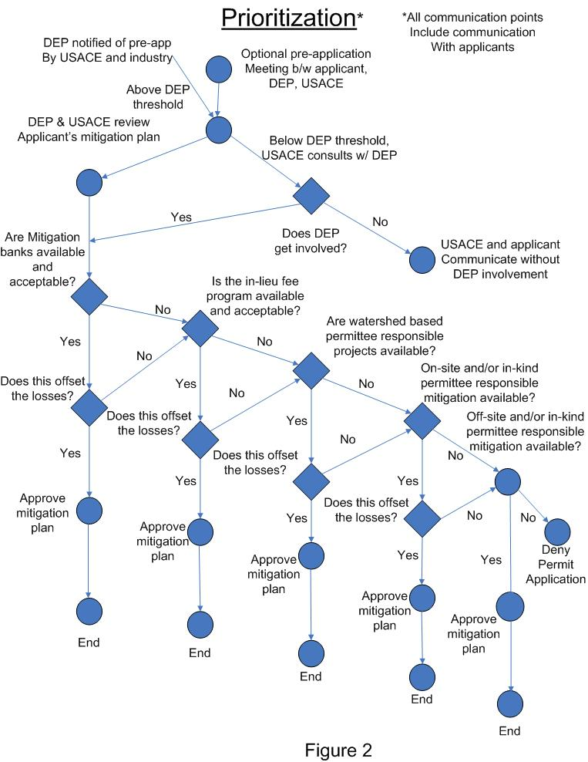

Mitigation Inventory and Credit Initiative
WV DEP will work to create a mitigation inventory and credit initiative. This program will:

- Provide incentives for early design and implementation of mitigation projects;
- Provide incentives for projects on streams on the state 303d list and other waters of special interest or regulatory concern;
- Leverage opportunities to use off site stream improvements to facilitate watershed objectives;
- Identify opportunities to incentivize on-site elements of projects;
- Allow DEP to evaluate project performance in the context of project designs.

The transaction costs of such a program should be minimized and the program should be self-sustaining.

Post Mitigation Planning

Bonding
USACE bonding requirements will remain in effect. If mitigation projects are on-site and part of a permitted and approved reclamation plan, a reclamation bond required by WV Surface Mine and Reclamation Control Act (“SMCRA”) will suffice. In several other states, USACE accepts the state reclamation bond if it pertains to the performance of mitigation on the bonded area.

A bond will not be required for off-site compensation when a mining operation agrees to complete the off-site mitigation project that is commenced within one year and completed and functioning within two years (or as otherwise noted in the approved mitigation plan) of breaking ground on a 401/404 SMCRA permitted area. If this timetable is not met the compensatory mitigation project will be bonded at the appropriate rate with the USACE.

Evaluation and Inspection
It is the applicant’s responsibility to submit a mitigation plan that offsets the mining project’s impact to jurisdictional waters. Together, USACE and WV DEP will collaboratively evaluate these plans. The agencies will ensure that the plan adequately offsets the impacts and, if so, they will approve the plan including the implementation schedule and performance measures.

The applicant is responsible for the implementation of the plan and ultimately the construction and efficiency of the intended design. USACE and WV DEP will evaluate the plan’s implementation.

Depending on the mitigation plan itself, USACE generally requires monitoring for five years (although sometimes longer). If the mitigation plan is functioning as designed, the mining operation is typically released from maintaining its bond at end of monitoring period. If the mitigation plan is not implemented or working as proposed, the agencies will not allow the bond to be released in totality and the mining operation needs to either correct the failures; augment the approved mitigation plan in order to restore the functions of the disturbed stream, or pursue the in-lieu fee program.

Enforcement
A variety of enforcement authorities are available to the state and federal government. All enforcement powers in existence today remain in effect.

Conclusion
The institutional and procedural content of this guidance should result in greater efficiencies in the permitting process.

