Performance of Steel Slag and Other Passive Treatment Systems
at the Broken Aro Mine in Little Raccoon Creek, Ohio

Brett Laverty
Vinton Soil and Water Conservation District
31935 State Route 93 McArthur, Ohio 45651
brettlaverty@hotmail.com

Ben McCament
Ohio University - Voinovich Center
for Leadership and Public Affairs
Athens, Ohio

Mitchell E. Farley
Ohio Department of Natural Resources
Division of Mineral Resource Management
Jackson, Ohio

ABSTRACT

Over the last decade, the Raccoon Creek Partnership (RCP) has made significant progress in abating acid mine drainage (AMD) in the Raccoon Creek Watershed. Their most recent project at the Broken Aro Mine in Jackson County, Ohio addresses one of the largest sources of AMD in the Little Raccoon Creek Watershed. Abandoned in the late 1950’s, this surface mine is a veritable moonscape of spoil and coal refuse characterized by an average acidity load of 1578 lbs/day. A contributing factor is the disposal of tipple wastes in a valley hydraulically connected to mine pits filled with AMD. Acidity and metal concentrations increase dramatically as this recharge filters through the valley-fill. In other parts of the mine, sulfide minerals exposed in the spoils and along the pit floors contribute to the production of AMD. It has taken the RCP nearly eight years to implement a multi-phase project to reclaim and treat the Broken Aro Mine. The Flint Run East, Flint Run West, and Salem Road phases were completed in 2006 at a final cost of $3.6 million dollars.

RD Zandee & Associates, Bergmann Associates, and GAI Consultants were contracted by the RCP to prepare a comprehensive strategy to reclaim and treat the Broken Aro Mine. Removing nearly 18 million gallons of water storage and diverting streams away from the porous valley-fill reduces recharge to acid-producing areas. In other areas, spoil piles were reclaimed by contouring for positive drainage and capping to reduce infiltration. One unique aspect of the project has been the use of AMD to produce alkalinity using steel slag. Mine drainage is pre-treated in a variety of passive system to generate pH-neutral and metal-free water, which is directed to leach beds containing high-alkaline steel slag. In the Flint Run East drainage, the pre-treatment system consists of a vertical flow pond, anaerobic wetland ditch, and limestone leach bed followed by a final leach bed containing 1000 tons of steel slag. Similarly, a vertical flow pond in the Flint Run West drainage is providing pH-neutral water to approximately 8,000 tons of steel slag. At the Salem Road project, alternative uses of steel slag include rerouting fresh water to a channel containing 800 tons of steel slag and directing residual AMD though two rock dams cored with 290 tons of steel slag.

Despite a decline in performance at some treatment sites, first-year monitoring results show a 1552 lbs/day or 98% reduction in acidity loading across the Broken Aro Mine. Most of the project drainages are net alkaline and export a combined average alkalinity load of nearly 300 lbs/day. The implications of this project go beyond local water quality improvements. Reclamation strategies in conjunction with steel slag treatment are currently being adapted to similar mine sites across the Raccoon Creek Watershed.

INTRODUCTION

Rich deposits of coal have been mined in the Eastern Coal Region for almost two centuries but adequate regulatory oversight has only been in place for the last several decades. If not handled properly, mining wastes laden with sulfide minerals will react in the presence of atmospheric oxygen and bacteria to form acid mine drainage (AMD) (Rose & Cravotta, 1998; Skousen & Ziemkiewcz, 1995). Nearby streams are often contaminated with high concentrations of acidity and heavy metals that can persist for generations and result in the removal of most aquatic communities (Earle & Callaghan, 1998). An evaluation of fisheries in the Northern Appalachian Region by the United States Environmental Protection Agency (1995) found more than 5,100 miles of stream affected by AMD.

Located in southeastern Ohio, Raccoon Creek is heavily impacted by thousands of acres of abandoned surface and underground coal mines. Water quality impacts are particularly pronounced in the Little Raccoon Creek Watershed. Efforts to restore this basin began over a decade ago with the formation of the Raccoon Creek Partnership (RCP), which is represented by individuals, organizations, and agencies such as Ohio Department of Natural Resources Division of Mineral Resource Management (ODNR DMRM), Ohio University - Voinovich Center for Leadership and Public Affairs, Vinton Soil & Water Conservation District (SWCD), and the Ohio Environmental Protection Agency (OEPA). Among the abandoned mine land projects identified as a priority by the RCP, the Broken Aro Mine represents a third of the AMD generated in the Little Raccoon Creek Watershed. This paper will present the first-year performance results of a multi-phase project to reclaim and treat the Broken Aro Mine. Three different project phases were completed in 2006 at a final cost of $3.6 million dollars.

BASIN DESCRIPTION

Raccoon Creek drains 683 mi² in the southeastern Ohio counties of Athens, Gallia, Hocking, Jackson, Meigs, and Vinton (Map 1). This basin has been classified by the United States Geological Survey (USGS) as a high-priority watershed for reclamation of abandoned coal mines (Wilson, 1985; Wilson, 1988). Abandoned surface and underground mines make up a significant portion of the estimated 47,000 acres of mining in the Raccoon Creek Watershed (Bowman, 2006). Assessments by the Ohio Environmental Protection Agency (1997) identified approximately 146 stream miles impacted by abandoned mines. As the largest tributary in the watershed, Little Raccoon Creek (Map 2) has been identified as a high priority area for mine reclamation and acid abatement (Laverty, et al. 2000).

Geology, in particular the amount of carbonate present, plays a critical role in the water quality of streams and shallow aquifers in southeast Ohio (Razem & Sedam, 1985). This region is underlain by sedimentary rocks of Pennsylvanian- and Permian-age that dip to the southeast at 30 – 40 feet per mile (DeLong, 1957). An important coal reserve in Ohio, the Allegheny Formation extends through much of the Little Raccoon Creek Watershed (Sedam, 1991). A United States Geological Survey (USGS) investigation of 35 watersheds in southeast Ohio found that basins underlain by the Allegheny Formation were particularly vulnerable to the effects of AMD because of its low overall percentage of carbonate material (Childress, 1985).

More than twenty years ago, the USGS documented widespread AMD contamination and decimated biological communities along Little Raccoon Creek and many of its tributaries (Wilson, 1985; Wilson, 1988). Acidity loads ranging from 5 to 50 tons/day were once common along the Little Raccoon Creek mainstem. Natural attenuation and a decade of restoration have produced an increasingly alkaline stream with recovering biological communities (Bowman, 2006). An investigation by the RCP identified the Flint Run and Middleton Run Subwatersheds as priority sources of AMD to Little Raccoon Creek (Laverty, et al. 2000). Separate investigations within each basin identified the Broken Aro Mine as the major source of contamination.

PROJECT DESCRIPTION

The Broken Aro Mine (Map 3) is located in Jackson County Ohio and was operated by the Broken Aro Mining Company between 1952 and 1958. Mining targeted the Clarion (No. 4a) and possibly the lower Kittanning (No. 5) coal seams with production estimated at 2,500 tons/day or 400,000 tons annually (Morrow, 1956). Sulfide minerals and other impurities were removed at the tipple by a process of crushing, screening, and washing in select media baths (R.D. Zandee, 2002). All rejected coal refuse was disposed of in a 140-acre valley located next to the tipple. Coarse screenings were relegated to the upper portion of the valley-fill followed by a series of slurry impoundments containing fine coal refuse. Water for the washing operation was pumped from a constructed impoundment known as Lake Milton. By the end of mining in 1958, the Broken Aro operations had impacted approximately 1200-acres between the Middleton Run and Flint Run Subwatersheds (Photo 1). Poor water quality is pervasive throughout the mine but collects in a few general areas due to surface topography and the regional dip of the coal pavement. These drainages are synonymous with current treatment projects and will be referred to as Flint Run East, Flint Run West, and Salem Road.

Flint Run East. Flint Run East designates a 140-acre headwater tributary in the Flint Run Watershed used exclusively for the disposal of coal refuse (Map 4). Coarse screenings are relegated to a 50-acre portion of the upper valley. Two slurry impoundments containing fine coal refuse occupy approximately 20-acres in the lower valley. A subsurface investigation found mining waste at depths ranging from 25 ft – 75 ft (Laverty, 2004).

Flint Run East is also hydraulically connected to approximately 170-acres of abandoned surface mines located up-dip of the valley-fill (RD Zandee, 2002). Precipitation slowly infiltrates into the mine spoil and migrates horizontally along the coal pavement toward a series of water-filled pits located on the periphery of the upper valley-fill. As poorly drained pits (FR0191), they represent a substantial amount of water storage (13 million gallons) characterized by an average acidity concentration of 391 mg/l (Table 1). According to water budget calculations, several million gallons of AMD is lost annually to the upper valley-fill where it continues to react with the coarse refuse (Laverty, 2004). Several monitoring wells developed within the upper valley-fill exhibit acidity concentrations ranging from 200 - 4800 mg/l. A perennial seep (FR0193) at the toe of the upper valley-fill marks a common discharge point for ground water. Average acidity concentration at this site is 1679 mg/l (Table 1).

Drainage from the upper valley-fill is collected in a diversion channel that crosses the lower slurry impoundments. The channel at this point is partially or completely losing to the underlying coal fines. Monitoring wells placed within or near the slurry impoundments exhibit acidity concentrations ranging from 973 - 8,000 mg/l (Laverty, 2004). Stream discharge begins to reemerge near the Flint Run East confluence (FR0126), which is characterized by an average acidity concentration of 2064 mg/l and loading rate of 702 lbs/day (Table 1). Average aluminum and iron concentrations are 93 mg/l and 761 mg/l respectively.

Flint Run West. Flint Run West designates a 657-acre headwater tributary in the Flint Run Watershed (Map 4). A 25-acre impoundment occupying the upper most drainage was created by the Broken Aro Mine to supply water to the tipple operations. A dissecting railroad embankment creates both an upper and lower Lake Milton. The lake itself contains an estimated 72 million gallons of water contaminated by abandoned surface mines primarily in upper Lake Milton (RD Zandee, 2002). Water quality at the lower lake discharge (FR0122) is characterized by an average acidity concentration of 51 mg/l (Table 2). Water downstream of the dam is further degraded by an abandoned slurry impoundment and AMD from other parts of the mine. All drainage is routed through a storm water pond known as Hothouse Lake before discharging to the Flint Run mainstem. Water quality at the Flint Run West confluence (FR0120) is characterized by an average acidity concentration of 193 mg/l and a loading rate of 696 lbs/day (Table 2). Average aluminum and iron concentrations are 12 mg/l equally.

Salem Road. Salem Road designates 70-acres on the eastern side of the mine consisting of barren spoil ridges, acidic impoundments, altered drainage patterns, and remnant underground mines (Map 5). According to acid-base accounting, the pit floor and the surrounding spoil ridges are the primary sources of AMD (Bergmann Associates & GAI Consultants, 2004). Drainage in this portion of the mine occurs along three tributaries in the Middleton Run Subwatershed referred to here as the Main Pit, Lake Farley, and West Area drainages.

The Main Pit encompasses 20-acres of open pits and heavily eroding spoil ridges. Drainage occurs along the pit floor and collects at a common point along Salem Road. Approximately 2 million gallons of AMD is being retained along an upper portion of pit floor resulting from the deposition of mine spoil (Bergmann Associates & GAI Consultants, 2004). Additional pit recharge is provided by 14-acres of drainage outside the bounds of mining. Increasing hydraulic head drives this water through the permeable spoil and into the Main Pit where it continues to react with the coal pavement. A comparison of sampling stations along the project drainage details the acid-producing potential of this area (Map 5). Drainage out of the headwaters (MiR0025) is net alkaline (41 mg/l) but degrades to net acidic (146 mg/l) while in the pit impoundment (MiR0022). Ground water seepage is widespread along the spoil margins creating a high water table along the pit floor. Water quality at the Main Pit confluence (MiR0021) is characterized by an average acidity concentration of 1447 mg/l and a loading rate of 72 lbs/day (Table 3). Average aluminum and iron concentrations are 167 mg/l and 111 mg/l respectively. Although not included in the calculations, it is important to note that a “flashy” storm event at the Main Pit confluence produced an acidity-loading rate greater than 4 tons/day.

Lake Farley is a storm water pond draining 18-acres of abandoned surface mines and providing storage for approximately 2.5 million gallons of AMD (Bergmann Associates & GAI Consultants, 2004). A wetland downstream of the dam marks an area of seepage thought to be related to water movement around the dam or possibly drainage from a nearby deep mine. Abandoned mine maps show a 5-acre underground mine located on the south bank of Lake Farley (Map 5). A common discharge point (MiR0032) downstream of the dam and wetland is characterized by an average acidity concentration of 506 mg/l and a loading rate of 56 lbs/day (Table 3). Average aluminum and iron concentrations are 54 mg/l and 24 mg/l respectively.

The West Area project drains approximately 30-acres of barren mine spoil adjacent to the Main Pit. An active ground water seep (MiR0093) possibly linked to undocumented underground mines contributes the bulk of the AMD. No such mine exists on state inventories but a series of sinkholes consistent with room and pillar collapse is located less than 500 ft from the seep (Map 5). Water quality is characterized by an average acidity concentration of 468 mg/l and an average loading rate of 52 lbs/day (Table 3). Average aluminum and iron concentrations are 23 mg/l and 87 mg/l respectively.

DESIGN AND CONSTRUCTION

The Broken Aro Mine has been a top priority for the RCP for many years. Highly toxic mining wastes and a complex hydrology have made restoration efforts both challenging and time consuming. Over the last eight years, the Broken Aro Mine has been the focus of several investigations to develop viable treatment alternatives. Project funding was pooled together from various state and federal agencies whose common goal is the restoration of Little Raccoon Creek. The Flint Run and Middleton Run Projects were completed in 2006.

Flint Run. Ohio University Department of Geological Sciences and ODNR DMRM partnered on the first investigation of the Broken Aro Mine (Laverty, 2004). Research activities focused on monitoring surface and ground water sites along Flint Run East plus drilling and geophysical surveys to provide some dimension to the valley-fill. RD Zandee & Associates was contracted by the RCP to conduct a preliminary design investigation of Flint Run East and Flint Run West projects. Surface and ground water sites were monitored over several months with a particular focus on the many pits and lakes scattered across the mine. An extensive drilling campaign provided additional subsurface data on the valley-fill and potential borrow areas. The consultant completed a reclamation and treatment design in 2002. Project funding for both East and West projects was provided by grants from the Ohio EPA section 319 program, ODNR DMRM Abandoned Mine Land (AML) fund, and OSM’s Appalachian Clean Streams (ASCI) program. GAI Consultants provided additional engineering and design work for the Flint Run West project. These two phases were completed at a final cost of $2.5 million dollars.

The Flint Run East design largely focuses on reclamation, hydromodification, and passive treatment (Photo 2). One of the first actions was to divert stream discharge or recharge away from the lower slurry impoundments and towards Flint Run West for further treatment. Approximately 13 million gallons of storage was eliminated in the peripheral pit in order to reduce recharge to the upper valley-fill. An open limestone channel carries the residual AMD to a chain of passive treatment cells designed to neutralize acidity and boost alkalinity. A sediment pond collects drainage from the OLC and discharges to a vertical flow pond (14,400-ft²) followed by an anaerobic wetland ditch (4,800-ft²) to precipitate metals. Further treatment occurs in a limestone leach bed (10,400-ft²) before discharging to a second storage pond (84,000 ft²) designed to maintain a 30-day supply of water for the slag bed. The final leach bed (32,500-ft²) contains approximately 1000 tons of steel slag. A gravity flow ditch discharges this high alkaline water near the Flint Run East confluence. Berridge Reclamation Inc. of Jackson, Ohio completed construction on Flint Run East project in June 2006.

The Flint Run West design focuses on pre-treating Lake Milton and generating alkalinity in a large steel slag leach bed (Photo 2). A vertical flow pond (20,000-ft²) constructed in upper Lake Milton has improved water quality in the lower lake. Water is harvested for use in a leach bed (36,100-ft²) containing 8000 tons of steel slag. This highly alkaline water discharges directly to AMD diverted from the Flint Run East drainage. Stockmeister Enterprises Inc. of Jackson, Ohio completed construction on Flint Run West in August 2006.

Middleton Run. Project funding for the Salem Road Project was made possible by an Ohio EPA section 319 grant and by the state’s AML fund. The Vinton SWCD launched an initial surface water investigation in 2003 to gather water quality data for treatment design. Bergmann Associates and GAI Consultants were contracted by the RCP to conduct a preliminary design investigation of the Salem Road project. Surface and ground water systems were monitored over several months. An extensive drilling campaign provided subsurface data on potential borrow areas. The consultants completed a comprehensive treatment design in 2004. These projects were completed in 2005 at a final cost of $1.1 million dollars.

The Main Pit design focuses on reclamation, hydromodification, and passive treatment (Photo 3). All surrounding spoil ridges and pit floors were contoured for positive drainage, capped with a non-toxic silt/clay material, and compacted to reduce infiltration. Lime was applied (5 tons/acre) and topped with paper mill sludge (300 tons/acre) to establish vegetation. Positive drainage was established between the Main Pit and upper drainage while the former impoundment was eliminated with approximately 30 ft of fill. An earthen dam at the confluence of the upper drainage was rehabilitated to increase storage of fresh water. New drainage channels were established along the pit floor and topped with limestone rock (4” – 12”) to prevent stream scour. Additional alkalinity is generated from 800 tons of steel slag placed beneath a 1,235 ft section of the open limestone channel. Recharge to the steel slag-lined channel is primarily from runoff but a floating skimmer and ball valve allow for controlled release of fresh water from the storage pond. Stockmeister Enterprises Inc. of Jackson, Ohio completed construction in November 2005.

Lake Farley design focuses on reclamation, hydromodification, and passive treatment (Photo 3). One of the first major actions was to eliminate the Lake Farley and establish positive drainage. The lake and adjoining hillsides were contoured for positive drainage, capped with a non-toxic silt/clay material, and compacted to reduce infiltration. Lime was applied (5 tons/acre) and topped with paper mill sludge (300 tons/acre) to establish vegetation. New drainage channels were established along the lake bed and neighboring hillsides and topped with limestone rock (4” – 12”) to prevent stream scour. An innovative passive treatment system comprised of two rock dams cored with 290 tons of steel slag was installed downstream of the former dam. Stockmeister Enterprises Inc. of Jackson, Ohio completed construction in December 2005.

The West Area design focuses on reclamation and passive treatment (Photo 3). Mine spoil adjacent to the Main Pit was graded, capped with a non-toxic silt/clay material, and compacted to reduce infiltration. Lime was applied (5 tons/acre) and topped with paper mill sludge (300 tons/acre) to establish vegetation. The remnant underground mine is being treated with a limestone leach bed (8100 ft²) containing approximately 450 tons of limestone rock. Stockmeister Enterprises Inc. of Jackson, Ohio completed construction in December 2005.

METHODOLOGY

The purpose of this paper is to highlight reductions in acidity and heavy metals at the Broken Aro Mine as a result of 1) reclamation, stream diversion, and elimination of water storage; and 2) treatment with vertical flow ponds, limestone leach beds, open limestone channels, steel slag leach beds, steel slag-lined channels, and rock dams cored with steel slag. Performance measures are largely based on changes to acidity and alkalinity concentrations and loadings.

Quality assurance project plans (QAPP) were developed by the RCP for post-treatment monitoring of the Flint Run East, Flint Run West, and Salem Road projects. Monitoring plans were submitted to and approved by the Ohio EPA. Data collection and sampling techniques are based on protocols developed by the Ohio EPA, ODNR-DMRM, and the USGS. Post-treatment monitoring of the Flint Run East and Flint Run West projects is under the direction of watershed coordinator Ben McCament and the Voinovich Center for Leadership and Public Affair at Ohio University. Post-treatment monitoring of the Salem Road projects is under the direction of project manager Brett Laverty and the Vinton SWCD. Water quality monitoring is expected to continue at both projects for the foreseeable future.

Stream discharge is measured at most sites using a variety of equipment including pygmy current meters, Parshall flumes, portable cutthroat flumes, weirs, and the pipe/bucket method. An YSI multi-parameter datasonde measures real-time field conditions including pH, specific conductivity, dissolved oxygen, and oxidation-reduction potential. Filtered grab samples are also taken at each sample site and shipped to the ODNR DMRM lab in Cambridge, Ohio for analysis. Field samples are collected in a triple-rinsed stainless steel bucket and split between two sample bottles. A 250-ml plastic bottle is acidified with 5 ml of 20% nitric acid to keep metals in solution. Air is removed from a second 500-ml cubitaner to minimize reactions after sampling. Samples are shipped on ice and typically reach the analytical lab within 48 hours. Samples are analyzed for pH, acidity, alkalinity, aluminum, iron, manganese, magnesium, calcium, and sulfate. Acidity and alkalinity loadings are defined as a product of concentration (mg/l), discharge (gpm), and a conversion factor (0.012).

RESULTS AND DISCUSSION

Flint Run East. Post-treatment monitoring of the Flint Run East project began in June 2006 (Photo 2). Goals for this investigation include monitoring the performance of steel slag and associated passive treatment systems as well as changes in water quality across the project basin. Early results show a net alkaline discharge at the Flint Run East confluence.

One of the first actions was to divert recharge away from the upper valley-fill and slurry impoundments. According to the design consultant, stream modifications may reduce acidity loadings by more than 128 tons/year as well as flows (63%) along the East and West drainages (RD Zandee & Associates, 2002). Despite the removal of water storage from around the upper valley-fill, the peripheral pit continues to be a focal point for AMD. An open limestone channel directs residual AMD towards a chain of passive treatment cells designed to neutralize acidity and boost alkalinity. Waters entering the first storage pond (FR0152) are net alkaline with relatively low metals (Table 4). As the next line of treatment, a vertical flow pond (FR0150) moderately increases alkalinity concentrations (74 – 160 mg/l) followed by an anaerobic wetland ditch to accommodate the metal precipitate. A limestone leach bed (FR0148) provides added buffering (137 – 277 mg/l) before discharging to a second storage pond. Based on limited data, the steel slag leach bed (FR0144) is characterized by an average alkalinity concentration of 1483 mg/l. Some of this alkalinity is lost along the gravity flow ditch (FR0140) that discharges near the Flint Run East confluence. This excess alkalinity is used to treat residual AMD discharging from the toe of the valley-fill.

Prior to construction, acidity loading at the Flint Run East confluence (FR0126) averaged 702 lbs/day. Current conditions include a range of alkalinity concentrations (17 – 232 mg/l) and an average alkaline load of 60 lbs/day (Table 4). Dissolved aluminum concentrations are typically below 1 mg/l but iron is more variable (5 – 220 mg/l). A recent net acidic sample (343 mg/l) may be related to seasonal AMD fluctuations at the toe of the valley-fill.

Flint Run West. Post-treatment monitoring of the Flint Run West project began in November 2006 (Photo 2). Goals for this investigation include monitoring the performance of a vertical flow pond and steel slag leach bed as well as changes to water quality across the basin. Early results show a net alkaline discharge at the Flint Run West confluence.

A vertical flow pond (FR0190) was installed in upper Lake Milton (FR0130) in order to improve water quality in the lower lake. Lake Milton (FR0122) continues to waiver between net alkaline (8 mg/l) and net acidic (43 mg/l) conditions despite the preliminary results showing net alkaline discharge from the vertical flow pond (Table 5). Water is siphoned off and routed to a steel slag leach bed constructed at the toe of the dam. Although capable of generating high alkalinity, recent problems are affecting the performance of the slag bed. One issue has been the failure of two valves controlling flow from the lake, which resulted in a rapid draw down of the lake and the depletion of water storage. Another area of concern has been the formation of cracks and slippage along the sides of the slag bed. Water levels continue to fluctuate as inspections and repairs are made to the treatment cell. Based on limited data, water quality at the treatment outfall (FR0180) is characterized by high alkaline concentrations (1921 - 2352 mg/l) and a loading rate of approximately 1 ton/day. Effluent from the slag bed discharges directly to AMD diverted from Flint Run East (FR0170). All waters are routed through Hothouse Lake before discharging to the Flint Run mainstem.

Prior to construction, acid loading at the Flint Run West confluence (FR0120) averaged 696 lbs/day. Current conditions include an average alkalinity concentration of 60 mg/l and a variable loading rate (42 - 199 lbs/day). Dissolved iron and aluminum concentrations are typically below 1 mg/l.

Salem Road – Main Pit. Post-treatment monitoring of the Main Pit project began in January 2006 (Photo 3). Goals for this investigation include monitoring changes in water quality as a result of reclamation and treatment by a steel slag-lined channel. First-year results show a net alkaline discharge at the Main Pit confluence.
Prior to construction, acid loading at the Main Pit confluence (MiR0021) averaged 72 lbs/day. Current conditions include an average alkalinity concentration of 230 mg/l and a variable loading rate (2 – 491 lbs/day). Dissolved iron and aluminum concentrations are typically below 1 mg/l (Table 6).

Despite improvements in water quality, alkalinity concentrations at the Main Pit confluence have been in decline for several months. Initial conditions were characterized by steady flow and an average alkalinity concentration 460 mg/l. This was followed by a summer of recurring wet/dry cycles and intermittent flow. A return of wet weather in the fall allowed for several weeks of continuous discharge from the storage pond (MiR0025). Average alkalinity concentrations dropped to 116 mg/l during this period. Precipitation of calcite within the steel slag may be responsible for the decline in performance. The disassociation of calcium oxide releases calcium ions (Ca²⁺), which readily combine with carbonate ions to form calcite. Conditions such as shallow water depths and frequent wet/dry cycles only increase the diffusion of CO₂ and the formation of carbonate ions. Calcite precipitation within the steel slag reduces porosity and access to the calcium oxide. Recent reductions in dissolved calcium may support this claim of calcite fouling (Table 6).

Salem Road – Lake Farley. Post-treatment monitoring of the Lake Farley project began in January 2006 (Photo 3). Goals for this investigation include monitoring changes in water quality as a result of reclamation efforts and treatment by two rock dams cored with steel slag. First-year results show a net alkaline discharge downstream of former Lake Farley.

Prior to construction, acidity loading downstream of Lake Farley (MiR0032) averaged 56 lbs/day. Current conditions include an average alkalinity concentration of 133 mg/l and a loading rate of 14 lbs/day (Table 6). Dissolved iron and aluminum concentrations were initially high but have declined to levels below 1 mg/l.

Despite water quality improvements, alkalinity concentrations have steadily declined from an initial average of 206 mg/l and down to 73 mg/l in recent months. AMD has continued to discharge in the vicinity of former Lake Farley as evident by the copious amounts of iron and aluminum precipitate settling behind the dams. It is proposed that armoring and metal precipitation within the steel slag will continue to reduce alkaline concentrations over time. As an innovative design, the rock dams were constructed to test the use of steel slag in direct contact with AMD. The RCP is interested in these slag filters because of their relatively low cost and the ease of steel slag replacement.

Salem Road – West Area. Post-treatment monitoring of West Are project began in January 2006 (Photo 3). Goals for this investigation include monitoring the performance of a limestone leach bed. First-year results show significant reductions in acidity loading at the treatment outfall.

Prior to construction, acidity loading from the underground mine seep (MiR0093) averaged 52 lbs/day. Current conditions at the treatment outfall (MiR0092) include an average alkalinity concentration of 197 mg/l and a loading rate of 26 lbs/day. Average aluminum and iron concentrations are 18 mg/l and 34 mg/l respectively.

CONCLUSION

The Broken Aro Mine is one of the largest sources of AMD in the Raccoon Creek Watershed. It has taken nearly eight years and several million dollars to implement a multiphase project to reclaim and treat this 1200-acre abandoned surface mine. Monitoring results show net alkaline conditions at 4 out of the 5 project discharge sites. Flint Run East and West confluences are both net alkaline with an average alkalinity load of 212 lbs/day. Acidity loadings have declined in these drainages by an average 1398 lbs/day. The Main Pit and Lake Farley confluences are net alkaline with an average alkalinity load of 86 lbs/day. Acidity loadings in these drainages have declined by 128 lbs/day. Acidity loads in the West Area have been reduced by an average 26 lbs/day as a result of the limestone leach bed.

First-year results show a 1552 lbs/day or 98% reduction in acidity loads as well as exporting an average alkalinity load of nearly 300 lbs/day. The projects success is due to a combination of reclamation, stream diversion, water storage elimination, and more than 10,000 tons of steel slag. Monitoring of the Broken Aro Mine will continue for the foreseeable future as the implications of this project go far beyond local water quality improvements. Reclamation in conjunction with steel slag treatment is an effective strategy that is currently being adapted to similar mine sites across the Raccoon Creek Watershed.

REFERENCES

Bergmann Associates and GAI Consultants, 2004. Middleton Run reclamation phase 1 AMD treatment option and recommendation report. Report to the Ohio Department of Natural Resources, Division of Mineral Resources Management, August 2004.
Bowman, J., 2006. 2005 Comprehensive Non-point Source (NPS) monitoring report for acid mine drainage (AMD). Retrieved March 3, 2007, from Ohio University, Voinovich Center for Leadership and Public Affairs Web site: http://www.watersheddata.com.
Childress, C.J.O., 1985. Classification of stream basins in southeastern Ohio according to extent of surface coal mining. U.S. Geological Survey Water-Resources Investigations Open-File Report 84-4212.
Delong, R.M., 1957. Coal resources of the lower part of the Allegheny Formation in Ohio. Ohio Department of Natural Resources Division of Geological Survey Report of Investigation No. 31.
Earle, J., and Callaghan, T., 1998. Impacts of mine drainage on aquatic life, water uses, and man-made structures. Coal Mine Drainage Prediction and Pollution Prevention in Pennsylvania, Pennsylvania Department of Environmental Protection, Harrisburg, PA, pp 4-1 to 4-10.
Laverty, B., 2004. Hydrologic mechanisms in a coal refuse valley-fill and their effects on acidity and metals loads to Little Raccoon Creek, Ohio [M.S. thesis]: Ohio University, 286 p.
Laverty, B., M. Painter, M.W. Stoertz, J. Last, J.B. Hoy, R. Hoy, C. Rice, and M. Farley, 2000. Acid mine drainage abatement and treatment (AMDAT) plan for the Little Raccoon Creek Watershed, Jackson County, Ohio. Report to the Ohio Department of Natural Resources, Division of Mineral Resources Management, June 2000.
Morrow, F.C., 1956. A history of industry in Jackson County, Ohio. Athens, Ohio, Lawhead Press Inc., pp 291.
Ohio Environmental Protection Agency, 1997. Biological and water quality study of the Raccoon Creek Basin – 1995. OEPA Technical Report MAS/1996-12-7, Columbus, OH.
Razem, A.C., and Sedam, A.C., 1985. Ground-Water quality and geochemistry of aquifers associated with coal in the Allegheny and Monongahela formations, southeastern Ohio. U.S. Geological Survey Water-Resources Investigations Open-File Report 85-4034.
RD Zandee & Associates, 2002. Final Flint Run acid mine drainage reclamation report. Report to the Ohio Department of Natural Resources, Division of Mineral Resources Management, October 2002.
Rose, A.W. and Cravotta, C.A. III., 1998. Geochemistry of coal mine drainage. Coal Mine Drainage Prediction and Pollution Prevention in Pennsylvania, Pennsylvania Department of Environmental Protection, Harrisburg, PA, pp 1-1 to 1-22.
Sedam, A.C.. 1991. Geologic setting and water quality of selected basins in the active coal-mining areas of Ohio. U.S. Geological Survey Water-Resources Investigations Open-File Report 90-4109.
Skousen, J.G. and Ziemkiewicz, P.F.. 1995. Acid mine drainage control and treatment. West Virginia University and the National Mine Land Reclamation Center, Morgantown, West Virginia.
United States Environmental Protection Agency (USEPA), 1995. Streams with fisheries impacted by acid mine drainage in MD, OH, PA, VA, WV. U.S. Environmental Protection Agency, Philadelphia, PA, pp 2.
Wilson, K.S., 1985. Surface-water quality of coal-mine lands in Raccoon Creek Basin, Ohio. U.S. Geological Survey Water-Resources Investigations Open-File Report 85-4060.
Wilson, K.S., 1988. Chemical quality, benthic organisms, and sedimentation in streams draining coal-mined lands in Raccoon Creek Basin, Ohio, July 1984 through September 1986. United Geological Survey Water-Resources Investigations Open-File Report 88-4022.

APPENDIX

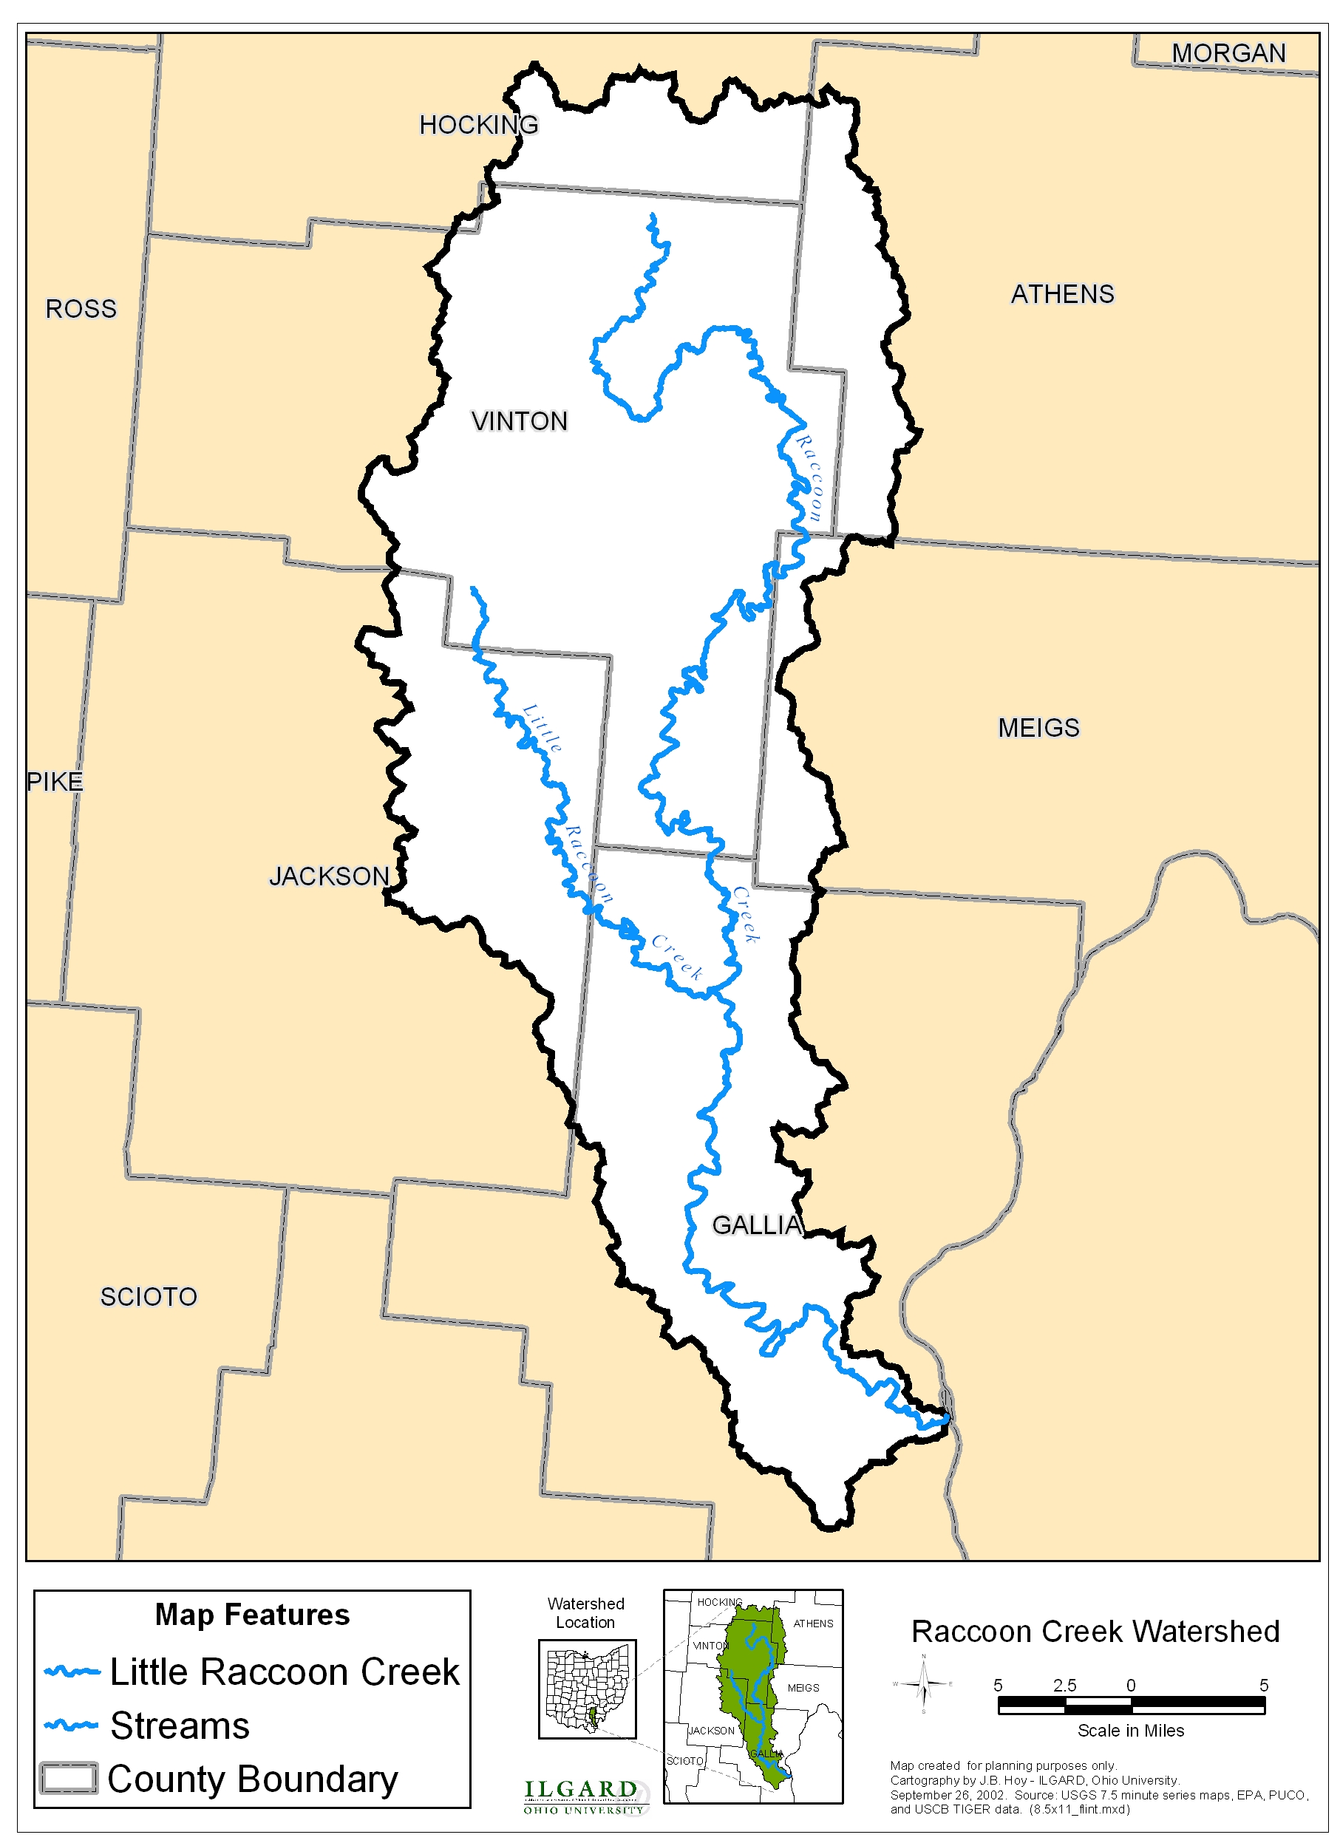
Map 1: Map of the Raccoon Creek Watershed

Map 2: Map of the Little Raccoon Creek Watershed
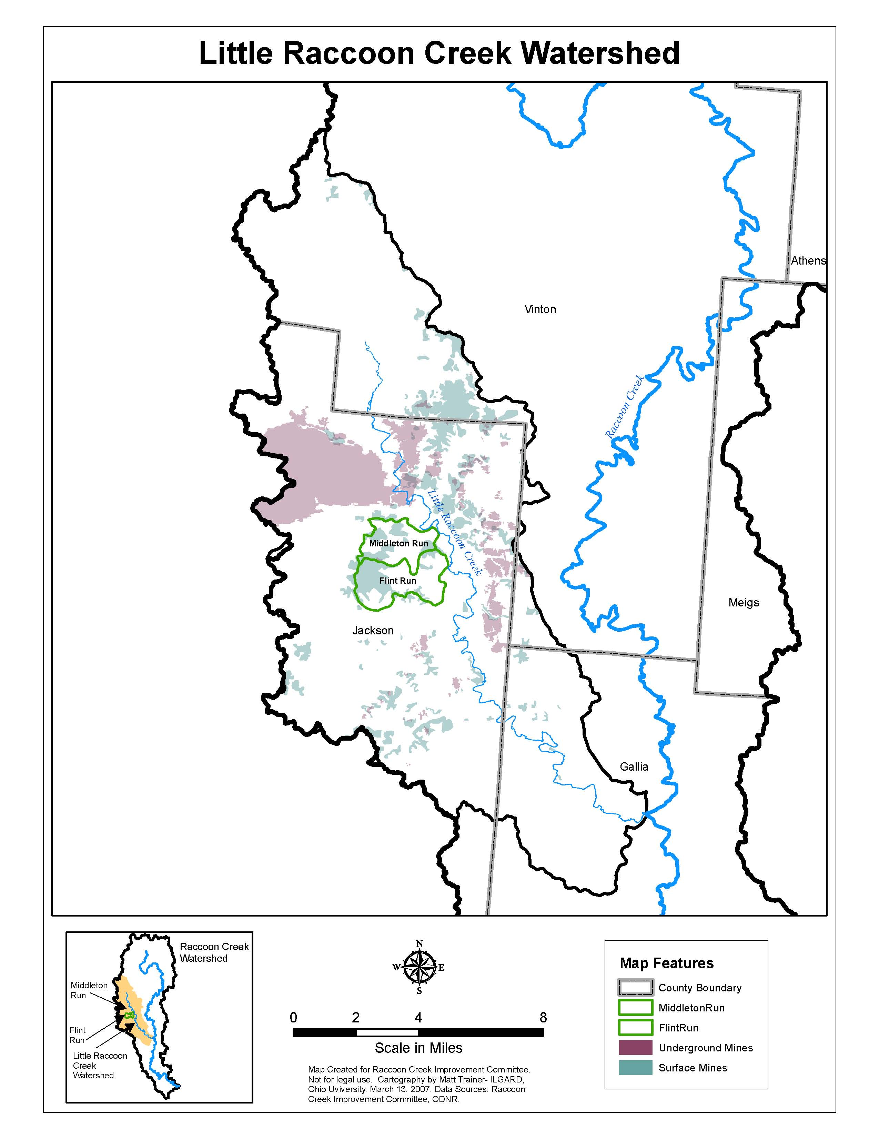

Map 3: Map of the Broken Aro Mine project.

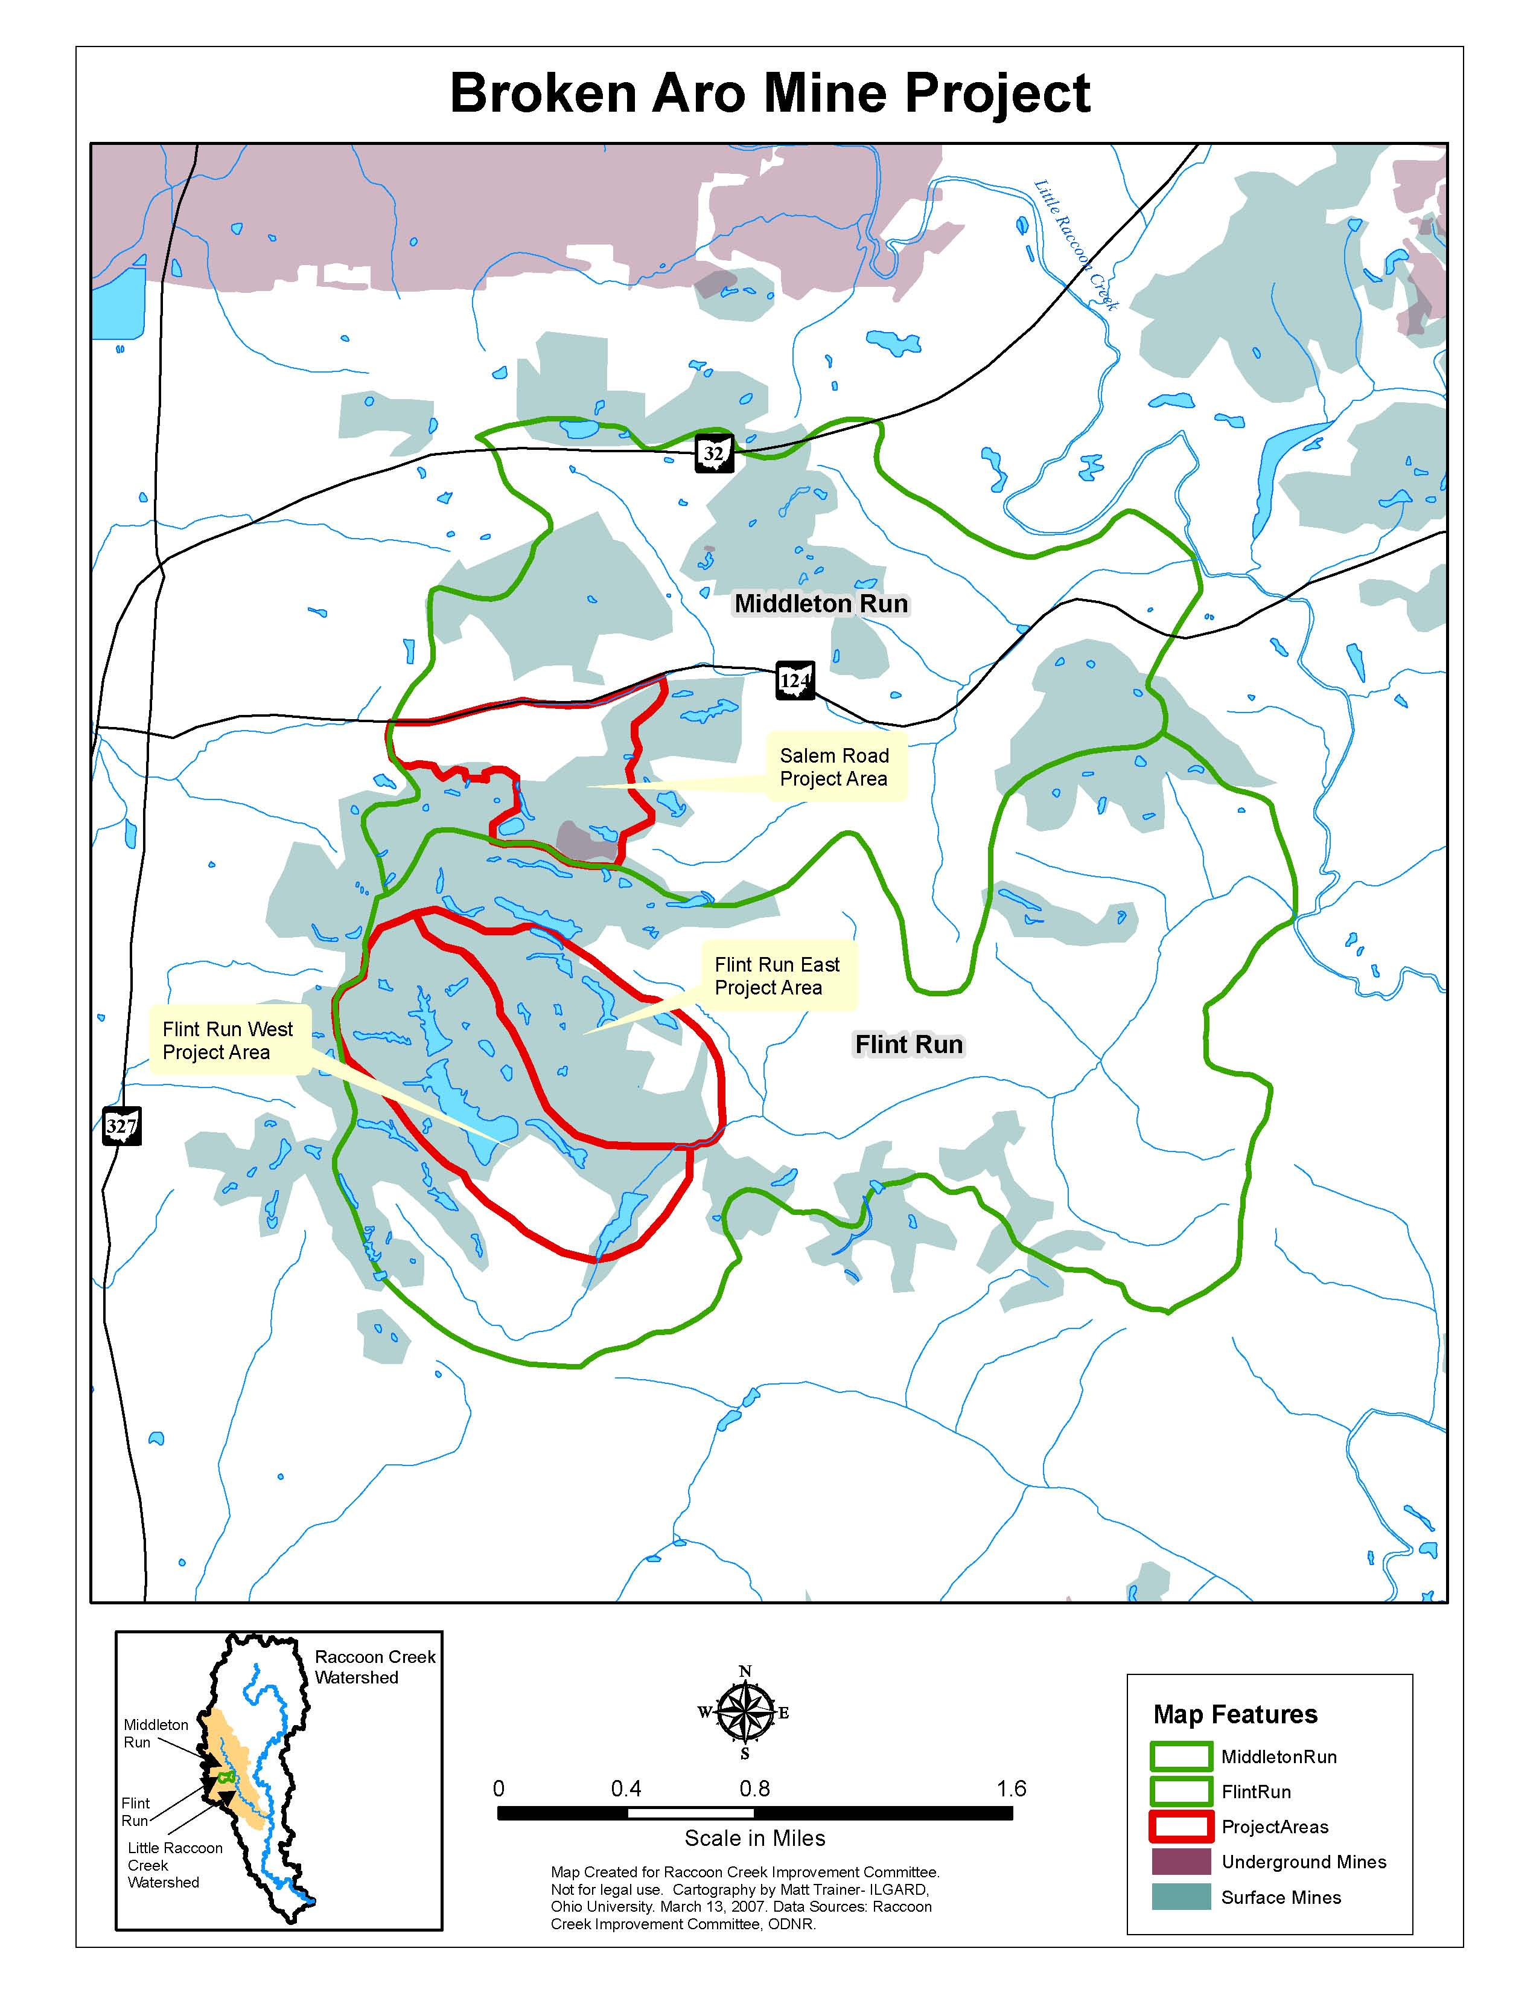
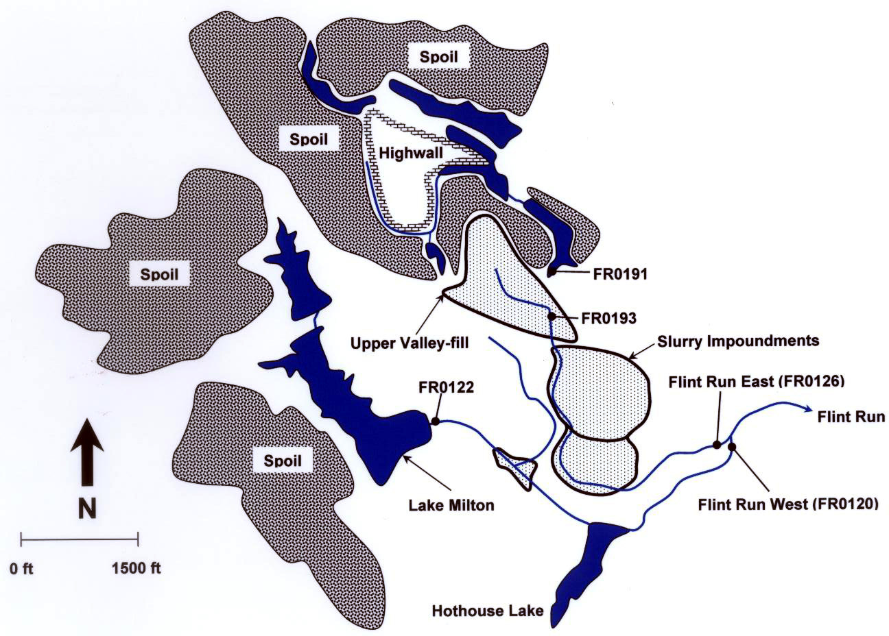
Map 4: Simplified pre-construction map of the Flint Run East and Flint Run West drainages.
Map 5: Simplified pre-construction map of the Middleton Run-Salem Road drainages.

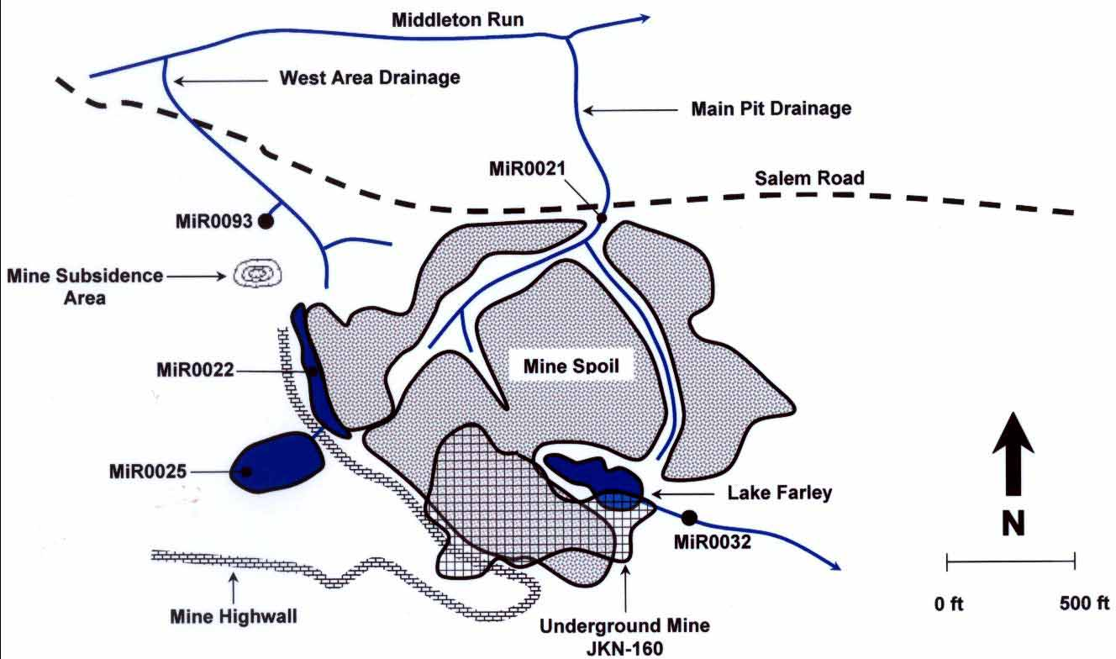
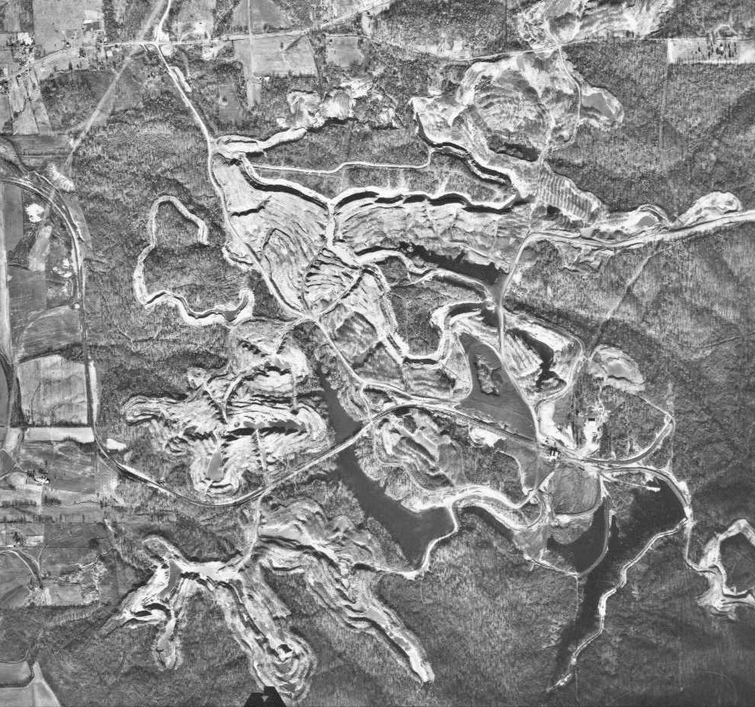
Photo 1: Air photo of the Broken Aro Mine (circa 1958).

Table 1: Flint Run East pre-treatment water quality data
Site | Date | Discharge (cfs) | Acidity (mg/l) | Alkalinity (mg/l) | Acidity  Loading  (lbs/day) | Aluminum (mg/l) | Iron (mg/l)
FR0126 | 7/28/1998 | 0.039 | 2732.00 | 0 | 576.77 | 37.00 | 560.00
FR0126 | 9/28/1998 | 0.011 | 2892..00 | 0 | 176.00 | 140.00 | 940.00
FR0126 | 11/8/1998 | 0.024 | 2168.00 | 0 | 282.56 | 100.00 | 920.00
FR0126 | 2/14/1999 | 0.186 | 1714.00 | 0 | 1716.95 | 73.00 | 560.00
FR0126 | 4/25/1999 | 0.045 | 714.00 | 0 | 173.04 | 108.00 | 746.00
FR0126 | 5/25/1999 | 0.029 | 2409.00 | 0 | 373.65 | 94.80 | 835.00
FR0126 | 6/15/1999 | 0.013 | 2979.00 | 0 | 205.36 | 138.00 | 1063.00
FR0126 | 8/2/1999 | 0.002 | 3973.00 | 0 | 51.35 | 171.00 | 1417.00
FR0126 | 11/9/1999 | 0.041 | 2811.00 | 0 | 617.67 | 105.00 | 1027.00
FR0126 | 2/5/2000 | 0.042 | 1213.00 | 0 | 275.68 | 94.00 | 912.00
FR0126 | 4/4/2000 | 0.152 | 1923.00 | 0 | 1574.19 | 75.80 | 577.00
FR0126 | 5/8/2002 | 0.406 | 951.00 | 0 | 2079.41 | 44.20 | 328.00
FR0126 | 7/26/2004 | 0.380 | 502.00 | 0 | 1027.36 | 22.10 | 136.00
FR0126 | 10/26/2004 | NA | 1919.00 | 0 | NA | 95.00 | 638.00
FR0191 | 5/27/1998 | 0.100 | 371.00 | 0 | 199.81 | 25.00 | 31.30
FR0191 | 2/15/1999 | 0.255 | 474.00 | 0 | 574.37 | 26.60 | 58.40
FR0191 | 4/25/1999 | NA | 387.00 | 0 | NA | 23.30 | 53.00
FR0191 | 6/15/1999 | NA | 439.00 | 0 | NA | 55.80 | 34.20
FR0191 | 8/2/1999 | NA | 502.00 | 0 | NA | 30.50 | 29.50
FR0191 | 5/8/2002 | 0.724 | 175.00 | 0 | 682.36 | 9.50 | 12.80
FR0193 | 9/28/1998 | 0.002 | 2337.00 | 0 | 30.84 | 140.00 | 810.00
FR0193 | 11/8/1998 | 0.003 | 2147.00 | 0 | 37.00 | 100.00 | 780.00
FR0193 | 2/15/1999 | 0.049 | 1996.00 | 0 | 531.03 | 160.00 | 731.00
FR0193 | 4/25/1999 | 0.014 | 487.00 | 0 | 38.03 | 13.00 | 883.00
FR0193 | 6/15/1999 | 0.010 | 2448.00 | 0 | 126.57 | 119.0 | 811.00
FR0193 | 8/2/1999 | 0.034 | 2387.00 | 0 | 437.08 | 75.70 | 922.00
FR0193 | 2/5/2000 | 0.014 | 430.00 | 0 | 31.96 | 128.00 | 705.00
FR0193 | 5/8/2002 | 0.240 | 1198.00 | 0 | 1548.47 | 69.10 | 392.00

Table 2: Flint Run West pre-treatment water quality data.
Site | Date | Discharge (cfs) | Acidity (mg/l) | Alkalinity (mg/l) | Acidity  Loading  (lbs/day) | Aluminum (mg/l) | Iron (mg/l)
FR0120 | 7/28/1998 | 0.227 | 109.00 | 0 | 133.30 | 5.50 | 5.50
FR0120 | 9/28/1998 | 0.205 | 190.00 | 0 | 209.80 | 9.10 | 10.00
FR0120 | 11/8/1998 | 0.205 | 184.00 | 0 | 203.10 | 13.00 | 12.70
FR0120 | 11/8/1998 | 0.205 | 194.00 | 0 | 214.20 | 14.00 | 12.80
FR0120 | 2/14/1999 | 1.28 | 685.00 | 0 | 4722.10 | 8.81 | 21.70
FR0120 | 4/25/1999 | 0.642 | 85.90 | 0 | 297.00 | 13.30 | 15.20
FR0120 | 5/25/1999 | 0.517 | 208.00 | 0 | 579.10 | 15.70 | 17.40
FR0120 | 6/15/1999 | 0.265 | 215.00 | 0 | 306.80 | 45.70 | 11.50
FR0120 | 8/2/1999 | 0.125 | 319.00 | 0 | 214.70 | 16.70 | 11.20
FR0120 | 11/9/1999 | 0.333 | 226.00 | 0 | 405.30 | 16.20 | 18.30
FR0120 | 2/5/2000 | 0.264 | 135.00 | 0 | 191.90 | 12.70 | 22.00
FR0120 | 4/4/2002 | 0.817 | 160.00 | 0 | 704.00 | 7.50 | 14.00
FR0120 | 5/8/2002 | 5.54 | 74.00 | 0 | 2207.90 | 4.39 | 6.10
FR0120 | 7/26/2004 | 0.004 | 25.50 | 0 | 0.50 | 0.25 | 0.41
FR0120 | 10/26/2004 | NA | 80.20 | 0 | NA | 4.52 | 4.58
FR0120 | 8/9/2005 | 0.045 | 191.00 | 0 | 46.30 | 11.70 | 10.20
FR0122 | 11/9/1999 | 0.213 | 48.40 | 0 | 55.50 | 6.95 | 0.67
FR0122 | 3/5/2002 | 0.153 | 61.90 | 0 | 51.00 | 2.88 | 0.31
FR0122 | 5/8/2002 | 0.152 | 61.00 | 0 | 49.90 | 3.65 | 2.21
FR0122 | 8/9/2005 | 0.092 | 33.10 | 0 | 16.40 | 2.14 | 0.59

Table 3: Salem Road pre-treatment water quality data.
Site | Date | Discharge (cfs) | Acidity (mg/l) | Alkalinity (mg/l) | Acidity  Loading  (lbs/day) | Aluminum (mg/l) | Iron (mg/l)
MiR0021 | 4/1/2003 | 0.02 | 1456.00 | 0.00 | 119.97 | 176.00 | 114.00
MiR0021 | 5/8/2003 | 0.01 | 1348.00 | 0.00 | 105.27 | 138.00 | 114.00
MiR0021 | 6/24/2003 | 0.01 | 1565.00 | 0.00 | 62.37 | 166.00 | 132.00
MiR0021 | 7/23/2003 | 2.25 | 675.00 | 0.00 | 8179.38 | 88.80 | 38.40
MiR0021 | 8/5/2003 | 0.01 | 1001.00 | 0.00 | 60.92 | 101.00 | 66.80
MiR0021 | 9/30/2003 | 0.001 | 1866.00 | 0.00 | 10.05 | 252.00 | 128.00
MiR0022 | 4/1/2003 | NA | 93.10 | 0.00 | NA | 5.41 | 7.79
MiR0022 | 5/8/2003 | NA | 132.00 | 0.00 | NA | 7.87 | 9.81
MiR0022 | 6/24/2003 | NA | 148.00 | 0.00 | NA | 7.87 | 12.60
MiR0022 | 8/5/2003 | NA | 180.00 | 0.00 | NA | 8.21 | 15.00
MiR0022 | 9/30/2003 | NA | 177.00 | 0.00 | NA | 8.42 | 14.30
MiR0025 | 4/1/2003 | NA | 4.13 | 39.90 | NA | 0.33 | 0.19
MiR0025 | 5/8/2003 | NA | 2.68 | 39.20 | NA | < 0.25 | 0.11
MiR0025 | 6/24/2003 | NA | 2.78 | 45.10 | NA | < 0.25 | < 0.05
MiR0025 | 8/5/2003 | NA | 4.17 | 49.40 | NA | 0.42 | 0.05
MiR0025 | 9/30/2003 | NA | 8.17 | 51.40 | NA | < 0.25 | < 0.05
MiR0031 | 4/1/2003 | NA | 276.00 | 0.00 | 0.00 | 30.70 | 7.17
MiR0031 | 5/8/2003 | NA | 292.00 | 0.00 | 0.00 | 31.70 | 11.30
MiR0031 | 6/24/2003 | NA | 298.00 | 0.00 | 0.00 | 28.70 | 13.30
MiR0031 | 8/5/2003 | NA | 303.00 | 0.00 | 0.00 | 31.00 | 16.00
MiR0031 | 9/30/2003 | NA | 294.00 | 0.00 | 0.00 | 29.70 | 12.50
MiR0032 | 10/25/1999 | 0.011 | 554.00 | 0.00 | 31.63 | 57.90 | 39.30
MiR0032 | 4/1/2003 | 0.002 | 497.00 | 0.00 | 66.92 | 57.60 | 20.10
MiR0032 | 5/8/2003 | 0.030 | 431.00 | 0.00 | 68.94 | 42.20 | 13.10
MiR0032 | 6/24/2003 | 0.022 | 500.00 | 0.00 | 58.16 | 50.90 | 19.40
MiR0032 | 8/5/2003 | 0.022 | 468.00 | 0.00 | 55.70 | 49.00 | 19.90
MiR0032 | 9/30/2003 | 0.017 | 587.00 | 0.00 | 52.79 | 67.00 | 31.40
MiR0093 | 4/1/2003 | 0.021 | 602.00 | 0.00 | 69.38 | 29.98 | 145.00
MiR0093 | 5/8/2003 | 0.019 | 515.00 | 0.00 | 52.98 | 26.60 | 93.80
MiR0093 | 6/24/2003 | 0.027 | 429.00 | 0.00 | 61.92 | 22.40 | 76.60
MiR0093 | 8/5/2003 | 0.017 | 418.00 | 0.00 | 38.27 | 18.80 | 64.10
MiR0093 | 9/30/2003 | 0.019 | 377.00 | 0.00 | 37.97 | 20.00 | 57.50

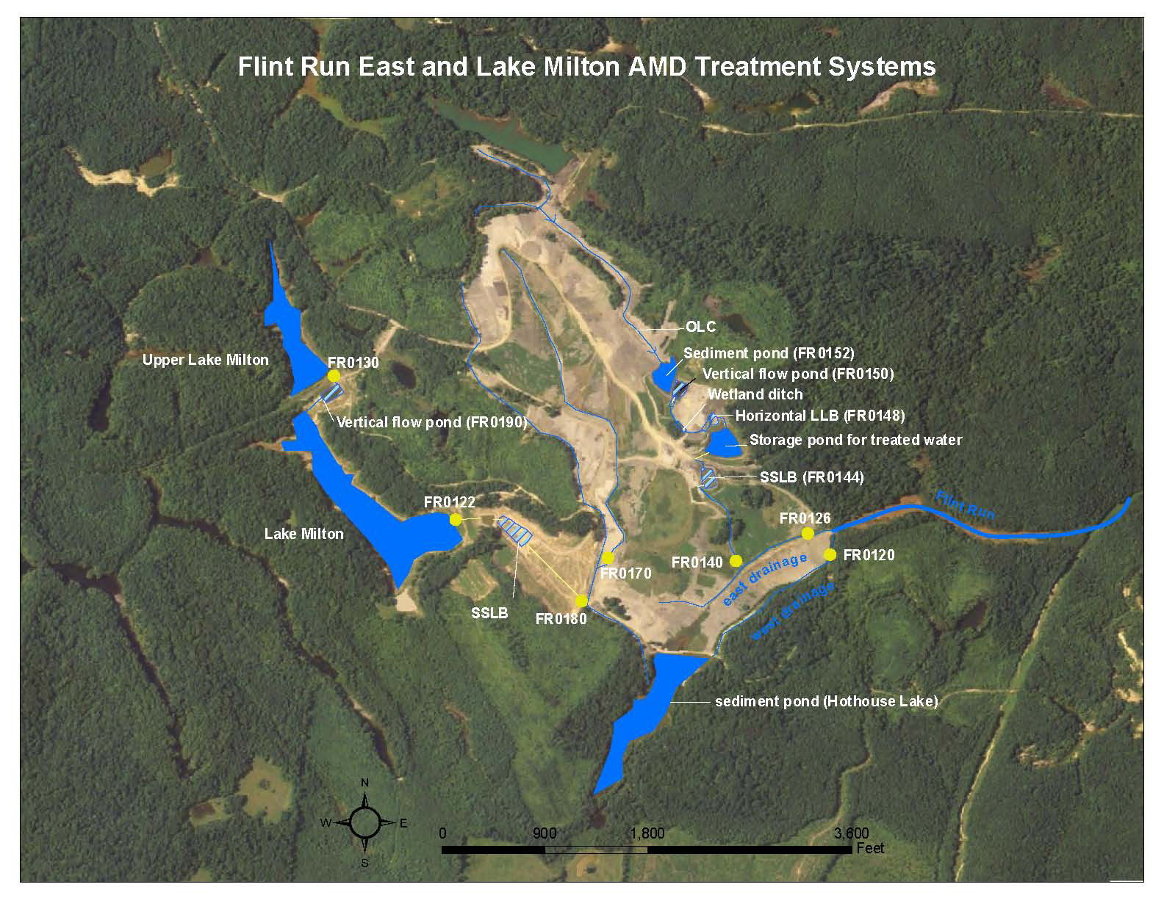
Photo 2: Post-construction air photo of Flint Run East and Flint Run West projects.
Photo 3: Post-construction air photo of the Middleton Run-Salem Road projects.
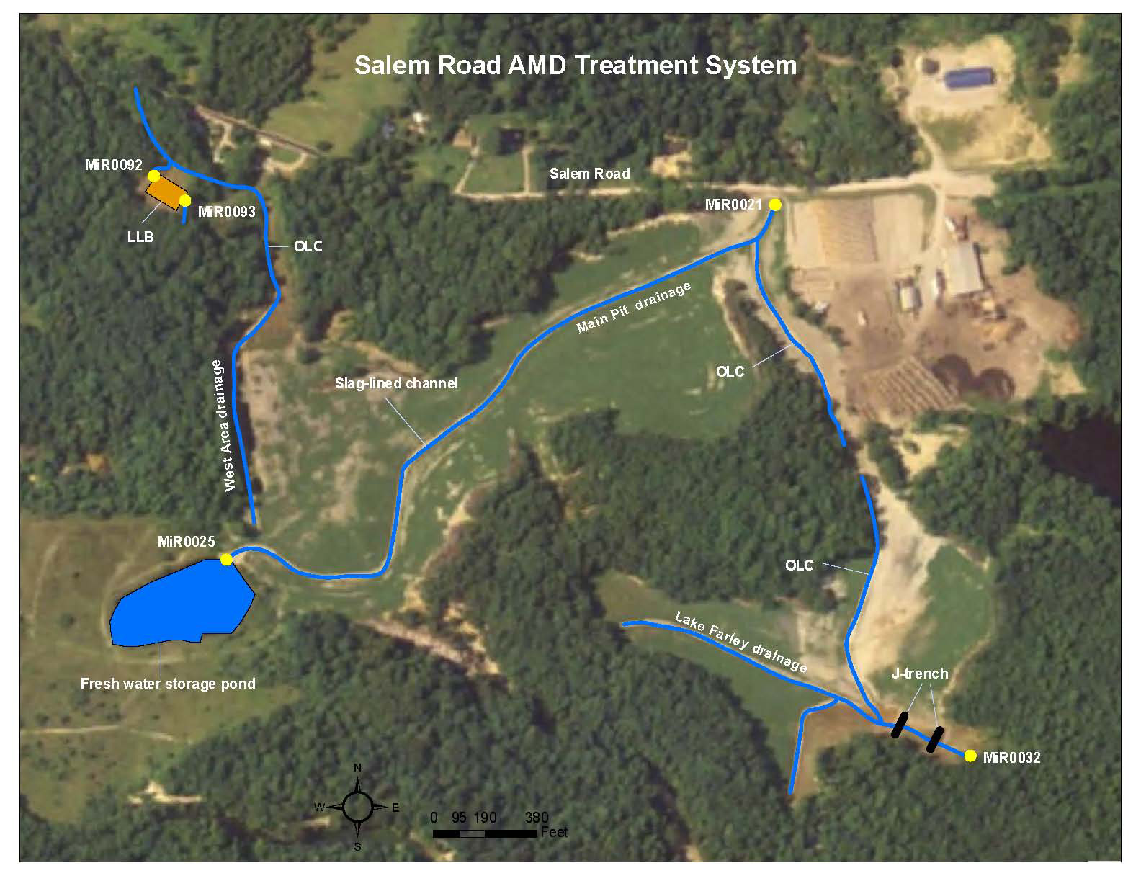

Table 4: Flint Run East post-treatment water quality data.
Site | Date | Discharge (cfs) | Acidity (mg/l) | Alkalinity (mg/l) | Acidity  Loading  (lbs/day) | Aluminum (mg/l) | Iron (mg/l) | Calcium  (mg/l)
FR0126 | 9/26/2006 | 0.149 | 71.80 | 130.00 | -46.83 | 0.14 | 85.90 | 509.00
FR0126 | 11/7/2006 | 0.175 | 54.50 | 72.10 | -16.59 | 2.64 | 95.00 | 610.00
FR0126 | 11/28/2006 | 0.125 | 5.960 | 238.00 | -156.58 | 0.05 | 5.48 | 630.00
FR0126 | 12/19/2006 | 0.103 | 16.60 | 49.70 | -18.32 | 0.05 | 13.90 | 652.00
FR0126 | 1/30/2007 | 0.024 | 357.00 | 14.00 | 44.74 | 0.26 | 220.00 | 559.00
FR0140 | 6/12/2006 | NA | 0 | 441.00 | NA | 5.72 | 0.58 | 432.00
FR0140 | 8/8/2006 | NA | 0 | 882.00 | NA | 0.82 | 0.06 | 499.00
FR0140 | 9/26/2006 | NA | 0 | 728.00 | NA | 2.04 | 0.15 | 550.00
FR0144 | 6/12/2006 | NA | 0 | 1081.00 | NA | 0.05 | 0.07 | 622.00
FR0144 | 8/8/2006 | NA | 0 | 1681.00 | NA | 0.22 | 0.05 | 782.00
FR0144 | 9/26/2006 | NA | 0 | 1700.00 | NA | 0.34 | 0.15 | 896.00
FR0148 | 6/12/2006 | NA | 27.60 | 305.00 | NA | 0.08 | 0.10 | 387.00
FR0148 | 8/8/2006 | NA | 43.30 | 319.00 | NA | 0.18 | 0.58 | 356.00
FR0148 | 9/26/2006 | NA | 12.40 | 149.00 | NA | 0.27 | 3.42 | 344.00
FR0150 | 6/12/2006 | NA | 15.90 | 90.10 | NA | 0.07 | 1.40 | 412.00
FR0150 | 8/8/2006 | NA | 19.90 | 179.00 | NA | 0.13 | 0.22 | 366.00
FR0150 | 9/26/2006 | NA | 7.34 | 124.00 | NA | 0.27 | 1.40 | 341.00
FR0152 | 6/12/2006 | NA | 8.41 | 7.32 | NA | 0.34 | 1.30 | 397.00
FR0152 | 8/8/2006 | NA | 11.20 | 115.00 | NA | 0.19 | 1.01 | 384.00
FR0152 | 9/26/2006 | NA | 4.99 | 110.00 | NA | 0.4 | 1.27 | 348.00

Table 5: Flint Run West post-treatment water quality data.
Site | Date | Discharge (cfs) | Acidity (mg/l) | Alkalinity (mg/l) | Acidity  Loading  (lbs/day) | Aluminum (mg/l) | Iron (mg/l) | Calcium  (mg/l)
FR0120 | 11/17/2006 | NA | 0 | 115.00 | NA | 0.28 | 0.24 | 185.00
FR0120 | 11/28/2006 | NA | 0 | 111.00 | NA | 0.23 | 0.12 | 204.00
FR0120 | 12/19/2006 | 0.355 | 0 | 104.00 | -198.84 | 0.48 | 0.08 | 249.00
FR0120 | 1/30/2007 | 0.709 | 10.00 | 21.00 | -42 | 0.08 | 1.30 | 86.00
FR0120 | 2/26/2007 | 4.07 | 13.20 | 21.10 | -173.16 | 0.34 | 0.26 | 41.60
FR0120 | 2/26/2007 | 4.07 | 12.10 | 21.00 | -195.08 | 0.34 | 0.25 | 42.10
FR0122 | 11/17/2006 | NA | 7.00 | 15.30 | NA | 0.31 | 0.49 | 187.00
FR0122 | 2/26/2007 | NA | 46.90 | 4.27 | NA | 1.43 | 0.33 | 121.00
FR0130 | 3/5/2002 | 0.044 | 63.60 | 0 | 15.07 | 2.67 | 0.88 | 192.00
FR0130 | 6/1/2004 | 0.238 | 64.20 | 0 | 82.29 | 4.80 | 0.75 | 188.00
FR0130 | 6/28/2004 | 0.084 | 42.40 | 0 | 19.18 | 3.47 | 0.35 | 207.00
FR0130 | 7/28/2004 | 0.083 | 33.60 | 0 | 15.02 | 3.37 | 0.53 | 197.00
FR0130 | 8/9/2005 | 0.045 | 50.70 | 0 | 12.29 | 3.13 | 0.74 | NA
FR0130 | 11/7/2006 | NA | 79.20 | 0 | NA | 7.18 | 1.14 | 199.00
FR0170 | 11/7/2006 | 0.073 | 2139.00 | 0 | 840.95 | 139.00 | 664 | 464.00
FR0170 | 2/26/2007 | 0.167 | 540.00 | 0 | 485.67 | 32.80 | 242 | 364.00
FR0180 | 11/7/2006 | 0.156 | 0 | 2352.00 | -1976 | 0.30 | 0.10 | 1043.00
FR0180 | 2/26/2007 | 0.223 | 0 | 1921.00 | -2307 | < 0.05 | < 0.05 | 891.00
FR0190 | 11/7/2006 | 0.153 | 10.40 | 44.00 | -27.69 | 0.99 | 1.28 | 237.00

Table 6: Salem Road post-treatment water quality data.
Site | Date | Discharge (cfs) | Acidity (mg/l) | Alkalinity (mg/l) | Acidity  Loading  (lbs/day) | Aluminum (mg/l) | Iron (mg/l) | Calcium  (mg/l)
MiR0021 | 3/20/2006 | 0.0006 | 65.50 | 584.00 | -1.68 | 0.15 | 14.00 | 170.00
MiR0021 | 4/17/2006 | 0.062 | 45.20 | 393.00 | -115.95 | 0.47 | 2.34 | 118.00
MiR0021 | 5/2/2006 | 0.0008 | 26.30 | 587.00 | -2.42 | 0.14 | 1.54 | 195.00
MiR0021 | 6/6/2006 | 0.001 | 13.70 | 447.00 | -2.33 | 0.23 | 2.04 | 207.00
MiR0021 | 6/19/2006 | 0.0008 | 22.10 | 463.00 | -1.90 | 0.09 | 0.44 | 238.00
MiR0021 | 9/19/2006 | 0.074 | 11.20 | 74.20 | -25.14 | 0.08 | 0.14 | 294.00
MiR0021 | 9/19/2006 | 0.038 | 7.51 | 146.00 | -28.64 | 0.11 | 0.10 | 316.00
MiR0021 | 10/11/2006 | 0.020 | 7.03 | 130.00 | -13.58 | 0.51 | 0.91 | 128.00
MiR0021 | 10/11/2006 | 0.020 | 5.52 | 114.00 | -11.98 | 0.46 | 1.09 | 130.00
MiR0021 | 10/11/2006 | 0.068 | 4.32 | 145.00 | -51.67 | 1.07 | 1.11 | 115.00
MiR0021 | 10/17/2006 | 0.570 | 2.97 | 162.00 | -490.84 | 0.25 | 0.24 | 113.00
MiR0021 | 10/17/2006 | 0.300 | 2.06 | 151.00 | -240.88 | 0.15 | 0.22 | 119.00
MiR0021 | 10/18/2006 | 0.590 | 3.67 | 93.10 | -28.32 | 0.06 | 0.12 | 116.00
MiR0021 | 10/31/2006 | 0.100 | 0 | 59.10 | -32.12 | 0.20 | 0.65 | 36.30
MiR0021 | 1/16/2007 | 0.050 | 14.10 | 139.00 | -36.12 | 0.09 | 0.47 | 106.00
MiR0032 | 1/31/2006 | 0.0108 | 53.50 | 351.00 | -17.30 | 6.26 | 22.20 | 253.00
MiR0032 | 3/20/2006 | 0.0097 | 47.10 | 224.00 | -9.24 | 1.48 | 10.30 | 218.00
MiR0032 | 4/17/2006 | 0.055 | 38.00 | 216.00 | -50.90 | 2.07 | 5.52 | 133.00
MiR0032 | 5/2/2006 | 0.012 | 28.20 | 152.00 | -8.07 | 2.02 | 9.25 | 315.00
MiR0032 | 6/6/2006 | 0.0047 | 19.50 | 273.00 | -6.42 | 0.93 | 5.11 | 318.00
MiR0032 | 6/19/2006 | 0.008 | 16.70 | 84.10 | -2.90 | 0.18 | 3.39 | 447.00
MiR0032 | 9/19/2006 | 0.0229 | 5.28 | 95.00 | -11.07 | 0.55 | 0.31 | 327.00
MiR0032 | 10/11/2006 | 0.033 | 3.53 | 46.00 | -7.48 | 0.34 | 0.05 | 378.00
MiR0032 | 10/18/2006 | 0.026 | 3.98 | 74.90 | -10.01 | 0.31 | 0.15 | 191.00
MiR0032 | 1/16/2007 | 0.042 | 0 | 101.00 | -22.68 | 0.50 | 0.05 | 198.00
MiR0032 | 1/30/2007 | 0.017 | 19.30 | 83.70 | -5.86 | 2.87 | 2.49 | 414.00
MiR0092 | 1/31/2006 | 0.024 | 363.00 | 0 | 46.72 | 33.60 | 68.80 | 214.00
MiR0092 | 3/20/2006 | 0.017 | 314.00 | 0 | 79.65 | 28.40 | 52.80 | 209.00
MiR0092 | 5/2/2006 | 0.011 | 82.50 | 3.29 | 4.78 | 7.76 | 9.41 | 257.00
MiR0092 | 6/19/2006 | 0.006 | 65.10 | 8.52 | 1.83 | 3.13 | 15.60 | 287.00
MiR0092 | 6/20/2006 | 0.0097 | 226.00 | 0 | 11.81 | 21.40 | 42.20 | 208.00
MiR0092 | 10/11/2006 | 0.012 | 144.00 | 0 | 9.62 | 15.60 | 17.20 | 257.00
MiR0092 | 1/16/2007 | 0.008 | 187.00 | 0 | 7.65 | 17.10 | 17.60 | 215.00

