Muddy Creek Targeted Watershed Initiative:
Strategic AMD Restoration

Richard Herd, Jennifer Fulton, and Paul Ziemkiewicz

West Virginia Water Research Institute
West Virginia University
Morgantown, WV

Abstract

Friends of the Cheat (FOC) and the West Virginia Water Research Institute (WVWRI) are partnered under a U.S. EPA Targeted Watershed Grant project to demonstrate a more efficient and effective approach for restoring AMD impaired streams. Ongoing assessment and mapping work by FOC and WVWRI will be integrated into a GIS-based watershed decision support framework that will strategically identify the optimal combination of both active and passive AMD treatment technologies to produce the most cost effective ecological benefit in Muddy Creek. The efficacy (cost and ecological benefit) of various treatment approaches will be evaluated to guide further restoration activity in the Cheat River and other watersheds throughout WV. Project outcomes include restoration of sustainable fisheries in 27 stream miles (thereby removing six stream segments from the 303(d) list), quantification of ecological benefits that have the potential to be used as mitigation offsets and water quality trading credits, and enhancement of the ongoing environmental educational activities in the community.

Introduction

The project focuses on restoring Muddy Creek, a large AMD impacted tributary of the lower Cheat River. The Muddy Creek sub-watershed contributes an estimated 6000 tons/year of acidity and 67 tons/year of iron and aluminum to the Cheat River. Approximately 16 stream miles in the Muddy Creek drainage are impaired by AMD. The majority of the acid load comes from the Martin Creek subwatershed, including Fickey Run and Glade Run. According to the Cheat Watershed Based Plan (WBP), Fickey Run is impaired by 2 AML and 3 bond forfeiture sites, while Glade Run is impaired by 5 AML and 3 bond forfeiture sites. Both Fickey Run and Glade Run flow into Martin Creek, which receives AMD from 2 AML sites before it joins Muddy Creek 3.2 miles above its confluence with the Cheat River. Approximately 0.7 miles above Martin Creek, Muddy Creek receives AMD from several AML sources originating from the Dream Mountain Ranch. Upstream of Dream Mountain, Muddy Creek supports a quality cold water fishery.
The primary objective of this project is to strategically optimize resources in the implementation of the Muddy Creek watershed portion of the Cheat River TMDL, restoring water quality in 27 stream miles in Muddy and the Lower Cheat River and quantifying the resulting ecological benefit. The secondary objective is to evaluate and compare the efficacy (cost and ecological benefit) of four approaches for remediation of AMD: application of appropriate and proven passive treatment technology at individual AMD sources, application of lime dosers to individual AMD sources, application of lime dosing in the stream channel, and application of a combination of passive source treatment and in-stream lime dosing (hybrid approach). Moreover, by monitoring water quality improvement and quantifying the ecological outcome we will demonstrate an approach for developing functional ecological currency that will have application as mitigation offsets or water quality trading credits. It is anticipated that the outcome of this project will provide a framework for AMD remediation in other sub-watersheds in the Cheat Watershed, as well as similarly impaired watersheds throughout WV.

Background

Application of passive treatment technology at individual AMD sources has been the traditional restoration approach primarily because state and federal funding sources have not heretofore provided adequate funding for treatment system operation and maintenance. However, experience has shown that construction of passive treatment systems to treat individual sources can be expensive due to the large number, diffuse nature, and spatial distribution of AMD sources. Moreover, landowner access agreements can be difficult or impossible to obtain, and construction of access roads to remote locations are costly. Furthermore, due to the uncertainty associated with the long term effectiveness of existing passive technologies, it is becoming increasingly evident that it will take much longer and cost much more to restore water quality through passive at-source treatment alone.
Like most enterprises, water treatment benefits from economy of scale. Ideally, if it were physically possible to consolidate all or most AMD sources within a watershed and construct one large treatment system, as is the approach to municipal wastewater treatment, significant cost savings and environmental benefits would result at a much faster rate. A recent study completed by the National Mine Land Reclamation Center (NMLRC) for the WVDEP Office of Special Reclamation (Ziemkiewicz 2006) demonstrated significant cost savings and projected increased environmental benefit by applying in-stream lime dosers at strategic locations within the stream system rather than using lime dosers to treat individual sources.

Approach

The project team will integrate data on stream habitat, chemistry, and biological conditions to identify cold-water (e.g., trout) and warm-water (e.g., smallmouth bass) fishery restoration priorities. Existing data will be integrated into a “reachshed” based GIS watershed modeling framework developed at WVU (Strager et al.). The original model was developed with support from the U.S. EPA STAR program for the Cheat and Tygart Valley River watersheds. The modeling program is used to quantify the ecological value of all stream segments in a watershed in terms of an EcoUnit (EU). EUs are a measure of the functional value of a given stream segment as a cold or warm water fishery (Jeffers and Petty 2007, Merovich and Petty 2007, Petty and Thorne 2005) and are presented in units of linear meters or as a surface area (m²). General equations describing EU calculations are as follows:

Coldwater EU = fn (drainage area, elevation, canopy cover, habitat quality, water quality)
Warmwater EU = fn (drainage area, gradient, water quality)

Figure 1. EcoUnit loss in the Targeted Watershed study area.
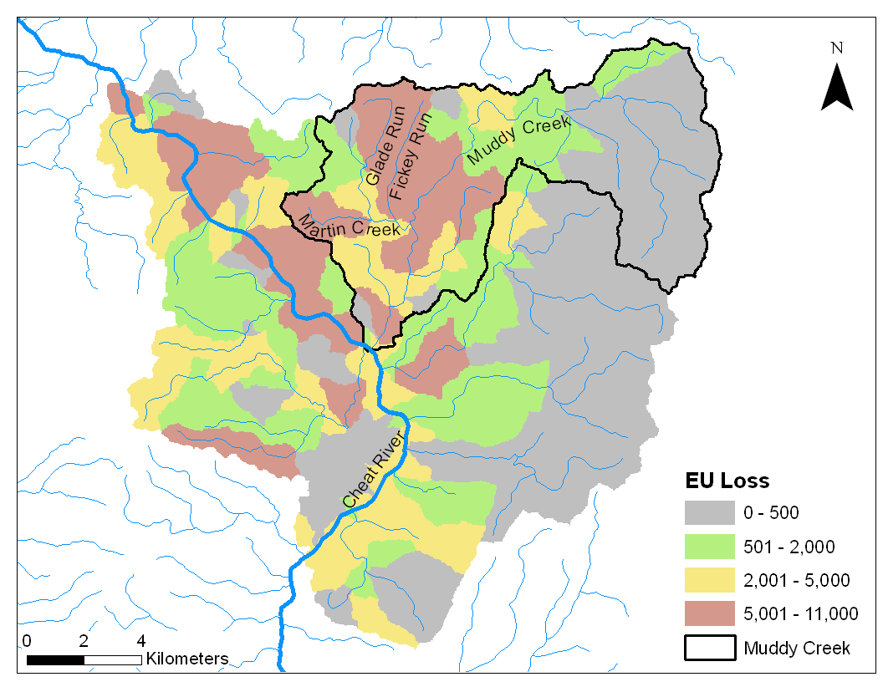

Priorities for restoration will be calculated on the basis of the distribution of “restorable” coldwater and warmwater EUs (Figure 1). Restorability for each is a function of drainage area (larger streams are more easily restored), current water quality characteristics (certain chemical signatures are very difficult to fully restore to a fishery), and the occurrence of other constraints (e.g, untreated sewage and other non-mining related pollutants). The highest priorities for restoration will be linked sequences of Restorable EcoUnits (REUs). An efficient mine land reclamation program is one that maximizes the recovery of coldwater and warmwater EUs with the smallest number (or least-cost combination) of reclamation projects (e.g., combination of at-source, instream, and in-situ designs). The end products of this task will be watershed maps that highlight stream segments and linked sequences that, if restored, would maximize fishery potential within the watershed. Maps are coupled with data tables that identify the location of high priority stream segments and indicate the amount of recoverable coldwater or warmwater EUs are associated with those segments (Table 1).

Table 1. Historic, current, lost, and recoverable EcoUnits in each 12-digit subwatershed of the TWG study area.

HUC 12 | HUC 12  MI | Historic  EUs | Current  EUs | Lost  EUs | REUs | % EU Loss | %  Recoverable
Muddy Creek | 13 | 372 | 175 | 197 | 69 | 53 | 35

Based on this outcome the project team will use simple mass balance calculations to identify the optimal type, number, location(s) and size of AMD treatment installations that will restore the greatest number of EUs within the watershed. Microsoft EXCEL spreadsheets will be developed and used to calculate and iterate mass balances for acidity, iron, and aluminum. Where measured flow data is not available, the Watershed Characterization and Modeling System (WCMS) for GIS (Strager et al. 2004) will be used to estimate average and minimum levels. The outcome of this effort will be a watershed restoration plan that will delineate the most effective combination of projects for achieving maximum fishery restoration (Figure 2).

Figure 2. Overview of the watershed monitoring, modeling, planning, and strategic restoration process. The process is cyclical and adaptive and ensures that environmental and economic benefits are maximized and documented.

Conclusions

The magnitude of water quality impairment from pre-law mining is too widespread to continue to address in the traditional source-by-source treatment approach. Consequently, restoration actions should be prioritized based on which actions will provide the greatest ecological benefits per unit cost. By integrating recent advances in GIS, environmental engineering, and aquatic ecology into a strategic decision support and restoration framework we now have the ability to more effectively and efficiently achieve water quality goals. This project will demonstrate an innovative and cost effective approach for achieving the maximum water quality benefits at the watershed scale using a combination of active and passive treatment technologies. This approach is now possible since the AML program reauthorization substantially increases not only the total allocation to West Virginia but increases the set aside program to 30% of the annual grant. This combined with the WVDEP Office of Special Reclamation program can now provide substantial funding to support treatment system operation and maintenance. Moreover, by quantifying the ecological outcome of this project, we will have demonstrated the efficacy of this approach as a currency for both mitigation and water quality trading programs. Since AMD problems are formidable and funding and other resources are limited, it is now timely to integrate innovative interdisciplinary technologies to achieve a more cost effective and ecologically beneficial approach for restoring AMD impaired watersheds.

Literature Cited

Jeffers, I., T. Petty, J. Anderson, and S. Kite. 2007. Brook trout habitat isolation upstream of culverts and restoration priorities in an Appalachian watershed. Restoration Ecology 00:000-000 (IN PRESS).
Merovich G.T., Jr., Petty J.T. 2007. Interactive effects of multiple stressors and restoration priorities in a mined Appalachian watershed. Hydrobiologia 575: 13-31.
Petty, J.T., and D. Thorne. 2005. An ecologically based approach for identifying restoration priorities in acid impacted watersheds. Restoration Ecology 13(2): 348-587.
Strager, M. P., J. B. Churchill, and V. Maskey. 2004. The Watershed Characterization and Modeling System - A Hydrological Modeling Extension for Environmental Systems Research Institute ArcGIS 9X Software. Natural Resource Analysis Center, Division of Resource Management, West Virginia University, Morgantown, WV.
Strager, M.P., J.T. Petty, J.M. Strager, and J.B. Fulton. IN REVIEW. A spatially explicit cumulative modeling framework for quantifying stream conditions at multiple scales. Journal of Landscape Ecology.
Ziemkiewicz, P.F. 2006. Watershed-based versus at-source AMD treatment: costs and
benefits. West Virginia Mine Drainage Task Force Symposium, Morgantown, WV.

